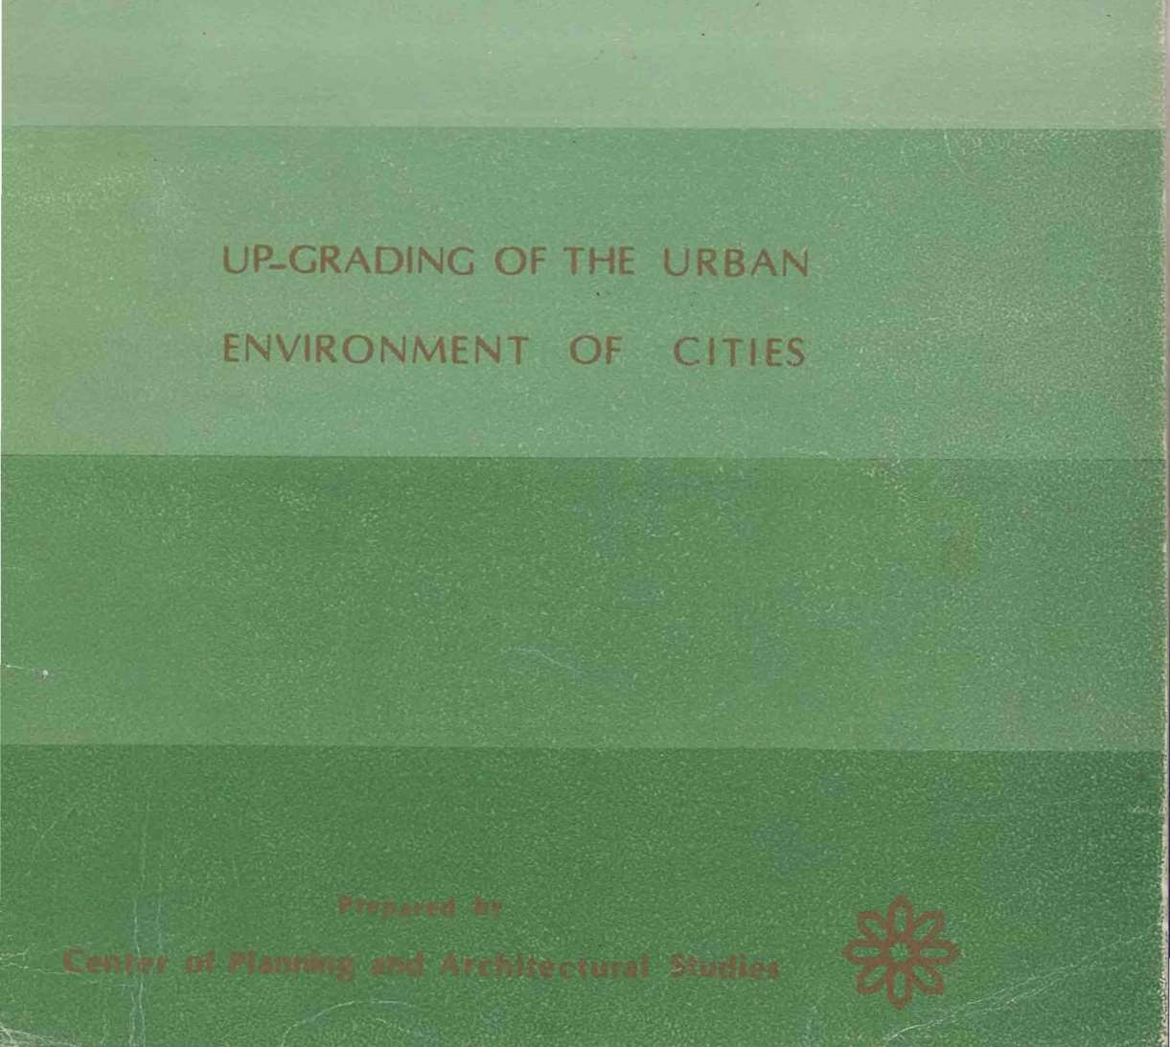

. .

MUNIC ALITY


, JEDDAH MUNICIPALITY

UP-GRADING | OF | THE | URBAN
ENVIRONMENT |  | OF | CITIES


 |  |  | Prepared | by
Center | of | Planning | and | ArchitectureI | Studies



The Civilizational Heritage & Cutler

Early civilizations started along the sides of the great rivers where man learnt to cultrate the land. He e x p r e s s e d his early experiences with the surrounding environment through the architecture of his home.
Nowadays, the architect and the planner play an important and intangible• role in order to satisfy the accelerating need and requirements of the inhabitants through the deduction of form and st)·les from IlL surrounding environment. Frank Lloyd \\'right used the co1uponenot·· tile organie
archi1ecture to reach chbest intcgrihle form ""'i1h the an iroannt(·n.t: fe Cor busier used different ckmenls and fornlchat s.eemet f)d-1 wi- h a he surroundins·et .satisfing its requir<'d rolusing ne" nuneria.s .g.
reinforced t;·oru:rcte. ohts' facades.. cs<. ala tbF'l. ai r l·ootHtiont·.r. ... eh'. On the oth r. hand.
th.Egypt ian arcbil<.'CI | i\'l oustala Pasha F1tm | Ol' | >f the· iwcnliet h | centur | pioneers (
IH86-197l ). preented | succ sfulideas
int egrat i ng fontl und fund ion using t h<· clement ' .and· form!!- <,f the ll:an2ic t\rchin.•ctu n! in the rac des nf hibuilding either horita ( t he llantk

Cha riHI o J)it ut ) or ofticc buHding \ t he 11Jgptia n r bilect. S<lt'i 9tion J
ur n1osques or pr h Hehouses. ,. ·a\ct.l K c> nlitn usetJ tuodern f()mts ri4i • l't!mcd odd \\ilh the str t'ruund ing t•rn i ron n1eoc or heratagt'. ( oru ra r· i . I ITas"u n
I• nthutiHz •d dw elt'nlt•nt s of 1hc nulu ntl ern ironnll'nt tu b J a onu:!'l • no lh ing spac:t s

J tnou gt tho!·P ut d i t Jet u ral bias aud trends. so1nc a r{·h itet· s a ppJied cheap
;tntl shahhdc ig ns fur u rJ!cnt housi ng. art· rt•s•dent ial C(•lnJH unds \\ ere l,u ih ncg,lt·ctiug the hun1anl"nlc. tht_) &trtisric tout·hcs and \a l tos c tht'r in the
•• ·ad ut· in the hH t•rior design or th<· n14:1SS i ze 't\ i t h re pect t.. tic hfl!ri zon.

hbrninar' u lwld to discuss the u p radiHg of urban en\· urnn t in the
i\fclh Ci1ic.:. efcrring to t he local her i1age to achie'e .the r ui d beaut'·
'hi. dn "not tl n the appJicar iun o f n1odern :suience and ec Q(J1og) iJI Jnodt..rn u:c.• hi:l'eture. his sem i nar give· d1e young particip Hng arc itect thchanc r <. on1t_\ doc to the eXpl•ri rncc of pert. ;:.d spccialbts
pa rdl!ipatiug iH tlH.I field or u p-g rading.
eeretar· Generu:J of .Jcdoah
t\ rch. . loh llnnled Sa efd Fr.eb'

(



An Introduction to the Seminars and Lectures Department

The eminars and Lecture Department wa establi hed in tbe Municipalit·of Jeddah on 1\'loharam 1405 A.H. The major objectives of this department are the supervision upon seminars and lectures, participating in international conferences and architectural meetings and publishing the lectures gi en by ,·isiting Professors and Pioneers in Jeddah

Through the activitie of the department, architects and engineers working in the municipality could participate in the seminars whereas the experiences of pioneers of different coontri are'discussed and analysed.These seminar bring the participants into a close approach to the existing condition of cities in the arab world. Any city is like an organic creature that growsdevelops and
is subjected to various presseures that might affect its progress.

In Jeddah, intensive efforts were made to develop the planning of the city, to improve the high ways network, to de,1elop several. green paces, and to preserve the historical local heritage of Jeddah. The different experiences should be analysed every now and the.n to evaluate the outcomes of e cry experience. The development of the city might proceed very quickly in the cultural and economic a pects pa ing by the society living in this city. This case might cause a severe civilizational gap between the city and the community.Even so,.any civilizational progre s should be evaluated, followed up and preserved or els·e it would deteriorate once it is neglected.

The seminars and lectures department aims to go ahead and tackle the different subjects related with the city, its structure and its problems in the seminars. Eventually, the first seminar was held during the period from the
12 th-15th of loharam 1405 A.H.The subject of the first cminar was the up grading of the urban en,'irooment of the cities.

Arch. Kamel Abdoullah Komsani Director of the Seminars
and lectures department
Jeddah Mnnicipality

E

The team work from Center of Planning and Architectural Stud ies

Prof. Dr. AbdcJ Bak1 Ibra him ,
Prof. Dr. H azem Mohan1ad Ibrahim

Arch. lman Barakat Arch. H ala Oma r
Arch. Adel Abdel Moneim · Miss. Lamia Abdel Razek Miss. Aysha Ramadan
Mrs. Soad Ebcid

. .
t

irst Edition 1406 A.H. - 1986
The Seminar of Up-Grading of Urban Environment of the city was hel d in Jeddah in cooperation between the Lectures and Seminars Department in Jeddah Municipality and Center of Planning and Architectural Studies• CPAS - Cairo - gypt.

The book was prepared. revised and designed by Center ofPlann1ng and Architectural Studie . Printed in Egypt by Dar-Al-Shorouk in Sha'han 1406 A.H . - April ·t986.

F

CONTENTS PAGE
.. civilizational H critage & C'ulturc
Arch iM ohan:rr_ed Saeed Faresy ... I II
·- An Introduction to the Lectures and Seminars Department
Ar;:;h j Kamel .L\doulah Komsani V

-The Seminar Review

·- First Lecture

Second Lecture Third Lecture

Fourth Lectu re

- -Fifthand Sixth Lecture:

-Recommendations
-Press Review
-Seminar Events ·.
Dr.1 AbdeJbaki Ibrahim 1
..An In troduct ion to the Up-Grading of the Physical Environmen t of the City Dr. I A bdelbaki Ibrahim 9
"'Up-Grading of Historical Areas'" De /Hazem fvlohammed Ibrahim . 13
..Architectural Restoration of the Civilizationat H -erjtage",.
Dr./ Saleh Lami Moustafa 47
''It:formal H o using'".
Dr.1 Abou Zeid Hassan Rageh 63
'"Up-Grading of under developed Area.'
Dr. / Ali Sabri Yassin 73
····················-··..····-······...····················.,······· 85
.....................................................··...,.,......... 87

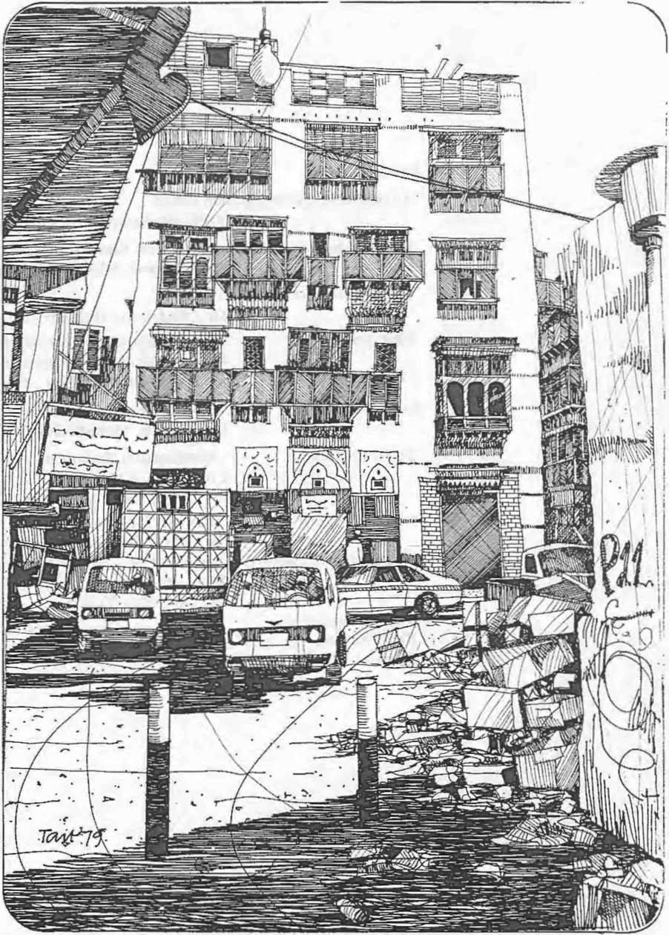
r
I

.

Jeddah - The Old City before de,·elopment

Semirar R e\·iew

Dr. Ahdelbaki Ibrahim Director of Seminar President of center of
Planning and Arcllitectural Studie ·

During the period from Lhr.. 12th-15th of Moharam l405 AH the Scmtnars and Lecture·Depanmer tin trc 1llnit;Ipaljt} of Jeddah held it first seminar about "Up-gradin-=- of the Urban En'ironn1enl of the City" in
o-opcration with the Center of p·anntng. & An;hitcclural Studic . The
:-.cminar wus opened by Dr. T\1ot-amlnc-u 1\.Jt Qattan on behalf of H .E. Sheikh Mohamn1cd Sa'eicl f- ary. he General Secretary of the Municipality of Jeddah. Univcr lli" anc consulting offices in Jcddah and Mecca participated in the semi na r. \lla yngi necrs and architects from the Municipality staff took purl in t he scssiC11:-; that were held in Holiday-Inn Hotel in Jeddah.
The seminar was concerned will:the p-oblcms of urban development in the arab city, as a continual procc!-s rnouvatcd by planning studies. lcchnu.:al anti financial capabi li ucs It ceals with the social. cconon1ic and cultural a pect of the communitY. The ,eminar mcludcd a series of lectures thal were given by Prof. Dr. A :>dtlbai Ibrahim, Pro[ Dr. Saleh Lamei Mostafa, Dr. Ali Sabri Yain. D r_ Ab 7cid Ragch. Prof. Dr. H azem Mohammed Ibrahim. Dr. EL/aT St ·cid abih anu Arch. E ·am Safey E1- Din.
The first lecture was given by Dr Ahdelbak1 Jbrahim abou t the HUp-G radingofthe Physical Environment of the Arab ity ·.The lecture reviewed the comprehensive concept of up grad1 1g with respect to the different areas: wherea up-grading of hjstoriccJ are 1s differ from that of under• d eveloped areas. The estabi..hment of t he n"'ccssary adn1inistrative and or• ga niza tional frameworks were t.iscusscd stressing upon the community•s participation in the up-grading protes.e. h rough financing and execution.
The second lecture was given by Dr. H e..z...m Mo ham rncd I bra him about
··up-Grading ofH istorical Areas, H c di..u scd the up-gradings compre• hensive concept and strategy streing p:>n the concept of · self help,. as a major incentive of the up-grading p-ocess the systems of financing and co-

1

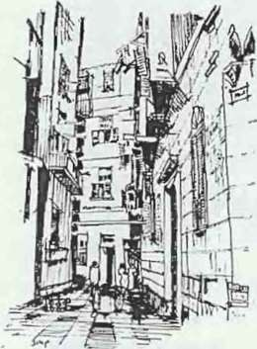
ordinating the community's partJcJpation tn the process. The general framework of the guide line d\!velopment plan in Al-Gammaliah district in Islamic airo was reviewed howing the general strategy of the up-grading policy as well as the proposed cevelopmcnt projects in the area .

..The Architectural Rcstoratlon of MonuJncntal Buiding:;" wa the su bject of the third lee;lure given by Dr. Saleh Lame1 Mostafa. The lct:t urc proceeded showing the deterioration of monumental and historu.:al bu ildin gs in the. a rab cities. discussing the factors rcsultmg in thi disagrcablc condit ion. ThenLh\; restoration project of the grcut mosque ( Al
Omary) in Saiua in South Lebanon was reviewed, showing the .

Cairo-The Hi.,wrical J slamic: Arcu
"" cr
ctrchitectural style and the cxi-..ling dctoriorating condition in deta il. The
review included a proposed work schedu le for the restoration of the mo que in particular a nd the historical Sltcs in the developing countncs in general .
Arch. Esan1Safey El-Din gaveH lecture about the .. Vtsual C.)mposition and its Treatment in H istoric;al Cairo ·. H c showed the diff4 ren t idea clca}ing with the developmcn: and improvcn1C11l or the fac tdcs of the existing bujldings and providing the ant h lshtnHc characteri ·tit: style uron those buildings wi th rc pcc t to the local hcntugc of the area. C•n the other hand Dr. E77al S 1·cid Nabih gave a lecture about the rrocedLre of visual
treatnlCtlt or the KanJrt dl lrkt in Jcddah. presenting the studies dealing.
with the ucvelopmcnt and up-grading of the area to elevate the living tundards of the inhabitants.

Dr. Al i Sabri Yassin gave two lecture. in the seminar. the first of which was abou t ··Up-Grading of L nder-De,·elopcd Area!' in the a ..ab cily. H c dascus cd the cotnprchensivc concept of urban cconon1y Mrc !'ing upon the importance of the feasibility studyand the dctcnnination of priorities.
planning 4tnd in1plcmcnlallon phases. The lecture inclutlcd as well the finandngof up-graJing projects and utilization of financial resourc...The Economit: and Administrative Aspects of the Up-Grading Pro:ecr· wns the su hject of the second lecture. whereas Dr. AIi Sabri prcscr led the up• grading project. of under developed areas around f-1 elwan in Egypt. The main objectiveof the up-grJding process. the linanciul r ourccs. the
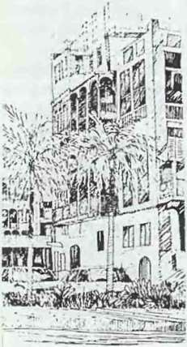
organizalion4d and the adn1inistrati c fnunework \a.crc reviewed.

- .
Dr. Abou Zeid Rageh gave a lecture about the "Architectural

.f cdduh-The Old Area The old are-A.' cm·lu'\l' a lr(.>mendou planninJ! and urchill·<. tura) trcu ure. (C consritulcl'.
a n npcn nutional mu eurn 1ha t needs
protecljon and prcscnution
Development of Jnforn1al Housing... The lecture proceeded showing the
problems and factors resulting in the deterioration of resident al areas and methods of treatment.

Many architects and engineers interested in town planning and the up• grading process attended the sessions and participated in the discus·ion·
held after the lcc tun;s, dcahng with the dincrcnt aspect s of the up-grading process. It was really inLere ·ting t o notice the Saudi mass-mcdi..l's interest in the seminar
The discussions went through a great deal of matters with respect Lo lhc

2

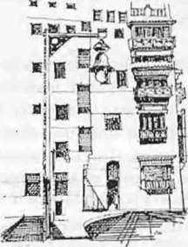

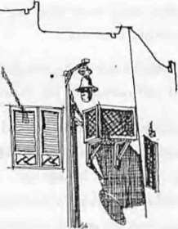

Jetlduh-Thc Old ,\ rea offer de,clopmcnt. The minute detailc.J! the lamp posts and air conditioninfl openings ''ere included ''irhin che
de-. dopmcnt prOC(."' '
up-grading process. The discussions tack led the problem of the migration
of the original inhabitants of the histo1 it:aJ CJrcas to ot her area. in the city. The accelerating development of the economic statu · deprived the
historical areas their capability Lo satisfy the needs or the occupants, who
left to li ve on the outskirts. The area was thn occupd by other inhabjtants of
<.lirferent socia l and economic structu res and actjvitics alien to the a rea which resu lted in its deterioration. The problem tends to be more critical
when t he new inhabitanls urc entirely foreigners to the area, of different reli gion, cul tu re. la nguage and civilization. This case i·apparent in lhc thi rd
world countries where a socio-cullural gap exists within the structure of their comn1unities, ralhcr than in <.Jevclopcd coun·ries.

The seminar discussed as well the establishment c•f the technical systems and the organizational framework respon , ible for supervision upon t he up• grading proce · and its execution. The up-grading process should be viewed within its comprehensive outline. The up-grading projecrs execution depends upon the creelron of the organizational fran1cwork that determines the executional and supervision bonrd, .;a-ordination between the different parties concerned a well as the objectives of the process, the priorities of execution, task description and system; of execution. The up• grading process depends greatly upon the existence or such an
.:slablishmcnt.

Most developed countries suHcr a lack or the ex perienced technical staJT capable or executing the up-grading process. Such CJ lack could he covered through an efficient training program1ne for t he technical l abour. Th is programme could be applied through the actual practice or work, wheras the lcchnical labour are trained by specialized cx.perts during the daily
practice, through the direct itnpact with problcn1s that evolute upon
application. This t raining progntmmc could be app icd as well through in- • tensified training courses, whereas the tc(;hnical l:tuour allcnd lectures.
seminars and come across the actual problems lh -ough field visits. This training programme would be more effective by editing directive manuals. which give a brief simplified job description in the rurm of instructional
.t..!. ll
ideIines.

The preliminary studies for an up-grading (XOjcct were quite an interesting poin t for discussion. The up-grading p:ojecl shou ld be deail with thoroughly within its comprehensive concept. The st udie ·must cover the various economic, social a nd urban aspects of lhtproject. H owcver.the
success of the up-grading process depends grcHtly upon the inh abi tants'
.
association in the process through ..self help " bc;;u·ing in mind that this
process ain1s merely to improve the living condit ions of lhosc inhabitants by all measures. The socia l st ud ies constitute an in1portant i tem or t he
preliminary sludies. It should be borne in mind t ha1 the social studies are not only a collection of nun1erical dutu as population censusfamily sizes.
population densities. growth rate, ...etc, hut it cleats wilh the inha bitants through direct impact. It determines their requirements, their social needs. their method of thinkingtheir capabiJity of association in the up-grading

3

process. Through the dired impact with t:1e c:lmnnmity, sevc:-al options
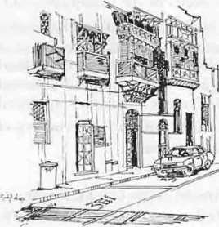
cou l<.l be suggested as well a the priorities ·f e:tecution. The cc•n1n1unity's reaction is a vital detern1inant of the best Jlte-native.

.J cddnh-Tiw Old citv
after d\·el opm t•fll. An approprhire system
must be laid for the trnflk now
through rhe ht';l orknl area by gh·ing
passing licences for the inh o.bitants olll)·, uch that each cur hn.. its own
parking an•a deliucd by itnumber

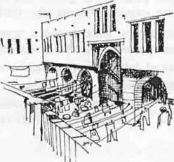
The discus ions tackled as well the subjet of the traffic in thhistorical area. Considering that thcc areas were built before the car in ven lion. whereas the only method of transportation w;ts the cans, eventually the street widths and paths were relevant wi ·, tl-e traffic size ard velocity.
However, the car invention and its usc inside th .:historic..d area ._onstitutcd rat her a da ngerous problen1. It necessitated the remo\ al of buildings to widen the roads and provide parking areas. The heavy tr fTic all•Jwed in the
area drastically affected the historical build.ng'due to heavy vibrations as well as the noxious gases. ln so1nc cases. the traffic inside thhistorical
areas could be forbadcd. yet it is so1nctin1es ne-cessary to allow the traiTic llow to serve the existing activities: commerce..ight industries, handicraft!)
as well as the inhabitants. Several optionwe:-e then suggested;
I. The entire forbading of trarfic in son·•e rarts of r he arc:a with the provision of the net;CSSary parking )OtS at the OUt-skirts.
- The traffic flow is .;onfincd to u one direction route t o solvthe tra ffic congestion in the area.
- The rem ovaof the cotnrnercial activitie:;, w.Lrehou es workshops fro1n the area to the out skirts thus decrcasir.g tl-e traffic i1ow in:o the area.
- Permission of passage of the occupantspnvate ca r:; only.
- Forbading the traffi..:; now into the area entirely except fnr cer tai n hours by daytin1e and night (for the loading and unloading of tl·e trucks}.
The preservation and conservation or h·sro-ical and n1onumental bu il• dings is based upon raising the cornn1unity sand authorities· crvi li zational consciousness as weJl as the cultural vetluc of those bui l d.ngs. Thee aut horities are responsible for th e decision n1aking process wnich greall) affects the urban development. The n1ass n.edic.. systems cou ld be utili zed to develop such a civilizationalconsciousncs through the press. publishing
organizations and the television progran1rr es considering the public interests. H owever, developing countries su.Jer a l a:k of :he cultural consciou ·ness as they concentrate upon :he ublic er.lerLainn1cnt which does not sLimul ate the development processes any further. The preservation and conservation of htiori .::a l areas necessitate the collaboration of the experts fron1 every field of interest such as urban development, mass n1edia, con1munication.and others in order to lay down
the proper realization progran1n1e.

Cairo-Wckalct Qait
Bey. The Viol ations Carried out by the
inhabitants urc quite app•arcnt.

The restoration of n1onun1ental and historical buildings ne ssitatcs the i1nn1ediate removal of violations and intruding addi tior.s and annexes. The restoration process includes the repairing of de11oli shcd parts. This process
n1ight need the utilization of historical d:)cua1ents and old references to determine the accurate description of the dem :J lished parts. The repairing
t>f demolished parts might necessitate the use of new building materials.

4

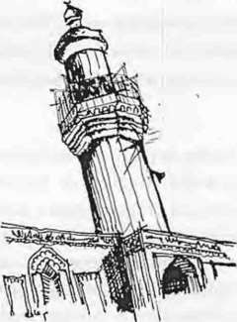

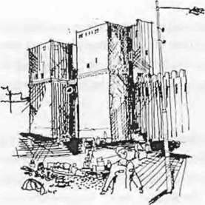

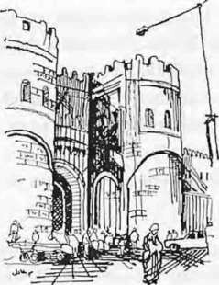

Cairo-The Historical Islamic Area• AI-Aqmar mosque-Bab AI Nasr-Bah Al-Fotouh.. a Part of the Arab Islamic Civilizational heritage that ough to be rc tored and protected
Yet. the unrelevancy or the c d · ud new buiJdjng materials together causes
shrinkage and cracking in ti-e b·tildin6. On the other hand, the retnoval of
sto nes and replacing them o t:1eir original position causes a 30°u-3511 11
\Vaste of stones. The reslorat or. nf polished wooden parts necc sitatcs the removal or the covering polhe.;. The restoratjon process nece ·sitalcs the
supply of t he suiTicicnt st-uc:t.rt! r:ctwork to pro vide suita ble li ving conditions. Yet this n1ust not ;nc ude a1y additions that will entirely change
t he general character oft he 1ist or.ca building.

The preservation a nd cort!;er"":.ttion of historical and n1onun1cntn l buil• dings could be achieved tr ·oLgh a stric t restoration progran1n1e. The monumental buildings shom.ld be considered the focal point of the up•
grading process in historical :Hs. Tl·.rough this proces, the monumental build ing could be utilized v.i t 1ir. the invcstn1cnt sector whether or not it has a social or economic benefit. fh utilization sho uld lak e place hased upon
the regulations and ra::om :n...ndat ions Laken by international
organizations. The tnonunu!nta builc.ing should be dealt w it h through its approaches, its visual con1potion 'vith the sur rounding masses. The restoration or monun1ental tuilLrng:-houltJ nnt ndeavour any changes or mod ificat ion respecting the l rditional 1slan1ic architccture. Any clement that might cause serious c .ur-1:ge.o the building should be entirely ren1oved or placed in an annex=:i building.

Most developing count ric..; t-.:le:- a lack or pernutncnt supervision upon monumental buildings, as wdl as the •.:ivilizationa l cultural consciousness. Such
·a fact is aggravated b:. the reject ion of sotnc part ics to t he conservation of historical h rit 1g.e. This lack of consciousnes!-. could be covered through legislations lha_ tlt<tin the governn1enrs power to protect
the monun1cntal bui1ding""'f-orr unaware individual behaviour. Severa l countries followed a strict r·:>1k··o !)reserve the monun1ental building
t hrough ex-proprjation and ::>rcviding: the suitable compensation for the in hahi tan ls. yet such a pol ic::· .n:!:cssia tes the availability of capital.

The subject of informal 1 :lu:ing in cities was overviewcd within the discussions. The phenon1cnan o' infor n1al housing evolutcd as a result of unp lanned migration to the ci .y, thexisting economic problems. the irregular distri hu tion of utili es tnd scrv ices. the expensiveland costs. the absence of the necessary le islations or as a result of the shorLage of dwelling units. This problem see:n ·111orc critical considering the existence of repulsion areas suffering ve·:iving conditions against the atraction areas su ppl icd by the neces '&.ry iving requirements. Thus the problen1 of informal housing should be td•.klcd as a plannjng problem within the fran1ework of hs actuaL social!!nd economic aspects. Itshould be dealt wilh upon the nationaL·regional a.nd local level as well.'

The occupants or the info-n1;. I hoLL..;;ing arc not necessarily or the low income sector. Surveys sho d ·.ta: tl':c moderate and high incon1e sector constitute a ren1arka ble pe t..:entagc :>f the population : son1e of those occupants inspite of their reLtlively high income level, yet lheir

5

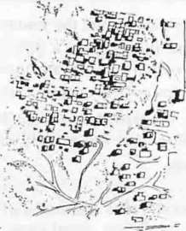

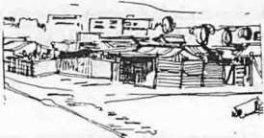

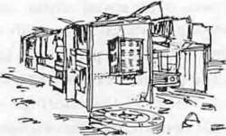

Ri·adh - The Informal llnusinJ! ia
remarkable phcnom nnu specially in
the thi rd
\Vorld
ivilizational level is apparent))low. To t:-..::se t)ccupants, 'the area of
I •
inforn1al hOU$ing is considered a distric. fshta? :iwclling units. Th"is racl is
recognized considering t fc occupants' capab..iLy of possesion of cars and luxurious equipment as colored T.Vs, ele tric r,-. rigerators, air conditioning systems, video se ts etc.
In Jcddah, the execution or the Pales inc Bt i::gSquare necessitated he removal of some deteriorating resid ...ntial e.:.rcJs. Inspitc of the large amendments paid to the inhabitants for the rcrro\ i.tl of their homes, yet they refused to co-operate. After the forcu - \ acuat nr of the inhabitants. it was noticed that nlOSl Of thenl have huugh t VCf) L.\pcnsive pieces Of land 10
build their houses.although they were given anendmenls considering their complain of their linancial condition. This pJ enomenon proved that the occupants of deteriorating areas a re not nec.;e!);arily poor, on the contrary,
·o rnl; or them arc wealthy enough to provide ttc:nselves with better liv ing condition: but they cannot utili ze their rinanc- al capabilities in the proper channels.
One of the mos t serious sytnptoms •):' the i1fc·rmal housing problen1 is that those areas are built by individua .s cape. Jle or investing their private
money and other individ uals problems They lOLid make usc of any gap in the existing regulations. Such a behaviour en ,(. rgs the problcn1s of growth
or informal housing.

Another main cause of the inforn1al housi:tg phenomenon is the long complicated process of getting the build i1g Jic c. registration, payment or taxes and fees for social insurances. Th .... impr(•'lcment of informal housing is often subjected to various lcchn JC.al, f n .tncial and organ iza tionaI
pressures which mighl not be tolerared by the local departments. The inhabitants could make use of the .g..overn mer( a) a mendments and loans to provide new dwelling units or to comp·ele texisting ones on condition
L hat they could withstand further additions. Thi -;.process might be related with the district's capability of handling moreLizens. Preferably, the loans ought to be invested in completing the existinbuildings and improving the existing infra-structure or addition of V/.Cs, c.. k tchen .... etc. Through th e governmental loans. the informa l growth prcces;could be directed in such
a way to provide better livin g conu tions. J: is to be noticed that t.h informal housing constitutes 84 'Jcl of tJ-.e tota tIsing in Cairo an d 90tl nor
that in Beni -s uef.

The n1ain features of the inforn1al hous:11.5 showed that the intcrnul design satisfies entirely the occupants.. need> C'n the other hand. the ,go- vernmental housing lack· such a cha racter -vh:!re the dwellrng unitarl.!
su bjected to violations through the adjition ::>f new rooms or change of functions of o ther elcmen t".... uch a-.; lr:1 -.krin!! tJ-,e kitchen into a bed-roon1 a nd psing the hall as a kitch n. ThL· ocit [ ILtbitaL in inforn1a1 housing area is characlriLcd by the deep 1 nnt d r lationships between the occupants through origin or religion or kinh .p.. Such a soc.ial coherence

6

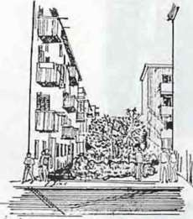

Cairo-!-> huubra The publk
parlidp••ti<m in cn ironmcnlal imprcnt.·m nl in one of the J.!U'crmocnta l huu ing areas through
"-,l'lf help ". The open areas in
hl' 1\\ CCJ1 lhc buildings \\ CrC pla nted
provides seJf security amoog t he neighbourhood. The occupants of governrnental housing lack :ouch a characteristic feature. The economic aspects of the development poeess and the l'easibility study was quite an
interesting subject for di cus ;jon.The success of the development proccs tlcpends grea tJy upon insuring the a vaiJabil ity of financial resources before execution. The fcasibiJity st u: y tends to determine the necessary financial resources. the expected bene-ts as well as the profit rates. This feasibility
st udy should be carried out ;.tilhin the regional. na t ional econo1nic and
·ocial development plan. Thefficieney of this study necessitates the entire collaboratio n and co-opcrat>n between the econ omic. social and urban planners.

The feasibility study sho .:ld be based upon the existing Jaws and
r gulallons taki ng into consi;:rati cn that any n1odiJication or change in thc L' regu lat i ons will fail the 1suranccs laid by the feasibility study. Thus, lhc-..c legislations should be deeth wit h as a given factaccordingly the khlhllity study could he car- cd out. It shouJd be borne in mind that the
more feasi ble project inot nccc sarily the one that bears the highest financial benefit. yet it mighr be the project t h at ensures the permanent benefit on the l ong run, or it cmight he the one that ensures a social benefit that wiiJ compensate the de<. -ease in the Enancial benefit. The financial

with trcas.

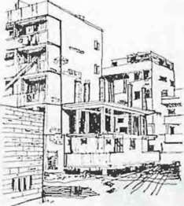

Cairo-Helwan u The
informal actions are actuaJJy the iohabitanrs procedure in soll'ing the existing
problems by 'Self help . The abon
figure shows the extension of an exist ing dwelling by the erection of a new building adjacent to the exi. tin
one.
bcnclit is related to different invest ment projects s uch as holds, to uri tic si
les, lu xuriouhousing.shopping cent res and oiTicc buildings. On the other
hand, the social bcnclit is rcla :?d with the service and utilities projects s uc.:h as infra structure network_ roads. mosques. hospitals, clinics and
govcrnn1ental schools. Howe· _r. thl: ocial hcncfit is never ab. entrron1 any investn1cnt project because -ec kinds of projects usually provide new working opportunities. The_y «..bo hdp tu achieve national self satisraction
or might produce a major 1.erchandise th a t 1night aiTect the national bencfi L.

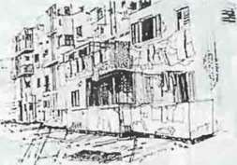
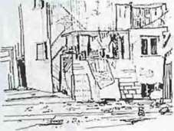

7

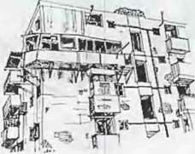

8

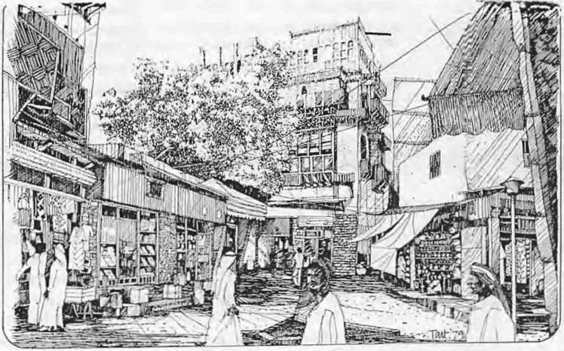

.Jcddah - "rhe Old City before de'elopn1cnt

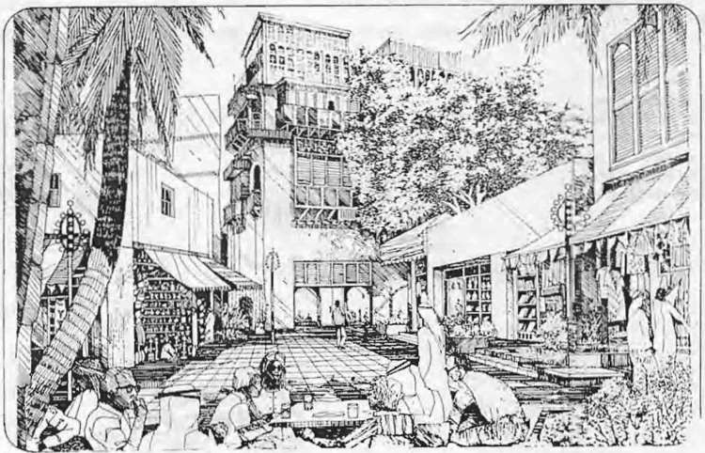

Jcddah - A J)roposal for tbc de\eloprncnt of fhc Old City

9

r\N I rrR<>D)l(''I'ION ·r<> 'I'HE . ?-GR· Dl (; c)F l"HE Pfl SlC. L ENVIR(J. ME T

P•·tJ.f: Dr. lhdelhtlki lhl'fthitll
- P'ROI·. l>R . \IUlJ.I 8\h.IIBR\111\Y
Prrtrc....,nr (If I uw '' Pf:umin. llcud of \rrhif "\'1 Utl' O pt. \in Sham' l ni\.
Pr idt•nl nr ( ''nlrl' nf PIUIIIliiiJ! & architl'CII.IJ':II ludt\'..,.
f..di1nr-in-chicf nl .. \lam \1-lh·nuu ··• mon ,J trl'hircc:taral planninf!nHIJ! UIIIC!.
l- ,.t ·"· ('hit•f l'pcrt in I un Plunnin . U. \. ( uiru l nh.
JIJ49.
B.A. l.hcrpool lnh. JlJ5 .
'1. c:. in l rb:w PlanninJ!. J.herpuol L ni\. I Q54. l"h. 1>. in lu"n r'hmninJ!. 1'\t:\\ ( a..clt l nh. I Q59.
+
I flo publ hed a number of rc"l'ttrCht·-. and 'audie'
bc.-..idt:, bt!ing 3 cnn..ulhtnr for munl'.Jt)pri:an .:..ntl lnll'mutinrud etrl!,antllltrcln...
Ill' dt'\t nt'd und plaum·d u nun1fwr nf urchit "<:turul ami
J'l.ennmJ.! pruJ'-"'''" in l-p! nd oth"•r una h t·uunlrw...

Thl: llhJC: t or up-grading <t-. cl S)"'tctn of XC llll\_'planning is still in its prdimnHir) C:\pcrirncnull tagl!. Up-grading is c >1 klcrl!d an a<hanccd phaC in lO\\ ll planning ahead of the tradittonal pia 11ingtheories ba cd up•
\lll ll1 1 tcr-J la·1s. The long tunc taken to prcp:u..; thnsc n1aster plans
<.kprn cd thoe thconcthc11·cfficJcncy in .ati ·r inthe rapid den1und for dc\Ck)pnknt n the third \\Orld.
The C\l t mg. c:nnc.li t ion nc<.:cssitatcLI the scan:I- fl)r a nc\\ c:on cpt or n1a tl:r plans. Tht nnc:cpt took the form or gut d.: line planwhich wc.:rc
u clc!\s.cx cpt in lhe c:asc ortnain road net wnrk. Intra st ru<.:tu rc services and
"omc s pecial-case projects. Thi · disagrcablc condition led to the: search ror a lll!\\'
s) slcn1 'upplcmcntary to the n1astcr plans ace guide-line plans (in a n1orc dct e:till:d 'icw ). Up-grading was then c:on iclc·Ld the mo. t Yilal proce•
dure in dcaltng" tlh the old ..tnd under developed.reas. Dealing \\'H h those area!'\ n1cans a complete understanding of the cxts.1ng problems and the rncrcasang rap.d dcn1anJ of dc\'elopmcnt anu it cquircl'ncnt . The up• gr;.td ing procc:-,s in itexp rimt.=n tHl phase hou ld b·oilowed up, evaluated. discus::-
.cu unc. published in order to altcun its rcq·1ircd goal: being in its prdirninary stage it should be followed up in ord r t() judge its po itivc and negative aspect·.
cvcral up-grading proccs.. e.. \'. carried out in Asia.
Afric.:a.. South America. a tern and We tern Eur..>"Je: such trials must be C\ aJuateu di ·cu .eo a nd published in order to be acquaintcu with all the
circumst u1ccof eve[) Lrial. On the other hctnd. tb.!Arab countncs suffer a lack of
Lht.: rot 0\\ up S}St em and evalualiOO of the U::>-grading trinls curried out.

9

1

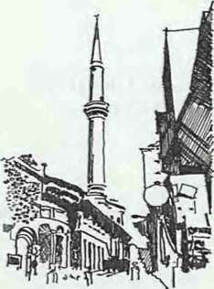
Cairo-The Historical Islamic Area -
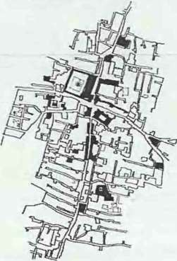
Al-Selehedar minaret - AI Mo'ayl.'d mosque - AI Khyamia area.
The major aim of the de·,clopmcnt of historiC2l areas is the preservation and protection of
monummlal.build•
ing and antiquities within the typical
character of the area.
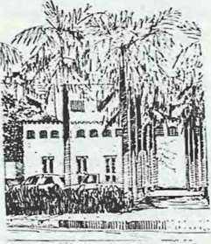

.Jeddab: The old area The prl'M!r\alion programme must in• dude rhc exi'ttiog elements
Up-grading in its comprehensive framework has several meanings that ditTer according to the different fields of science e.g. in the engineering Jicld, it means improving the infra-structure network which includes roads network, domestic and drainage water systems.electricity and gas network
... etc. In architecture.. up-grading means improving the architectural from
and its development. To the urban designer.. it means development of the urban environment expressed in the built up mass, site organization and landscape design.To the sociologist the up-grading means raising the living
!-.tandard of the individual. and his communal relationships. On the other hand, to the economist up-grading means in1pro\·ing the status of the individuaL his income and his production. Since the unique goal of the up•
g..... radin.g_ of the urban environn1cnt is elevating.... the individuaL the of nature e.g trees, busbes., ··-·etc.

10

community and the surrounding en\ ironment. then up-grading in its wide
comprehensive form should be \ ic\\J within its physicaL economic and
. ocial aspects. Within this comprehensive concept. the application might va ricntl y change according to the priorities and circumstances of each area: e.g. dealing with a historical area difTcrs from a deteriorating residential area or from the central district area.
When dealing with a historical area.the prime goal is the conservation of the general civilizational charucter and the protect1on or the existing anti• quities. This goal requires the careful study of the hi ·torical buildings.. their
architectural clements.their building materials., the system of repairing and renovation as well a<;
method of
dcalinwith the surroundin2 area
enclosing residentjal. commcr ial. industrial.. educational and
entertainment buildings. This indudc!-. as well future buildings expected to be built up in l he area. ()n the other hand dealing with an
underdeveloped
area is cntirel) din·crcnt: it is the indi idualli\'ing in this area who should
be under deep concernbc ausc the major problem of such areas is the Jack ofthecivilizational consciousness. Dealing with such an individual is a very sensitive matter. this requires
most appropriate development policy.

Dealing with modern itrcas ancctcd by the western character is a different matter. The community inhabiting: these areas is probably of higher social standard and cultural educational leveL In this case the social aspect is less importanL while the up-grading of the general Corm is of prime importance.
These three ditTercnt cases might be gathered in one areaaccordingly the
up-grading process will undergo the three procedure .gf treatment within one project with different specialization and application.
In an up-grading project, the cstablishcment of the organizational frameworks is necessary to turn the theoritical concept or up-grading into an applied developed onc.It is disappointing to notice that most Arab
countries lack the existence of such organizational frameworks and the technical labour needed for the execution of the projects. This problem
tends to be morecritical with the lack of qualified technical labour. It could be overcome through holding "training programmes and qualifying

the st ud y of thsocial aspects of the communit. Psychologist.
so...:Jolog.i h. cconon1ih
tog.cthr "'ith the urbanplannr should fonn a
tcan1 to provide the

.. ,, .

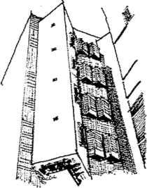
technical labour_ Those training programmes should cover up two main objectives one through holding· intensive training courses to elevate the employees·efficiencythe other through training the working labour during
the actual pract ice of work with an expert. They should be supplemented by the preparation of planning manuals by experts. in order to direct the
planning concepts and systems of work. These manuals should cover all technicalfinancial and managerial aspects.They should be prepared in the
simplest form that shows in detail .tc. systmatic procedure of work and the

Jeddah .. the old area. Thr- dominat• ing characteristic st)·le in the old areas must be provided in the new districts as
,..-eU.

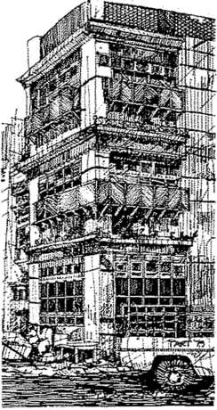

.Jeddah- the old city. The planning and architectural patterns of tbe his• torical areas should be studied to deduce the elements tbat could be utilized to provide the new areas or
the existing ones with the chili•
zatiooaJ character.
main outlined and detailed tasks. These manuals should accentuate the
. .. -··- .. .. .
.. ·
concept of ·Make It YouselC to enlarge the size., of labour capable of
dealing with an up-grading process. It should be noted that the establishment of an appropriate organizational framework does not mean that an up-grading project could be executed through the usua] office work because these kind of processes-especiaHy when dealing with the social structure of the society necessitateslhe direct daily impact with the community to make use of its capabilities and encourage it to take part in the up-grading process through self help.
. ..
In order to guarantee the success of these particular kind of projects-: the
· society must take part in Lhe carried out processes by laying down its requirements and wiJ1 and st ting· the priortties for various development
processes. During the field study phase, the society plays an important role in determining its OWJ?- social and economic characteristics.. In the planning preparation phasea conquest and public hea ring sessionsshoul·d be held to
discuss the various planning probabilities.The society's important and vital role is in executing and financing the project. This role is the guarantee for the project's execution and it expresses the society's impulse as being the
prime benefitor. .. .
:·
·
I
An up-grading projecl should gain some public attention specially when dealing with various social organizations. This includes radio. television and
· .
news papers because they are the unique tools along w·hich an up-
grading concept could be transmitted throughout he community. In this
· way the community could be more familiar \Vith the up-grading concept as v.:ell as its role in its application.

On the other hand seminars and conferences should be held to discuss all the factors and circumstances affecting the up-grading process and to discuss dealing with this process from its various ·economic; social and urban aspects.

In this mannetrhe up-grading process could be ident ifiedirs concept
c.nd its goal d etermined 'Nithin the Arab Islamic traditions and the local environment. Consequently the theoretical concept of up-grading could be turned by th e community to an applied science.
' . . ..·....... . . . .......

. ,. ..
......·.... •. ...,f ...,. .. ., •

11

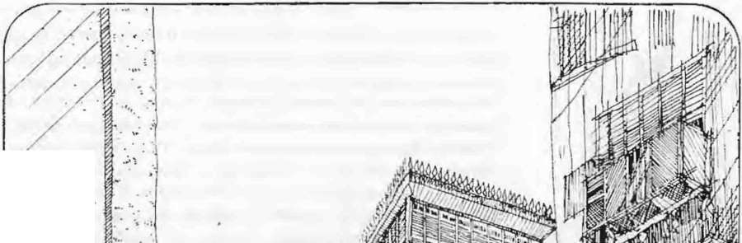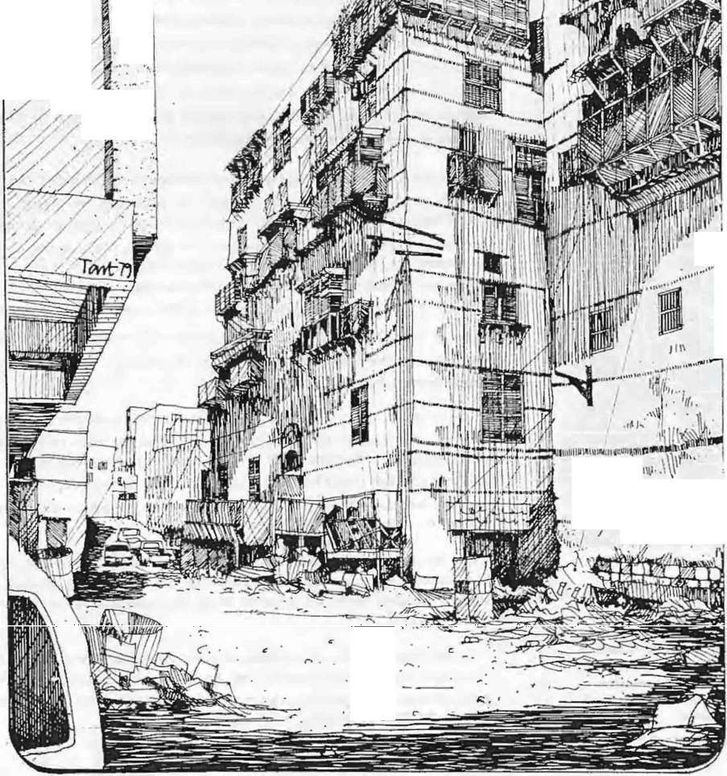. ·'..-·.
.......
...

/ / ,. ..... ..
I . ...
·.

.

.,
'I ,.,ll·.
. .r"· th•• 4 , \ • • · ,• • .,.UH• u 1t,....

..
1/Io '

,...

,... '

,Jeddah-rrh Old city before de\·elopotent.

12

UP-GRADING OF HISTORICAL AREAS

Dr. Hazem Mohd. Ibrahim

-PROF. DR. HAZEM MOHAJ\IlMED IBRAHIM
- Professor of Planning, Faculty of En&ineering, Al•
Azhar Uoh·.
- Technical 1\>lanager of Centre of Planning &
Architectural Studies.
- Assistant Editor-iiH:hief of •• Alam A1-Benaa "
Monthly Architecrural, Pla nning Magazine.
- Ex- U.N. Expert in the field of urban design.
- B.A. Ein Sbams Univ. 1964.
- Pb.D. on Town Planning, 196 .
- HepublisTown nnm.beJ: of srudies, researches and books on town planning and participated in many architectural projects in Egypt and other arab
countries.

INTRODUCTION:

,

The historical area an the I Iamie city are considered of a pure civilizational value to the entire human race. The revival of the deep rooted

'J Iamie Yalues the modern city could be achieved through the consen•ation
in
and presen•ation of this historic trea ure. Lately, the Islamic community has been subjected to a strong cultural in,•asion that tends to change entirely the Islamic values and concept , methods of Ji ing and culture to attract th(•
community and the individual from their I Iamie tradition to the western
cuhure. Thus the call for presen·ation of the urban Islamic heritage, the conservation of Islamic historic buildings and the revh·al of the I Iamie moralities in tbe modern architecture of the city is nothing but a further reinforcement to tbe pure Islamic faith.
Recently, the different historical and Islamic sites and buildings were ubjected to severe damage,. violation removal and destruction. The ab ence of supervision upon those building a well as the necessary restoration and renovation work have made the e i ling condition even worse. If this carelessness and inadequate control upon the e sites increase further more
the most \'a1uable part of our I Iamie culture and heritage will vanish.The call
for pre enation, restoration and reno,·ation of historical buildings is not to be seperated from the up-grading of the "hole surrounding environment. The environmental up-grading doe not deal only with the urban aspects but includes as well the social and economic aspectk of the population and their acth·ities.
The up-grading of hi toricaI areas \\ill be discus ed in the following pages "'howing in general the main strategy and concept of up-grading and in

13

particular that of historical areas. An applied example of AI-Gammaliah district in Islamic Cairo will be discussed as a wbole followed by the stud)' area adjacent to AI- Hakim mosque and the Cairo northern wall. The entire reHectioo of the up-grading strategy upon the up-grading and development
process in the action area and its cxcutiona.l projects will be reviewed.

THE UP-GRADING CONCEPTS AND
STRATEGY The up-grading of historical areas shouJd be dealt with through a de• r
lined conceptional outline and strategy. To outline the general strategy of
up-gradingmany determinants must be overviewed as follows:

The comprehensive concept of the up-grading process. The up-grading as a gradual process.
The self help as a major incentive of the up-grading process. Self financing of the up-grading proce5s.
Investment of the positive aspects of tl-.e existing problems.
Relativit) of evaluation of thl; up-grading process. The standards of thl! up-grading process.
Decision conflict and contradiction. Levels of decision making.
Different parties participating in the process.
Determination of the appropriate m.... thod for treatment of bad, , n1oderate and good conditioned buildings whcthl!r they arc historical
or not.
.: The up-grading concepts and strategy wl"l be discussed in detail in the
.. following review.

't. THE COMPREHENSIVE

.,
CONCEPT OF UP-GRADING

...

Up grading as a comprehensive concept includes several fields of action. as

.. ' ,
,.
follows:·
- 1-1 The Up--Grading of the Infra Stucture:

The builtupmass

up- grading
  - ..

. ,
I , J • I
; This field covers the up-grading of the infra structure net work , e.g. roads network. pedestrian routes, domestic water supply and drainage water
system, electric supply, gas network, communications, ...etc. This process is not concerned with the social, economic or urban characteristics of the
area. Being very specific, this field of action. does not cover up the

. . . Areas . ·

Communit
comprehensive concept of up-grading.
·1-2 The Up-Grading of Social Services:

• ' •y
,.. ._. ,
• • t . •
. This field .or action is deeply concerned with up-grading of the vario us social services which include religious buildings, educational, health, cultural,

I'I • • : .! r • '.,
The comprehensive CQncept of up - grading ahdudes ; '
. ..
up-grading of built up
mas.s, up-grading of infra
sports, entertainment and departmental services. The educational services include kinder-gartins, prin1ary, peparatory, secondary schools
1• and la bour training c_entres. The health ervices include clinics, health centres and hospitals, ... etc. The cultural services include public libraries., cultural and literary dubs and arts centres. The sports and entertainment

s,tructure., '
up-grading of social services and
up-grading of community.
.'... services include sports club., play-grounds. public gardens and childrens·

' ..
, t-c.
' ' .

..
""• I.
playgrounds. Departmental services include post-offices, police station

.. • • ..•.• •
14

.. . .-•
• •• . .
.....o a •
..,• • ••
••

  - UP-GRADING AS A GRAD'LAL PROCESS
and governmental departments in the districts.
This field being very specific as well does not cover up the comprehensive concept of up-grading.
  - Tbe Up-Grading of tbe Built-Up Mass:
This field of action is concerned only with the built-up mass and it
includes all the existing buildings whether residential or non-r sidential. public or private. It should be noted that the exterior of the building rather than
its interior-that is the subject of the issue.
This field being very specific as well does not cover up the comprehensive concept of up-grading.
  - Tbe u..-Grading of the Community:
This field of action could not be interpreted without dealing with the sociat economic aspects of the society. the enclosed space in which the
individual livetshe social services and infra structure.Thus the up-grading of the community covers up-grading of the infra structurethe social services and the built up mass all together with the social and economic up• grading of the community itself.
Therefore the comprehensive concept of up-grading is based upon four main items. three specialized items and a more comprehensive one. On dealing with an up-grading project., it is better to overview the subject
within its comprehensive aspect to attain the required goal. Dealing v.rith an
up-grading project within a single specific aspect might counteract the fruitful results achieved through another aspect. Regretfully., this is the case with most arab countries whereas up-grading is applied in its specific form.
Up-grading in its specific form could be applied in the following cases:
t a) As a preliminary stage of a comprehensive upgrading programme that will be followed by supplementary stages.
( b) As an experimental project to test the public reaction and its opinion in the development process.
{c) In case of a Jack of the sufficient financial resources and the
uncapability of the necessary financing for the up-grading project. ( d l In case of evolution of urgent problems.
( e ) 1n case of evolution of problems of a specific nature which can be solved
through specific up-grading programmes.

The up-grading within its comprehensive framework is a relat ive process. An up-grading project does not aim to ameliorate the !'tate of a deterior ting district or an under developed area to that of a luxurious
suburbsuch amelioration would cause a .sharp leap in the sociaL economic and urban structure orthe area. \\·hjJc up-grading cannot tolerate such
leaps. but it is a gradual process. The up-grading of a district aims to the up• grading of the social and economic structurethe built up mass. the infra structure, utilities and the surrounding environment. The different features

15

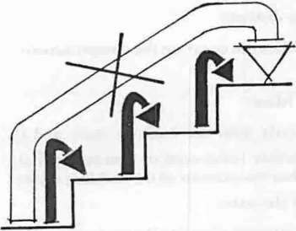
up- rading iu l'tllll'nt ial
prorcs!\ rhar could ool rolcratc an leap).

  - ··.'ELE HEur· AS A t\lA,JOR 1:"-CENTI\'E OF lP-GRADI (;
L> f the previousl) men L ioncd rielus or at i0n nee -=i Lll t h:
opcrali ng or the llp-grctding process. This COli kl be :,.. j ·cd rurt hcrnHli'L' considering the Iont imend t!rea L c iTort exerted to c .an rrc the socia I strul:turc. u c h ange that result!'! i n t he ligh test ouH.:on'""Vh k: the coJH)Jl1it· up-g rading needs Jess c!TorL and time t o recJch greater rc u.·. Sin1ilarly. th
'- ._ '-
up-grading oJ'thc built up 1naand the :-.u rrounding c-rY ron tnctH takes le :-. elTon and time to ach k\ e im med ie:ttL' result .
Stepping an up-grading project is the most ap p ro p r a_e procedure t o co• ordinate between the various field s or action w ithin tr.ccomrnunity"s adu tl n eeds.

Since th e up-grading or Ull) area aims to the provis or of better living conditions for its in ha bitants. then the ;on1tnunity is t he 1rain target. Thu:-. the progression or the: up-grading. prnjet primarily d pc:lds upon lhe l'
- orcli nati on between thc commu nitand all s stems ir:Hll\.!d 111<.lthat is thl· Go\'crnment. Tht: comn1unity-as a bcnclitor-can pia_\ it :1 im?nrta nt and
,·itul role in the up-grading projt through .. self help .. ulnng the different field-.. nr clCl ion.
Thc:-.e ·· -..drhclp .. uct ions t:(t n prn<:ecd along d ifkrt:n: p:lasein the :-.a

The st ate's role in up-grading lies in prmicJirt).!. thl" pulcnliali tic;.;. l->Upl'r•
\ i...iun and t·un Irul. As fnr till.'

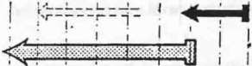
'
t ime e.g. training. self linancing. practi sing i.lncl sharin t he: tasks and
duties.... etc. In the case or soi'tl up-grading. the puh il: appro\ tl of the: '\Ocial cha nge requ irements is it::,df a ,·ita! role-taken b) the communit,- lO
nsure theS:llt.:<.!SS nr the project. The ..self helpu co ncc;x -nitiatca rcding of
tnL

t:ommunit·r ole. it li es in sli mulat•
i ng the up-g rading pron·:-.throu'-!h
.-.l'l f ht.•lp •.

  - SELF Fl A 1Cl G OF AN l'P• GRAOI , PRO.J ECT
bclongi ng t o lhrlat:c '' h ich enu res lhe com nY.n i.1) ·s a ppn.1\ ''' u nd su pcrvision 0\ r \he other ll p-grad j ng projects i11 the ..trc l c
g. ll p-grad j ng or
the infra-st ructure. scr\'iccs, built up mass and til ..· -..l!rrounding environment. This in turn ensure:-. the perfect utiliLa tint r•f Lhcc :kmcnls. thus decreasing rep<tiring and rcplr.tccrncnt cost s. A.n illu tr..ttnln or th con1m unity's role in an up-g rading project couiJ be cc·nJonst rated through
the cstabli,hmL'nt of outh wnrk camps whereas. .th.:1o1 and uni"crsit stud ents ould participate in carrying O Ut inlpi'Ct\CI1C ll1 \.\'Ork oi' the surrounding ctnironment such a: clearing up swumps or garbage: 't nd rcCusaJ collect ion or garden ing of o pen spaces. Such t 1.;s ..tnu d ul ies do not need a h igh technical eiTiciency but H muscular capar.ilit yh. e utilinttinn t\1 youth effort'\ in 'iUCh tasks decreases th e pro_jcct!'·s _c•sts-a n C<:t )nnm iL: benefit an d invest:-. an d util i ti zcs the: you th·s cnerg} during vacation.' Futhurmor. it initiates a reeling or belonging l P· tlh: a ·c:t-'\ social benefit.
· On the other hand. t hl.! role of the go,·crnmcnt lic:-. .n t a ing :he ini tiat i\'c
··g i\'in g the first push··. su per vision and co ntr ol. Tr. - If h elp ·· polic: enables t h e governmen t in direct ing se\'eral up-gra di ng ::>rojects at the sn mc ti me wit h less expenses and responsibil ities.

Self financing or an up-grading project docs 11 O l depend Ll pon lh com mun ity's fin anci ng because this is included withi n til ·· sdfhclp·.·but it

16

St:lf- l"in.andnJ.!
f-
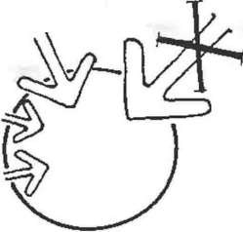
:'\IL·rn: JI
l·inandn g
depends upon the ut1lizat ion oft he existing dcmcn t:-. and cotnponcnts oft he environment l o obtain sci f financin. In other ...ar,ord '·the progress or an U[l• grading project depends upon pcrtc-ining as m uch s lr financing as posiblc
within the projccrs execu tion.
The financing oran up-grading p -ojcct is coside-red a n1ajor prohicm to governn"'l!nlH I organizations in Jcvel npir g ounlries- due to it considerably high costs. specially when it i:. Lrcr.tcd within the service projects-as a consumer or the av<. ilahlc fi1H:.ncial !'(;sources and h as no i1nmcdiate or direct beneliLial rctur1. At this point. it shou ld be noted that
nov-.- tdays, governmental authorititend to c•:ncentrate their efforts upon
thlux urio us suburbs neglecting t}· uncJerdc\·elopcd deteriorating areas.

The suct:essful projl•ct is tbt.• onl' th•tr iru:orporalt.'S self financing.

  - I!\"\'ESTMENT 0F THE
POSITIVEASPECTS OF THE EXISTIN(; PROBI.EMS
Th(! sci r financing of an up-gracing rrojecl could be well understood COllSid ring 1 he fo llO\Ving CXaJn pie: -:\U ppose h}·pot hct ica lly the CX istcnce or swamps, pools or garbage yar.d in t 1e rt·ojccl Jrea. If this area was cleared
up.on one hand it itnprovcs the gcnl ral ror m a;1dn !\ ironment.on the othe r hand jt provides a suitah1c piece t•f land tha t could be utilized in other
dcvelopn1ent rrojccts in the area. cr else it ccuiJ be sold and its incon1es
.
could be utiIi;;.cd for the up-gradin::! projec t's ··inancing.

Though underdeveloped areas uodcrgo a nwnbcr of serious problems yet they arc dealt vv·ith through therr negative aspc•.:ts nnly. But in a n U[l• ntding rrojccL a1t Lhe xisting rrob t:ms in the area hould be dealt w·ith or
treated \\·it h in Lhcir negative and posi tiH! a:.;pecb as we1L The perfec t


l·::xisc in prohlcm
po!-.itin•
a pects uhjt•cth
t.'!-.
utilization of those positive asrccts (nsurc:-- the o1nnntnity\ association in the l1 [l-g.rading rrojet:t thrOUgh seJ hcl fl a11L ind CateS t hH(lpropr ialC sta ndc.trds fort he up-grading prl)Cl!S7 as wen <ts .he p·_r hJ ic req uiren1ents and their priorities. Th(,; study of the (.;Xisr ing proble ms uctcrmincs thl;ir posit ive
a pccts HS well as their priorities ( r soltnions As .a maltcr of racl. sOnle problems-if solved-in the ca_rly t;.tge.s of an up-grading project might seriously affecl the progress of lhC project iO"-."ctrds its goals.

fhc cxistinpwblems could bL" uriJ• izt:d lo\'iehin thl'ir posithc aspects tu uchicve thl" objccli\·eof the up - grading process.
To illustrate this concept. consicer the ca.of an area. in which the
i nhubitu nls have huilt their housct in an inlorrn<.l 111ega1 manner. The occupants Df these houses h Hve illeally tenured tl·.e state land property. Such an illegal situation could be uti' ized to fon:-e the occupa nts to slHlre, i n the
up-grad i ng project th rough ··.,el l' help"'. A compromise co u ld he undertukcn in such a way that the tH:cupants·l·n: ur(' cou1d be 1egi:ilated: in
relurn they should tukc rart in thv up-gntdir.4 project. In this way, lhe public approval could he obtaine J through utili.zation or an existing
si L tli:iti on in order tn rush the up-g-ad ing prc...:·ess.

This cou1Jc fu rth u r clarified con:.idering the phe:1omenon of violaLions upon the open areas ))Urrounding tllc govcr nmcn ta1 low-in come housing where the inhabitants tend ueli hcra· ely to cnl<.:.: ge their dwel hng units hy
adding one or more roOJns in the opn space bclwl!cn the hou cs. This cnse is that of illegal housing upon public ut i11ties yc., it can be viewed within it'

17

  - RELATIVITY OF EV ALUATIOI\ OF UP- GRADING PROCFSSES

:-y-)
:

Thc t•xist ing
pos1t1ve aspects as being an indicator of the poor capability of the goverrunental housing model to satisfy t h(;. occupants' living requircn1cnts.
In the same time it shows the occupant's capability of solving his own problen1s by hin1self through .. self help''

'
On preparing an up-grading project. field studieshould be carried out to
evaluate the existing urban, social, economic and environmental
conditions. It should be borne in mind C.u:-ing the evaluation that it differs relatively from one person to another anc from one place to another. Thus, all

":;I-ii:-::-
g.dwclliog

points of view should be taken into co:-tSideration during the eva Iuation process, specially when they arc related wi.·h those who have direct concern with the project.
To illustrate this concept. consider an existing shaby hut. This hut is looked upon fron1 various points of view tl'.at differ from the field researcher to


the decision maker to the econo1nist - the user himself. To the field

. I .JBe.QJ,

The existing dwelling has a dirccl and an indirect ,·alu. The total nt• luc include.; the actual ,·aluc of thr dwelling plus thc ,·aluof itslllcr- nath·c.

  - STANDARDS OF AN UP• GRADING PROJECf
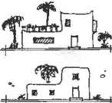
1., n}._··
o
'

Every project has it own stundards which differ from those of other projects and cn\·ir nmcnlal pro• blems.
- DECISIONS CONFLICf & CONTRADICfiONS
researcher it n1ay be viewed as to be in a bad condition a nd should be removed. To the decision maker this hu:i'removed should be replaced by another dwelling unit. To the econorr:.ist this hut's value plus the new dwelling's unit value is the cost with which he is concerned, to the occupant it is his home and shelter. Every point of view should be carefully con sidered to achieve the required co-ordination bet\..'een all those concerned with the project.

The standards of an up-grading project differ relatively rron1 one project to another according to their nature, site, time and the variantocial. econ omic, urban and environmental structures. Thus, the standards that have proven a success in an up-grading project could not be applied to attain the satne success in another project. On the other hand, those
.:>tandards applied in previous project5 ould be made use of through studying, evaluationand discussion of treir posilive and negative a pects
and the procedure of application.
The different standards cou ld be illustrated in the definition or the

IO\\ income sector which differs greatly frorr: one place to another, frotn one cou ntry to another. Also, what may be e·valuated as a "luxury'\ in a project might be seen"moderate'' in another, or ·'less n1oderate" in a third project and so on.

The conflict and contradiction of dec: ;i<>ns concerning any project. and in particular an up-grading project, causea complete distortion in the up• grading process, inspite of the fact that those decisions were undertaken
based on specialized specific studies. Thc:ontradiction evolves from the application of a nun1ber ofdccisions that lie perfect on their own, but when

18

appl ied within one entity they conflict leading to the projecrs failure. Thi s conflict cou ld be overcome by turning the outlined policy in t o executional decisions and studying the possible conOi:ts. This evaluation process might

19

Strategy

The Planning decisions should be thoroughly studied to avoid their conflict, to determine priorities and the execution programmes.
necessitate t he omrruss1on or modifjcation of some decisions. Simultaneously the determination of priorities within an execution programme will be necessary at this stage.
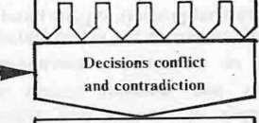To illustrate such a conflict, consider those decisions taken concerning the population density in a certain area. The social research carried out in this area showed that the inhabitants desired to depart the area due to the bad condition of infra str ucture and utilities. On the other hand, the research carried out concerning the services and utilities, showed the deteriorating condition of the existing infra structure network and
Executional Decisions
Final Decision ProgTamrnin
g priorities.
'·
recommended its urgent restoration and renovation. Considering the two decisions each on its own. they are perfectly right. but the former decision
was based upon t.he bad co.ndition of the infrastructure network, while the latter recommends the network's immediate restoration, which does not
agree with the inhabitan ts departiog the area. Realizing such a conflict, one of the two decisionsshould be executed, either the immediate restoration of
the infra-structur,e. network which accordingly cancels the decision con- cer ning the decrease in population density, or the restoration process
would be postponed to some other time until the population density in the area is decreased to adapt the new condition.

9. LEVELS OF OECISIOI'
iVIAKI G

Local

The success of the up-grading project depends greatly upon the co•

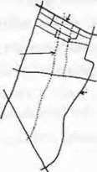
District Planntlg le,·el
Planning Le·,el
City Planning
Le·vel
ordination between t he different levels of decision making. Every decision should be made within certain level that grades from the national level to
\ .
. the regional level to the local level uptill local detailed planning level. The
process of decision making should be carried out within its defined level e.g. t he regional level is concerned with the main transportation arteries main water and sewage network etc; While the local level is concerned with the detailed implementation programmes. local network of roads. local infrastructure network. etc.
To illustrate this subject, consider the existence of a main arterial traffic

Each planning level has its own bor• ders within whi£h the decisions arc executed.

JO. DIFFERENT PARTIES PARTICIPATING I THE ·p_ GRADING PROJECT
road that crosses a residential dist rict. The district can make decisions concerning the local road networand pedestrian routes that are within its borders and its local planning level but the arterial traffic road is already out of its local planning level but it lies within the citis regional level.

.
The participation of differ nt parties, (governmental agencies, community leagues, investment companies) in an up-grading project, by their financing through execution . ensures the project's success. Such an association minimizes the possibilities of failure,distributes the tasks with in
each specialization and it assures the continuity of the projeers execution. Accordingly. the role played by the different associations in an up grading

20

project sh ould be dete1mined with respect to their specified concern. The government, the investor. non profitable age ncies, the community and the
individual all together play an important and vital role. The distribution of

19

Project Framework

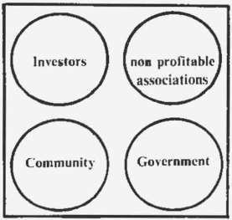

'(he succc:o,!-tt'ul UJ>-gradin proj{'l'l should enclose
,·arious concerned parties to participate in implementation
  - METHOD OF TREATMENT OF
THE EXISTING BAD
CONDITIONED BUIWlNGS
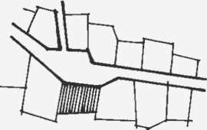
The ddapid<tlcd building is general! undergoingstructural Failure. Thl· rcmo\'al of a dclapidatcd building nccn•ssitatcs tbc study of utilization
nr its site within the risual com- .
--position of the ana nd accord
intu
the managerial and financial coditions.
tasks within a programn1ed schedule assures the succesof tlte proje l.
The governtnental organizations can play an itT.ponc..nt role through the supply of the necessary infra structure net works and u :ilit ies and through the establishment of the appropriate organizdtic nal and ad1ninistrative fran1eworks. The inv stor plays his. role th roug:h i1 vestment projects.
commercial, tourism.entertainn1ent. or industrial projtcts. on one hand he increases the income and on the other hand ir:lpr)ves the urban features.
The non-pro fit able organizations such as un iver ities, .n tern at ion a I organizations, progran1mcs, foundations and research centres can participate in the project through supply of sc:·;ices anu utilities.
renovation of antiquities and historical buildings,socia and en viro nmental improvements or treatn1ent of pollution. As for the community, it can paruc1patc through its sociaL religious. charitablc-nLY'l proritablc con1n1ittees or through the individual; it can take part through co• ordination of self help activities.

These buildings arc those having a serious st ruct u rc. l:ailure that could not be r .:paired or if repaired wilJ need high expenseor these buildings built by inconvenient building materials such as tin, stLaw, tents... etc. The up-grading of an exist ing bad conditioned bt ilding i.1 a his torical area necessitates the study or Lhe general prespecti,·e :>f the area to determine
whether the building is to be removed and left as ar_ ·)per s;>ace or rebuilt on
the sa rne l rad it ion a! outl inc. It is better to overcome all the ad minist r<lti vc. financial and tenure proble1ns to rebuild on the san1L tctnlr within the san1e character. It should be borne in tnind that t he ren:oval or :tny building
should be carefully studied within the social aspect Such a rer:.1oval tncans the imnlediatc provision or new dwelling units for the tan1ilic. besides the
rebuilt new residential units must not suffer the 1n1e o vercrowd ing and high densities.

  - MI:.IHOD OF TREA1NIE1\T OF THE EXISTING MODERATE
CONDITIONED BCILDJNGS The up-grad i ng of these bui ldings i ncludes the rep'- iring, encwal

and renovation of son1c pans which differ frotn one bt-ildiL:g to a.1other, each according to its own nature. In encrul. these modr_!rate .;ondition buildings
arc those whid1 do not undergo any structur' tl failu :e <.u-d can be renovated

2

I
·.l
....
-

Ercry building must he

22

rnlmllt.'d S(.'p(.•ratly to set its own tl )-grading progrnmnu:.

  - METHOI> OF TREATMENT OF THE EXISTING GOOD CONDITIONED BUILDINGS

These buildings should be evaluated each on its own o detc:- mine all th
repairing work and requirements. Arter the out.ine :'.ratcg} is laid. the decision is made whether or
not the repairing wil: inciLd·lhe interior and exterior of the building. A detailed report should ·:>c p-epared with a
cost cstin1ation then the decision is n1adc either by re ti:-ing, removal or replactncnl.

The up-grading project n1ust not be
rclat, .J 0:11\t
\Vith the bad conditioned and
underdeveloped areas, bul it :..h)uldindudc <l

19

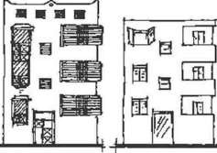
Fucade.'ot' th ir ing j!ood coooition d bntJdin '\ in
historical arc11ought lu he prm·idcd with 1hc c:haraticristic local
sry l c.
1-J. :'\lETIIOD OF TI{EATl\IE T
OF HISTOIHCAL Ai'\D
..\ "- TlQ llrnES:

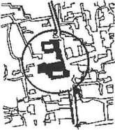

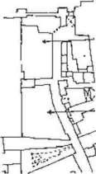
Monument

Annex
con ervtttiOn and pr scr ,: l o:n progran1me o( t h e existing good conditioned buildings. Thipr:)gr:llnrnc could be applied either within a long- tcrmetl conservation and ·epair plan to prcs rve Lhc good slat .: l)r the building and prevent its deterioration, or hy remodeling the arch1tectur d
form and facades or the good conditioned building whustnodcrn ronn seems odd to Lhe c:uJtura l and hisloricl heritage of the.: are 1.

Dea I ing \.\'ith a hi::;tori<.:al bu 1d ing - lh rough ll pgrading- d j rrcrs Cll t irei) from the ordinary existi ng bL ilding=' whjch t.:(tn be ckalt \Vit h through rcn1oYaJ or replacement. Th•.! or.ly met bod to deal with a historical hudding is by rroteclionprc$crvat ion a 1d rc torat ion. This process will not ind udc the hi storical buildings only hu t "'..iL include all the bujJdings \\'ithin i ts visual prcspectivc as well a-> tl:cir approaches.
The ex isting historical huilc ings undergo a scnous rrohlcm as being induded in the servicL' sector· thus having li1l)SC builu ing. rcn ova ted, repaire·c.J prcscn·cd and consc:·veu i." con:-;icierccl a consumption or the avaiJablc financial resource. Thbe·a anti appropriate approach to the up• grading of historica l area!- is through having then1 invested in social. CCL1l10tn ical p r oli Lahlc projct:ts.. i.c. using: the bui I ding .! according to
iLs na lurc and ca pa bi lilies. or rcsllUrL·L·s - Is a r sta uranl, a hotcL <l cuiL
u rc centre or a ruhlic library -· c .c. These functions should he carried out
\"-..ilbin .xrta n1its to rrcvcn t lhmisuse or the bu il<.ting or dcteriora Lion of its uti l i tics.

In Jea]jng wilh h istoricaJ Isian1ic hu ild jngs. the l'o!lowi ng prccu lll ion:-; should be strictly followeJ:
The historical building shnu ld not he su bjccteJ tl) any n1odiricat ion. Forhading the Lrunsl'er C·f a1y n1usquc to any other fu nct ion.
Forb 1ding the interfe rence ( 'any uctiviLy or l'unctinn ir rclc:,·anl with thl: Islan1ic cui t u rc.
Forbadinthe xistcnce uranv_, clcrnl:nl thut mit!- hl c.:aue serious danl!'.crs or hazards in the bui ldi ng as a bo iler. pet1'\)l tank anJ cn1ergcncy
gcn rutOr that n1ighl CH:SC rV4lfH)l'H tionOf gases. heavy Yibrnti(.)rt:-- Hlld
hca\'y traffic. If those clen1el- ts were necessary then lhey can be iluateJ in an annexed building up1lier.J with the requjred safety factors.

AN APPLIED f:.:XAJ\lPLE FOH TtiE LP GRADI (; 01:
HISTORICAL AREAS: To ilJustrate Lhe process of ur-gr.:tJ ing: of historicalareas. the up-grading.
project of AI-C'iamnutliah di·ari .:t will be revie\ved. The ur-grading project was prepared by the Center ·_)f Planning and Architectural Studies in Cairo
{ CPAS }. The teamwork wor k .ng jn the project include prof. Dr. Abdc
Lbaki lbrahin1 and prof. Dr. Hazen1 M oha rnad Jhrahirn an d a nutnbcr of architectsplanners anJ r.:s.;ar•.;hcrs.
The original st udy was su btnit tetl-in Eng!ish -in t V·/O parts. The t itle of' t he first part was,. the Dcvdop1nen: and Planning concept::> for Al-Gamn1aliah

21

District''. The title of the second part was ··The Organization al and Administrative fratnework for the Develo"'Jment projects of AI• Gan1maliah ". The project encloses the lield .tudies carried out within the physica I, administrative and organizat io:1al fieki .;, and the analysis of these
studies to distinguish the advantages .1nd di,.a.dvanlages of the existing
condition. Several recon1mendation:; wer _ laid upon which the developn1ent and up-grading policies were propcsed. These proposals were divided into several implementation programrres cla sified according to their benefit-either economic or:social benefit. Th e projects were prepared independently so that each of them cot: ld be s peratly executed within an integrible framework.

INTRODUCTION TO AL GAJVIMALIAH

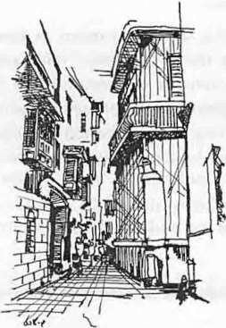

Cairo.. The Historical Islamic Area"
A I"Gammaliah Bcit AI- Sehcimy

Al-Gan1n1aliah district is located in the historical Islan1ic region of Cairo Known as fatin1id Cairo or n1edieval Cttiro. F:.r:in1id Cairo was established by Gohar Al-Seqely during the fatimid Cali?h Al-Moez Ledin Allah's
- period. After four centuries from its es1 ablishm nt, in 969, it became the center for con1n1erce culture and civilize:..rion :Juring fourteenth ccntury.lls population an1otmted to half a n1illion. e ual fo.H times that of London and five times that of Paris in the same per od. 1be area of n1edicval Cairo is defined by Badr El-Jamali walls includir g Ba·:·:2l-Nasr and Bab EI-Fotouh to the north, 1he Citadel to the south, Al-Darra!:aJ1 hills to the east and Port said and Mohan1n1ed Ali street to the v.est. ThJ.rea covers 847 acres. It is divided by Al- A zhar street from east to west. The area is surrounded fron1 the north, east and south by old cen1cte:ries v1hiJPortsaid street seperates the area fron1 that of central Cairo we t wa.rc.s
The urban pattern of the area is built dlon:he spine of Al-Mocz Ledin
Allah street tha t passes nort.h-south, and the area between it and AI Gamrnaliah street is known as Al-Qa abah. -\ ong AI-Qasabah. several economic. con1n1ercia l and social activities evo uted as well as historical buildings, wh ile light industries and handicrafts were located at the back-on both sides - of the main spine. The econo1:1 c pattern of ·the area is characterized by the ex istence of handicraft ·.:lusters as the copper smiths, tent makers. gold smiths ... etc. The hi torical bui]dings cover a n area of about 44 acres, that is equal to 7 '}of the bu ilt up area which is about 614 acres. The land use pattern in the are8 is nol clearly defined due to the intermeddling of functions within the same buildings and amongst the different floor. Commercial and residential Lmctions are usually mixed together with handicraft industries.
The physical survey of the area sh•Jwed tne:_t 85 .," or the existing buil• dings are in a very bad condition. The t1rca uncrs a lack of a proper infra st ructu rc network: the exist in g services and Jtilities arc deterioratinu
rapidly and affecting drastically the other e'< .s .ing bui ldi ngs in the arc t specially the historical buildings. In 19 32. tte population of the area was 300 000 inhabitants of an average denE.it}' 857 p-erson /ha. This population is
doubled cluring the religious festivals. On the other hand, the existing social
services do not satisfy the existing p<XJlat i on..s needs and requirements. During the last hundred years, several u ban .:ranges took place. The green

22

..XISTINGCONDITION OF THE A "JON AREA IN
Al- GAMMALl AH
patches an d gardens that SL -rounded large houses were replaced by poor residential buildings to accc-nodate nc:w low income migrants to the areal to replace the high income ettlers w1o left to live on the outskirts. The cha nge in the social structuwas acc001panied by a change in the land use pattern, as well as a deterior rtion in thsocia] structure which is even tually rcllccted upon the s urrounding en vironmcnt.

According to the up-graciing plan lid for the region, a demonstration
a rea was eJected to carry C•Jt the necessary st udies. The demonstration area covers 14.3 ha. It is Lcated Lo the south of the norther n wa ll. it represents Lhe northern pa r of AI-Qa ;abah. It is characterized by a high
concentration of historical buHding vhich constit ute 25.8 of the total area. On the o ther hand the roetds a nd 1=•edcstrian routes network constit ute

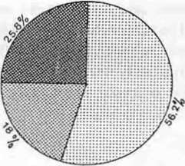
18 °0
and the residential bu ·< 56.2o' of the total area. The area includes

several histor ical buildings ;a.tch as ncrthern Cairo wall. Ba b El-Fotouh. Bab AI-Nasr. AI-H akim me -que, Bcit AJ-Sehimi. Sabil AI Sclehcdar.. Al-
Sclchedar mosque, Sa bil an : Kotta b \uda Pasha and others.
. The land use pattern in t -e are<= i greatly intermeddled. The built up n1as represent · 40.6 n" of th!urban bulk, whil e the pure residential n1as represents 43.2 "n ofthe urba- buJk. The remaining area of the built up m·tss

which onstitules 8.1 :!.-0
, is r ainly '.'acanl land and ruins. Apparently1 Lhc

Built up mas
Ell 'Vlonumt•nts mm Road

Land usc in ,\ction Ar u

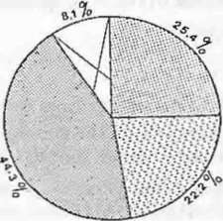

c:J Oclapida red
lillTITIB lodcrare
E.:-.7-1 Good
k8:i \'acanl land Building Conditions
mixed up land uses arc ga·1ered alo1g t he Qasa bah. The commerciaL industrial and other mixed a :1ivities analmost concentrated in the gro und fJoor. they rcpresen t 78. J %ofthe tot a l :.rea. In higher stori es, such acti vi tics regre.s leaving space for re i:.ential USL. for instance, non residential usc in the second noor constitutes ::9.25 /u while it is 9 c•u for buildings of 5 or n1orc
storeys.
The building conditions ir the demooslration area vary greatly between bad a nd good. The bad condnion builcings represent 44.3 ul,., the moderate condition build ings represe• 25.4 °o wh ile t h e good condition build ings represent 22.5 1 ., of the total bui lt up mc.ss. Th e majority ofthe buildings arc nol h i gher than two storeys :-ep rese-nting 50.8 /n of the total bui ll up mass. The floor area ratio ofthe ar:a is 2.31. The network of sanitary sewage and
}
potable water cove rsonly 77.3 '};,of the total built up mass while 12.2 aure deprived of both of them. The whole art!a is covered hy the electricity net work.
Brick and wood are the ptcdomioanl construction materials in the area. They constitute 43 °o of t he t:.•tal urban bulk; mostl y they arcjn a very poor condition. Skeleton type bu dings cor.titute 24" while t hl! wall bearing structure build
.
ings constitu·!11.5 :%, t•f the total urban bulk .
The enti re popu1ation oft -e area is c/00 inhabitants. th e gross denisty is
203 pers 1 feddan. The occu:-ancy rate rangei' rrom I -6 pcrs1 roon1 by an average or 2.36 pers1 room. It is notcu that there is no direct relat ionship between t he oc upany rate aod the income levelswhen lhe occupancy rate
''las 1 pers1 room the averamonthIincome was 70 LE 1 monthon the
other hand, when the occupancy ..rare was 6 pers,1 room. the average monthly in(;ome was 143 L.E. I montL.

23

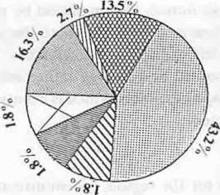
[§ residential
Commercial
. Com t Resid
. mmn Com / lnd
Industrial mm offices
IBl educational
residential , indus( rial k8J vacant

THE GE ERAL FRAMEWORK OF THE G IDE LI NE
DEVELOPMENT PLAN fN THF. ACTION AREA:
It was noted as well that more than one ramil y shared ·hese:me dwelling unit such that the house hold sharing rate oft he dwelling Ln:· is L14 family I unit. The survey showed that the highest sharing rate was Lc-7 family I uni t. in this case the average incon1e was 91 L.E.Imonth, the occu;>ancy rate 1.8 1
pers / roon1 and the average uni t size 2.8 rooms 1 u1i. he averagc max.in1u n1 income in the sample a rea is 185 L.E. 1month w-ile the average n1ini n1un1 incon1e is 70 L.E. 1 mont h. The total a verae in....ome in the _ sample area is 121 L.E.I month. This phenomenon sh)v..-5he diversity
between income level in the same c:.rea, as well as the co siderably high average incon1e, which means that a large sector of the in hwi·ants arc not an1on gst the low incon1e sector. This is the case consider.ntllal the given data is concerned with the official income of the parent or p£.rt of it and not bearing in n1ind any additional income earned by the f:llril} n1en1bers.
Several con1mercial, crafts and in:iustrial activities wrr! e tablished in the drca in the form of jun ior companies and as .. ciaLons with a con.,Jderably few number of working staff. The area enclof eD ther activities appropriate to its histo ric and civiliza tion al character, as -ar4dicrafts a nd traditional industriesyet other interfering activ itie wre e tablis hed drastically affecti ng the area such c.s gar lic markets v-.ar h.)usesmetal workshops etc.

The general ou tline of the development plan was bas.!d upon the field st u dies carried out in lhc action area. the gcncr tl strategy of : he up-grading policy awel l as the proposed nutst...r plan or the area ;tS -allows
L APPROA H -
The existing tradi tional approaches to the area a-c n r ircly out of c·:-der. New approaches are to be developed direct ly frcrn 3alah Salem road to encourage the development processes in the :tar pecially the
touristic, cu lt ural and investment proces es. FOCAL POI T·
The historical a rea is to be considered a major fcc& r•oint for the
various economic and socia l developn1ent projects in -t <uea specia lly
t he northern historical complex. The state's tenure can be a well
considered a focal point for various up-grading project. This area includes Cairo wall, Bab Al-Fotcuh, Bab Al-Nasr, AI- a!(Jffi mosque and Wekalet Qail Bey.
.:!. Al- QASABAH
The area situated between AI-Moez Ledin Alla.h .;treet and AI• Gammaliah street should be accentuated as the centtal activi ties area. The existing industrial activities as well as the commel"ci.:ll ware houses should be

removed to the outside of the area to dccrc:ea the traffic congestion, a..
weJI as the environmental pollution. lr: t 1is way. the
central area will achieveorne harmony in the land us=. p:tltern.

24 .

.Till:. F \.STER',\ N D \\ f.'STERA R E

The easter n and w tern a rca of the qasu bah ho..lld :'\C con fined as rcsidcnlial areas in the fi rst place. -'.cry bui di:lg shold he studied within Lhe u p-gntding policy with re:pcct l o it.; .!.(is·ing .:oodi 1 ion. Thl'
'A hole area should be dc\'elopcd with n the C"(is.inlalld uspallern
except for the wo rkshopand ware hc•uses.
5. R Ot\ 0 i'E.I
\\ORI\
In the fi rst phaC nrthc dc\'ciOpmcnt ilan. EI- 1.Jc; LCLX Alluh :trcct and AI-Gamma h ah -..Lr l arc to be re paired. In t he late...,· pha cs thc c street\\'il l he tran:-.l rccl to pcdestriar rou teonl). '
().1 '\ FR A fRl CTl REET\\ORK
The exist ing infra tructure network t$ t o be rer lired aa preliminary tcp for the Olhcr sociaL economic and touristi..: J..::vdop81C1l processes
as well as the road net work dcvcloprren t.

    - DE \'ElOP:\11- "\ 'I PR JON1'1 Jt"
Thdevelopment proces sho uld sta-t with l1 c.lt aba:1 region giving the priority to the invc ting econom ic 1nd sooal de 'clo1mcnt projects a!' they do not n\! d any governmcnta. fundinThup-grading of the
other areaare to be t:arricd out in lL t er pha:c<\.
PROPO ED PRO.JE  R | rs | J·O
0f\ E LO P\.11- |  | 11H-· .
.•;, r
\( TIOI'. \RI-
_.\

\\El\,\1l· r ()\H-UE) ·r ot lllSTIC UOlEJ.
Wc kt Qa it-Hito bt: rc Lnred ;. nd C\ crw ue-11) l rat?...:rmcd t n tt n
blamic fouristic hotel. The exbt ing bui.dings 01i1s -)Uit em sitlc arc to be renin\ ed and reph.tccd by an annex i1cludintl-.:! s!n it.c·of the hoteL
Lhc kttchcn. the laundry. the e1ncrgcnt.::, gcnercLCI' &U d t 1c toragc and an) other runt:ti<Jns that l:ctn hann the :nontrn1t.nt..tl hui ldinThis hulcl could he managed through one of lhl! intcr na i·.) 1af hold:. working i n Cairo.
Df'. \"ELOP\IEi\.1 01· !\1AIDt\BAB AL-.SR A )) 1- ABLI H-IF.NT OF ,\,
AR:\HI( (, \Ril E"\ A'J THE ORTHU'\ ALL
The uemolt::.hl'd part or the no r thern wu ll is to be TCl'C"ns-ucted. The existing viola tionat M ida n Bab AI- Jsr sho l l d be rem::) d. Also, the existing buildings and violations be·ween )-ar-tl Al-Ot··,ur and 1he
nort hcrn Cairo "'all . hould be clcarec. I nstt:a•J. u1 slar:-1IL . rabic ra r• den would take their pl ace s upplied by ..tn oricr•' I i.tr th it.·T1.>taurant i.nd cufes. The complex shoukl be treated \ 1thin :J·c b ami .n.:hilcctu raJ
character.
ESTABLISH,JE!"\TOF A \l l, I .TI-Pl RPOSt COi\-lPl EXT T H[S:lt TH OF AJ.•
tl t\KI!\l \ lOSQl E

The c.\i ting dclapidatcd building. \\ arch )V!·C!\. stoc. workshop nH.I "'a.hlclying to the outh or AI-Hakim rro -}Ue-bclw::cn Al-1\tloe/
Ledin Allah and Al-Ga n11naliah Lrcct - shotld he renlO\ ed. A mul ti- rur posc co mplex induding a hand icra rt set-oat 1ricutt. I hand icru ft

25

workshops.shops and dwelling units should be built instead. Eventually a nw road linking thnorthern an:J so uthern parts of the Qasabah is to be opened south to AI-H akim Mo::;que.
ESTABLISHMENT OF THE AUDA PA(HA CULTLIRAL CEI\TER
The existing Sabil and Kottao orAuda Pacha is to be cleared fron1 its residents and restored. Thadjacent vacant land could be used to build
an annex including an Islan1ic I ibrary, finc- art gallery and a cult ural seminar roon1.
ESTABLISHMENT OF A TOURISTI(' (.OMPLEX AT BElT EL- SEHEIMY AND BElT AL SELEHEDAR.
A touristic con1plcx including Beit El-Seheiiny. Bcit EI-Sclchedar, and the adjacent vacant lands is to be bu:J t. This includes the restoration and renewal or Beit El-Seheimy and Beit El-Selehedar as well as the rcn1oval of
the dclapidatcd buildings in bet ween: annex is to be built consisting of an
oriental restaurant, a cafe and an oriental garden on the rcn1aining piece of land to the west of Beit El-Sehcimy.
ESTABLISHMENT OF A J\IULTI-PliRPOSE COiVIPLEX TO THE 'WEST OF AI. HAKIM MOSQUE.
A multi purpose complex ( residf ntial, conunercial office co1nrlex) is lo be built on the site located to the west of AI-H akin1 Mosque, and lying on AI-M ocz Ledin Allah street. The cxJ .-ting dclapidatcd building.s ( Waqfs
property) are to be remo\'ed and tepl Lcd hy the rnulti-purpose con1plcx.

DEVELOPMENT OF MAIDABAB A-FOTO'lH AND ESTABISBMENT OF AN ARABIC GARDE!'\
The existing violations on site ar·-2 to be cleared up. The dctnolishcd parts of the Cairo wall arto be restored. An :trabic ga :-den is to be made in such .u way to forn1an integrated co1nplcx 'Nith lhc garden existing at Bab AI-Nasr.
REPAIR OF OTHER .\10N':l\•1ENTAL B'IlLDINGS
The other monun1ental buildings an... to be rt.storcd and renewed. They include Don1e of AI-Kased. Sabil A -Amir fvlohamn1ed, Khanekah or Beibers, AI-Selehedar Mosque. and Zaw i ya t Abou EI-Kheir El-Kilan y.
Several projects were rroposd for t 1c development of the action area. The proposals were followed by intens i•;e detailed studies for every project on its own, uron wbkh the economic and technical feasibility studies were based.
Accordingly. several a lternativt.:.:were proposed. each of which was then studied and discussed to dctcrrnine the ad van tages.disadvantages and side effects. Then the sratial and financial requ i rement were defined with respect to the expected benefit.
T he best alternative was then furt t-:er·tudied for the determination of the final programme, its related designs and Lhe adeq uate financi ng. An efficient
executional fran1ework was then established to follow ur thl.! im·plementation or the project.

26

..

E AL ATIO . OF THI-. EX I Tl G CONDITIO"' FOR. THE FIRST ALTERNATIVE

* The Required Areas
-Wekalet Qait Bey (Antiquities -state properly I
-Adjacent building
(to be ex-propriated. Waqf property)
.

- Required Building Floor A rea
-Existing buildings in \\ eka lct Qa it B!y ( to be restored)
.. Ground floor (shopand workshop. )
  - Ist & 2nd floor ( rcside,tial)
  - Adjacent building

TOTAL AREA

.,
m-

1552

686

2238 n12

225
2063

(shops and workshops to be remo\'ed )

- The Inhabitants & their Ac-tivitie
-Wek a let Qait Bey
  - Population
  - No. of Fa n1ilies
  - No. of occupied roons
  - Average monthly inc:)me
of parent
-The removed building
- No. of shops and wor'<shops

TOTAL AREA

15() per ·ons
27 families
26 rooms
1 34 L.E./tnonth

5 shops
686

* Required A rca. for the DiFerent Element"
- Weka let Qait Bey touri!itic hotel ( lo he reostored) (a ntiqui ties - tate prop rty)
-Annex (to be built on t he adjacent land}
TAL AREA

155_

686
2238m1

*' Building Floor Area
- Wekalet Qail Bey touristic hotel
- Ground floor 14 shop... (to be rest ored)
- J st & 2nd floor ( 60 roon1s - t o be restored)
- 3rd & 4th floor ( 60 roon1s - to be rebui Jt)
-Annex (an entirel y new building - Two storeys)
- Shops ( 4 shops)
- Kitchen, utilities. \\'archouse
- Re.. taurant and cafctctia ( 275 pers)
TOTAL AREA

225
2288
228S

I00rn2
55 On12
55 On11

27

,:, I nvrs1ment Elenu·nts
No. or hu\c l r<)lHllS
Capacil) of c tf t ri:t & Re:-.tau ran t N(.). {lr hop

l0 rooms 2 75 rer: I X shnr

E\':\ l.l ATI00I· TI-lE EX ISTI(; CO"Drl 10'\ J· OR. THE SECO D THIRD
.\J.TFR!'\ ,.\TIYF

: l'he R quired Area Wek a let Qa it Be
( antiquiti .:- state p1·op rt ) l Adjacent budd ings W tllJ r prt) rcrt) p ri\'at c rru pt:rty

''' Building Floor Area

T4)TAL AREA

nr'

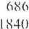
407Hnr·

Existing building!'> in W"- 'tlct ()ail He _.' ( H' be rc:-- t ured }
( iroun<..l llt){>r ( \n)rJ..h nrs and siHli> 1 st & 2nu lllH)r ( re itlcn tial)
l3udut ngs to e\propri<l!\,;d. ( lO be
I"CI11t)\'t:J}
- Wuqr rrnperty ( :-.ht)p:-. and \\ orkshn·1-.
- Pri\'a 1 e propert) ;\ ( s lo rcs )
- J>ri·,atpn.>rert) H ( re-.;itkntial l
T(tL\L ..\REA

225n1'
063m2

(l()
IJXO 920
5274nl

::: The Inhabitants <. Their Acth·itie!-,
P()pulati<H1 & FLtmilies
- in WeJ..akt ()ait Be)
- in <ldjaccnt building No. or occupied rooms
- in Wck :.del ()a it Be)
- in adjaccnt building
N{, t)r shops und store:-.
-i n Wckalet Q tit Bey
-in ud-ic.tt.:cnl huilui11u....
{ lo he rcmo\ cd and rcbui It ) A,·eragmonthly income or rarent

15(, pcrs (7 l'<tlllilit:s ) 60 pc rs ! I 2 ramiIic)

2(1 rooms
)0 l't)OJns

) :--hops
I )..t I.. F.. month

* Required Areas For The Different Elenu·-w.in ThSl·cond Alternatin
Wckakt Qait Hey touristic hotd
{ antiquitic:-i- Sla trropcrly)
- to he restored -
Annex (an entirdy new building t{1 he rebui l t on adjacent lanu)
l()TAL AREA 407Nnl

28

:·: Building Floor Area
\Vck alt Qait Bv ( L('luri t rc.: IHJtcl)
- ground tltlll r t 14 :-:hops
- to be restl' rcd -
- Ist 8.:. 2nd lloor I (,(J n"o: ls1
  - Lo be rcsturcd -
- 3rd !<. 4th 11our 1 60 rtH.) : ls)
  - Lo :->c rchuilt -
Anne1 m cnlird) nc\\ huilding
t.\\'0 store\ s

225

22XX

22XX

"') ...

- ·"

- Shors ! l4 shors)
- H otd room!-{ YS ronn1s l
- Cali Ll'ria & Rest au ra n l 320 pcrs )
- M uh i-Pu rp(t.lHull ((Xr pr-..1
- Kilc1n' . utili ic etc.

TOT-\L AREA

·== lnvcstn1en t El n1cnts
No. l)r ho tel rnum"
No. of L'tHnllh.:n:ia I shop
Capacl) uf Cafeteri a & fr.!Sl(tllr tn t Caract) or m ulti purru.c hall

* l cquired Are41s for the Different Ei m nts in tht· Third Alterua ti\'t'
Wek alet Qail Bl'} 1uuri!- lJ(.' hold ( antiquitic- stall' propci't:- )
- t u be r lnrcd -
Anne1 an cnt 1rch . 11\\.' h..ikhn! !
to he rhuih L>n adjac.:cnl : nd)
() 2X(l0
600
500

2(J() ()
l099lm 1

21 5 ronnb 2X shop
320 per .
300 rcrs.

,
m-

Building Floor Area
Wckakt Qa i t B) t uurtii_ hn td
- (jround lltlo r ( Ishop:- J L<.l be ·cst<H't:d
- Ist & nd lltHH t60 rnu11" ) tn h ·cstor d
- Jrd & 4t h llnur l (l0 nx1nts 1 to ht: ·t:stored
Annex tan t.:nllrdy llC\\' b.t lding I
- lwn s tor ys -
- Cornn1ert.:ial sho rs 1 llJtops)
TU'1 AL AREA

4078nl :

- Cafc(ria & Rctaurant I i{){) rcr )
- Tu r k sh hath lH a m ma n·. I { 1 50 rc;rs)

1 00
29

5{)0
..j.{ )()

- Arabic Garden (Oriental restaurant
- 150 pcrs)
-Multi-purpose hall { 100 pcrs)
- Stores. Kitchen, Utilities. etc.

TOTAL AREA
645

150
650

7646m 2

* Investment Elements
- No. or hote l rooms
- No. of commercial shops
-Capacity of Cafeteria & Restaura nt
-Capacity of multi purpose hall
- Tu rk ish ba th
- Arabic Garden

120 roon1s
33 shops
200 pers
100 pcrs
!50 pers
150 pcrs

30 31

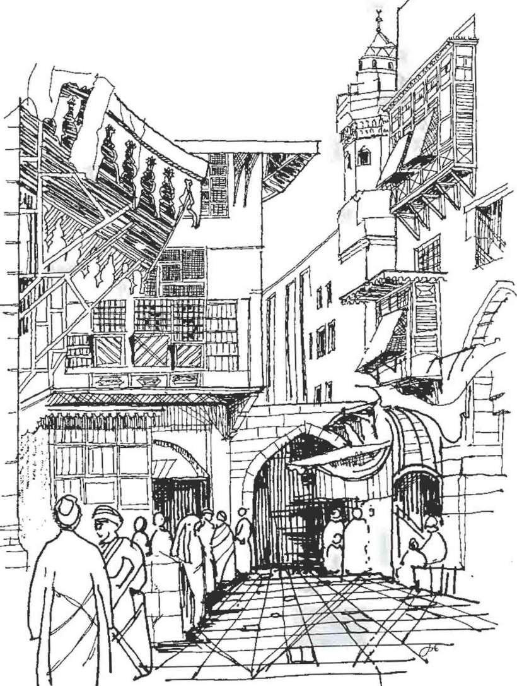

Cairo-A gcnt'ral 'icw ul the Histurkal Islamic .1rca

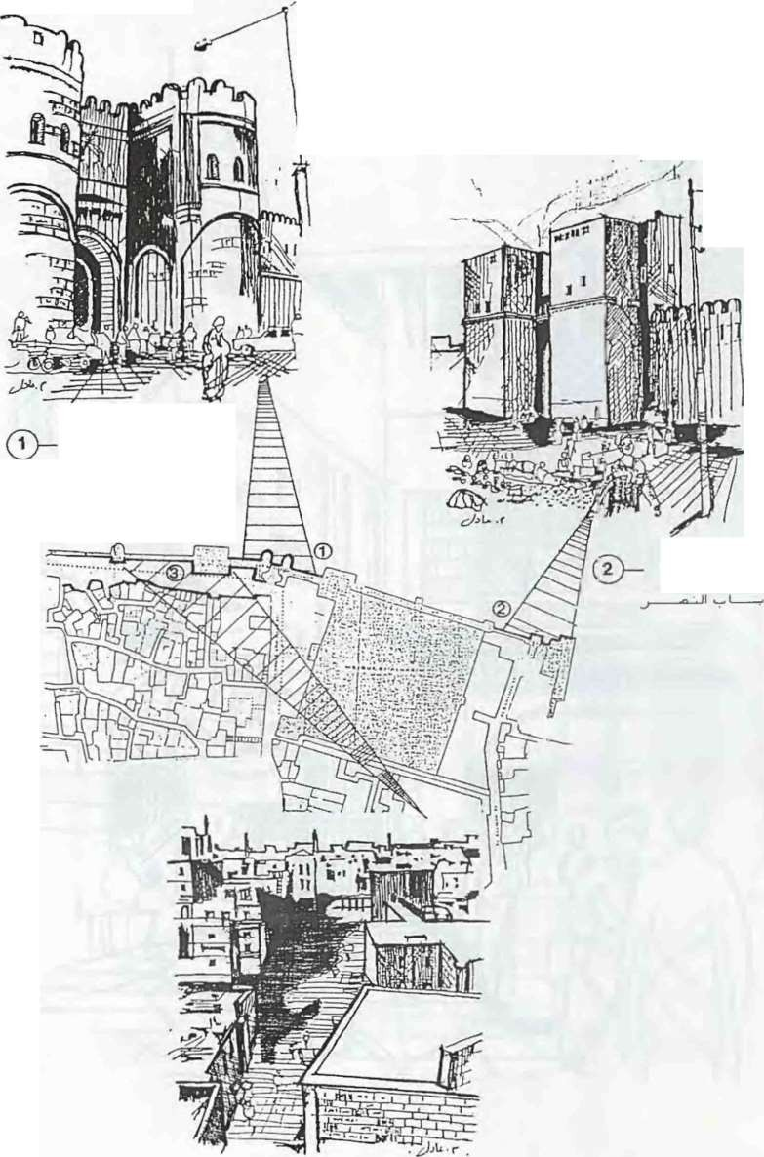
MONUMENTAL BUILDINGS IN AL GANMA I H
4...-----:-!Y •lit L,-JI
4..-- - --:!-'
..
, , I
_,
Sab-El-Fattouh

_, ·· >LJ; If ........ ' '
Bab£1-Nasr

Northern Wall of Cairo
I -' 1b Wi.JI .., _, ·•

32 31

HAIN APPROACHES AND CIRCULATION
o _ c. _,-11 J.>I ...\...o.J I _, iS_r-J \ _, J_,..o_,.J I JJ L. a

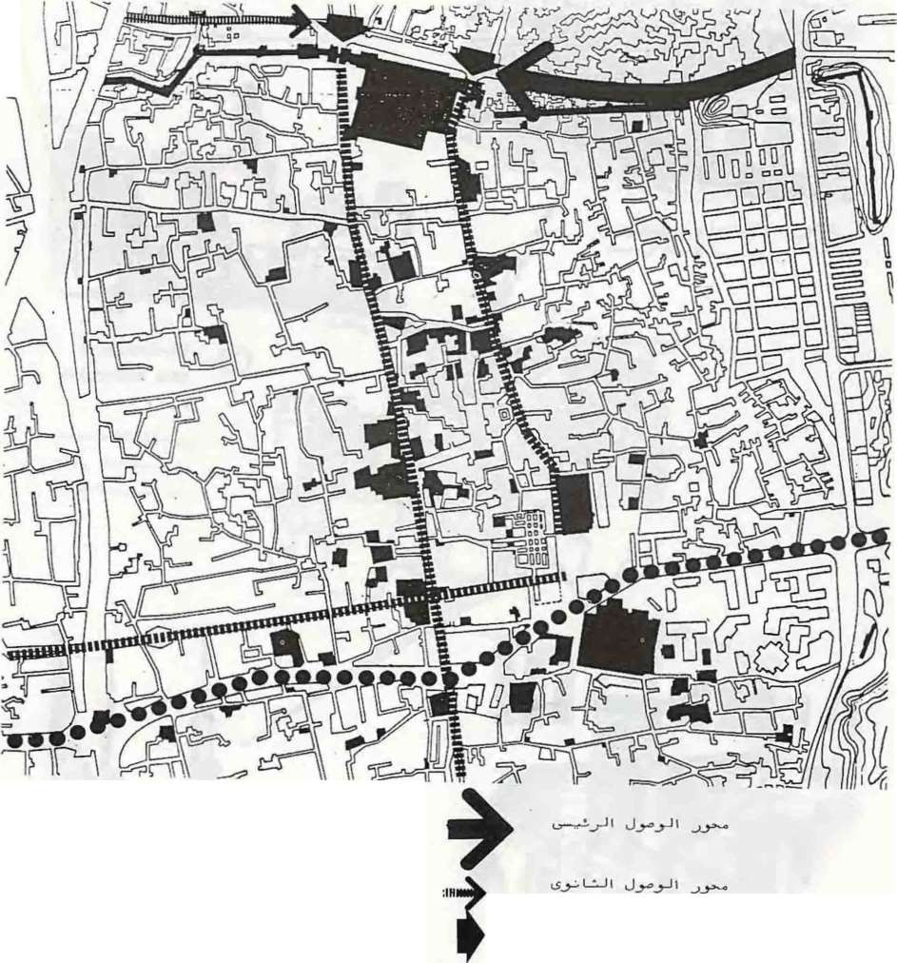HA.IN TRAFFIC
J
j
J
NAIN APPROACH
SECONDAR Y APPROJ\CH
ENTRAN'CES
J ---->>1 ...\...o.J 1
ARTERIES IIIIIII : . o .: - "_,-1I OS_r--)1_,_, G......

AL-AZHAR AXIS
••

33

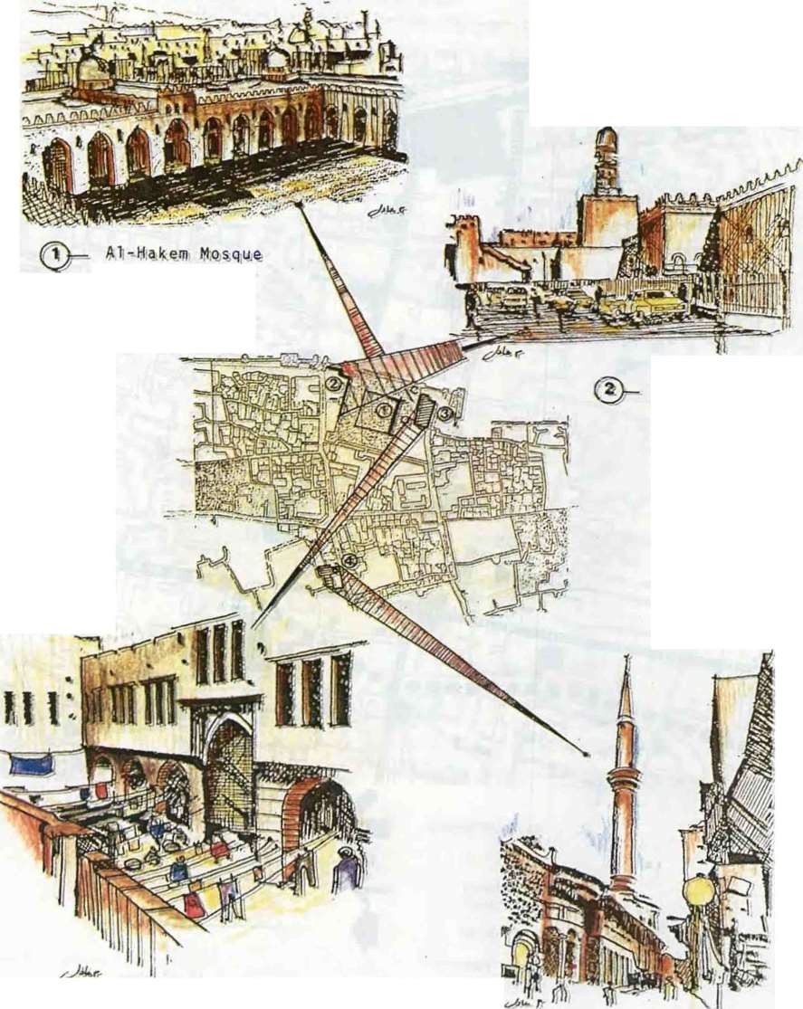
MONUMENTh:. BUILDINGS IN ALGAM"1.-
\LIAH
-
;,

....--- - .
..._ ....._,
jt
.. o1.>-· L-.JI

-• -- = s L>.JI ' > o

El,Hakem & tn
N.or-thern
Wall
r--5L>.JI ' ?"- o 4,_-.-CbLi.JI ..J.>-.J
v.-----t-.:-J I

·,

.) -..>o..LJ\
Wakalat Qait Bey
Mo:]ue of AI-Sclehdar

34

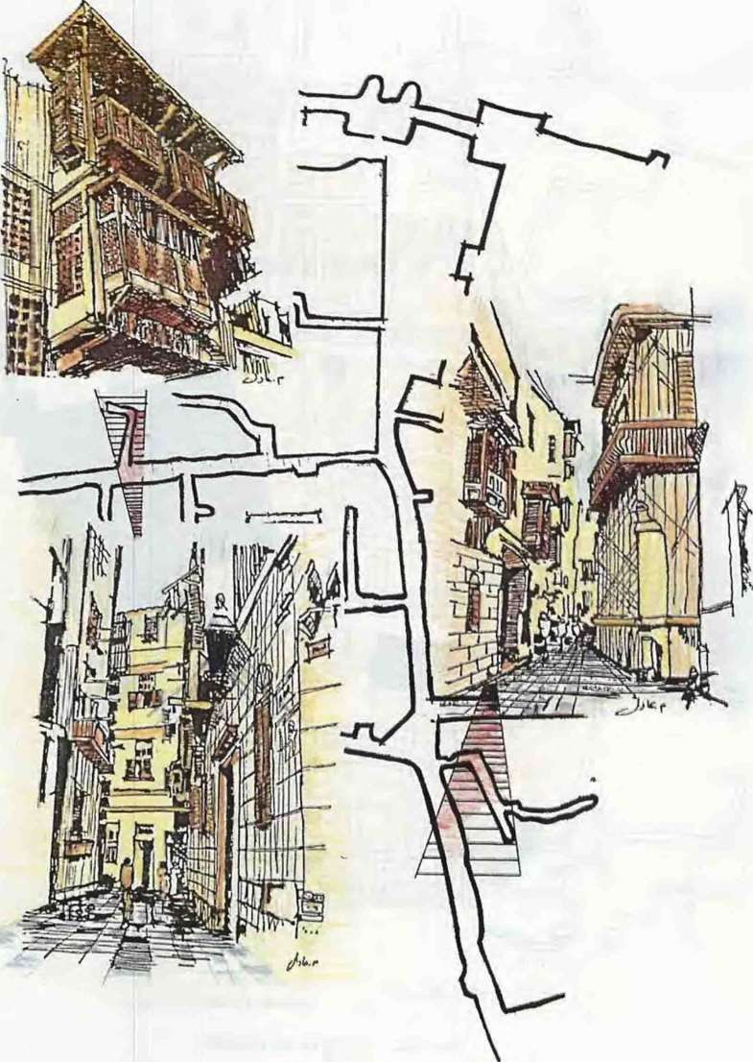
A r c h 1 t ec t u r a 1 C trt a c; te r for A1-Gammaliah
- .., lt-...Jl 1./t..J L......r....JI L.6JI

35

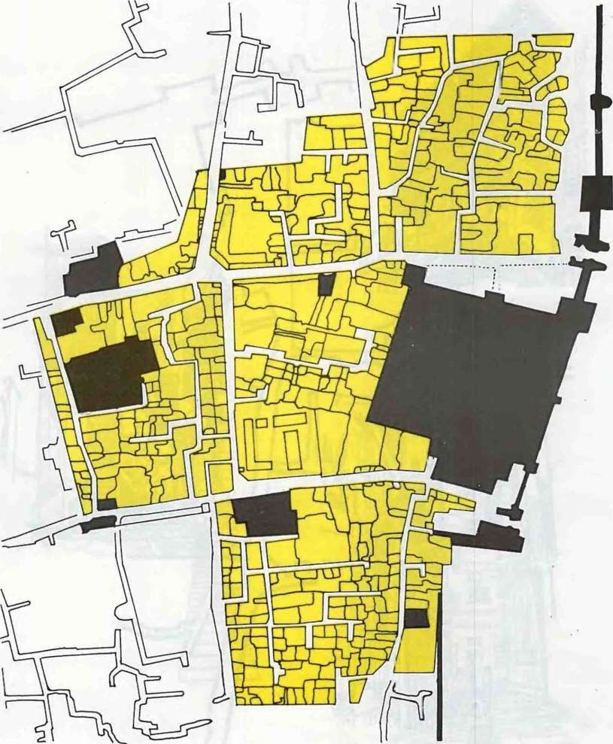

GENERA li ZED LA!\ D SE

.. ) BUILT UP ARE·\

Jlil - MONUMENTS

..:.JI_}) J.P ( ) PATHS

36

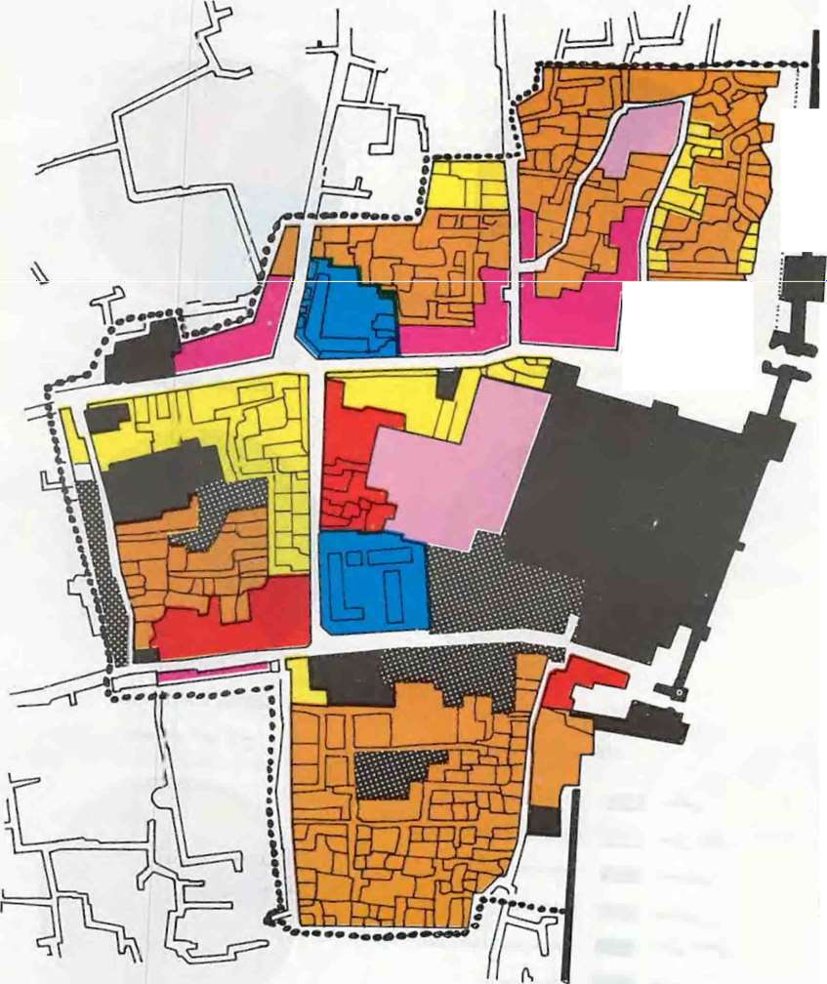J41J WI ':II E lERAUZED 8 HDI cs SE
:I
.
.
.
.
i.
,II
I
=
RES DENTIAL ISJ 0 COi\1. RESJDENTIAL
IS) COM 1ERCIAL ...f'I:..J, l>J 0 f. INO . TRIAL
INC• Rl L _,;..,loiJI DIF REI'IT USES
ED ATI01 AL ;Ut -MO MENT
4-l)wi.JI )J.U.. ••• BORDER OF STUDY Al EA

37

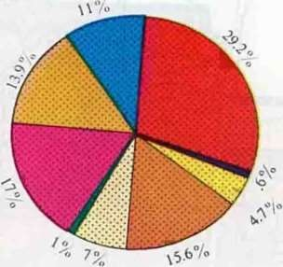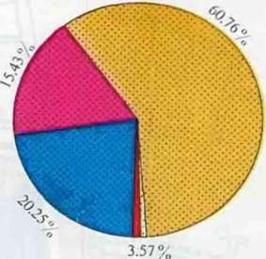

Building usc J st Floor
J/:it JJ...Ul \.ol t
Building use 2nd Floor
j\!Jt JJ...Ul u
...l•

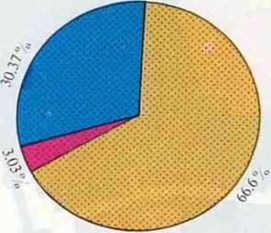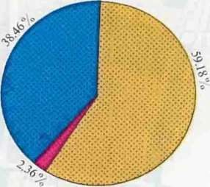

Building usc 3 rd Floor Building usc 4th Flcor

:...P-
..r
CIJ Residential
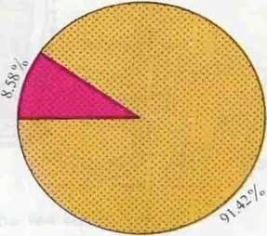
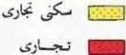
Commercial Residential
Commercial Industrial
Residential lndustri:tl

u Q -1-
-
Educal ion aI Commercictl Indust rial

- Religious
L.At ..J'} Vacant Area

38

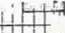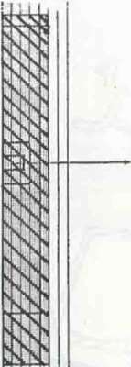8AB El fOTlOJH CJ - •n¥ ,.
EL
i:f r r r
t'

HAKEH HOSQU£ u..JI e-4-

HARI.TOAIW EL GARBAH 1....._ LA..JI'-#..J..l 'i.;l>

ATFtT BIN El SAYARG€ L.,.-11 Vr-:' AAs
£L A ARGESTREET
{;..)I a II t,Jl.; .

t





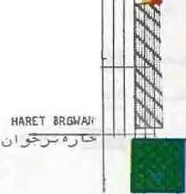FLOOR'S US£ tot El. HOtn LOIN AllAH ST •
L..' '
...UI v-..U..r--JitJL..:. ...; l J..'lI\ >= t

ZAYIT ABU El JJfAA
£lI<LEBATf.

El OMUAH STJIEET .
..._.,t..J L.!

HAR£T EL TAYAQE v-i L.t-b-JI •..J L>

u.---
...;:j<. ,
Jl
,....
RESIOC'iTTAl Cc.t!MERCJAL

v •• 1- -. I UUCATlOHAL

L:...o I.SJ COfflf.IU:IAL
lND
lJ •....l P.£LIGlONS
-
t$...J l ..l I All'!IN ISTRATlV£
J' •\ t'U>N E.HTS J..l' • • OT(LS

J-X>SQUE & SASE
EL ELHOAR

l _l_ -
·--
--

l "":""...J.).JI 4.) L> HARtT ElDARB tl ASFAR

39

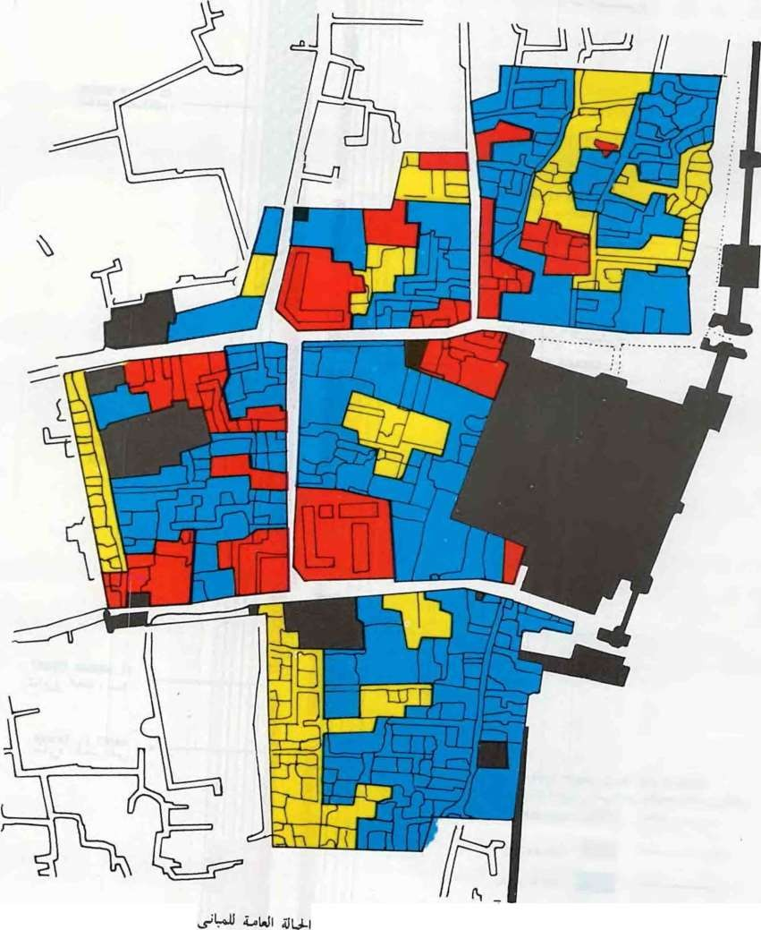
N:JS CONDITIONS
DELAPITATED
GENERALIZED BUILDJ

k...,_,:. f'--
.J FAIR GOOD

40

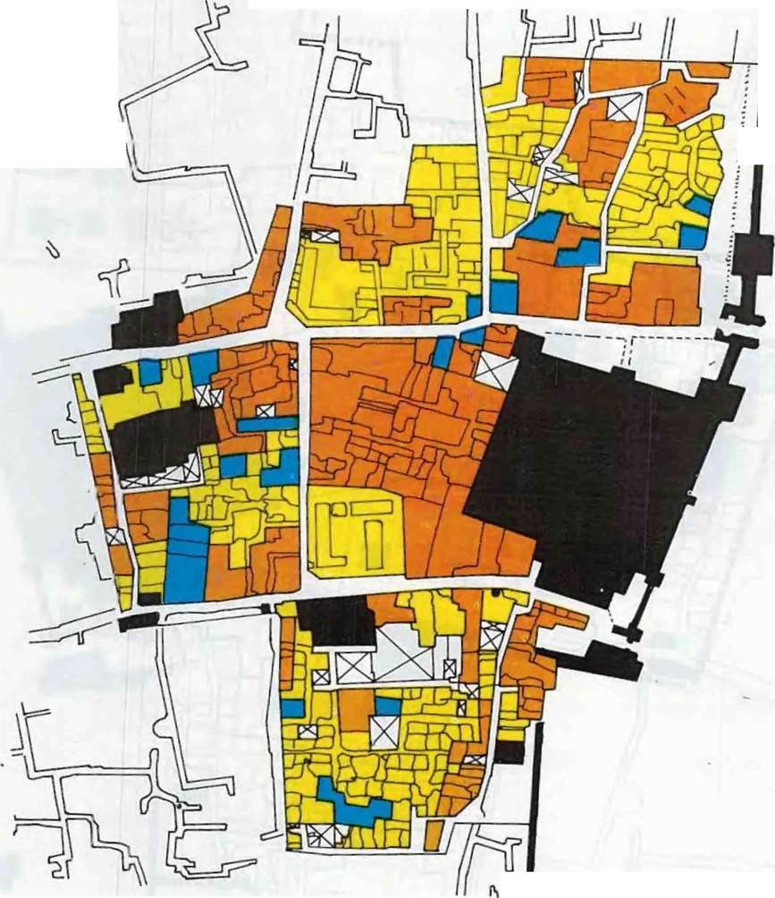
.•.
I

LAJI ...:, )I GE 1ERAUZEO BU
ILDING Hf: I G Hl.
..:1..»- .» .J' DI Sl & 2nd FLOORS
J1J.)j t -J.) j r' 3 n4 & 4 tb FJoon

5th
Floor

;LJT - MON MENTS

41

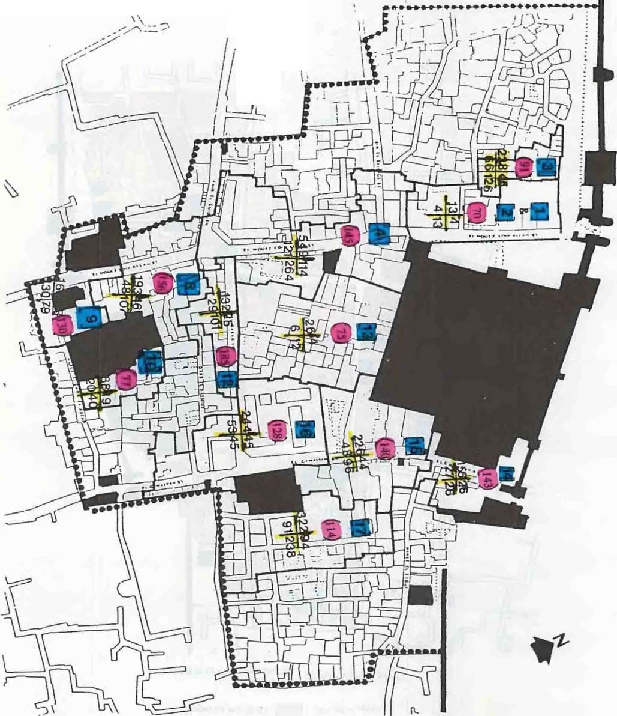f
I ,I
I
. /l'

- ..._

......
.,\

I...: \

c j .

POPULATIO N
U I S,. 11 J

42
HOUS
HOLD W IJ.
::r
».

UNITS ·
.o I_.,J:l,• I



·o. ·. .! ..
If rJ..)

J>...WI
..b-
_,.::-
ECONO IC& SOCIAL COMPOSI':'ION


SAMPLENO
bVERAGE INCOME

43

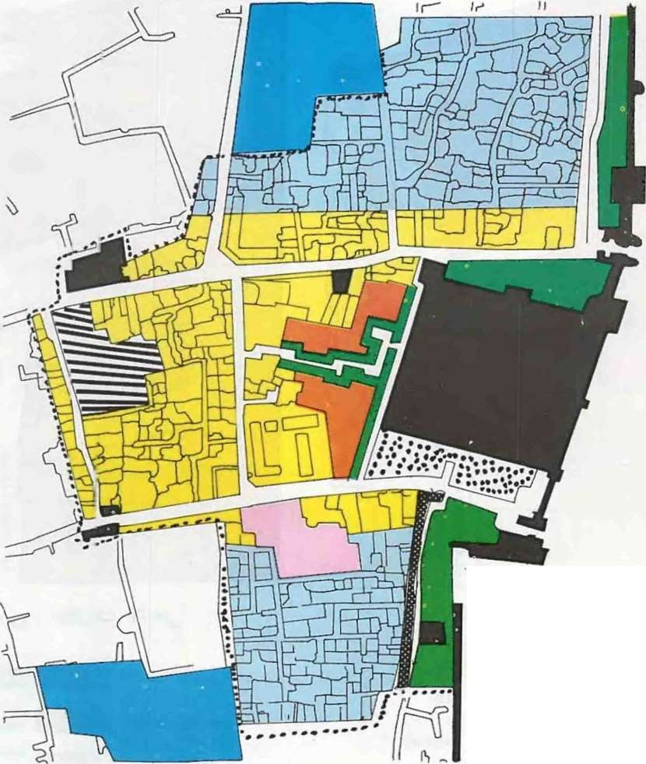Proposed dcvclopmcnl coneepl.

rr'll TOL RISTIC HOT L
LA-J ...r J.ci
C JLTURE C NTER
.j :?
T•)URISTIC CE Tl:
SHOPS PROPOSED CAR PARK
...::.J"#. r:jM )Ji y
ORIENTAL CAFE & REHUILTAIRO WALL
-R ESJ; T """" coJ j) i_,.lM\ J_rJ
GA RD EN MAJN PEDESTRIAN ROAD

([JJ] R

...rl:-- :?/
JuT

HAl Dl RAFT
D- SOIOOL
i.:i.r 4-J;..1.
tl. ON ME TS

44

.,b. IUIUII aL:.- 1.1 "CJ CEN"

X ITING URBA D
AR

AS REN . WED & UP-GRAD

D

f- A I XED USE ...... PROPOS:. D STRIAN ROAC
"!.J"f . Ol.!..e _,l

<c.> > W\i

45

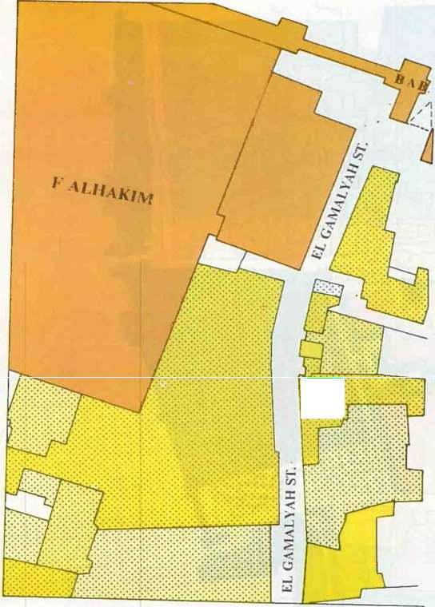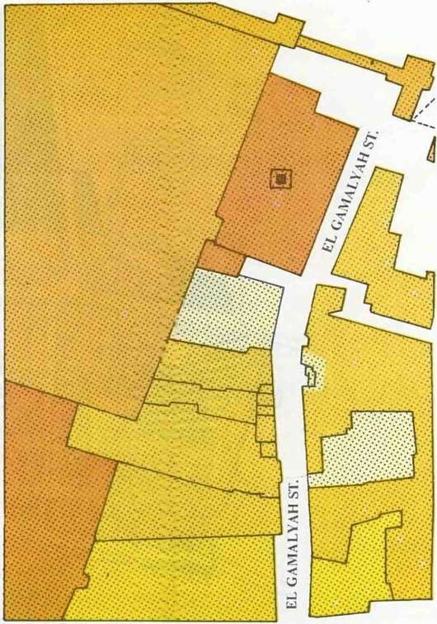
://%·<>>·····
......'
.
·.
.·..·.·.·..·....
·..·.·.·.·.
:-:.:-:-·:.·.


BUILDING
CONDITION .t;)/\ - .\;\
LAND PROPERTYS

r.......:........... t MONUMENTS (ANTIQUITI


.
BAD ;

cl(.'iJ./t)'\1
,.._,
L:.
J

.. .\;\
4 1-..a
E•·•S.·,•.·•,,.•· r•·••• •••

ORGANIZATION PROPERTY )
CIVIL MONUMENTS (
\\'AQFS


IODERATE
.....
_, PROPERTY}


GOOD
jliJ".>c U

p
).l;\
t·.'·.......l RELIGIOUS NIONUMENTS
:··.··.··..·.·...·.•·..:·.:· ( \\'AQFS PROPERTY)

..jl.i_,')\1
I;: [.....·. J PUBLIC BUILDINGS

#
J •
·:.::·::.:·:.·:-::·:.::·

4 1f.·:.:·:-:··:·/:.'.]
(\VAQFS PROPERTY)
RELIGIOUS

MONUMENTS
.jl.i_,"#)\1
j .•.
r.....·.......·....
J
BUILDINGS ( \VAQFS PROPERTY)

RELIGIOUS BUILDINGS

46
-$.>- . .·:·:·:-:·: :: .'.
GOVERNMENTAL PROPERTY

w .>

--:.:.- .·:-:.....:·:1 PRIVATE PROPERTY

47

Wekalet Qait-Bey Touristic Hotel and annexed building

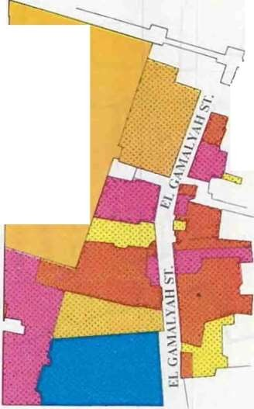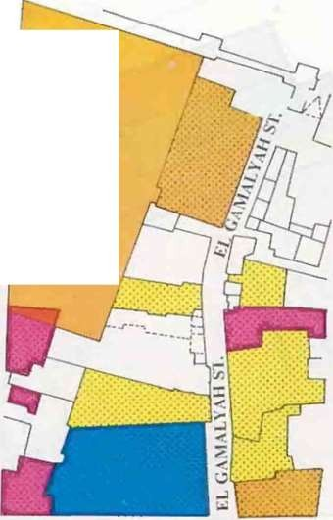
·
'·.
,
\III \Kii\1
[
Ll-l.\1\1 I

Seconu Floor Use



(."J

·I!·..·I

1·:1 :·:1


First FJoor Use

Rt:..c;tdcntwl
Rt:sitl nlml Commercial ommercH
ll

lndustnal
-
Rc!>identinl Industrial Educational
<:ommerciaI Jndustt ic.al Monument
Mosques

48

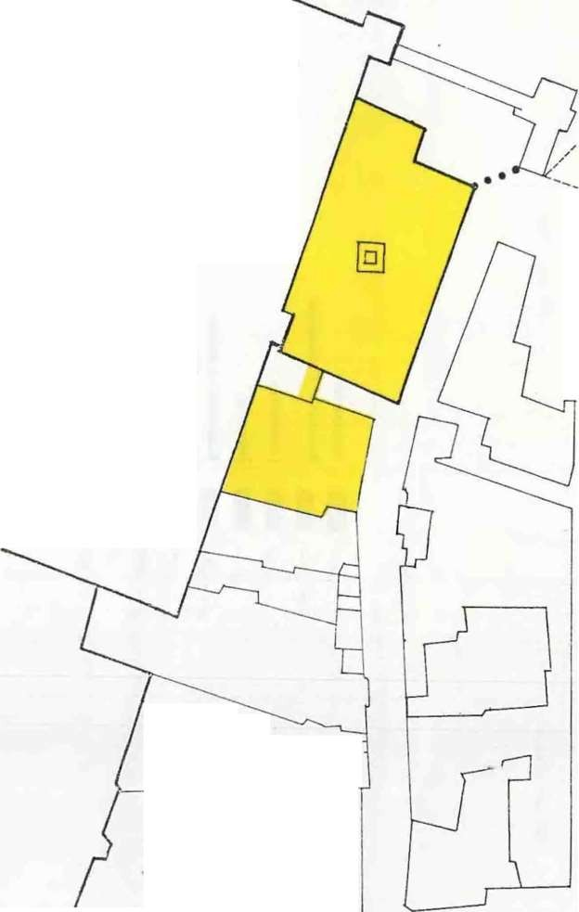0\
(Ji) al\5')1

Wckalct Qait Bey ( monumcrllal
building)
L
y JJJ
) I
( ...Jl!J'<)\1 !l)l)\ ' ))J
Annex ( workshops on the ground floor
- Waqfs property )
r ,·
l j
I
r .. _
-...
._..
{L_----_ ------· <#
_
._,_ ........ -
r------

., .

: ,jfts;f,
- t,-.-J='
•
.J
·
It(.,., ·
h lc,ra ' Of(•/
Vllit b
<'on. ,.Q{Jh.
,.,.,.,.
'''·11·) -•·1}\' •
j.U uJ11 j!..l:Jl First Alt rnati\'e

- .
IIJ\fJ,(J'P\
L

•
..., .
'- 1

"-'£..
llll('. d IJ. . .
- IJo,t!/ IJJ]diiJg CJ
;,lid lll•i•iJStf;'"•ic,.,
\.

......,..................
,I.r.._-.-.........

L J
_

{L- ...-
_._. _
_ •r------

J J IVt.J...U
-
-.-:o-il I
tJ.rJJ i a I J') I
The proposed

Thpropost!d Plan for the First alternative
Land for the project



I
l
. • • I
l L I Is r L J

· Wt
1'!,e & ..I! !; Jey,
ecofld «:1'h• ..1!, ;
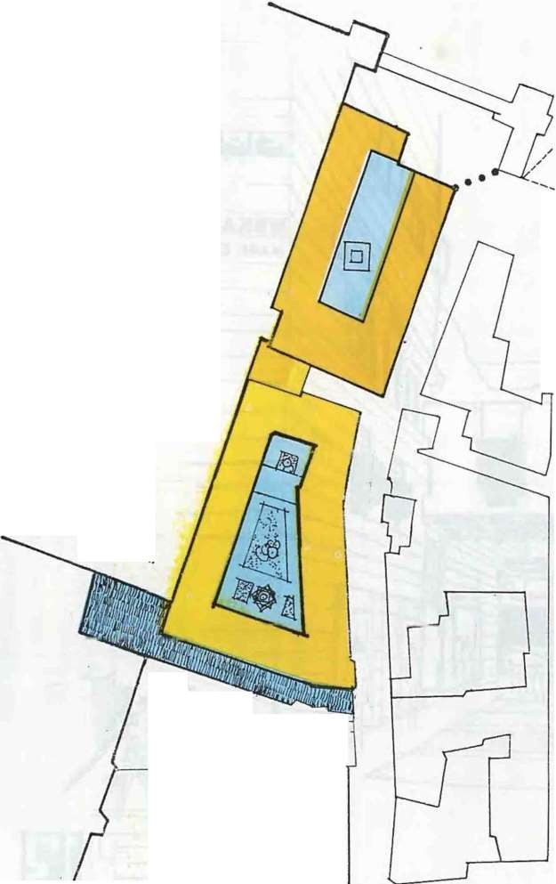.., Q -L. ' "d 41ter .,.
t{.•g-!•;4• : .jJLsjf,
.,_'..
u.
....
....
-.)
Jilek-1/et Q .
.._ hotel flJt 8ey
.._ Coq, ooltls
fllerci:J/ ,,_
s,,oPs
.
-
w..Jk" -
/
u.
....
L
)£<
!.,ii - - lsJ
. .,..,
'--'j
- :J
....
....
.jJ
....
I.J
; (q
f
•J . ....
....
.._ Coqln. .r.oolt1,s·lflg
.._ 'JfeJ IJJ1d:
.._ hl(le.\'ed lJ
, ,e,.,
.._ 1. it< re. Po,.,.C!Cctr; j.
.._ 'lt llrfl siJo
..._ (l_siCJ CjCI/
R
JJ; ll/ti ..
11t
'Ps
"ch' hou.
Pur
C!J] ' ·
CIJf]i((j <ll'
h
lterCl
4drq. St.•r•'i
IJ(j
lllis Ces
tr<IOrIJ
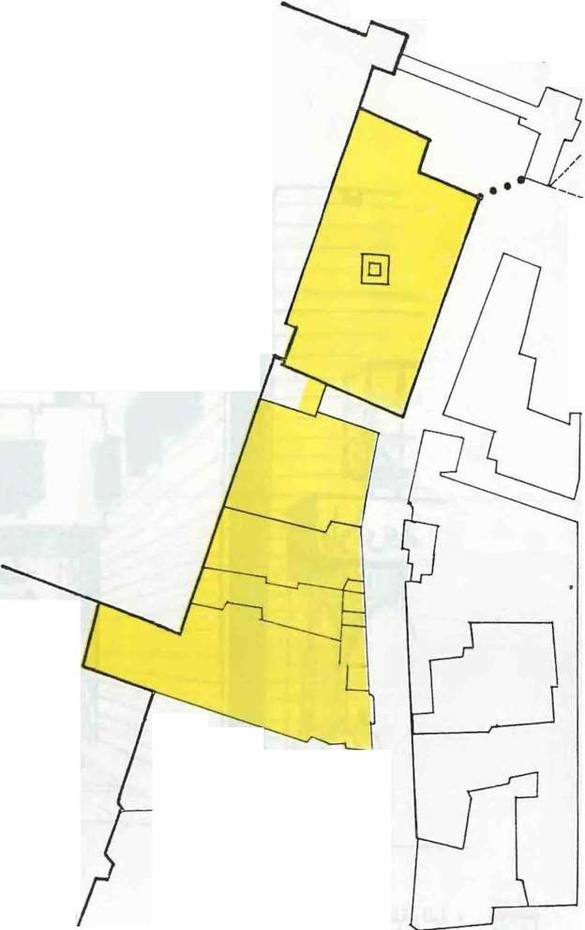ProPosed l ._...._,y,11q
:Jlld lor tb
e Project

Jv.
(_,i/) .fjt.•
U_If ·

li ·
( ek;uet Q flloqllflleqt :tit IJey
:J/ hliJ'lr ·
Vlflg)

L

- "."'(..,.:
•
""'I• 4.,$tC o/ 'i-., / 1

- ){J . '

<($"1
I _, .)J.J . ,._. "'"(J/

• •'\W • • •I• V":',.

I , J ..J.).J • -v-
,..
  - .Ju·t·.:)'- ; .
....

- d.;/! u.. . ....
....

rrI----..---
_
L--- r------
Annexed building
- Workshops on a

r ............. .......
,
t( ---...-.....-,

_ _ _ _ _

LL__ -----_-,-------.J ground floor (
Waqfs
LL_ --- .Jr------

.,1::
1.
.)..

. ) I l.J..ll
iJ.. .

t·J=-1-1

The proposed Plan for the second alternath'e

J I I
- I
property)
- Warehouses and stores on a ground
floor ( primtc property)
- Residential quarter in a very bad condition occupied by 12 Families
( prh·ate property)
L _J

I I I l I l I I I

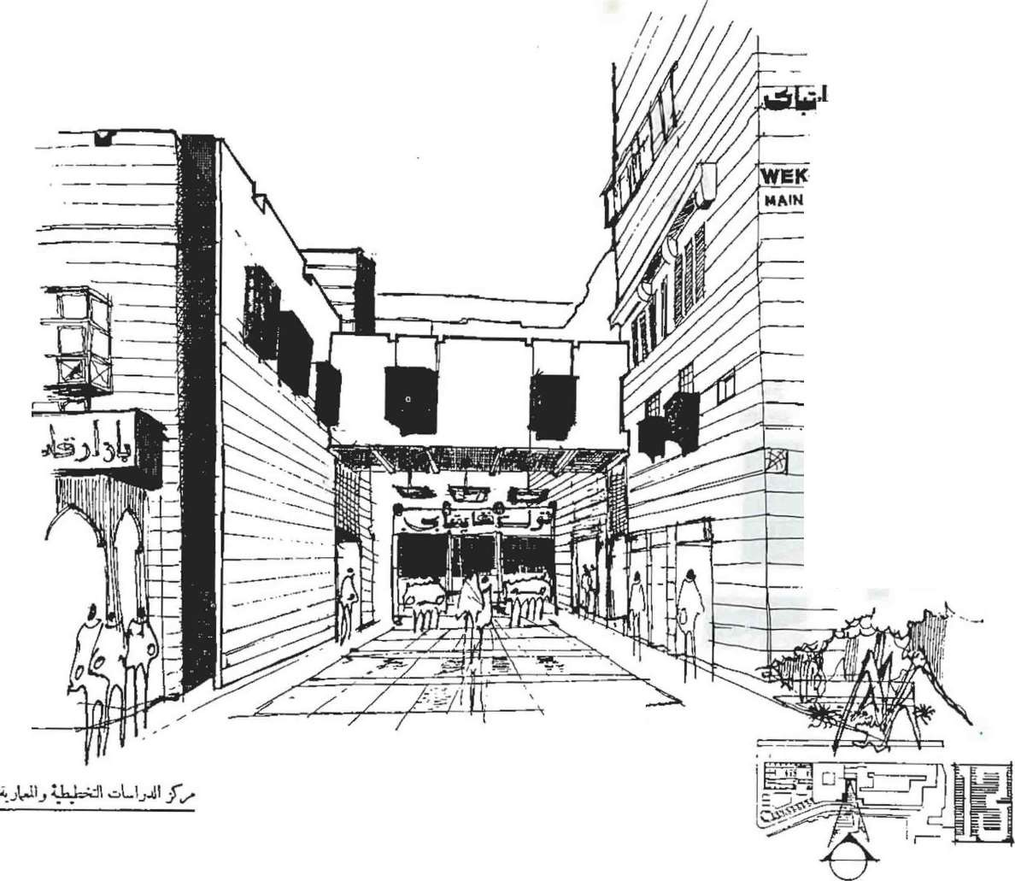

·-

)-.. -- LET QAVT-BEY
ENTRA!'JCE

I --l--·

....

C ENTER Or=' P L AiiN JNG &. ARCHIT EC TU RAL STUDIES
CP J. S

0..q0-

-:l

>
Ill
ID s
tl

t-
':!\ !
if g .. (I
0 2
..-
_,aa
!I
Clo n

.. : :
..•.

1.11-A
i)
..

--:'
-'"'
.4Jw"' 7o-.0
-:>
-·'•· '

_j
<..

.. •)
JJ<
l.t.::
- :J
- .

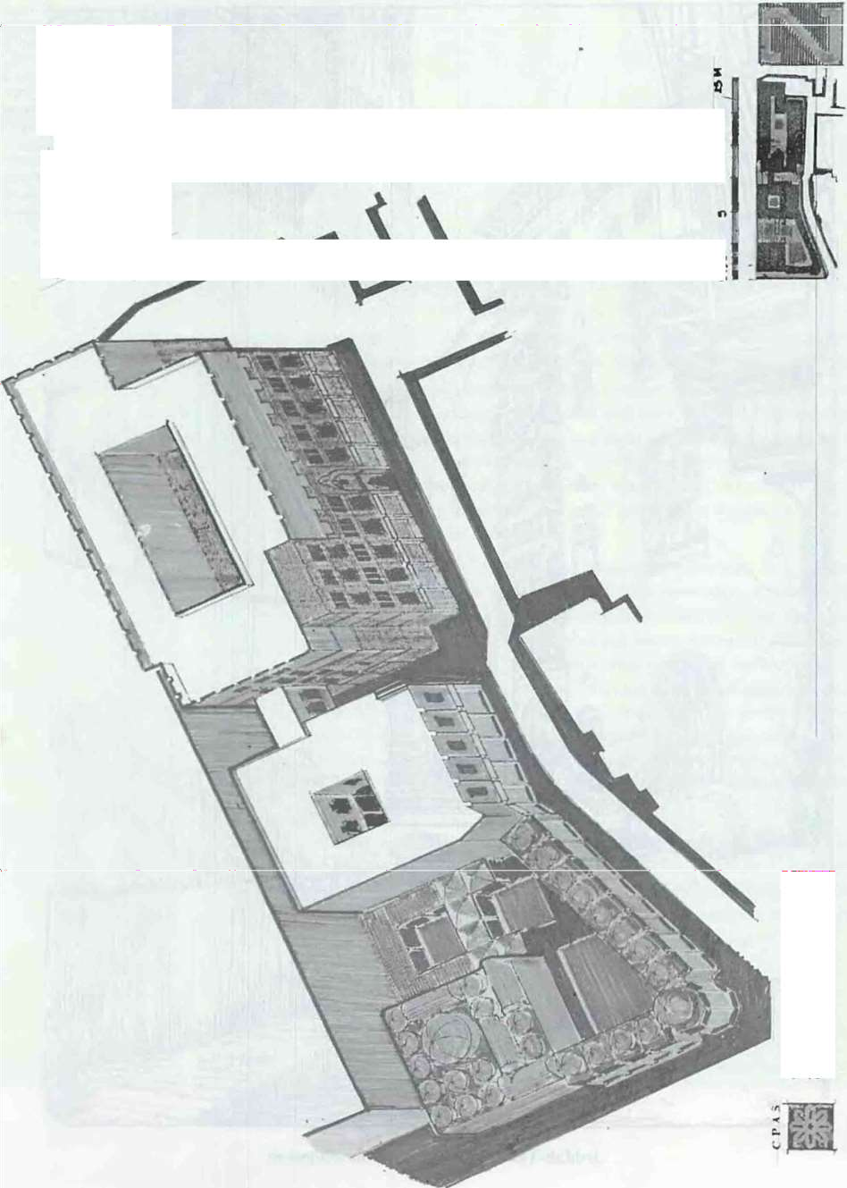.) I•
·...'.J w
  - 1--.o...
,
. -
:-U
.. ·<I'
    - J<

49

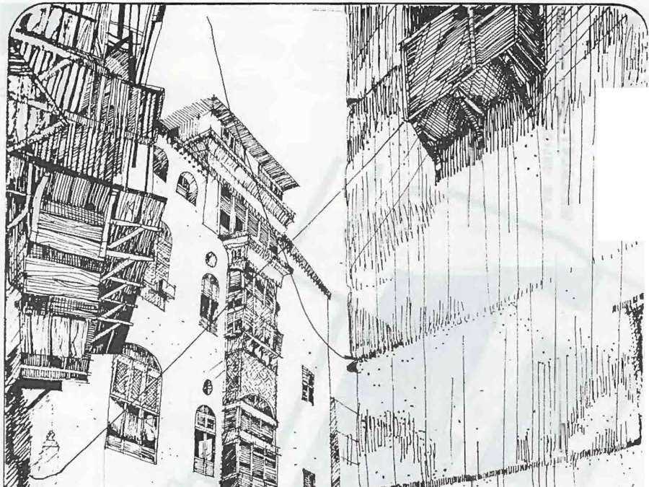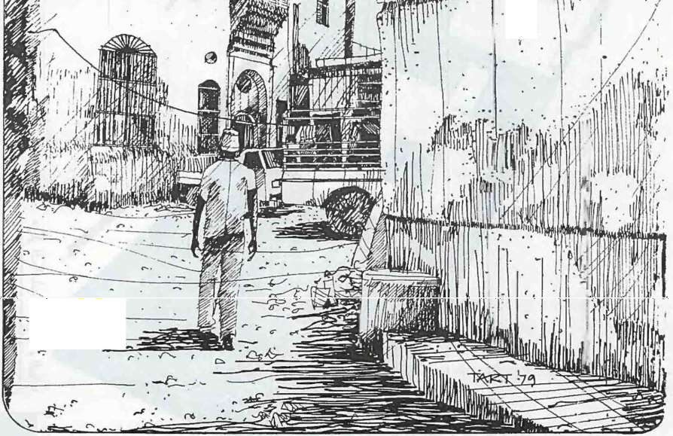I

, . ..... '
.
.·..

- I t I'

.
"'• (;::" ·r
. .,.. .

Jeddah-The Old Cit)· before development

50

The Architectural Re toration of Historical and 1\-lonumental Buildings

P•·oj: Dr. Saleh Lamei Moustafa
..
- PROF. DR.SA I.H LAI\11-:l MOl S'l A f. A
- t::\ pert in Architectural hlamic llerihac•
¥ t·.\-Ocnn uf J.;n• ull ,,r t.nJ!mtl'rin.
Kcirul l niL
- £,-Prof. of Hislol'") of An;hih.'Cl un·.\lc.,ltndriu
Lni\..
- B.A. 1956, Oiplom.a in Arc:hhtcturl1963 lUlJ:nrt
oil-
.
- Ph. D. in l I mit Arc hi H.'Ctun.-. 1966 kc:n nh.
- He partieipllted i n a J:treal dul uf torution\ ork
of blamic monumental buildi112' in r g)pt and other arab count riK
- He publil hoo man " ear<:h&."> wnd 'ttudi in th
H tor) of .\rchicrcturc und 1\rchitectuntl
RestonHi1>n.

The Islamic art and architecture have evoJutcd based upon pre-Islamic arts founded in the Arab lsJan1i.; World. but ha ve always had their ov.n cha raclcri tic style. A long the Jb"CS. the Islamic archi teet exercised hi
knowledge or ronn. space and hutnan scale in his study or visual l:nmposition of masses and the relation bet ween the elements and each
other on one handand with the rnad ystem and surrounding open spaces nowada).:; on the other. It was noted that Jnost historical {mediaeval) areas arc of high population density a:-u:l most of their occupants are of a Jow income . ector. The existence o:· in tctrela ted in <..I ustriaJ and commercial areas "'ithin the rc idcntial a-e:.ls caused the deterioration of living condition·in the area that was once the district of palaces of governof\s. weathly people and merchant .
The deteriorating conditiOn or ht torical buildings was mtsleadingly related to the fs1amrc architccr!» ·ack of knowledge of the appropriate •. construction n1cthod. the usc of llnsutlablc mortars and the absence of damp proofing laye1 "·: But by stud ytng many historical buildings in the Arab I lamic World. it was found that the Arab builder used several building materials each according to its required functions.the rubble used
in the foundations diJTered from that used above the groundthe mortars
used in waJls, foundation and w:ater tanks diiTcrcd fron1 each other. To be fan1iliar wi th the deteriorating C•)rdition of these buildings, the origin or
such a probletn and iCs reasons. bould be t udicd in order to determine the .. optimun1 solution.
To start with. the treatment of th e building should be identified whether it is a restoration of the demolishcc. element or JS it a matter of preservation and conservation oft he building c.nj tha t will include repair and removal of
'iolation carried out during succc;; 1vc years. in addition to a study of the

51

surrounding environment to ensure the best protection againts its negative aspects on the building.
The treatment might be thought c:f as a matter of rehabilitation of the building either to reconsume its' functions o- to adapt it to another function appropriate with its architectural corr.posi:i.:>n, or it might be a case of con1-
plete renovation. This subject shouki be .aandled by experts bearing in
mind that preservation and conserv::.tion S.'tlould not be treated seperalely from restoration, because the resto:-ed tL l1ding might deteriorate again unless it was preserved and conser'vec withi1the surrounding media. This is the case with many historical bui'dings :n mediaeval Cairo.
To recognize the factors resulting in t deterioration of monumental and historical buildings. the following aspects must be carefully considered:

l. DETERIORATION RESULTING FROJ\11 THE
PEOPLE
buildings.

    - DETERIORATION RESULTING FROM
E VIRO MENTAL
.CONOITlONS:

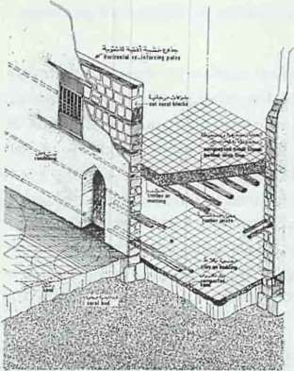

.tcdd&h•. The Old City. A dcCuilcd struc•
ture system in the traditional

52

It is obvious that individuals ir. dev<>ping countries suffer a lack of historical cultural consciousness and tllnawarness of the artistic and historic value of the historical area a:1d the monumental
buildings especially when the people gain no di.:-ect benefit from these buildings they lost interest in those antiquities a:td resulted in misusing them and accumulating dirt and garbage.
corrosion.

  - The accumulation of dust ::>n wc.lls and ceilings causes severe damage in the wall paint. The Lumidity as wclJ activates the formation of fungi in the waJJs anc. ceilings.
  - The modern means of transportation and existence of indu stdal areas within lhe city causes air-poJution which greatly affects the
building mass. The vibrationresulting from the heavy traffic affects the foundations (being \'ery near tJ- e gro und surface they were not designed to tolerate lhe bea y traffic).
  - The deteriorating condition ·Jf the nfra-structure caused a
leakage · ofwater in the walls anc foLr dations. This leakage caused unstability of soil beneat h thfOll 2-4 The leak age of sewage water and
its accumulation beside the
walls caused the formation of st:lpberic cid which caused the corrosion of the stone compostion of the bLilding.
  - The accumulation of rain-water OL the roofs and the deteriorating
COndition of the damp proofing CC•LfSe caused the COntinual leakage of water and humidity to tt e waitS.
  - The nature of the Egyptian oilcontaini n g a considerable concentration of salt (sodium .;nloride )- greatly affected the
building mass. When the surface
?later carrying disso1ved salts rises in the walls by capillarity. it ev.1porates leaving crystals of salt accumulated on the stone surface causing surface

    - DETERIORATION
RESULTING FROM THE GOVERNMENTAL
ORGANIZATION:

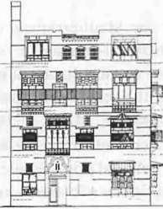
\

Before restoration..

.
•
'

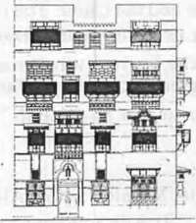

..After restoration..
Jcddah.. The Old City. A residential huilding before and after restoration.

CITY OF SAIDA

54

'Lh..! deteno1:tti01l 't'f"&rt.:k't·ly tne following:
- The continualtntcrferenct- beteen various ur·\nizations responsible of such historical buildings e.g Ministry of 'W .1qi and Antiquities
Organization.
- Some of the historical buildings are being rented by n1eans of governmental organizations -:c carry out other functions rather than their original one.
- Absence of antiquities' centres whose responsibility lies in registration, documentation preserva ior: and conservation of historical buildings.
- The existing regulations cor_:e:rning preservation and conservation of historical buildings in develcr_I;ing countries are uncapable of carrying out their req uired function. Most of these regulations are mainly concerned with the historical cuilding rather than the surrounding area, w hich accordingly meanthe up-grading of the social and commercial composition of the diEtric: as a whole. This in turn means an amelioration of the exisbng s vices in the district.
The new antiquities law :t-;o. L 17 ( 1973-) is concerned with the Historical sites and buildings as a w h Jle. J t lay down strict regulations for the new buildings built in the area Th e law included historical (non antiquital) areas.
The treatment of historirnl buildings could be classified as follows:
l. Immediate work tc pre nt -:he buildings colla pse.
- Urgent work to stop aLy dterioration from extending furthurn1ore within a period of three morJ..:1. s.
- Necessary work to re h the desirable state within a long term renovation plan.
- Desirable work needed t•) ad3.pt the building to carry ou t its functions.
- Periodical supervision o1ce e,.ery month.
It should be noted that resto:ation or histoncal heritage should be

carried out by ·experts ir re!St:> ration, sufficiently acquainted ...vith an tiquities and historical stl.ldJes to determine the original and intruding elements and to recog:tize te mc-st appropriate methods of treatment. To be more familiar with the atove s·Jbject, the restoration project of the great mosque ( AI Omary) in Sai:ia :S::>uth Lebanon ) will be reviewed.

The city of. .Saida is 1oca te:rl a: 33 34' latitude and 35 22longtitude to the east. It is 45 Kms from the Lebc..n-ese capital Beirut and ilying on the east
coast of the Mediterranean. Th.:- city of Saida used to be a vital port during the early historic periods. It -;vasdestroyed several times either by Palestines Assyrians or Persians. It was a c ony in the Greek Empire then later in the Roman Empire until the llaoi:reign. During the lslamJc era, 1t wa
captured several times by tre crusaders until they were defeated by Sultan Qalwoun ( 1291 A.D. )

53

THE GR EAT 'IOSQ E ( EL 01\ti ARY)

I. LOCATI O!"

The great mosque l ies on a hil l lookit-g O\'Cr the Mediterranean across t he western side oft he old city. [t lies to the north of" A:-Maqasscd ., school near ·•H ammam AI Ward". The mosquehas two entrances, one along the east side reached across·Zahr Al-Arnir ··str...ct. the econd entrance- the old ent rance - lies along the northern facade cading to ''H aret Al-Jamei ''.
The building was originally built by .. H ospitalers" of·John the Baptist Church" in Jerusalem. It was built to serve tbe sick and poor people of the district besides military functions. It was buil: at first aa fortress- and not
as a church as was mentioned i n son1e references. It consists of suites, a refectory, a chapel, a st able and service sectors. Now, the mosque is occupying the same building of the fortress: it extended east wards and further beyond the existing no rt hern doer. To say that the existing mosque occupies the san1e build i ng of the ex-church is con1pletely misleading due to the significant difference in the ha ll plan. It differs from the those of early
Gothic churches and that of l ate Roman sque Architecture eit her iri radial or stepped plan, and in the absence of t he Ap-;e and the Choir. The remains of this era are recognised in the northern ais e in the forn1 of ribbed vaults
and clustered piers. In 1291 A.D / 690 "-.H tht fortress was turned to a n1osque and since then it was known as the great mosque··AI-Jatnei Al-
Kabir" or AI Omary - rela ted to KhaLfa (>mar Ibn Al-Khatab··.

- HSI TORICAL
VI EW The GrecH mosque of Sa ida was built late after Memluk Sultan AI-Ashraf Kha li l l bn Qalwoun defeated the Crusaders 1 1291 A.D.) and put an end to t heir occupation. The mosque was destr:>yec se,;eral times by earthquakes
and sea storms, but every time it was repaired and restored to its original condition.
Duri ng Su ltan Abdel Majid's period ( l 848-1849 A.D.) many restora• tion work were carried out, and many pc.rts were added. The Sultan's work
included bu ilding the minaret and covering the entrance porch with a dome carried by col umns with Corinthean capitals co';ered by a layer of gypsum.
In Sultan Abd elAziz's period ( 1870 A.D ) Khoshiar Hanen1, Khidawi Ismail Pasha's mother - carried out S•)n1e re toration work. The latest renovation work were carried out in Sul1an Abdel Hamid's period and they
i ncluded the external piers an d n1odificatio:1 of the Gothic openings and addition of the three domes in the so uthe1 n c:jsle as well as the n1arble min bar to the left of the n1ihrab. Successive restorations took place in the second half of this century. the latest of whih was carried out three years ago
whereas a reinforced concrete ro:>f \\as built above the n1osque·s origi nal one. This last addition seriously spodt the architectural forn1oft he
mosque.

54

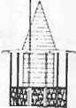AI-OmaQ' MO!\QUl'
aid-Lebanon
--=
==
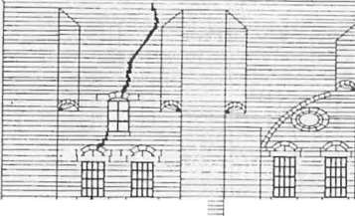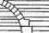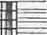
\
=
=
- -
--
=! -
rf =
...
II
1-·
= '-
·' ;.. \ ' t ..,

South Elc'ation

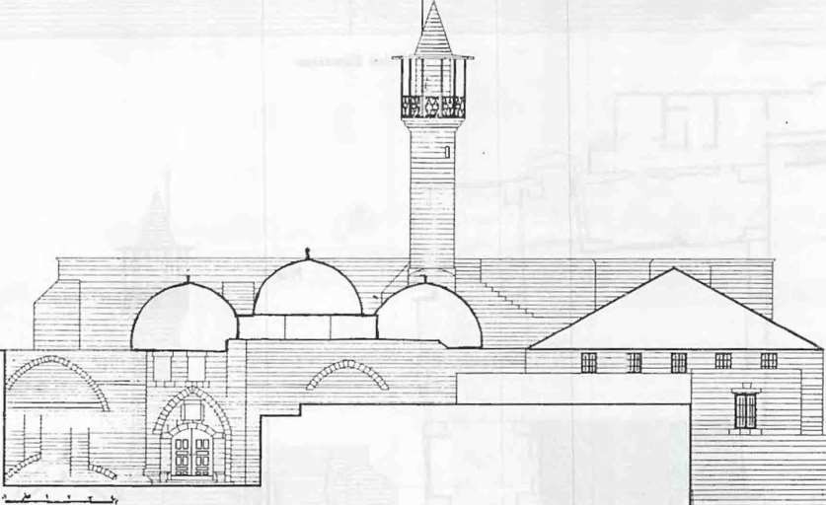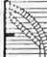
orth Elevation
The drawings di clo e the cracks in th(' facades as well as the dcmoli hcd
parts in the plan, which resulted from the lsraili Bombing.

55

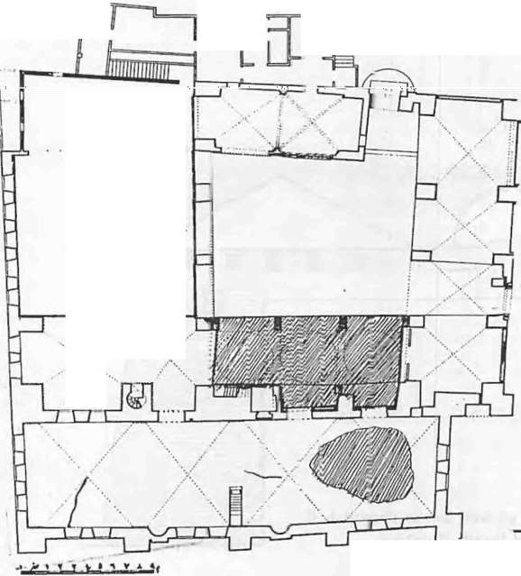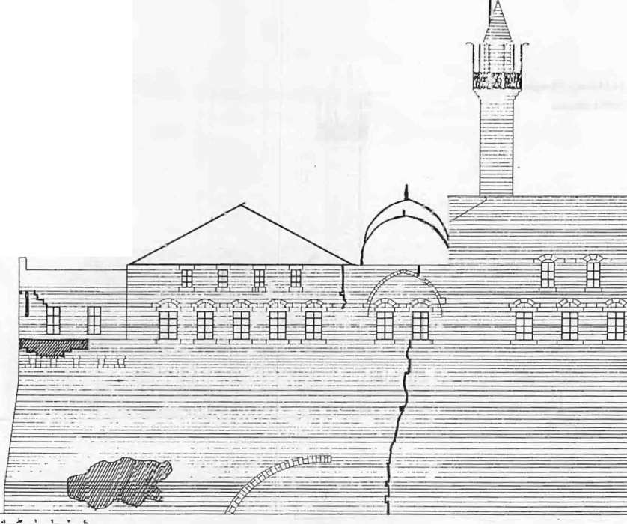
.... .... .
....:.."·.
:
....... .
..
.·
··.
AI-Omary t.iosque
Saida-Leba•on ·
West Elcva:ic n

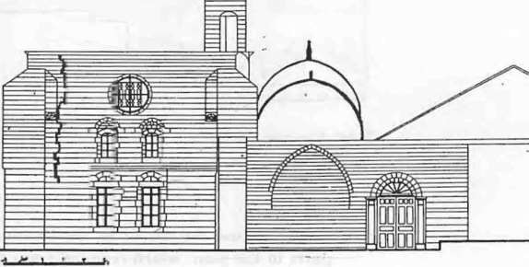

Plan East Elevation

- ARCHITECilRAI. STYLE

The mosque LOmbincs two architectural sly.cs side hy 5ic.lc. that of the European Romancsquc architecture and Llu=.t of lslnmic ()llomati ·trchi• tccture. The Romanesquc ttrchitecture could b:-ccognizcu in the remains
or the COJ1Linuou!i rectangular windoen the north and cast facatk:-. occupying full height and ending wit 1 a pointed arch . T:1e cross ribbed
\'ault found in the northern aisle \Vas prc, iously found in DLrham church in England and was then considered one :l'the <.:h.uactcristics or early Gothic architecture. On the other hand the Is ami·- t le is rccognjzcd intcrn1s or ()ttonlan architecture in the circu lar dcmcs cm-ried by pcndentives at the L·urncr:-. and the usc of cross vaults anc Jccorad doors. T:1e circular forn1 of the n1inarct that ends with a circular\lc:·111y ..:urried o·;cr a squared body and ending with an upper cone is ol' ;1 typical Ottotnar. t) pc. The rnarblc
minhur!-. and thl' decorations found at :heir k•\M:r sides wL:n:very typical of the Ottoman period. they <.:ould be seen it· Kc:khoda Jnc.,.;quc in Saidu.

The n1osque is built using wall bearir.g system. Sandstone together with sand-lime mortar were w,cd. In son1c JXlrl5, n1)rtar tnadc up or lin1c.. mud
and slag were used specially in those pc rts built during the Ottoman period. This kind of n1ortar as well as that ccr.sis:ing of sand, l irre and red brick
powder were used as a dan1 p proofing layer on roofsnd dan1p areas.
The structure systen1 is based upon thusc ·Jf cross vaL-Its carried by large piers on the facade. In an attempt to balance the h ori zonla lth rust rcult ing fron1 the vaults and the vertical loads. 1he piet3 were strengthened by half vaults at the boltorn and truncated at i·s uppe- edge. The .:ourt is covered
with cros .vaults. Tbc southern aisle w.u covcr .:d with domes carried on di -
t:cn lric pointed arches. These arches tr.._msfe:-ed 1r.cir loads to rcctangula r or
squared piers. The \'ariant form of ..uchs a:1d piers re.;ulted rron1 the successive repairing and additions ca-ried ou1 during thL nineteenth and twentieth century. The reinforced cor.crctro_Jf that was built abo ve the
ot iginal one as a means f protection a ainH dampnesresulting r,om
rainwater actually ruined the.form.oft:1;n1osqJe. Being ve ·y rigid,it seems inconvenient with the nexiblc form, the pnmiti\ e foundations.size and type
or stones and the mortars used. The iroo circu ar belts use:i in the circular minaret were subjected to corrosion re!-u1t infrom ru!:-1., which in turn resulted in the shrinkage and separation of st:)ncs.

- Tt-lE RESt'1.'1 I 'G UAMAGE :

  - Damages Resulting fron1
Israeli Bombardatiou 5-1-1 An area of 90 sq.m of the roof wa ccnpletely destroyed, cracks
appeared in several parts in tre vaul s. This might need either rebuilding or strengthening the cxistir:g vaults using polimcrs. This could be dctcnnined afler carry ng oul lhc necessary research and accurate cxan1ination of the stone. and n1ortars u ·cd i n the roof.

5'1

'.1

)--l-.,

5-1-.3
5-l-4
1\ n a rca or 70 sq.111 of an a ,·cragc wid1 h t•f 70 ems v. as con1plctel y destroyed in the northcr11 wall in addirion. to JO sq.m in a ,·cry bad l:OnJition.
The soul hern ai!:'Jc - or an urcn I 00 sq m has collapsed.
A 6 n1cters long crack appeared in the b•)tl.)Ill mal)fthc n1inaret u well as a 5 n1c1 ers I ong crack in the w.:i rcu]a r mass beneath the
""

minaret bakon).
5-1-5 A I 0 meters long crack (full facade h:ig.ht) appeared hct ween thl: south eastern pier and the adjacent elt stL rn and southern \\'ttlls.
- 1-6 A 7igzaged crack of 5 n1ctcrs long in the Sl.'t:Ond ..Qausarah .. (to the
cast) appeared over the circular \\'indow abon! the m inbar on the southern wall.
)-1-7 A zigzaged crack :t ppcnred in the\\ cste ·n ··Qausarah··starting from the top of the facades - beside the pier - uptil the upper arched window then rron1 the bottom ornl.:r ·Jf the window uptil the grounJ level. There has been as well ar·nkage in the bottom part of the southern wall rorn1ing the base of Lhe mosque.
5-1-8 The sou t hcrn facade was subjeclcd to'c-a I grooveresulting fron1 splint ers. An area or 150 sq m should be renovated.
5-l-lJ Sc\·cntl parts of the western facade o..·crlooking the sea were destroyed. An area or 20 sq. n1 abo\e the ground level ncar the northern end should be renovated.
5-1-10 A zigzagcd crack appeared on thwest•.!rn fat:ade starting beyond
the fourth window -eastwards up till the ground level.
..
5-1-ll Sc\'cral cracks appeared in the upper pa·t or the southern racadc. 5-1-12 The t russcd roof covering Lhe we-;tern ai:;k has colla pscd.
  - -13 A disjunction appeared in the walls of the "Vestern facade to the right
of the trussed roof.
5-1-14 The 11(.:\\·Jy built cotH.:rctc roof ( north\\' thcrn aisle) has failed.

S-2 Damages Resulting fron1 En'ironment and Building i\httt'rial :

The mosq uc has erected o\·cr a hill look inf. westwards o\·er the sea. The rnain structure is n1ade up or sand stone. linsc-stonc in position s subject to repairing- and lin1c tnortars. The damages resulting from the site natlii'L'
( envi ron tncn t and building ma tcria Is ) are a..; follows:
5-2-l The n1osquc being huilt on the coa st is cor.tinually cxpo ed to wind
carrying sand and sea salt \\'hid1 rcsl !ted in the corrosion of the stones· surl'<u.:c. .
-1-1 The mosq uc·s localion a n1idcst a f(.;:idcn tiu I district of a high population resulted in the leakuge of S(. wC:fgc water hy absorption to the walls.
    - Leakage or rainwater from the roof to .he \va• ls re·sulting in the rornuttion or harmful fungi in the stcnc mass.
    - The high humidily aflcclcd the tron bar"' •)f the n1inarct rcu lting in
their ru st anu corrosion and subscqu ntly ending by cracks in the minaret.

,

5-1-5 Hair-cracks appeurd an rcsu I L rr.1m the diJTcrcJH:e in lcmpcrat urc th rougho ul day-nigh l.
5-2-6 The usc orcement mon:n scri onsl) aiTcctcd th ..·bu ildmg mHtcrials. lntcrnattonul rcu. ..ulatioils rorhade the U!'\C orcement in monumental
buildin.u_ sdue to its hiu.... f salt con.;i tencv that ruins the stone surface The dirrcrcnt expansion rates aud permcabilit) ror ccrnenl m ortars from Other bu ildin g ma t'-. rials Je· d..; lO t hcconccn:ration orhumitlity in the mortar.
S-,_7 The usc orrein fl) JTcd concrete roo!' abo \·e the on.u..i na I stone roofled to the ineon,·enien L i ncrease of oads on \\ u lls a:1d roofs. The rigid form or reinforced coJH.:rl!tc is quite odd ainong.;t the surr ound ing
environ ment .

-),---(0)

.:"----:(1\
The Lise of new den loped bLii:Jing nuttcrial\ in the historical · building ruined its st) le .L JH.l cha ·acter. Mosaic tiles were used in LIH.: court an d aisles a \\ I..'! I .t" mosaic leaves on colu mns. The Hddition nl
u restdent ial quarter for the gu.lrruined the western facade.
Placin\\ cltcr tanks in the \\allk·d to the leakage of- wah. r. ( Thi

6 WORK SCHEDL I.F 6-1 Rl'gist ration and
Documt•ntat ion Proc<.''-
!'t:
could be rccognij'ed in the non I\·.t.:stern CL)rner 1. Besides. the ugl
\'iC\\ or\\ atcr tankon the facaJc CcllfscJ great Ulsfig.uration

Detailed records and do... umcnta.icr. have been cornplctcd showing the existing <.:ondition. to recognize the nc'v\ rcnnovated clcmcnh

rrl)m the o ri.u..i nul t'ncduring proecs!'-.
t...he rc-huildin1..! and reno ation
I

Detailed measures of e\'crv.. clement in the inter ior hus been taken.·/\,
-..harp :-.an1ination has been t;arri ed out on the cracks tht l
tppcarcd on the eastern. \\'Csterrnd southern facade!'\ in order l{' detcrn1ine the )stem of treatment

  - Proping-up Proccs :

  - Lab-Exam ination Proce:-,scs:

58

6-2- 1 The \·aull -forming. t hi..' mosq u:·. rour - sh otdd be i rnmcd i,lt I propcd and supp<. rtcd b.!forc an} further cracking occurs- reciall
jn the\\ inter. The ntinfa I and leak4: g.c of water to the inside of wall" and cilings led ttl the intlation of Y.alls with water and salt.
6-2-2 The boltom. bod) of lh.! southr r 1 side of the n1osquc has been propcd up and supporteJ after the- rcmovd of the adjacent school quarter and the increase oft raiTic ;dnng the coastaJ road. A stair- case
has been added on the .;outhcrn side.

    - The soil of the wetern ai lc s}H1tdd ·:1c tested to determine its qu tlit and LOnsistel1<.:): it \\ ()S round OUl that it is ll"lttdc Up Of remains.
    - The sandstone and litnc stone U!'-.:d '-"building m..ttcrials have hcen anul)scd to dctern1inc tt"-cir qua ity and consistency. their l oading ca pa bilit).a It and n1ctal consis·eney and thcir per mea bilit y. This inforn1ation determines the n1ethoJ of proping up.
    - Thmortars used in l he wu lis. ,·nulls and damp prooring course h'" c been anal) sed

59

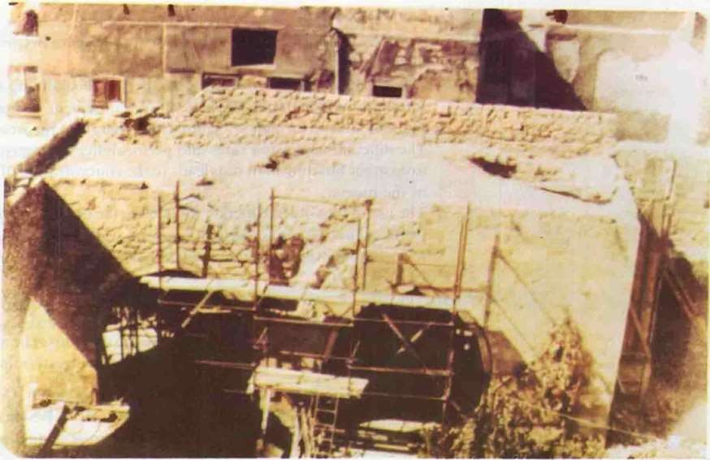
I

The nort hern aisle of lhc mosque-looking over the court.

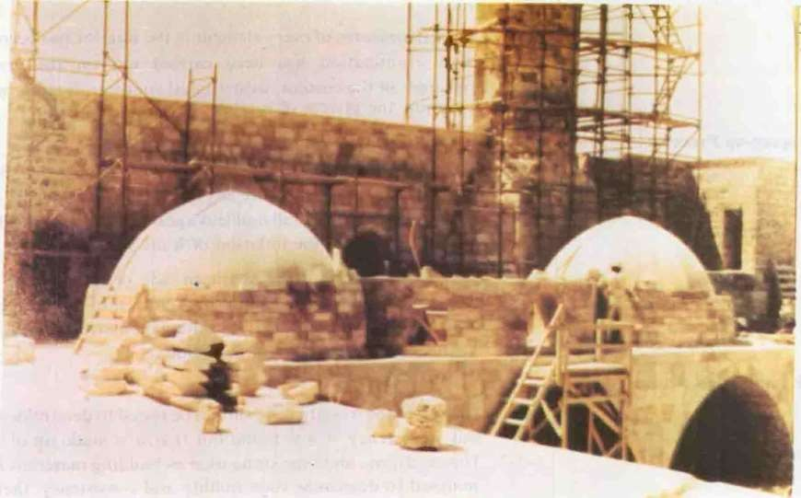

A photo showing the re-building of the so uthern aisle-looking over the court.

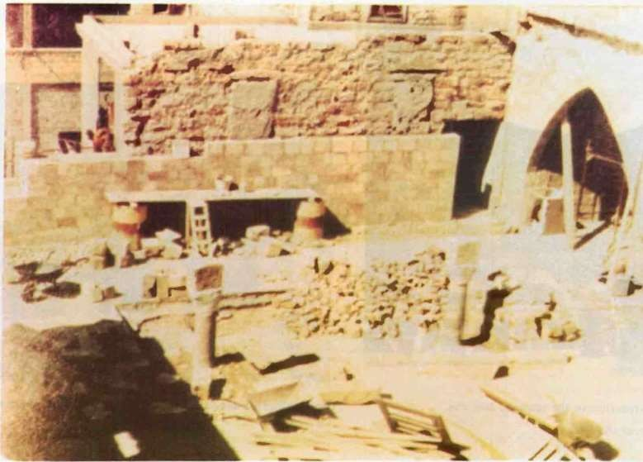

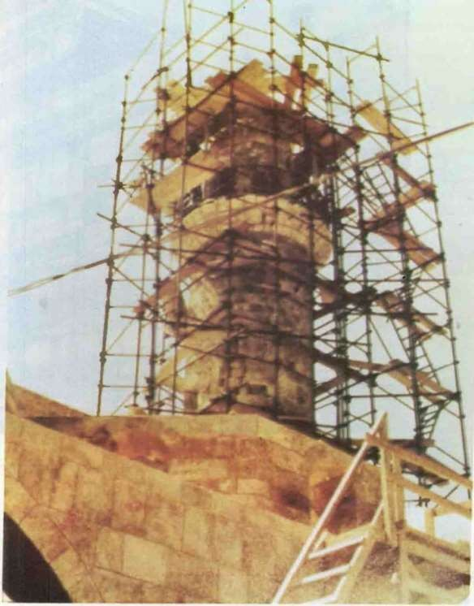
A photo showing the excavHtions at the weslcrn pa rt of the mnquc

A photo showing the rc-buildin of the minaret.

60

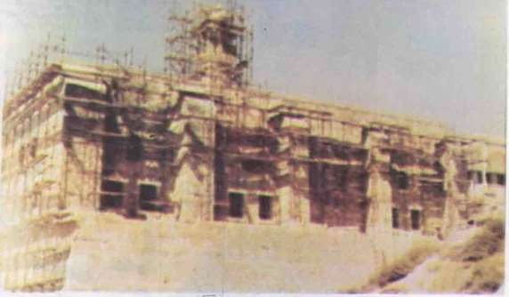
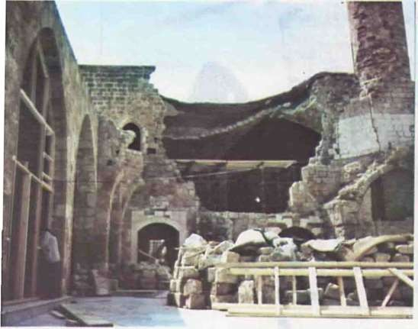
A ph..>to showing the destruction in the mosque and the Sl>Uthcrn aisle-looking over the court.
The Southern Facade of tt.e mosque-d·uing lh: restora tion proe:-.:-..

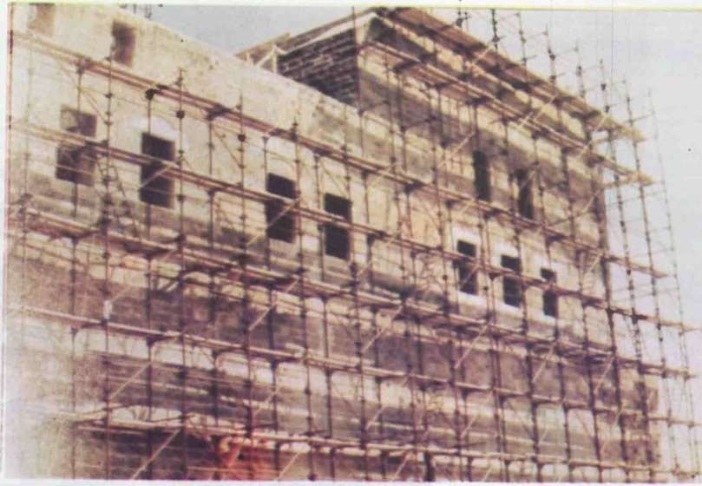
The Western Facade of the mosq u e-during the restoration process.

62

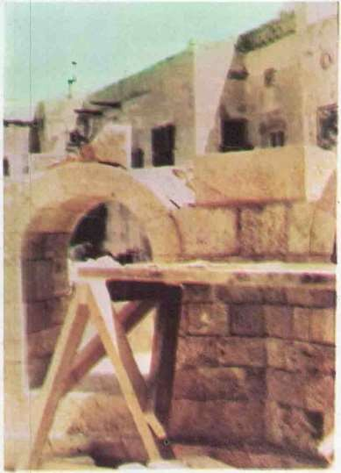
\> The d<)mdrun1-<1t the mosque's entrance- during the restoration process.

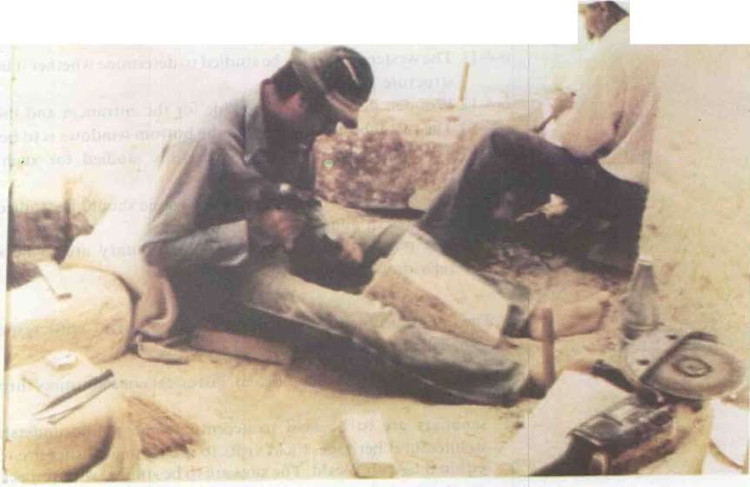
r

One of the gutters being made for the dra·nagef rai,watcr.
"

63

  - Repairing and RenoYa tion ystem:

6-4-1 The dcmolihcd wall arc to be rebui lt und thn"L' part-.. that wcr tH)l seriously uan1aged arc to be renovated and r paircd using the plans previously prepared.
6-4-2 The vaults and don1cs (or the 'nCStcrn aisle) a rc to be rebuilt guide<...l by photograph · previou sly taken during the last few years.
6-4-3 The botton1squared body ofthe n1.nart is to be stren gthened while the upper ci rcul ar body is to be recor:strucll..:d.
- -4 . The sur face of the sand stone a nd lin1cstonc is to be treated by the ren1ov'd of preci pitated salts a nd strengthen ing the affected weak areas.
6-4-5 Walls and cracks arc to be treated and strengthened by the usc or polimers convenient with tcJ type of the bui lding n1atcria l.
    - Walls arc to be cleaned by rcn1oval of dust. fungi a nd smog formed on their sui faces cau sing r.;hangc of form and colour.
    - Walls are to be isolated horizontal l y at a height of J m. Wa lls arc to be also vertica ll y i elated (depending on the type orstones and their charact eri ·tics). This kind of isola tion is a met hod or protection of
wa•ls again st ground water.
    - A layer of a damp proofing n1ortar sim ilar to that used in early islamic ages- ito belayed on Oocrs and covered with Ka za n tiles.
    - The mosaic tiles arc to be ren1ovcd f1 om the lloors of the n1osqu e and replaced by n1arblc tiles decorated with sim ple isla mic or nan1ent s.
6-4-1 0 The ablutit'n foun t a in is t o re built in it s o ri gina l rosition. and put t o work.
    - The western aisle is to he st udi ed t o deh.:rminc whether it had its own st ructure systen1 or not.
    - Wooden doors arc to be nutde for the cn tra n<. cand the minaret. 6-4-13 The metal partition covering the botton1 windows is to be designed.
    - The ligh t sy ten1 is to be caref tll y studied for such religious
buildings.
    - The landscape su r roundi n·g the n1osque should be stud ied pecially the eastern and southern approaches.
    - The position and elem ents of the ablu t ary arc to be studied in relati on with the mosque.

The n1ain problen1 facing developing count ncs with respect to ar• cheological sites cou ld be o utlin ed as follows:
l. Raising the public a rcheologica l, historical co nsciousness through mas media.
- Seminars are to be held to accen tua te the public und erst an din g or archi tectural heritage. Field visits to archeol ogica l sites are to be made within the Arab Wo1 ld . The sites arc to be tudied with respect to si n1il ar sites in de eloped countries to deter mine meth od or treat ment and
preservation.
- Refunding centres for·research and regi 5tration of Arab Islamic heritage.
- Establishing an archeological committee whose duty lies in the study of

64

new projects erecting adjacent to archeological sites. The study will determine the architct:tural sty:e with respect to the pure islamic architect ural heritage.
- Heights of build i ngs and masses should be studied as well as building materials concerning form. texture and colour with respect to the historical areas. This study aims to the establishment of a harmonica! physical compound bet ween the old and the new.
- The traffic within archeological and historical s.itl:"i ..;hould be carefully studied and regulations arc to cc formulated.
- Training working labour and craftsman to carry such a delicate and fine work duty.
- Original building materiab shou 1d be used in repairing and renovation of historical buildings in order to achieve harmony and unity or mass.
Finally. the renovation of historical buildings aims not only to the prcscrnttion and t:on cnation .or the building but to 1b rc llll llll'll to life as \\'C]I. This docnot mean a slHIH.i still on the route ol'dc\cloprncnt ·
but instead. it accentuates the continuit y or the bilan1ic city. The rcno\·a t ion process n1ust origin..tlc from the ideology or the Islan1ic
oc:icty within its own sociul. ccoromit: and political entity which rcllecb the unique lslamit: Jdentil).

---

65

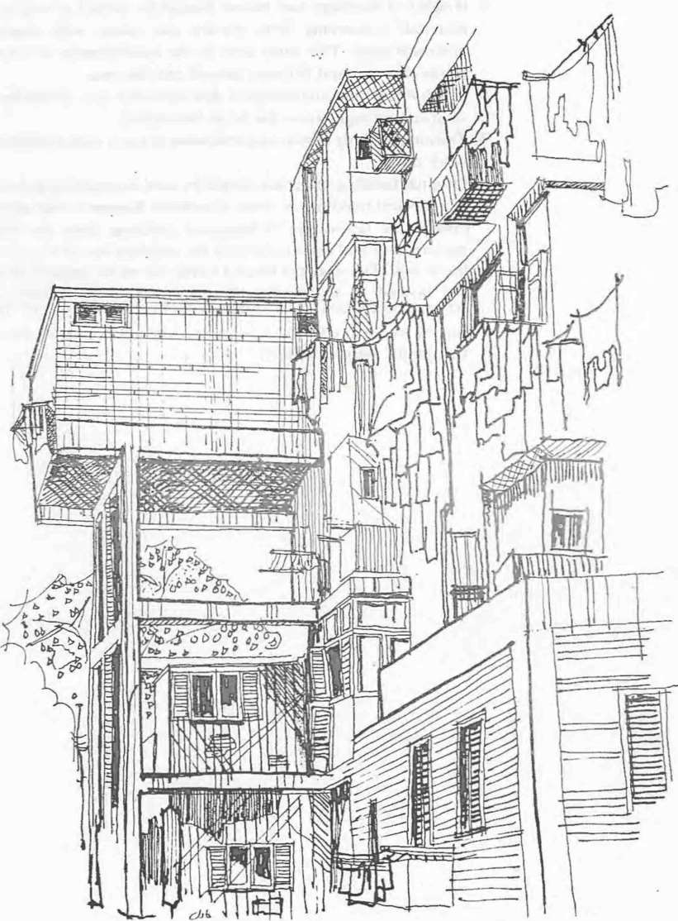

CAIRO- Heh'an- A typical exa pk nf inforntal gnn' t h "ithin tht• c iting
n: idential bulk. It c presses the indh idual trial 1o oh c the problem of inadequate housing badding nc" illegal anne e .

66

-DR. \BOl ZnD RAt;EU
.. Chairmnn of tht• 8ounJ ••f Cht General
Or otunirJJrjoo for BuHdinA. llou inA
:1nd Ph·.,kal J'lttnnin ludib.
.. Hum.in coru.ullunt for t•airo anti (;jzu COlernomt -..
- :\lember of the !lupnmw llou.,in C' ()nunittct.· in
:\ lini'itr) uf Hou in .
- \1cmr of the Buildinand ( cmo,tructiuo ( ouucil in the \eadem) of ScientifiRl'Sl'»rch.
  - :\ll'mr of Rehabilitation ( ouncil
in thl· nutiunal
INFORi\IIAL HOUSIN(;

D,.. Ahou Zeid Ragell

.. Spceiuli1t:d ccnmt:ii;S.
I Je ( trricduut !.1 number ol n.'.,f:'.trt:ht·., in lhc lit•. Jd,
uf Cftl\'ilrUtlion and hou..ing.
Uc.·dc.•.,igucd munarl·hiH•cturul prc)jl'l'ls in l-:J,!Jll and other arll euuntf'ic.,.

R nt I) 111(111) n:lal tH::I) llC\\ Lerm
·J a\ c h en adtkd lo lhlanguage or
architecture and planning: thus hc oming. an integral part of this language. These terms arc··Visual Sl.!qucncc ··arH.J ··Spatial Scqucnc··in addition to older tern1s like ··Human Scale·· ant ·· Landmarks··. de.
This nc\\ language LXprc:-.::,cs :hl: dialectical relation hctwccn impressionism and exprcssiont n1. ·1 he huilding. lhc street or the neigh b('l1rhood is an cxpressit.'n of snn1ct hing. t·dstorical \a lues for cxan1pk. und this ex pre.sion is prcsen ed in nur min<Js in the fonn of t:crtain 11npression like feeling nf belonging 01 a 1tHhcr en1otion. rY1an) architects tJ) to \!stablish sdentitic ruk r,,r thi....; dialugw.: bclwcn cxpn 'iit>n und
i mpression through thanalyis of factors and stud) of their 1nt1.:a relation: dcar or hiddn.
Thcrarc sirnilar effons in U.S.A aiming at stc.tblishing \\'hat they call
··Space Psc_} ehology .. or··En\ i rnnnal:ll tal Ps<.;jchology •.· We might hear Stl011 of ··rban Psc.:ychology ,._ Th st·.:JTorts anti their possi bk branche rprcsent only half lhtruth. Whcr ""'C talk of ··Visual Scqucnc.:c·or
-
.. Hi torical and Civilization at Value....e !'lhtHdd nolforg et Lhc scientific.:
and cngtncering aspect t)fan;hitc tun:tnd planning. In order to provide the.: an.:hitcc.:L nr planner with int\!grity and balance. he hould ha\'c thL' basis of scicntifK and engineering facls beside olher human and cn1otion a! fields. This r\!q uircs a Cl1n1binaLion of scicnc.: and logic nn one side and etnot ion

and reelinu...s.
on the other.

That is why it is necessary to p'ro\ ide the architect. who always work

67

towards in tcgration of knowledge. i.lr'i.;tic creation and com prchensi \ t: thought with pure engineering ra ts. To achieve this ai•n. the following

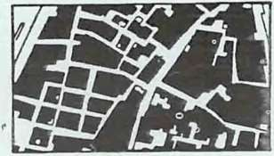

I rregular Pattern : It usually exists on vacant
land & djacenl to the
engineering topt cs should be included t n archil\!ctural :;t nd planning thoughl :
I. Local building n1atcriuls. their natural a u.l mcchanit:al cha-acteristics and their 1iahilit y to n1u nuract u rc.
,Testing of nuttcriu Is.
- Study of local and international. mechanical and semi-mechanical building ·yslems.
- Soil n1echan.ics and testing.._.
- Building ph ysics.

exist ing residential huU<.St rectidth Vary From 2-3m to lorn.
- Study or different ho using and 11htnnin.g,_ model·includin.g.. traditional. formal and informal models.

Natura II). these topics arc not mcun tto be indtH..led in un l\ ersity cou rscs. but rather they should be subject to researches in specialized s<.:ientific
enters where applied researches arc done <.;O ntinuully. These researches shoul<.J deal \\ ith the real problems of the s "1cicty in the fields of housing, planning, building •natcrials und their 111anu..'act uring and bui ld ng system:
' i.e. builtJ ing... scicnt:cs and ind ust rics.

68
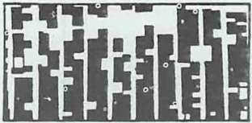

Uncar Pattern: It usuall)' exists in a regu lar pattern relatjvcly
Fur from
the existing re idential tiulk.

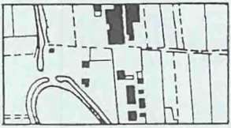

Fra rnt!ntnryPattern: Jt usually exists in
agricultural area. As thc&c urea
de·,elop into
residcutiul 69
ncighhourhc>odsihi!\ fHl tu:rn Hnd
to form a linear parwrn.

The phcnonlcnon or infornlal ncighbourilOOUS is a new and · enous
prubknldue ll) C\'l:J'tll fut:ltll
:
1. The bulk of tluphenomenon i 'too gr.!at to forget or igrorc: it has
become a dominant lrend in all our citi·::s.
i The infornHll cnvironn1cnt is far helo" the acceptable urban sta nda rd
due to its lack or architectura l and plan ling value .
J. 1t is u untquc phenomenon where one tr at un1 or the socie t y takes O\cr
allU sol \'CS its hnusi ng
problcnls 0 Lit ide govcr nnlell ta l sphere or inllu ncc. aturally this stratum depend!" wholly on its litnited financial and cultural potcntialitte.
- The speed or grO\\"th orthese areas is \..Cry great. SC•mt: like tn call it
··canL:er growth ··. Thold Fu tim ide Ca i-o took cent u ries o:' growth to reach its highlj artistic form and it had th.e benefit ofb... ingsupponcd by rich anti culturedultan s and Princ.:es. ccn1parativcly.informal housing occupied an area tn tin1cs as big as old :'uiro with u populalion of the san1e densit} and was built during. a pc-iod of only ten years.
Informal housing could be
Ol\ idcd as l'olllws:
xoIIU itifo rn1al housing

described. _tsing 1 he famous cxpre sion. Architecture\\ Lt hout Art:hitect .. as well as··Planning\\ ithouL For the lirstlimc the art:hitl!Cl and
phlnncr '-" ·)rk ''ith the ;1eoplc und not
for the people. Jn this particular c.:usc they arc partners and not ga rdian s.

Informal a rcastarted to grow as a result oflargc in tcrnalm ig·a lion from ren1otc arcas. rural or bcdou in.
1o urh< n ccn tcrs. This rr igra lion is accornpanicd with t't\o other S}n1pton1s; a) the absence of city t uthority the tnability or this authority to
confront flligration prt hlcnls: anJ b)
the
li1Hl \'U iIa bility of CCOllO lllic h ousing for migra nl. To n.:a I i zc the
!)i i'C or
info rmal growth it should be rncntioned hu·c that the number nf hou ing units built per year can he

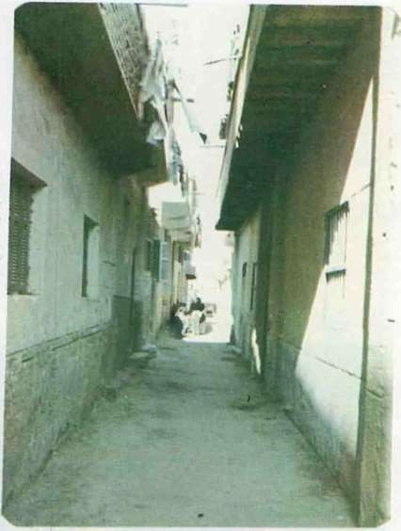
In areas of informal housing. the minimum width of streets and paths is left to achieve the maximum u t ilization of land a matter which alTccts the required privacy for the residential unit s.

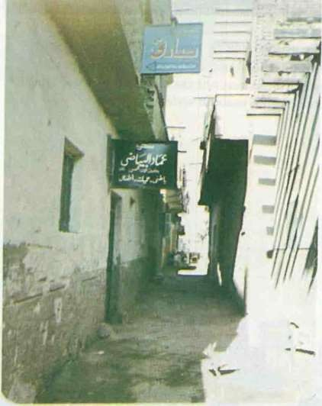

The inha bi tants of informal housing arc not neccessarily poor:
The housing problem left those
in h abi t ants with no other choice than living in those ar\.!as. This photo shows the erolution of activities
that arc normall) related with moderate income groups.

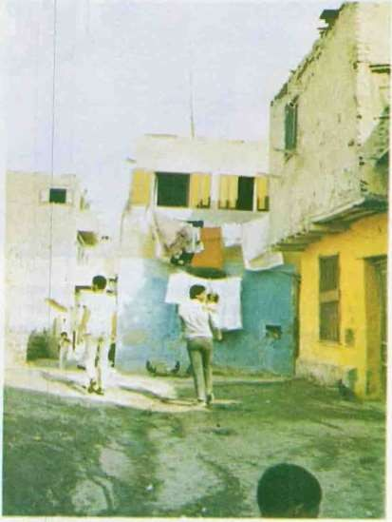
t\ trial carried aut lty the occupants to improve the facades of 11: I- h•>uscs in informal areas.

69

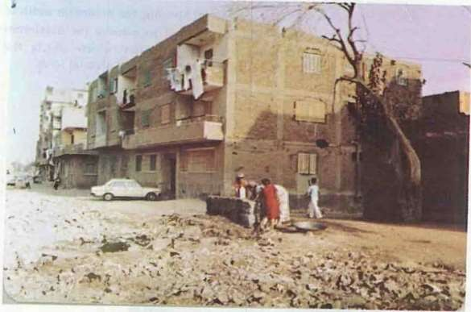

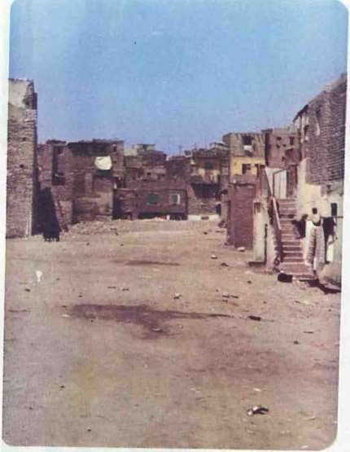
In areas of informal housing the rura l character could be recognized through the form and clement!-. of the residential buildings, which renect the nature
of the community living in those areas.

70
I oformal houses arc usually built.in areas deprived from the proper iofrastrul:turc networks. This forms a Kind of presscure upon local Jepartments to provide those areas witthe necccssary networks which
arc probably not included witt in its budgets.

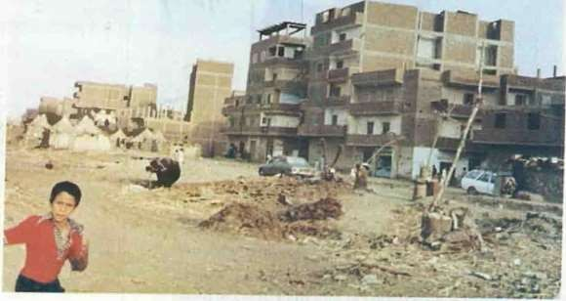
The building modes and materi.tls used n ic.formal areas do not ili.ffer much from those used in legal. plar.ned ttrcas.The buildings size and the ownership of cars show the investors' high i ncome which is utilized in illegal projects

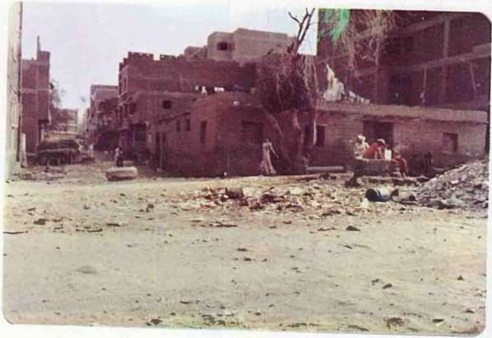

In areas of informal housing, the rural t.:haractcr coulu be recogni7ctl through the form and clements of the residential buildings. which rcflc<.:t
the natul e of the community•living in
those areas.

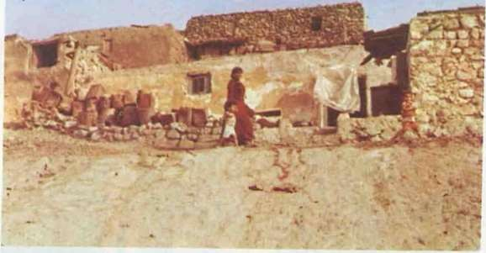
'

The rural t.:haracter of life and building modes cou ld be clearly recogn ized in nreas of informal housing. This shows that most of the
occupants have originally migra ted from the country-side to the
city

In areas c[ :uforma I ousing. lhc rural chara<.:tcr t.:oultl be - c<. gnized h-oug"1the form and clements of the rcs,._jcatial buLd r.gs. whit.:h reflect the n<Slurc of Uae
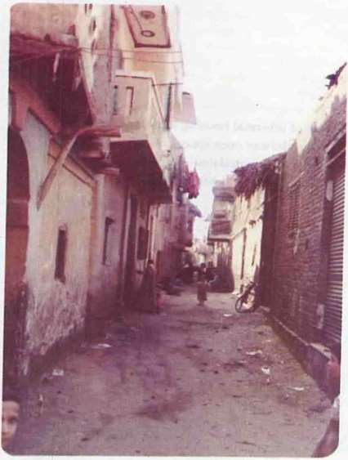
;ommuuily livi nt= i 1 those areas.

71

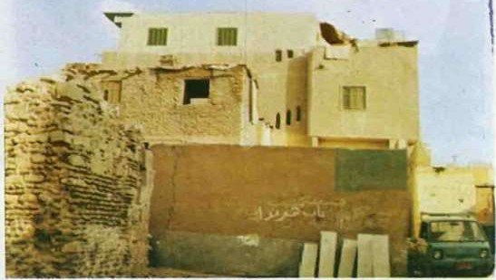
The mi '\c.:d huilding modes. urban, rural. and semi .. urhan actually refects the mixed socia l
structure of the community

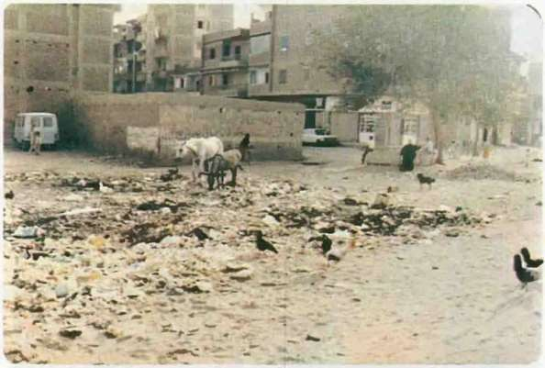
Arras of informal housing are sirnilar to plannl!d areas in the way open spaces are misu ed. whcrea. garbage is accumulated and house animals and chicks are left in those spaces.

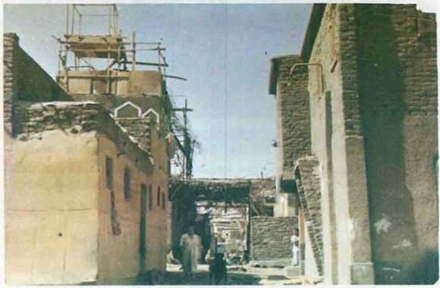
The rural character of life and building modes could be clearly recognized in areas of informal housi ng. This shows that most of the occupant · have or igina ll y migrated from the countryside L o the city.

72

73

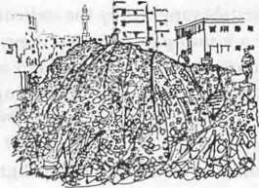

I hl· :ll'l·umul tiun ul garlwgl i' ntH of 1tw ft::tlurt:'- t.·twnll"ll·riJinJ.! unch 1 dl''l'lopl·d and informal an·:•'

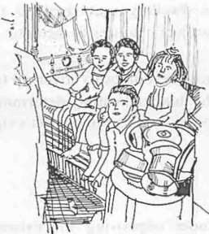

I hl· pruhlc:m-. of utukr d·'t:llt iH'tl
<n·<t-. ;tnd infnrnwl 'l'llll·tlll'llh in•
dudt· 1 hl· rdathC.' Ihigh
OlTllp
an .·
r:tll· room mu.l lhl· illl' rt.'HM' ol I hl·
houM· hnld 'haring r;JI<•.
20".. llli"JllaiiHlliSing: 1 5"u of whid1 is pri\<tlC housing and 5 '\, public and go\ ernrnental housing.
lnfonnal areas 11()\\ urround Cairo ·rom the north in Shouhra EI• Khein1a. rrom the west in Giza ttrd El-H .1rarn and fron1 the south in Dar Essalam to I-1clwan. ll is worth mentioning here that these areas were esla bl ished \\'here watcr is avai Iable. It secas that the a vaiIa bil ity of wu tcr is
'-
a basic pre<:ondition for inforn1c.J housinsince water is used in building processes awell as it is a necessity of lire. Water docs not n1can only dty water net work hut it indudes irrigation can aIs and underground wa tcr.
Elcctridtand sewage do not h..tvc the ,arne importance as· water since kerosene c tn be used for lightinanl scpti<: tanks can be used to solve Se\\'agc probl.en1s. When these ar('JS take Lhe fonn orsellled I11attcr-of-fact societies. the inhabitants start putting pressure on city authorities to gain recognition and den1and to be pr•Jvided with ser vices. City authorities. in
this case. have no otht=r choice but to d:-1 ·o. Nevertheless.informal areas nrc
alwavs lc. s serviced than fornutl areas; anc inhabitant ofinfonnalarea. .g... et used to li\·ing for years without ser vi:es.
It goes without saying that lhcsc settlcn1ent 't re stablishcd on unplanned lnnd and without building l icen<:es. H cnL·tl11a.:rc outside both ity authority inllucn<:e and rnrn-tal s:ate statistics.
The 111ain features or these an::ts C<lll be Sll11ll1Htri/ed as follows:
I. From the engineering poin t . r \it:\\. tilL· tn h;tbJtants used the ttll1L'
buildingS)stema ntl building nw teria batho <: used in ro rnutl housing.
Al o. the tksign inot much kthan thut or g<.1\ernmcntal public or
cct)numic IH'Llt ng. The three- ·oom tlilil ialso prominant in in formal housing a il :-.lltb the nature of Ca·recn l'amilic. It can be inhabited b) one !'amil).4\11 cxt ndcd l"ttmil •W the r tmily can r nt one ofthe roomto increase their income. T\\ o-ruum <.L1d L)ne-ronm units also exist in le cr number. Mo t t)!" the huildin:rs ar.: l\\ o l)r one llnor hi!!h and the) Ol' not ustwll\.. exceed four l1oo1.. TIK.\,. i.li"L' u ualh. built u ine LOncrct
skeleton and hr ick \\c.tlb bu t mc tl)\\ithout intcrnul and extern'"
plc.t!-,tcri ng.
' Frotn thplunning point of vic": t h is is the major weak point in infornut l housing since n1o t ,)f the basic planning rules were n<.H obsern!d: particularly street ·.vidth 1 on1c of thcn1 do not CX<;ecd 4 metres) and open and green spaces. Nc•t n1cntioning visual sequence and spatial sequence as thce rcpre... cnt irrele\·antluxury to inforn1ttl housing inhabitants.
These areas arc mostly u..;cd for housing. Other activities lik comn1crcial or industrial acti\ iues exist only to meet the basi..: needs in these areas. So<:ial services which include health. education and entertainment racilitis and oficial sen i<:cs such as fire brigades, post office. etc. do not exist at a II.
  - It is quite obvious. as menti.
benefit by forn1al wa tcr. Sl:\\ c·ragand elect ricit y net work s. Stat istics indicate that the percentage of infornLrl houses \\·hich are connected to scr\'icc net work s is nuH.:h less than that of formal houses es pecially in t hl; carl) sutgcs of cstahlishing in fl•rtna l sctt lcmcnls. H 0\.\Tver. this gap get

73

... ,- '

This means that if the building sectors were directed only to supply housing requirements, neglecting other economic sectors as industry. agriculture. thi s would greatly affect the execution of the urba n project due lo Lhc insufficiency of jndustrialized building materials supplied by the indu strial sectors. Similarly.it is nonsense to execute a housing project that deprives another housing sector of its utilities such as electricity or water sup pJy or if it
causes a sharp increase of population densities in the area. Accordingly. the first
step to be carried out in an urban project is an economic feasibjfity
study which tackles aH the planni ng, urban and non urban aspects of the project. This study has a common n1ain o utline which might diiTer slightly (rom one project to another according to its nat ure. This outline includes the followi ng:
-Analysis of the site's economic aspects with respect to the predetern1ined goals.
- Determination of the planning a nd execution phases.
- Determination of land use pattern with respect to the different required functions in a way that achieves the efficient utilization of
resources.
- Determination of _the best alternative with respect 1n the actual costs and the expected benefitsThe urban designer should bea r in mind the fact that the increase of cost of the dwelling units beyond the customer's ca pabilities leads to the project's failure to achieve its goals. .
Financing and supply of regul ar financial resources to cover up the necessary investment requirements. The financial supply determines the dirTerent urban phases for execution as well as the project's size.

THE OUTER FRAMEWORK OF THE UP-GRADING PROCESS:.

The concept of urban up-grading includes improving the extst tng
conditions of housing and conservation of the housing capacity. This j includes several repairing and renovation processes in the residential area
such as repl acement of wooden rcofs by concrete roofs, addition of W.Cs. induction of water, electricity, sewage networks, strengthening of foundations. using new bricks replacing the old ones ..etc. Yet, up-gra din g showed some failure in the prev iously mentioned med ia. lt should have
incl udedall the circumstances and the surrounding en viro nment incl·uding
the infra str uctu re, public services. It should be n oted that improvi ng the housing sta nda rds ca n not be achieved except by eleva tin g lhe soci al and eco nomic standards of the inh abitants in the acLion area .
Naturally, the old districts sho uld be subjected to up-grad in g processes and urban social and economic improvement. The same applies when historic mon utnents are located · within the district, a case which migh t necessitate the removal of some houses in the surrounding area or a change of the existing f unctions.
The up-grading action inclu des those·districts th at have been ,i nformally erected on the city's outskjrts very cios·e to th e economic and industrial

74.

I

RBAN UP-GRADING OF NDER-DEVELOPED AREAS:

THE STANDARD DEFINING THE SELECTIOOf NOER-
DEVELOPED AREAS SUBJE("'l
TO UP-GRADING PROCES 'ES:
centres. This phenomenon is very common .jn de\ elo ping countries. It resulted from the evolution oftarge economi:and industrial centres in their cities causing the continual migration of individuals from the country to the city.accompanied by an increase in the Jiving costs. Thi s cae resu lted in the erection of jnformal housing for low in...:ome people. Thus up-grading of such areas includes improving the living an d housing conditionof those underdeveloped areas.

The urban up-grading pol icy aims to improve the living conditions in und er-developed areas either through the removal of the old areas and the erection of new communities providing bettt:r living conditions, or through the partial removal of he area followed by a process of improving the state of the
existing buildings. This process auld cover the area asa whole without the removal of any building.
The determination oft he best a lternative ci fTers according to the housing and economic status of the coun try. The co mplete remo al of the area should be applied if the repairing and renewal of the old dwelling units should appear to be a waste of resources considering their present condition. It should also be applied if the '!_rea is so close to the city centre that any further extension is out of the question. It should be borne in mind that this alternative is to be accompanied by the gover nment's provision of alternative housing for the individual families. The high economic value of
land in the old areas and its utiliza tion in a more feasible economic activity• in order to improve the living conditicnin those areas -is a sufficient motive for the application of this alternati\le. On the other hand, the partial removal of under-developed areas is so metimes prefered as a method of development and up-grading.specially wher. the hou si ng conditions ca n be
handled and improved. It is to be noticed that the removal of any building
- before its normal life span is a waste of the national capital and causes a decrease of the existing housing capacity, specially when it is replaced by building new dwelling units at higher cost.. In this case. It will be more feasible to use the existing resources in b·Jildi ng new dwelling units instead of removal (Thus keeping the housingcapacity in a more stablecondition).
There is no doubt, that the complete rerr:oval of an under-developed area has a direct economic and social impact upon the inhabitants. They have long had their liverelattd with the area tl-rough their shelter work, and however cannot be compensated for thei r losses.
Yet. It shou ld be borne in n1ind that th improvement and development process in the existjng und er-developed areas is not as easy it seems. specially when it is concerned with the ir.!duction and renewal of the infra structure net work as weii as improving the approaches to the area and the road net work.

An:y up-grading process aims to improve the indi_vidual's economic and social li ving status through an1elioration of the housing conditions and the

75

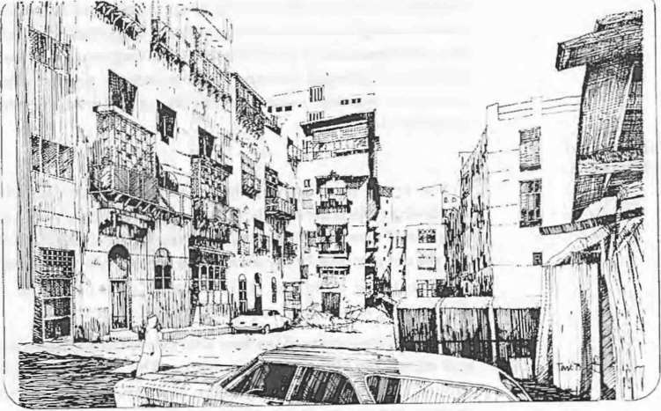

.\

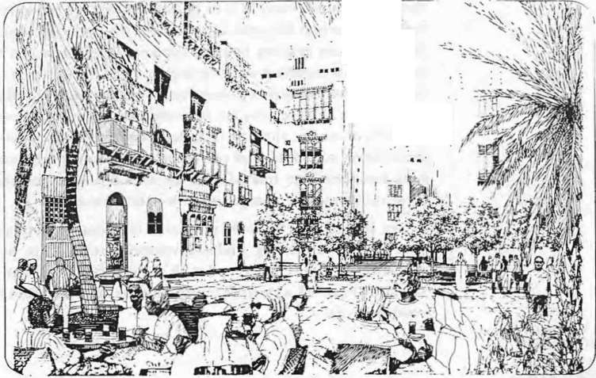
if. :. '·
1\•·'
\:,.
"
"
Ifrl
, ·.
. I
l
. .
••

76

UP GRADII'G OF L1 DER-DEVELOPED AREAS

Dr. Ali Sab,.; Yassin

- OR. AU SABRI 'ASSI.'
  - E'per1 in Economi. Hnam:inl!and
\lana mc01 of Ph sical De
elopmen1 project!\.
E,_ \-tanaJ!er of the Egpti11n E.-,tanBan'- , 8.(. 1946 - Diploma in la,c.."!\ 195U. Diploma in
1.- conomi1954.
  - \.l.Sc. in f.conomic 1961.
  - Ph. 0 m Economic- Cain• l nh.
  - He carried out manstudiand rest>archan
lconomic de\elopmem. hou..,ing.finandni! and co• ordination of up-gradin51, project!. in underde\eloped areas and :'\eTonl\
Economic
and Management.

THE GE ERAL OL Tl t.. OF
THE l'RBAEC0 0\·1\:

\ '

Any urban project aims to satasf) the various social and economtc requirements of the inhabitants. Unless the project is capable of satisfying these requirements within reasonable cost limits. it will be a failure and a waste of resources. The urban economy of any project should be dealt with within the existing natioual economy framework.
Any urban project should be defined as a public or a private one. The public sector's urban project s include establishment of ne" urban communities. ne\\ cities and to\\ln5, supply of utilities and necessar) infra
-aructurc. renovation and up-grading as well as other miscellaneou urban processc.Theprojects are always earned out by the go\·ernment. As for
the pri\ate sector projects. the} include establishment of communities. commercial centres. utilities (health. entertainment. ... etc). Thec projects utilize all the elements of land, labour and capital. Such resources represent the construction capacity expressed in the form of available building materials. contracting companies... etc. If ever this capacity was to be subjected to any stresses. it would greatly affect the establishment of thc:-.c
projects. The lack of those construction capacities increases the cost .of erection of urban projects due to the long time needed for operation. This
case necessitates the determination of priorities of public urban projects with respect to the requirements upon the local and regional level.
In order to attain an efficient utilization of resources, the urban project must achieve a total surplus in the production capacity on a national level.

77

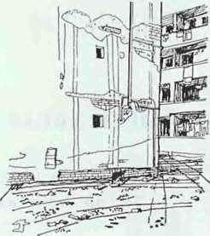

An·unf gm l'rllllll'ntctl hou ing suf• flor from the dcl;lpitlntcd lmiltling condition duto lack of mnintl·nnnct•
:md lhl· (il-tl·rioraling l'll' irunllll.'ntal condition. This ia charartcri!'ltil' fl.·aturc ul in formlll hou!'ling although
1 hl' forml'r it>rm idcd hI hl' l' l'll-
sn1aller over years when city authority co1nects these areas to service net works under the presure of their inhabitan ts. But it seen1s that the pro blem of garbage collection is rnore c.Jmpli cated. The absence of
acceptable garbage collection systen1 leads to the accutnulation garbage in the streets. J anes or in rela t ively penplaces. This situation contributes to the unhealthy condition of inforn1a l cnvironrnent.
  - The environn1ental character of these set· Iernents is no·t urban but ts
rather that of the original areas of 1nigrao ts. In the case of Cairo. the domi nan t cha ractc..:r is rural. The habitc= nd modes or behaviour urc dearly rura l such as raisi ng cattle and hird:in their houses.
  - The fi nancial relations bet ween owners a nd inhabitants arc satisfactory to both sides although these relations do r.ot con1ply with ren t laws set hy the governn1ent. A family pays an a ven gc rent of 30 o o of its income: whi le the gover nment could not achieve this percentage in govcrnn1cntal housing. But we can say that in general the cconornic rules and princ..:iplc whic h control fo rn1al hou ing equally cnntrol infonnal housing on all levels suc h as land price, building cost ..trd labour wages.
  - All attempts to litnit inforn1al hou sing were unsucces ful. Inforn1al areas arc still growing a round the borders of Cairon1a inly on arable land. Despite
the defects and nega t ive points of infornutl housing, its con tribution in ol ving the houing prcblen1 on the nat ional level can
not be denied.

1iaIutiI itil'"'.

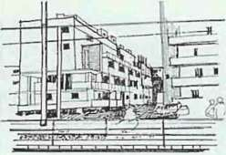

·a ht J!.OH'rnmcntal hou!'ling ••rca!'! an·
... ubjl'l'H•d to' trious informal act inn.., "hkh e:\pr·t. o. lhl· inhu bit.ants· a t • temptt o oh c thcir m\ n prnhlcm.., throughself hdp.One oft hc <'onnnou inform&ll actions is the erection of a Ill'\\ building ndjacl•nt to thc c iM ing mH.' in an attempt to cnlarJ!.l' the
C:\ isting d\\ ell ing

The General Orga nization ror Building. H ousing and rba n Plan n i n St udies ca rried out an inte nsified study upon info rn1al housing in omL· areas in cairo a n d Ben i-sucr. This study included the roiiO\\'ing:
    - Offici al sta listics.
., A rchitectural and planning aspects of tne area.
- Social aspects and behaviou·r between d i Tercnt social g roups.
- Population and fan1ily aspects.
- Infra st ruct ure and util ities avaiIable.
- Econon1ic aspects including incotnes a:1c expenditure patterns.
- U t itization of spaces within the dwelling u:1its and the occupation ratios.

Eventually, the devdopnletlt of areas of info rrnal housing should take
place with the least external interference:in such a way that does not disturb the co ntempor,c.H} patterns orlire. Contrari·ise. the devel opment orthc L'
areas hould occu r through the in habitant and ·scIr hcIp..

Lately. two up-grading and dcvelopn1ent rogramcs were carried o ut in informal hou ing arcHs. in lsma ilia and in H elwan.
The developmen t of urban environment L•JOk place o n seve ral phases
- The first and n1ajor phase is the plann i ng pha e which includes the · following:
(a} Providing new approaches and paths fer the traffic and pedestrians.
This process n1ight necessitate the rcm :tval of some buildings ( b) Supplying the a rca wit h 1he infra st ructure ncl work.
- Supply of social ser vices e.g. clinic., sc hools. police sta tion s.

78

-The second phase is the archite:tural phaseand i Includes the following
  - Ren1o val of delapidated buildings
  - Repairing of deterioraling buildings thro.tgh s:rengthening of foundations and addition of colun1ns
  - Carrying out ex ternal finishing work e.g. plaS1-ing . (d) Establishing new focal poinB in open spaces.
(e) Carrying out several architectura·l renovation: of facad es, ... etc.
The .third phase is the devclopn1ent of trade... nd he:tndicraft work through the development of workshops and SUIJ :ly of new equipment.
Programs s hould be set to train the working labc-.J-.
Irregular Pattern. Represented in traditional sec- 1·Jns of the study areas which were built up areas before 1950. Informal dY1.:11ings are constructed in a fi11-in n1anner on vacant lots adjacent -.::J exi:,ting residential,
commercial or industrial structur•-S. Street widths V-lry frcm 2-3 n1. to 10 n1.
.
Linear Pattern. Represented in recently-dev:oped sections which
becan1e built-up areas during the late 1960 sand 1S :-os. IrJorn1al dwellings are constructed in a regular pattern as a result of re -J nts·e/Torts to provide unobstructed rights-of-way and layouts that do -.ot diverge con1pletcly from zoning guidelines. Street widths vary fron1 -0 m.
Fragmentary Pattern. Represented in agricultL -al sections within and outside the cordon on the u r ban periphery .._. ·here subd ivisi on and conversion to residential use is being undcrte:tkn. Spacing between buildings distinguishes this pattern from the irr ular pattern in which dwellings are attached to foro blocks. As th" areas develop into residential neighbourhoods they usually assume c. lmcar pattern.

79

urrounding eni\ronrncnt. This process l.Lk es phlL'c thrc.Ht2.h two mu n pha es.
The First Pha se : lt depends upon a comprehensive devdopment plan that cove rs not only c rH.in undcr-dc\elc.•pcd areas but the city as a whole. This plan in cludes all residentia l bui I<.I ings whet her they need restore1t ion or repatr or renewal of infra structure nct\o\:ork .
The Second Phase: It depends upon the s ..:k ction nf old under Jc\cloped areas that were built informally and arc cepr .,·cd or the suitahlc
living. condil:c•ns to he uh cctu.ito \he de\'elopmcnt process.
The twt) phases arc not optional but can be appl ied together nn the city level. The first phase is m<)rc valid in the improvement procLs and is mo re capabk of directing. the available rcsoun.:. s to achicnl:,e required goal. The strict a ppl ica t ion of this pol icy wiII prc vcn 1 the dctcriorat ion t)f complete areas con side ring the existing Ia·, in Egypt. tr,<1t entrusts on the owners to carry out the necessary restoration and rcp.lir work and so mel imes ren1ov' I of the deteriorated pans. Yl'l. th is rolic} loes not co\ er up the development and up-grading oft he cc·.1nomic und social status L1fthe inhabitants as a majo r goal.
The existence or several under-developed areas within the city necessitates the determination or the up-grading and dcvclopn1e nt or the up- grading und development plan l1f thesl tIras ISwell .Sthe priorities of execution impos<.;<.l by limited resources a:-:c other diffcr nt economic and
social factors: The national and regionc.·.l housing. plan iconsidered a major determincnt in this lield. This could be furth er cxpbinec.l considering the entin: or parti removal of derelict housing. This necc sitatcth . provision or alternative housing. for the inhf.:.bitants. Thn.;e houses must hL' pHn·ided prior to the rcmo\'al process. Similarly i n1proYinthe infr<t slnH.:ture net work 111 under-tk\cloped ar eas cannnl pri)Ct:Cd
l'orward without t hL: previous supply of near -by cl ct rici t y. wa ler. se\J.'agc resources. etc.
On the other hand the lnL·atinn of 1hc underdcvcloJcd area i s a dcterm incnt or the pnPri t l)l lhe de\·clc pmcn t and u p-gt ading. process.
Being. very dosL: to the city centre makeit vitally imp(·, rtt=.nt to start the up•
grading process in this area rather than an' other area . The deteriorating social and economic condition orthe ar:::a with respect t•1 other under• developed areas or other parts ol'the city dt:t:.:r111inc-.. a. well huv. se riou s thl'
case could be.

Till-: PL.-\f' I NG Pll ASES 01· Till-: l P-C..\DI (; P
O('FS: After the selection of the under develop.,;<.: area that i..... tu :1c suh_ jectcd tn the
development and up-grading proc(s -thcre 1.1rc two pointto he L"onsidcred :
The components nr the up-grading. (lHll'eSs.
.,. The foea I points of the up-grading prnc::ss.

30

THE ECONOMICINDICATORS UPON WHICH THE
FEASIBILITY OF THE
UP-R ADING
PROCES IS
* The up-grading process in.::lJdes 5evc:ral items :
- l!J1proving the dwel ling .mils.
-Installation of the necesSG-y infrastructure network and carrying out the restoration work .
- Ins tallation or supply:::>ubli:se1"vices.
- Supply of the economic c nd sociaJ development requirements.
It should be borne in mind th-lt these components need a schematic plan to be fol.lowed. The existing d lling un _ ts cannot be improved unless the necessary infra structure nct"o - k is Jro :ided. In some projects the public utilities are to be provided bt:· ore impnJ\'ing the dwelling units.
On the other hand , the up-.C:tding pr:lcess should cover the entire area through 'eq uential stages-clo;y rel.:tted to each other in order to ensure the efficient utilization of resc111·ces. :-or xample, AI Gammaliah district - 300,000 inhabitants - was sub ect b sc::\eral ideas for the development phases as follows:
- The district is divided i-: he mc.geneous zones sectors, e.g. the residential sector, the ind\l ;:rial ;ecb:-, the commercial sector etc.
Such a homogeneity indL•.::...s thrr_cst appropriate and vital deve• lopment plan with respect::: the ._urc)unding environment. In this way
the more effective sectors a_he first t•J be subjected to the plan, then the less effective sectors and sc• •)n.
- The district is divided eqll..ally jntc adjacent zones having similar volumes and requirements.. Thus the aevelopment plan wilJ start with
-those zones close to the po-... er resources and then the adjacent zone and so on; thus accelerating the u:>-gra::lin..sprocess and ensuring the efficient
utilization of resources.
-The district is divided with n:.specl to he approaches and the n1ain axes and location of the central a.:tivites. In this case EI-Moez Ledin Allah street - being the vital c.. <is of th area having all the activities concentrated along its 1enfl -is C•)ns:dered the focal point after which
the developn1ent process e <t:=nds grajually along its length.
-The old historic n1onument 20nes. thot are considered a touristic centre are primarily subjected to 1 h; pro_esof developn1ent and up-grading. Then the process extends gr ajuallJ to include the surrounding areas. In this way
the developn1er-r prcces:; is linked with the heritage preservation policy ( Reviv ..tl of ti-c d ep rooted traditions)..

OETER t\:11 EO: The up-grading process sh(j ld bt: based upon an e onon1ic feasibility study to assess the decision m.1king pr::> css in order to determine the necessity of carrying out the ;:rojec: aE well as the best and n1ost vital alternative with respect to the p-ojecrs n 1ture. It includes also the different indicators essential to select the ap opriate up-grading process 111 con1parison with others.
The most important item i n the feasibility study 1s the cost benefit

81

FINANCING OF UP- GRADING PROJECTS:

BALANCING THE GROSS FINANCIAL
CAPITAL WITH
THE INVESTMENT REQUIREMENTS

UTILJZATIOOF FINANCIAL RESOURCES
analysis. It should be borne in rnin d that the previo11sly n1entioned benefit is not in the form of extra 1noney, but it ri at he- a sccial benefit through the
elevation of the individual's stand:.trd' of liYll1J a1d housing conditions.
The cost benefit analysis is rather a comp:uisoo between the expected benefits if the same resources were uti! zed in a1otJ1er project; for exan1ple consider that the up-grading process of a di t:-ict c:A 50,000 inhabitants will cost 100 n1illion pounds. If this cost estima&e i5 equivalent to that of establishing an entirely new district son1e whe-e c:..Jse. then it will be n1ore feasible to cancel the up-grading projecL Sinuia1y fthe cost estitnate of the installation of water and electricit) network in a certain sector is
considerably higher in con1parison with an thet seclor, it will be n1orc feasible to apply the same process on L he k.tte-r s ctor.
Thus the cost benefit analysis togetner w th tl.Je econon1ic indicatiors assist the realization of the up-grading ?races. c: nd its procedure. However, the econon1ic feasibility study is gradt:.ally vie\,:./ed upon a wider scalethe financing processes as well as the admir_istnLL·v= frJ.n1ework for the project are considered among the major items of thsttdy.

Financing of up-grading projects is a "et"Y important item in the feasibility study. The financing proce-s is cot-sidered a success once the urban planning process and the economic plar. in particular can achieve a gross increase in the individual's income and a rerrarkable improvement in the social and econon1ic standards of living.....
The financing of an up-grading proje•:t has sc vet al aspects: the first is the provision of the necessary capital befo:-e execLtiOt1 i.e. the necessary costs are to be estin1ated and the resources are to b ade available to avoid any delay in execution due to a deficiency of the rc.uired resources· this in turn necessitates a phasing schedule of planning a1d executionFor exan1ple, improving the housing conditions in u certai n area could not be achieved
- except th rough the provision of the necessary infra-structure network which in turn depends upon whether or not -:he gJvernment has provided
. the whole area with the necessary infra-stru.:turc: network.
The cost cstin1ate of urban projects is not as ea:.;y as it seen1s. The urban projects take a long time to be executed. Bearing i11 n1ind that the prices are steadily increasing; the project n1ust be di·1.ded jnto integrate phases to
reduce any change of costs and to check UJ: the cost estimate.

There are several n1ain resources to fina.rct·Le up-grading process as follows:-
-Governn1ental Budget
- ·Loans
-Individual and Organization C:::operati:>n
-Self Resources.
The governmental budget is the mc.in and unique financial resource in n1ost Arab countries. There are certain Lp-grading operations that

82

.
•

FINANCING OF RE TORATION
WORK IN A.R.E. ·

THE MAIN CONCEPT OF
THE AOMINI TRATlVE fRAMEWORK FOR THE UP-G
RADING OF
NDER• DEVELOPED AREA
:
necessitate the govern men fs financing such as:
-The electric power supply as ·,veil as water and sewage.
- Road network
-Supply of public utilities and services as health cultural centres.
In order to ensure the continuity of the up-grading process, it is better t o provide additional fjnancial resot.:rces other than the governn1ental budget
e.g. independent agencies banks etc to avoid any irregularity in financing. On the other hand loans are considered another main resource for funding
the up-grading process either through governmental organizations or specialized ban.ks. These loans shot:ld be paid back within a definite period
I
of time. As for local con1mittee councils they can pay back the loans speci ally if they have their own private resources. In son1e countries these councils have the right to impose c rtain fees or taxes upon those making use of the up-grading processes, through the increase in the rental value of
the dwelling units and the land prices. In this way, the individuals can take part in the up-grading process thou5h it takes the form of fees and taxes yet it is apparent that improving the living conditions in under developed areas
encourages the individual to take part in the restoration and renewal work. However, the concerned authorities should provide incentives to
encourage the owners to carry out the restoration work.

The existing economic and legal conditions greatly affect the state of many residential buildings which need an entire process of restoration and renovation. Defining the rental val..1e of the dwelling units as well as the laws restricting any raise in the rents led to the owner's delib rate neglect to carry out any repairing and restoration work. Although. these regulations aimed to protect the occupants, yet they caused a serious deteri oration in the housing conditions.
The new law NO. 49 ( 1977) laid down the organizational regulations concerning the restoration and r:!novation of deteriorating buildings. According to this law, the administrative authorities are responsi ble for examining the buildings and making decisions concerning the partial or entire removal of demolished parts. If the owners refuse to carry out any repairing and restoration work, the ;1dministrative authorities should carry out the necessary work at the owner's expense. On the other hand, the necessary financing is made avail.ible by bank loans tailored for easy repayment. This l aw provides tha:tne tenants should share with the owner the costs of repairing and restoration work.

The organizational process of up-grading is necessary to ach ieve the required goals. It helps to co-ordinate between the vari ous parties concerned and responsible for tl:e up-grading process. It is necessary to differentiate between the planning and the executional phases of the same process.

83

MI:"' JST£
a Ot'
tiOUSI I'C

AMF:AICAN AIO

lfEAO OF TJit:Ul:CUTI\'E A IJr.lli' .H'TI\' l

YPTIAS
L

EC
£STATES BANI(
CIOOALRI'CDI
- "'-

\
rS•L"'PIUI:!:

I
P RCHASE

M!"C
l
PLA.
C'O

COMI'lTF:\EtriT££

I I

C'OliiMlr.'lfJ\ C'O!\STlll.CTIOA!D\MIMSTJI.AlWF
Fli\0.\J\ClA L AND I

Sf'Jt\'ICF.<;DEPART. RTM£.'T
DEl'
OEPARTM£T'

Flg ( I ) Tbe or aalz.atloul Framntork for pro lo
.S.udopmall of "'dc:rdcnlopprd arus In Hc:hu.a.

Ct:NEIIA l. OIAECTOR
CONSn.JCTION 0£1' ..\aIEI'oT

II
H JTY
I

OfPJ•IA.ARNTIM'IEl\NGT
.J,...CI
.
H I
DOCUI"lll':'ml
AQ-U ('O,

DI R ECTO
R Ot· P·CII
ADil' C I'RO Jt CT

OIIOREAC
;-O.(VFI CNOIMTM\

Lt (;AL AfTAI RS

OEPAATMt:NT

C()..OIDP'fonON
r-
.AI'ID SUPOt IISIO

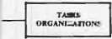SI1N1G0 ,
E£DS TI\If.!'oT
Ol:I'AR

I COIMUNm'I I I

C'TOIWCT
SERVle!S
FINANCIAL

IDOENPARTMENT DE
811'£ M8A1NTI.:AIIGLfI.'Af.AGD Srrt:

I'AIIThl£tloT OEPAATII1f.l'lT
FIJI (2}Tllr Oraaauadoml Frlltlle ork of lbe Ex cutlon11l Bollrd.
IUIIf.T SIDKIIMAlNlzA:Cnt:!-JWI N) ft:Uit."T

Fig (3)
RASII£01

The:..,..nluilon•l f111m
..orl. for he t'O..,I nJCII.-

84

83

To ensure the success of the admrnistrative framework of the up-grading process:-
I . The sufTicicnt number of well experienced working staff should be provided covering the different .administrative, urban specializations.
  - Responsibilities should be determined within every specialization.
  - The necessary information should be accuratly made available with the provision of the adequate com-nunication channels between the staff working on site and those entrJstcd with decision making.

UNDER DEVELOPED AREAS AROUND HELWAN.

The studies carried out by the American Aid experts in a joint project with the Ministry of Housing in E ypt, covered through <.1 survey most of the und erdeveloped areas in Greater C<1lro. Accordingly a comprehensive development plan was laid with res pect to the economic and sociaJ standards. The district of H elwan-at a distance of 30 Kms Cairo - was selected to be covered by an up-grading process.
The informal housing that has erected around th e city of H elwan is merely inhabited by the low incon1e factory work ers. This informa l housing resulted from the housing probkm and the i ncreasing costs of dwelling units specially when the area is co:1sidered as a major industrial centre.
The economic and social survey trried out in the action area showed the erection of nearly six informal communities <.1round Helwan of an average population of 6900-27000 (in l9'B ). The existing dwelling units in the action area are deprived of the pro"Jer healthy conditions as well as water, electricity and sewage networks. The internal roads are out of order and non-efficient besides the absence of the necessary public util ities. The average income of 70 \)of the fa mil es varies between 20 to 60 L.E. I month which is far below the proper livir g standards.

THE MAIN OBJECTIVES OF THE UP-GRADING
PROCESS: The up-grading process covers u-:> all the econom ic a nd social aspects of the
action area as well as the restoration work of the dwelling un i ts. Thu s the project's 1nain objectives coulc be translated into two xnain iten1s:
First:The Community in the acti on area: This includes provision of the proper living conditions and util ties as water. electricity, sewage a nd garbage collection systen1s as weiJ as elevat io n of economic an d social standards of living to encourage t:he inhabitants to take part in the up• grading process.
Second: The dwelling units' improvement: This inc!udes retnova I of the deteriorating dwelling units an d building new units with better living conditions.

The social objectives of the. up-grading process include the establishment of health centres. sc:1ools, clubs in a way that satisfies the

85

inhabitants' needs. On the other hand.. the eco1omic objectives tend to
.elevate the individual's income level and wc·r.:<.ing opportunities through :
-Establishment of Ia bour training cenrres f•)r thdiffercn t building .t..r. ades such as carpentry, brickwork sanitarj work. In this way the inhabitants
can actually play a vital role in the- restorat on and renewal of their dwelling units and the other inhabitant. units This trend enhances the labourer's technical expertise in . uch ;.1 1111ay that improves the individual's incotne level besides sharing in tlae up-grading process.
-Establishment of home industries e.g. te:>.tde, clothing industries. This
•

FINANCIAL
trend utilizes the efforts of the wotne11 ( J-ouse wives) which arc considered an unproductive l abour C:)nstituting 46 % of the population. It also improves the living conditions in lh ... a•;tion area specially when the project's directorate provides the necessc.ry eq uipment, materials
and marketing centres.

RESOURCES:- The estimated costs for th e projects ranged around 28 million pounds (by 1 979 prices) as follows:

Infra structure Social structure Materials

Total Loans
15,339 .1illion pounds 63Yt, 4,460 .11llion pounds 18
4,646 .1illion pounds 19 %
24,445 rviillion pcunds 100.
4,100 r.1illior: pounds

28,545 r.1illior pounds

The social structure costs are confined to :;chools. A co-sponsored funding project between the American Aid AJency and the Egyptian governn1ent has been established to assure t'1e fir ancial resources to cover
the above n1entioned costs.
The dwel1ing units costs will be covered b) tinhabitants -themselves. The project's directorate provided all the techrical and financial aid as follows
- Provision of loans through specialized b:lnks
- Provision of the required building materials.
- Provision of technical advice as to the: besJ and n1ost appropriate methods of dwelling unHs' improvement.

ORGANIZATIONAL AND ADMJNI TRATIVE
FRAMEWORK General Organizational Framework:
The success of the up-grading project depends upon the efficiency of the administrative board. The project's organizationc.l framework a shown in Fig ( 1 ) consists of the following:
-Planning, supervision committee.
- General planning and purchase commjt:ee.
-Assisting funding agencies as the Am rican Aid agenctes and the Egyptian Real Estate Bank.

86

· -.

The execut i ve boa rd is responsible:or r.he executive supervision upon the project. The head of the boa rd c·:>u..1cil has all the prerogatives for
supervision and execution.
. .
The execu tive board as sho·wrn in (fiJ 2) co nsists of a general technical
director and the differen t ad n1inistrat1or s that cover up the different as pects of the project.
The organizational fran1ework of the construction com n1ittee (as shown in fig 3) is divided in two sect ions:
    - The first sec tion acts as a link betwe n the project' admi nistration and those work ing on site through supervision.
2. The second section is concerned witll the action area: thus 'the working staff should cover all specializationso sa tisfy the various needs on site.
It shouklbe borne in mind that the- above mentioned organizational frameworks on their a pplication wersu bjected to modification: The different administrations have developej with respect to the size of wor k in the action area.

·• '
.

87

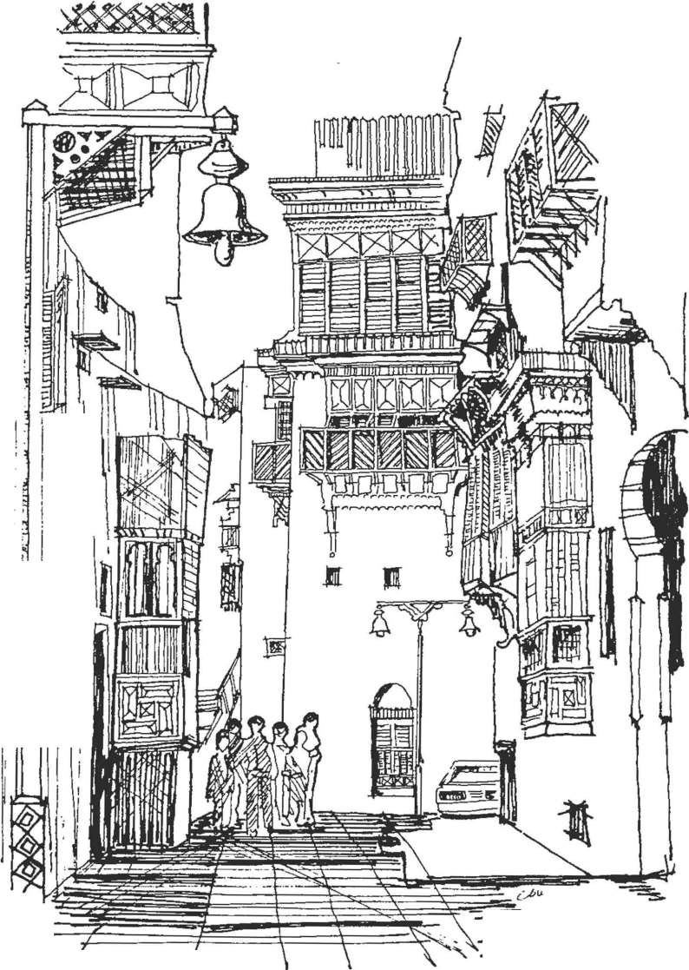i Ii

I I I I
11
, I
I·
; '
II t ')
I
!)}
i r

I

I
I I

-
I
I ..- ·-··-I'"- \ b....p...

Jeddah-The Old City after den lopment.
The streets were restricted for pedestrians only. The lamp posts
were designed with a typical character

88

RECOiVIMENDATIO

On the 12th or Moharram 14(.'5 hj. the Jcddah Municipality held• through its Lectures and SeminarDepartment-it::- first eminar in co-
operation wnh the Center for Planning and Archite<..-tural Studies in Cairo. Or. Mohamn1cd Ali Qattan opened the scn1inar on behalf of H .E. Sheikh Mohammed Said Farcsy. the Secretary General cf the Municipality of Jcddah. The sen1inar chedule included eight lecturethat were given along six sessions. Many universities. architectural and consulttng Offices in
.Jcddah and Mecca took part in this seminar, as well as the architects of the Jeddah Municipality. The attend· nls participated in the discussions and lectures.
The Sl!Jn nar ended to a number of recon1n1cndarions as follows:
- The participants appreciated th:! establishment of the Lectures and Seminars Departtnent in the Municipality as bein.s of a unique character
in the Arab World.
.., The participants recomn1endcd setting annual programn1es for seminars dealing with the differ"nt aspect of t:rban development or cities.
3 The participants recommended provtding the !\i unicipality of Jeddah
by the adn1inistrative and tel.:hn t•;al systems necessary for monumental restoration or the old historical buildings in Jeddah.
- The participants recomn1endcd that the Municipality of Jeddah should asses the up-grading process othe urban env ronment through the establishment of a local handicraft centre that will help the revival of the artistic character of old Jeddah.
- The participants recommended the preparation of work n1anuals for the up-grading of under developed areas of tt.e city in a simplified manner. These manuals should be reviewed every now and then to check the outcoming results.

89

- The parttctpants recommended setting mascomn1unication pro grammes to elevate the public con ciousness v\'i( h rcspl!ct to the up· grading of historical or under-de\·elopcd areas. Tht:c orogran1me-.. direct the inhabitants·participation in the up-grad1ng pH>cess in their areas.
- The participants accentuated upon collection and rc\·ision of the lectures and the discussions held within the cminar. Thce lectures are to be published an1ongst the Municjpality"pnnb.
8 The participants stressed upon the importance of ha\ ing the Saudi planners.architects and engineers participating inthe seminars held by the Lectureand SeminarDepartn1en t.
  - The participants recommended the c tabli hn1cnt of the appropriate administrative and organizational frameworks to direct the up-grading process. The tasks. responsibilities ana detailed job description should
be identified \Vithin those frameworks. to elevate the organizational level of .the various departments responsible of the up• grading of the urban environment.
  - The participants requested the identification and analysis of the contemproray architecture with respect to the local heritage. This general character should be published as a reference for the stafi' working in the consulting offices and the diiTerent local municipalities.
t 1. The participants stressed upon the importance of the visual analysis that could be utilized as a tool in the up-grading of the physical environment.
    - The participants stressed upon the importance of studying the Yarious economic. social and· cultural aspect to ren1odel the urban envrionment of underdeveloped or historical areas.
    - The participants recommended that the lectures and seminars department should discuss a variety of subjects in the coming seminars to allow the staff of the municipality to take part in the sessions.
    - The participants recommended the study of the ci\·ilizational heritage as an important subject to be laid within the interests of the Jeddah Municipality. Field visits to the historical areas should be carried out.

90

PRESS REVlE\\.

: ..b&,..,.J I J_,..:;.H•-
: Y!- 4»
The lectures and seminars department in theM unicipality of Jeddah heiJ i.\ sen1inar du.ring the period from the 12th- 15th of Moharran1 1405 A.H The subject of the sem inar was ··The Up-Grading of the Physical En\·ironn1ent of Cities··. The Saud i press has thoroughy covered the events
nr the seminar.

-

01 J l..t «>4..1 :·. "i'
u.>-*-u' ,-:......oi 01; _.1 ..11 ·'
ul l...S c 4J .l..!....,.."i ... JICU
.:o_:.JlS"il
On the 9th ofMoharram 1405 A.H.· AI Madina.. newspaper wrote about
the esta blishn1ent of the Lectures and Sen1inars Departn1ent in the
Municipality of Jeddah and about nominating Arch. Kamel Abdoullah

01; 01 -··.:.JLS"i1 o.,.>--Alt
· '
•;
.

,y. U.. "i ..::.1
cj 6..:..·'i;.l 11.l ..A J 1-
>J
.;"il,:r IoJI UI t "i\
t...l L-: .t ·. -:tt ·-•1
l
- ............... - -·.
4\:,..,... Ji:. J.c.- r-1 t ..::.1 IJ•
.llS"il J .)J
- · t... WI
..:..."\ ..::...W:.OJId.;W:.J
0-- · 6....-'r 4J)I.;... J...e
:fi...>- -> 11 4JI ->fo

L-!- ,y. I.J4=-JI ..::..C..lJ ·
6-> IJ ->GJIJ 6.;l A..II c:,i ':) i
l. "i1
...,1 r-l:al J I_,A )L. "il
JJ L......-.1\J ;_.-L.u_.L..;:.:.L I.;.JJ
-.; 1
I c-JL.....:a .;fo IJ

)L.."il o.;L......H .:,G 1J ..::.J.>t-!
.L.._.L .;all .:ll 11 ("jl.:....
.;_,:o.s: IJ
.jtw.l .;fo..!1!_, JAj'll
.>li.>JI L....01 b:L.;.:;
,, lJI I.;fo IJ
L.... '?I '?->lh.ll I -> J
WI I -> I.;
jY.I .;_,:o.s: tJ
L. .:L ;.;IIJ .-.4-JIJ u "il
Qomsani ashead of the department. The newspaper wrote as well about the acti\·ities of the department and about holdjng the department·s first seminar in the Holiday Inn Hotel in Jeddah.
On the 12th of Moharram 1405 A.H E·l-Belad··newspaper wrote about the seminar, the sessions programme and the part icipating lecturers. The
lecturers included professors of planning, architecture and economics fron1 the Egyptian universities.
The·Okaz" newspaper wrote about the opening session on the 13th of M
oharram,s edition:The openingsession sta rted with the Holy Koran then Dr. Ali AI-Qattan made a speech on behalf of H .E. Sheikh Mohammed Saeid Faresy

c_rL..o
-
rL...c..c. U" 'J
. C?->l-11 -
'-'"I '
the General Secretary of the Mu nicipality of Jeddah - welcoming the participants and declaring the importance of holding such seminars that aim to discuss the various problems of urban development. with re p_ect to the existing administrati e and organizational systems. Then Arch. Barakat Bagoneid the vice secretary of the Municipality of Jeddah made a speech, stressing upon the secretariats efforts in up-grading of the city of Jeddah. Dr.
Abdelbaki Ibrahim, the president of the center of Planning and Architectural Studies and the head of the Architecture Department in Ain Shams University, mad e a speech in which he stressed upon the seminars role. The next day'sedition wrote ?lbout the eventsof the first session refering to the first lecture given by Prof. Dr. Abdelbaki Ibrahim about the H Introduction to Up-Grading of The Physical

91

.::.I_,..LJJ ·;_,t.,l •.,1 V"'l '- ., ··I .J
.r_,u
.::.I..,...,:.WI.,
· ..1.-6 t4
.J.,.-.JI vl V<t I a
.J
J IV' .JI.J WI.,..>-'JI.J
a l V<t 4 .:·'·11 o..ll.l ; :l..c
· ., ._....;'...ti_,Mt_,
Envi rorunen t Of The Cit y": the second lleclt re given by Dr. H azem Ibrahim Professor of Plan ning in AI-Azhar _l nj·;ersity, \\;as about the up- . grading of h istorical areas. On the sa me day, Dr. Sa!eh Lamei Mostafa, the
proressor of'architect u ra l heritage in Beirut Arac Univcrs ty, gave the third lecture about the architect u ral renovation •)f rronumen t al and historical buildings.
On the 15th orMoha rran11405 A.H the t.hirc day of the sen1inar, L• AI• Bclad", newspaper wrote about the final :.ession, ..Th:! seminar of up•

,jy .i.H.,.., . -.<.St,_.,lt...;.-1..W4 ,.u:;I_,l..J.·l._-.u-..i-.
s

,. ..., i..-_,.i.J1tl Jl .,.,(
.::..i j

.:.1 1v.•.,'- ..;..
grading of the ph ysical cnvironn1cnt in the hrab Citlie. is the lirst seminar
to be held through the Lectures and 5cm nars Dcpann1ent in the Municipality of J eddah.··The newspaper wr:)te i n d.etail c:..boutthc different sessions. lectureand the discussions that took place.
.. lq raa., magazine- a political and socia[ wet!k ly magazine wrote t wicc about the SCnlina r. The firs t time was on its I 6th or Moharranl 1405 A.H ed ition i n whi ch it wrote about the opcninE, se5sion and the participating
l ecturers. In the fo1Jowing edition. a detailed report was presented about
the sen1inar covering the various scssio lS, lectures and

<J S.,
J
-!' .-)'-
-:f
- 'j., L.-....o l...S'la'l
discussions,

.:.US, JWJ.I
•.l:it. l
·'li.;.....-t ......-.<1 .::.1 1
141 Ju..
0.,........ 1
··':..·:14 .. _,1tk I _,:; t.
.!.
l...k •J l:t l_,. a.ll.
- WI .roJI

..J......._,'Jt ' .w .j.,
'L.. ..l:'LJ .l.fl :St 'la't
,.1JI j.J J V.;_,,UJI ul JU ;., uJ1
.,)1.1 .,.,..y.._11 c.,;.u .n_,
- tz_,I J-:i.l ,1.e, J.c. .::..i..ll
ltll 4o.
.6:1., · 1_,.-aJI •··.:'.·'4
·,_..i.. ..1.-i •., , ul-t .L..t:.o 'll'
v• .I l.lA i ./·lf:JI J,.6..ll-t
stressing upon the seminar's objecti es. Th_ recon1n1endalions were published in detail. The newspaper comn1entcd that the sen1inar has
!)Uccessrull y fulfilcd its ain1s and that in turt.J this should be an ince n tive to hold further seminars that aim to improve tile u-ban con ditions oft he arab cities as well as the conservation of their civil;za tional heritage.

On the other hand.··Al-Shark Al -Awsat·· newspaper wrote a detailed report about t he sem inar on .its 22 nd of r..1oharram edition. The paper wrote about the main object i ves of th seminar. the lectures, the participants and the activities of the Munic pal ty of Jeddah and specially
that of the Lectures and Seminars Department. It wrote as well an abstract of Arch. Mohd. Sa ed Faresy's speech. Ar:;h. Faresy assured upon the im po rt ance of raising the civilizational con::.cio·Jsness in order to preserve
th<.! architectu ral heritage in the Arab citie-:5. He stresst:d upnn the lll ass media's role in this process. The paper he d a:1 interview with Prof. Dr . 1\bdelbaki Ibrahim , the head of the seni:nar· Dr. Abdclbaki Ibrahin1 poin ted out that this sem inar wa not held 10 r ach cer tain solution with
respect to the cnvironn1ent a l up-grading b•t it sti n1ulat....d the discussions
which dealt with the various aspects of the 11rban econon1ic and planning problems related t o the up-gradJngorthc ur1an...nvironn1en t of.Jcd<.la h . He
added that the urhan development proce.. must satisfy the accelerat in g

L1- ...c. -
L.-·
,•.

!.) -
requirements of the inhabitants.

_,.J.U1_,1 .,·
J,.6..1t ..aOl:i..:i.ll J-:i.l I JI
·
1 1_, i:L.. .:b.;;UJS:l...!. U
I 4=ti,.,..-JI 4.. ..1l......r:.:.. I..J
.
ln another i nterview, Dr. Saleh Lan1ei hlou ;tafa saic that this sen1i na r approached the Saudi t rials of urban up-gr 1di ng in Jedcah. H c added that lhc conservation and preservation of laeri tagc n1ight son1etin1es be
su bject cd to execu lional probletns a nd c.fiffic ul ties, yet these problen1s
could be sol ved through intcnsilied rescar_he:: a nd stu-vcys_

92

