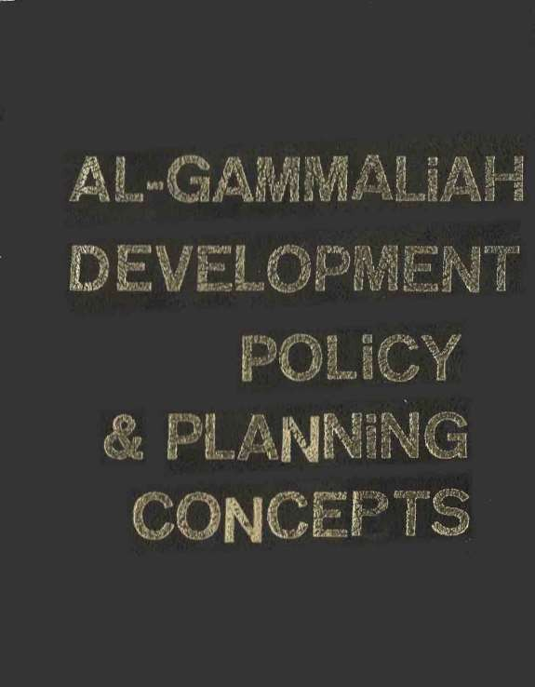

AL- GAMMALIAH DEVEMOPMENT POLICY
& Planning CONCEPTS

BY:DR.BIDELBAKI lBRAHIM
Urban Planning Specialist CPAS President

ASSOCIATE BY:

Dr.Hazim Ibrahim Arch.Hala Omar P1an.Mohammed Sadek P1an.Ahmed Selim Plan.Khalid Abobakr

CONTENTS
- Introduction
- Existingconditions of the action area.
  - Introduction
  - General Land use 2-3 Building uses.
  - Building conditions
  - Building height.
  - Building supplied with public services
  - Building materials and modes of construction 2-8 Use analysis of the different floors
  - Population.
  - Activities.
- Planning concept of Al-Gammaliah.
3-1 Introduction to the general development policy 3-2 Organization of the development process.
3-3 Planning concepts for Al-Gammaliah.

- Al-Gammaliah Development Policy.
  - Nature of Al-Gammaliah.
  - Decisions and planning levels.
  - Diversity of development and resources 4-4 Conflict of decisions and phasing
  - Development Agency
  - Architectural Character and the revival of the deep rooted Islamic values 4-7 Monumental Buildings
4-8 Population Densities 4-9 Existing building stock
4-10 Infrastructure and circulation network 4-11 Shift of land use

- Preliminary concept for the Urban Planning of the demonstration area.
  - The Main Spine.
  - The Northern Monumental Complex. 5-3 Wakalat Qait-Bey
5-4 Midan Al -Nasr Gate and the Cairo North - Eastern wall 5-5 The Sourthern Border of Al-Hakim Mosque
5-6 The industrial area, south to Al-Hakim Mosque 5-7 sabi1 and Kottab Auda Basha
PAGE

1

14

39

46

74

5-8The Complex of Beit El-Seheimy and Beit Al-Selehdar. 5-9 Other monumental buildings.
5-10 Other buildings and Urban places. 5-11 Streets and Paths
5-12 Utility network
- Appendix 1- Set of maps

FIGURES NUMBER
Fig.l-1 Fig.l-2 Fig.l-3 Fig.l-4

Study Area in Relation to greater Cairo Midieval Cairo
Environmental Setting Local Activities
TITLE
PAGE 5
6
7
8

Fig.l-5 Fig.l-6 Fig.l-7 Fig.l-8 Fig.l-9 Fig.2-1 Fig.2-2 Fig.2-3 Fig.2-4 Fig.2-5 Fig.2-6 Fig.2-7 Fig.2-8 Fig.2-9 Fig.2-10 Fig.2-11 Fig.2-12 Fig.3-1 Fig.4-1 Fig.4-2 Fig.4-3 Fig.4-4-1
Fig.4-4-2
Fig.4-4-3 Fig.4-5 Fig.4-6 Fig.4-7-1
Fig.4-7-2
Fig.4-7-3
Monumental buildings in Al-Gammaliah today 9
Monuments 10
Monuments
Movement of population source UNESCO 1980 11
Monument Misuse 12
General land use 13
General building use
General building conditions 27
General building heights 28
Use distribution of the different floors 29
Buildings uses of the different floors.
Floor use in Al-Gammaliah Street 30
Floor use in El-Moez Street 31
Floor use in Al-Dabbabiah 32
Floor use in Al-Darb Al-Asfar Socio-economic composition Daily Activities
The suggested urban planning Nature of Al-Gammaliah Decisions and Planning levels
Diversity of development and resources Evaluation of Contradictions and impact.
Example of development programs contradictions and decisions. Preparatory works
Development Agency 61
Local Architectural Character
Treatment of monumental buildings
Restoration of the monument and the environment
Example of Annex in monuments 61
Determination of the future size of the monuments according to the conditions Decisions on
population density 6

Fig.4-7-4 Fig.4-8 Fig.4-9-1

Fig.4-9-2
Fig.4-9-3 Fig.4-10 Fig.5-1

Fig.2-7 Fig.2-8 Fig.2-9 Fig.2-10
Fig.2-1 l Fig.2-12 Fig.3-1 Fig.4-1 Fig.4-2 Fig.4-3 Fig.4-4-1
Fig.4-4-2
Fig.4-4-3 Fig.4-5 Fig.4-6
Reflecting the local character on the facades of existing buildings of good conditions 64
Example of a work schedule for reparation and restoration of the existing building stock
New construction should respect the existing restrictions 66
Development of the utilities and circulation network 68
Proposed development concept 69
70
72
76
Floor use in Al-Gammaliah Street
Floor use in El-Moez Street 33
Floor use in Al-Dabbabiah 34
Floor use in Al-Darb Al-Asfar 35
Socio-economic com position 36
Daily Activities 37
The suggested urban planning 38
Nature of Al-Gammaliah 41
Decisions and Planning levels 43
Diversity of development and resources 49
Evaluation of Contradictions and impact 51
Example of development programs contradictions and decisions 53
Preparatory works 54
Development Agency 55
Local Architectural Character for A1-Gammaliah 57
59

TABLES NUMBER TABLE 1
TABLE 2

TABLE 3

TABLE 4

TABLE 5

General land use of the study area. Building uses of the study area.
Building conditions Building heights
Buildings supplied with public services
TITLE
PAGE 16

18

19

20

21

TABLE 6

TABLE 7

TABLE 8

TABLE 9
Buildings materials and modes of construction 23
Use Analysis of the different floors. 24
Socio-economic composition of the action area
25
Location of the various activities in the demonstration area
26

PREFACE

The following report is prepared within the con text of the job description stated in the development-project plan. It is mainly cancer ed with the general policies for the up-grading and development of Al-Gammaliah.
The report consists of -
- Introduction.
- Existing conditions of the action area.
- Planning concept of Al-Gammaliah.
- Al-Gammaliah development policy
- 5- Preliminary concept for the urban planning of the action area.

Appendix one includes the following maps: -
- Site land use l/1000
- Borders of samples 1/1000
- Building use 1st Floor 1/1000
- Building use 2nd Floor 1/1000
- Building use 3rd Floor 1/1000
- Building use 4th Floor 1/1000
- Building use 5th Floor 1/1000
- Building conditions l/1000
- Building heights l/1000
- Building material l/1000
- Infrastructure l/1000
- Socio-economic studies l/500

1-INTRODUCTION TO AL-GAMMALIAR

- INTRODUCTION TO AL-GAMMALIAR

  - After four centuries from its establishment in 96.9, Medieval Cairo became the center for commerce, culture and civilization during the fourteenth century. Its population amounted to half a million, equal four time that of London and five times that of Paris in the same period.(Fig.1- l)(Fig.1-2)

  - The area of medieval Cairo is defined by Badr El-Jaman walls including A1-Nasr and Al-Futuh Gates to the North, the Citadel to the Souths Al-Darrasah hills to the East and Port Said and Mohammed A1i streets to the l est. The area covers 847 acres. Al-Azhar Street divides the area from east to west. The area is surrounded by old cemeteries in the North, East and South. Port Said Street to the West separates the area from the Central area of Cairo city. (Fig. 1-3)

  - the urban pattern of the area is built along the spine of El Muez Ledin Allab Street. This social and economic pattern of life extends along the same spine. The land use pattern which was built along the spine did not change in kind as much as in condition. The spine attracts the commercial activities of the area supplemented by light industries and hand craft industries at the back on both sides of the spine. In the meantime, most of the historical buildings groups are clustered along the same spine. (Fig. l-4)

  - The historical buildings in the area cover about 44 acres equal to 7% of the built-up area which is about 614 acres. It is rather difficult after that to determine the coverage of housing or commercial uses as they are usually mixed together with handcraft industries. There has been no control on the land use pattern in the area. (Fig. 1-5)(Fig. l-6) (Fig. l-7)

  - The physical survey of the area shows that 85% of it is considered s1um areas 10 % of 1ow medium condition most of it built along Al-Azhar street and 5% of medium condition built for low income groups by local authorities. This shows that most of the area is under developed. The services and utilities are deteriorating affecting drastically the condition. Of historical buildings. About 83% of the buildings in the area of less than four stories in height.
  - The population of the area is in the vicinity of 300000 inhabitants in 1982. The average density is about 300 persons per acre. The population may be doubled during religious festivals and the holy month of Ramadan. A large percentage of the daytime population line outside the area and work in business commerce and hand craft industries. The heavy movement to and from the area is reflected in the traffic connection and the lack of parking spaces in the Area. Therefore, it is rather difficult to measure the average density of the population as well as their income brackets or standard of living. This planning standard could not be easily determined or applied to the dynamic community living in the area. The classification of labor force in the area is essential for its economic development within its function as part of the central and cultural heart of Cairo. The change in economic base will be reflected on the replacement of labor force in the area and eventually on the community structure, which will then be reflected on the u ban pattern of the area. This is a long-term procedure which needs proper managerial and administrative power. (Fig.l-8)

1 -7 The main urban changes which occurred during the last hundred years could be observed in the diminishing of green patches which used to surround large houses. They were replaced by poor residential buildings to accommodate new low-income immigrants to the area to

Rep1ace the high-income settlers who left to1ive in the outskirts. The change in the socia1 pattern was accompanied by a change in the land use pattern. The deterioration in the social structure and the increase in the density of population was eventually reflected on the deteriorating physical environment in the city. Add to this the neglect of the governmental departments who were in charge of the upkeep and the restoration of the five hundred historical buildings in the area. The situation was then affected by the heavy traffic which penetrates it especially along Al-Azhar street, adding to this the increase in water level able which affected the foundation of most historical buildings. The present population lost all cultural and human contacts with their historical values. The environmental situation nowis very alarming and although the area is considered one of t be world historical heritage but the long neglect to it will lessen any hope for its restoration. The call for the world conscious should be accompanied by a call for immediate action for restoring its historical buildings and up-grading its urban environment(Fig.1-9)

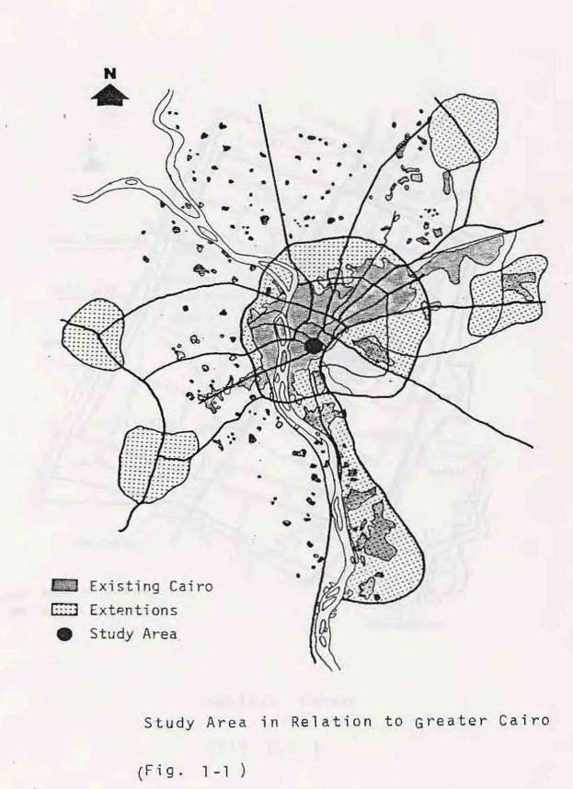

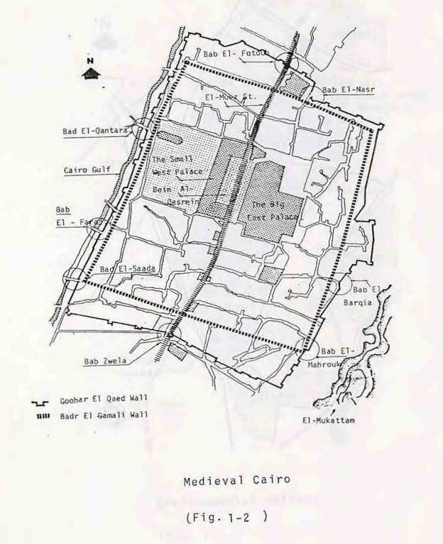

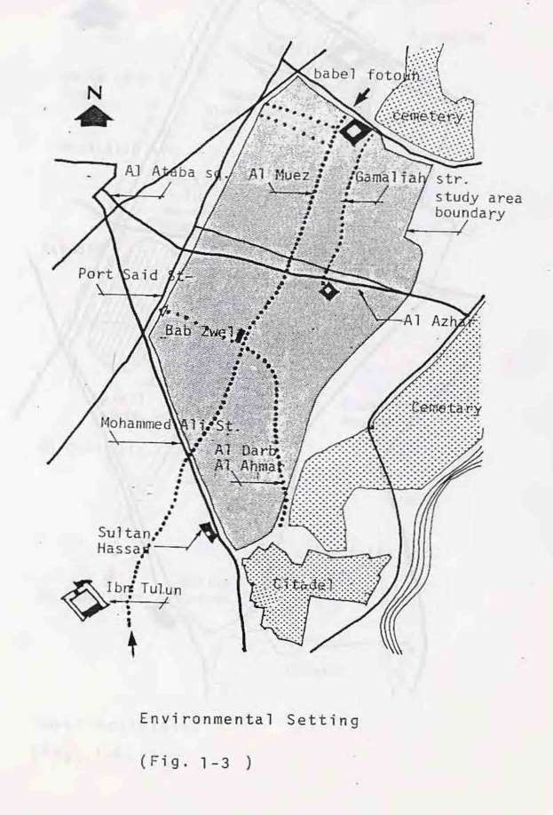

pg. 15

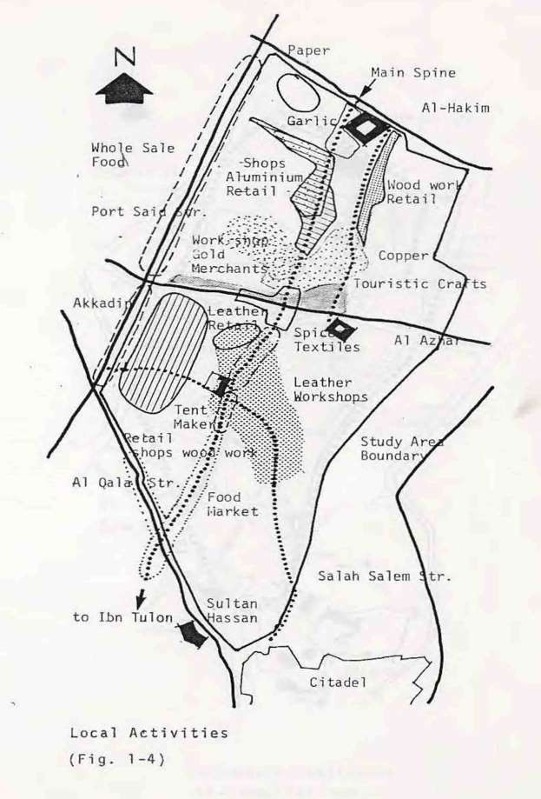

pg. 16

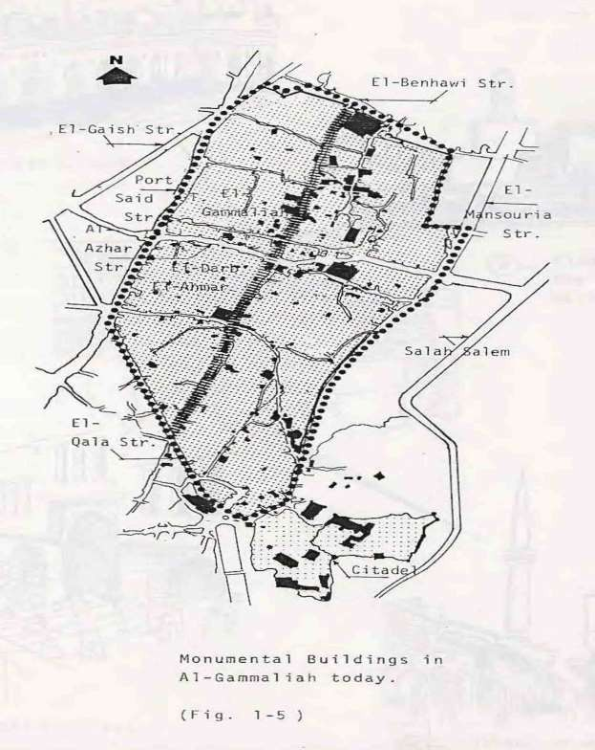

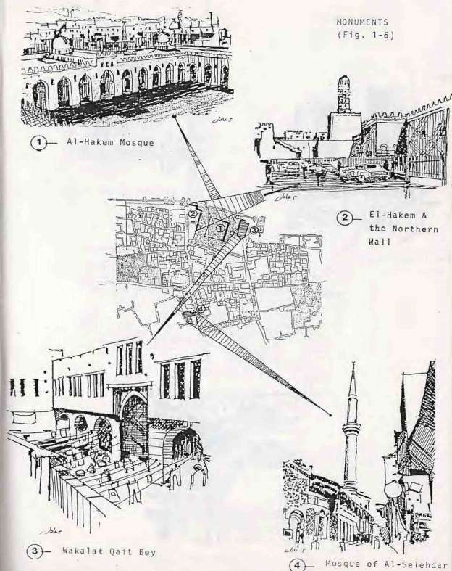

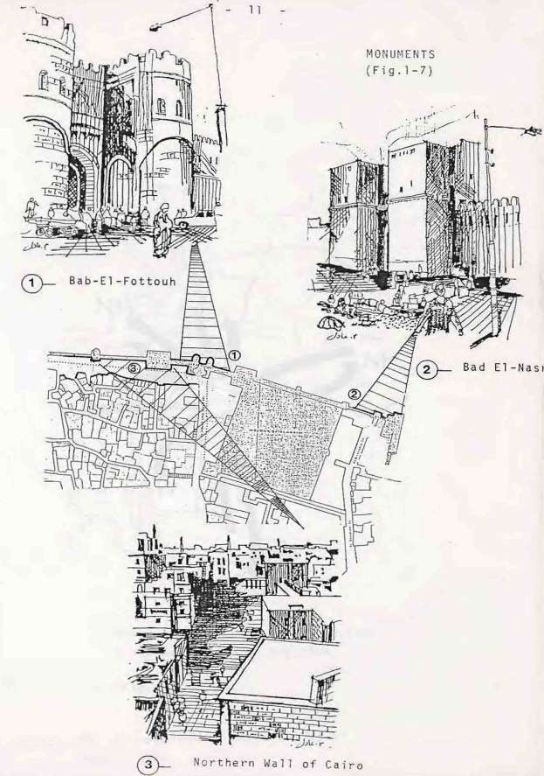

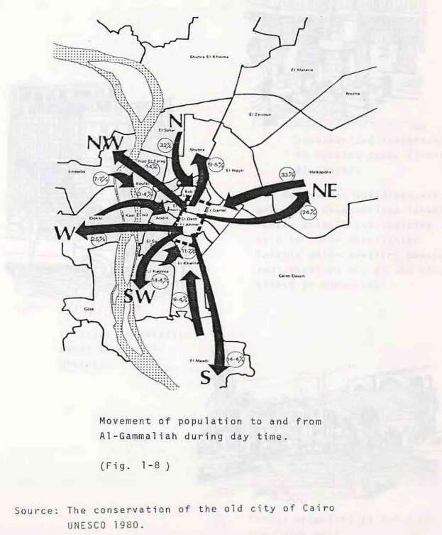

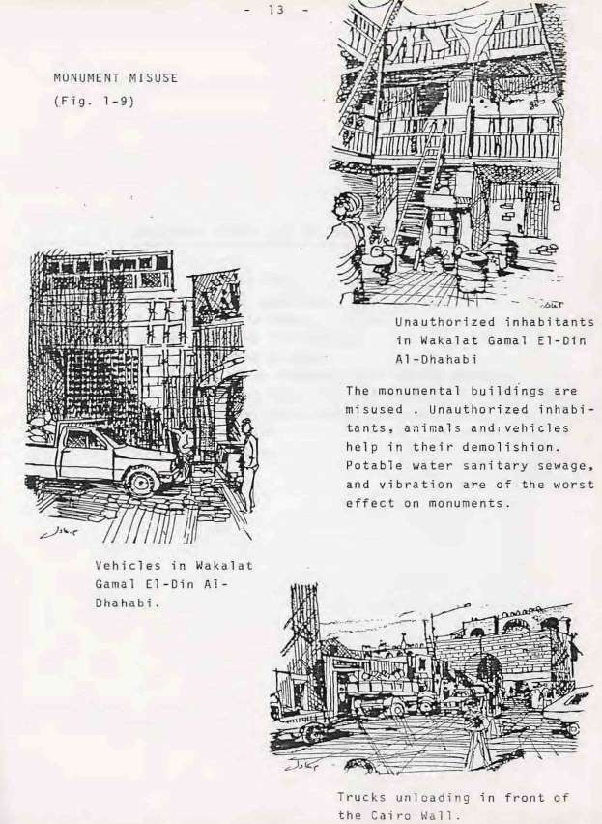

- EXISTING CONDITIONS OF THE ACTION AREA

- EXISTING CONDITIONS OF THE ACTION AREA:-
  - Introduction
  - General Land use 2-3 Building uses
  - Building Conditions
  - Building He1ghts
  - Buildings supplied with public service
  - Building Materials and Modes of Construction 2-8 Use Analysis of the different floors
  - Population
  - Activities.

- EXISTING CONDITIONS OF THE ACTION AREA:-
  - Introduction
In July 83 a sample field survey for the demonstration area was conducted to cover a total area of 26 feddans. The physical survey consisted of the following aspects:
    - land use
    - Building uses, heights, conditions, material and modes of construction
    - Detailed use of the different floors.
    - Building classification according to the availability of services and utility.
A complementary survey followed in August 83 to cover 7 feddans more. It consisted of the following aspects: -
    - Land use.
    - Building uses, heights, conditions, material and modes of construction.
  - General Land use
The demonstration area covers 33 feddans. It is characterized by a high concentration of monuments consisting 25.8% (8.5 fed.) of the total area. The body of the area is divided to the roads and pedestrian paths network of 18% (6 Fed.) of the total area, and the urban bulk of 86.2% (18.5fed.}. (Fig.2-1)
Main streets and harahs in the spine of the demonstration area are the pole of attraction for commercial activities, industries and hand crafts. While the residential use is highly concentrated in the eastern and western borders of the area.

ELEMENTS | AREA IN FED. | %
Area of the Urban bulk | 18.5 | 56,2%
Area of the monuments | 8.5 | 25,8%
Area of streets | 6 | 18 %
Total Area of the study area | 33 | 100 %
General land use of the study area (Table 1)
Source= Survey of the demonstration area July/August 1983.

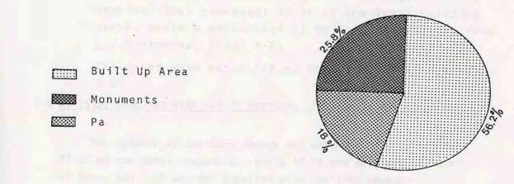

  - Building uses (Table 2)
Pure residential use represents 43.2% of the urban bulk. The commercial, industrial and mixed uses follow this majority they are of 40.6%. Both education, and vacant lands and ruins are each of 8.1% of the urban bulk. (Fig. 2-2)

  - Building Conditions (Table 3)
Budding conditions in the demonstration area vary between "bad" and " good ". Vacant land and ruins are of 8.1% of the total built up area. They could be used for future improvement in the demonstration area. Buildings of bad conditions constitutes 44.3% of the total urban bulk. Thus impelling a major repair, demolition and replacement process, in the meantime major reparation for the medium condition buildings will take place. They are of 25.4% of the total area. Good conditions buildings are of 22.5% of the total built up area and will require an adequate degree of maintenance. (Fig. 2-3)

  - Building Heights (Table 4)
The majority of the buildings are not higher than 2 stories, they represent 50.8% of the total building stock, while a percentage of 9% is for buildings from 5-8 stories. (Fig. 2-4)
The floor area ratio FAR of the demonstration area is 2. 31.

  - Buildings supplied with public service(Table 5)
The network of sanitary sewage and potable water covers only 77.3% of the total properties, while 12.2% are divided of both of them, and 2.6% are not supplied with sanitary sewage.
The whole area is covered by the electricity network

USE | AREA IN FED. | %
Residential | 8 | 43,2%
Educationa1 | 1.5 | 8.1%
Commercia1 | 1.5 | 8.1%
Industrial | 2,5 | 13.5%
Commercial Industrial | 0,5 | 2.7%
Commercial Industrial | 3 | 16.3%
Vacant lands & ruins | 1.5 | 8,1%
Total for the whole area | 18,5 | 100 %
Building uses of the Study Area (Table 2)
Source = Survey of the demonstration area July/August 1983
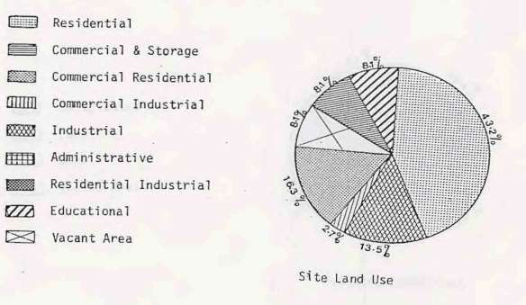
- Does not cover monumental buildings and roads.

ELEMENTS | NO | % | AREA IN FED. | %
Buildings in good condition | 70 | 15,3% | 4.1 | 22,2%
Buildings in fair condition Buildings in bad condition Vacant land and ruins | 107  250  31 | 23,4%  54,5%  6,8% | 4.7  8.2  1.5 | 25,4%  44,3%  8,1%
Tota1 Area | 458 | 100 % | 18.5 | 100 %
Building Conditions (Table 3)
Source = Survey of the demonstration area July/August 1983.

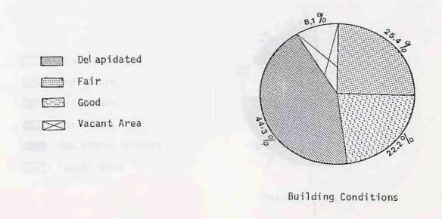

ELEMENTS | AREA HI FED. | %
1 Story Buildings | 4,8 | 26 %
2 Stories Bui1dings | 4,6 | 24.8%
3 Stories Buildings | 1,4 | 7.5%
4 Stories Buildings | 4,5 | 24.7%
5 or more stories buildings | 1.7 | 9%
Vacant land and ruins | 1,5 | 8%
Total | 18,5 | 100 %

Building heights (Table 41
Source = Survey of the demonstration Area July/August 1983.
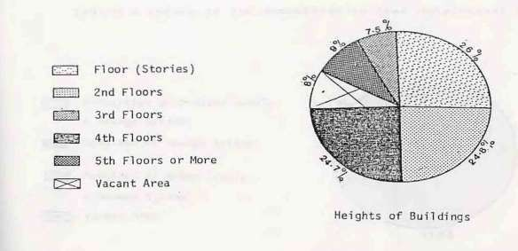
- Does not include roads and monuments.

ELEMENTS | AREA HI FED. | %
Properties supplied with both water and sewage. | 0.9 | 7.9%
Properties divided of Sewage | 8,9 | 77.3%
Properties divided of both water and sewage | 0.3 | 2.6%
Vacant land and ruins | 1. 4 | 12.2%
TOTAL | 11. 5 | 100 %

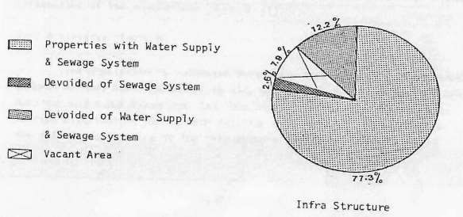
Building? supplied with public services (for the samples only) (Table 5) Source=Survey of the demonstration area July/August 1983.

  - Building Materials and Modes of Construction (Table 6)
Brick and wood are the predominant construction materials in the demonstration area. They are of 43% of the total Urban bulk. Mostly,
They are in poor conditions and in need of replacement. demolition, or renewal at first hand.
Ske1eton type bui1dings represent 24 % of the tota1 Urban bulk, while wall bearing structure are of 11 %.
  - Use Analysis of the different floors (Table 7)
The commercial, industrial, and other mixed activities are almost concentrated in the ground floor they represent 78.1% of the total area. In higher stories, such activities regress leaving space for residential use, for instance non-residential use in the second floor is of 39.25% and shrinks to 9% in building of 5 or more stories. The rest is pure residential use. (Fig. 2-5) (Fig.2-6) Fig. 2-7) (Fig.·2-8) (Fig. 2-9) (Fig.2-10)
  - Population (Table 8)
A sample field survey covered an area of 11.5 feddans. The sample population was of 2337 inhabitants. The population projection of the total demonstration area is estimated to be of 5700 inhabitants. The gross density is estimated to be 203 pers./ fed. Table (8) shows detailed intonation of the population. (Fig.2.11)
  - Activities (Table 9)
The population is increased during day time specially in the area between Al-Muez Str. and Gammaliah Str. where most of the commercial, industrial and other mixed uses lay. The outside lateral area maintains an average distribution during both day-time and nighttime. Table (9) show the detailed activities in the main paths of the area.(Fig. 2-12)

ELEMENTS | AREA HI FED. | %
Load-bearing wa11s | 1 ,3 | 11 ,3%
Skeleton Type | 2,8 | 24,3%
Brick and wall mixed | 5 | 43,.5%
Vacant lands and ruins | 0,9 | 7,9%
TOTAL | 11. 5 | 100 %
Building materials and modes & construction (for the samples only} Table 6
Source = Survey of the demonstration are July/August 1983.
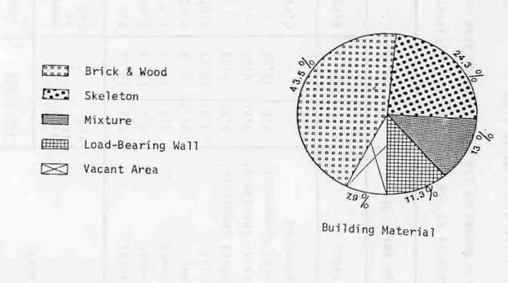

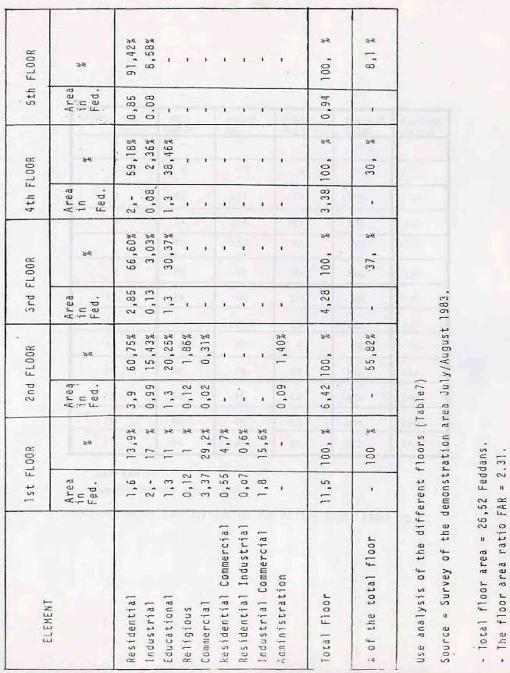

SAMPLE NO. | RES. UNITS | ROOMS NO. | HOUSE- HOLD | POPULA- TION | AVERAGE INCOME
l | - | - | - | - | -
2 | 4 | 13 | 4 | 13 | 70
3 . | 45 | 126 | 66 | 228 | 91
4 | 114 | 264 | 121 | 549 | 145
8 | 46 | 107 | 48 | 193 | 156
9 | 28 | 79 | 30 | 160 | 130
10 | 19 | 40 | 20 | 88 | 77
12 | 25 | 101 | 29 | 132 | 185
13 | 4 | 12 | 6 | 26 | 75
14 | 26 | 26. | 27 | 156 | 143
15 | 44 | 96 | 48 | 226 | 140
16 | 45 | 45 | 53 | 244 | 128
17 | 94 | 238 | 91 | 322 | 114
per family
Sample Survey Aug. 1983 ·
SOCIO-ECONOMIC COMPOSITION OF THE ACTION AREA TABLE (8)

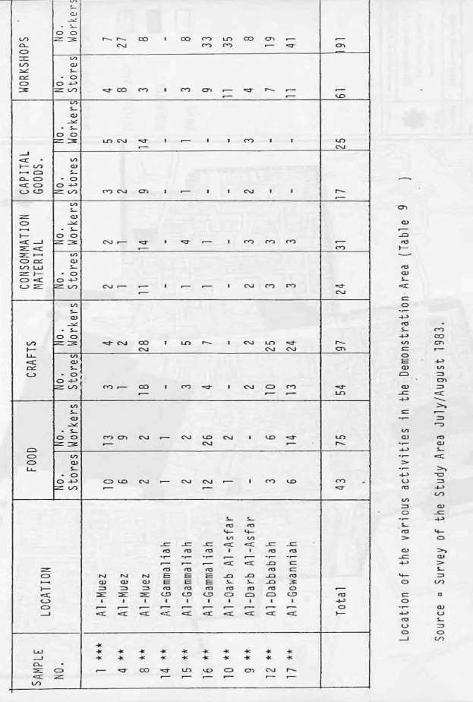

pg. 34

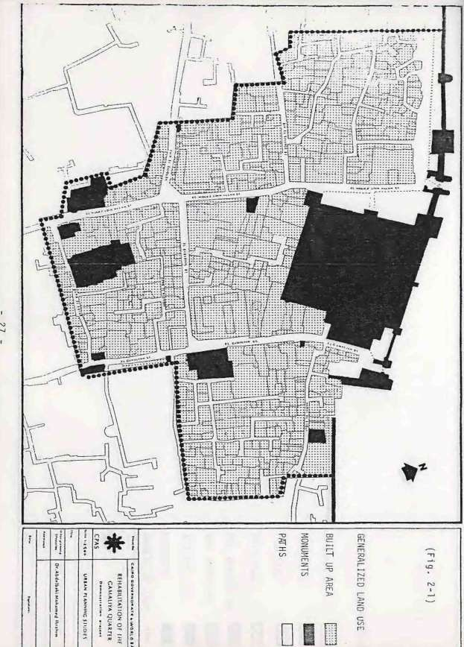

pg. 35

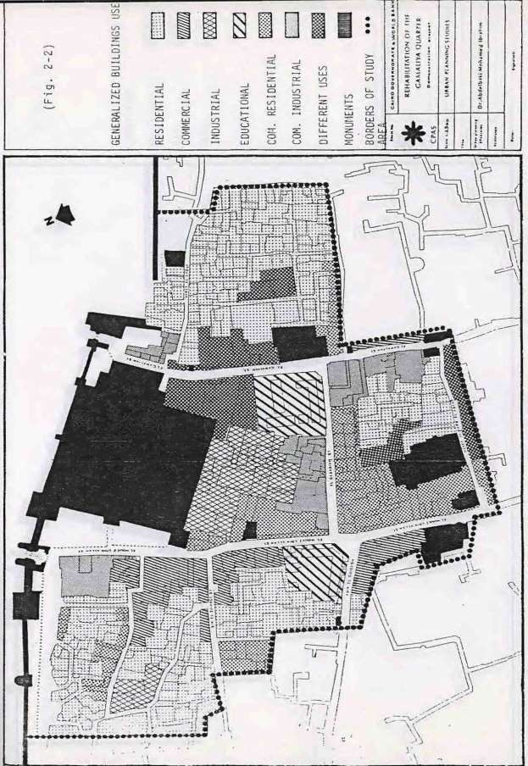

pg. 36

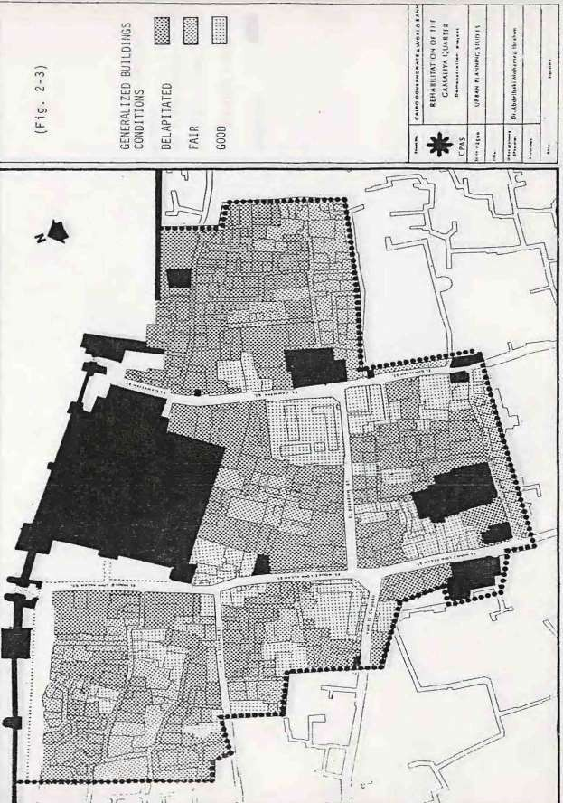

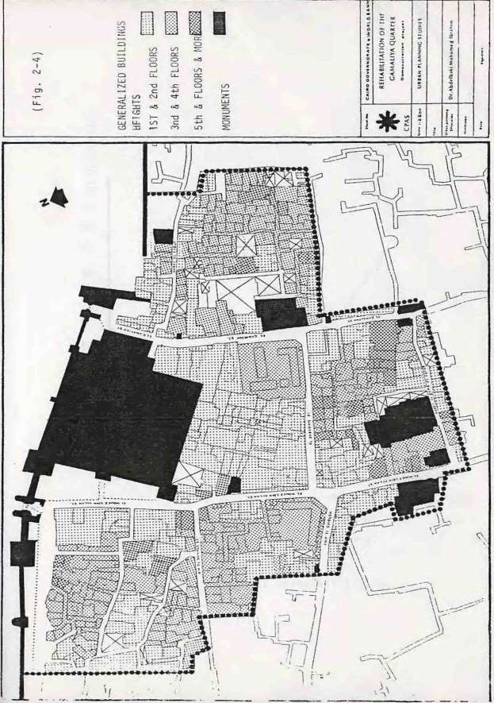

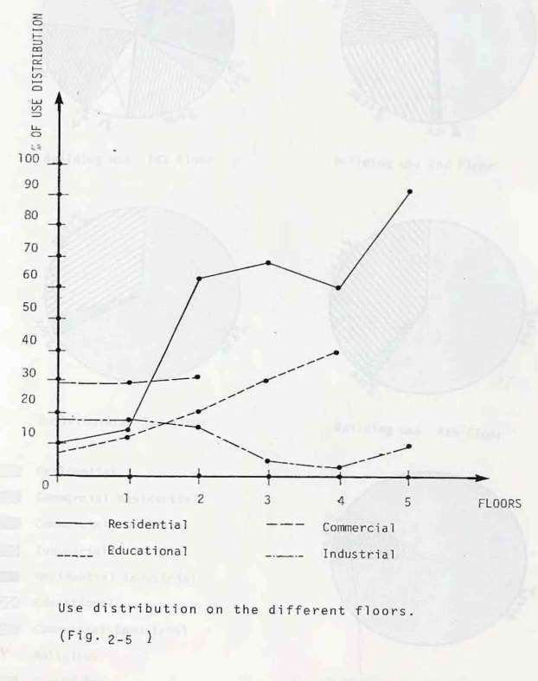

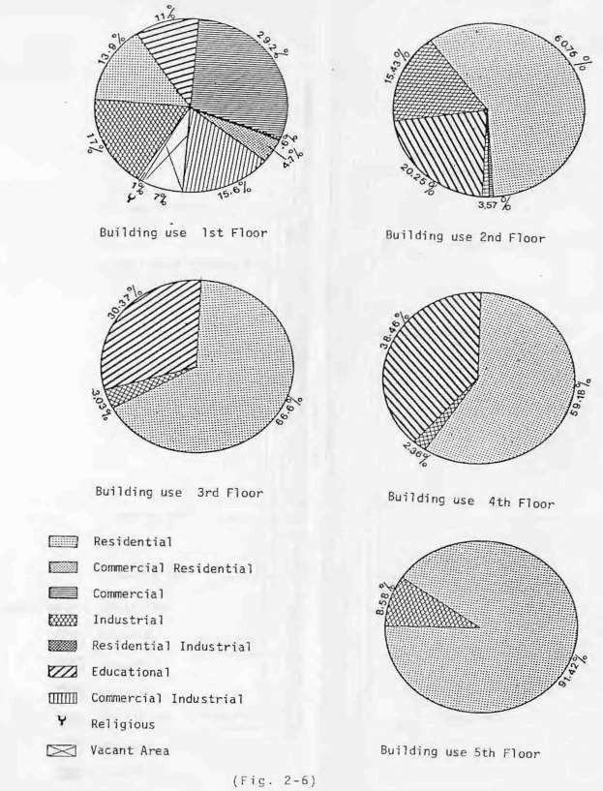

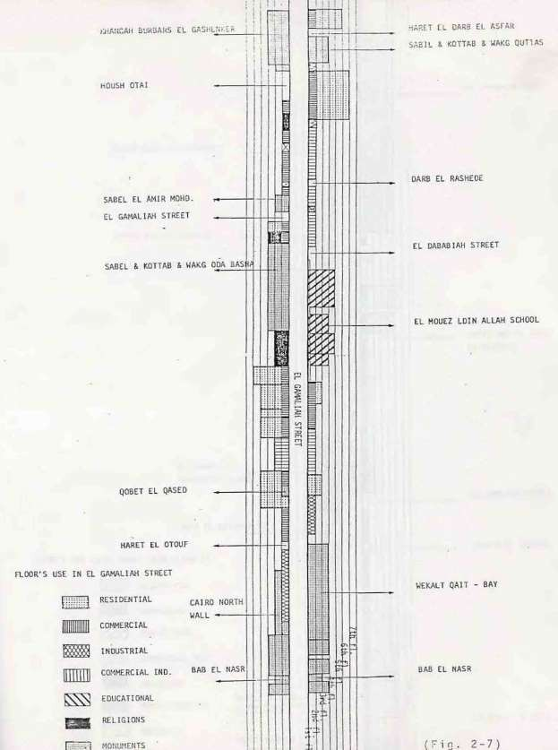

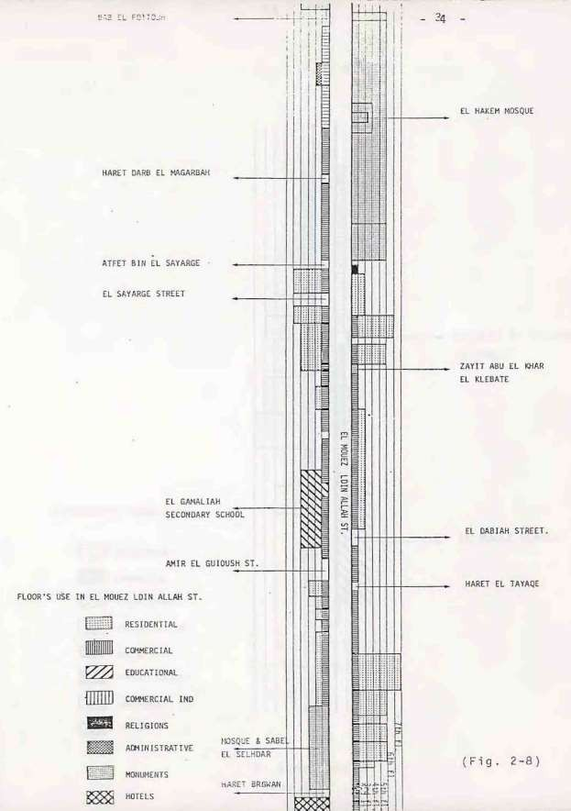

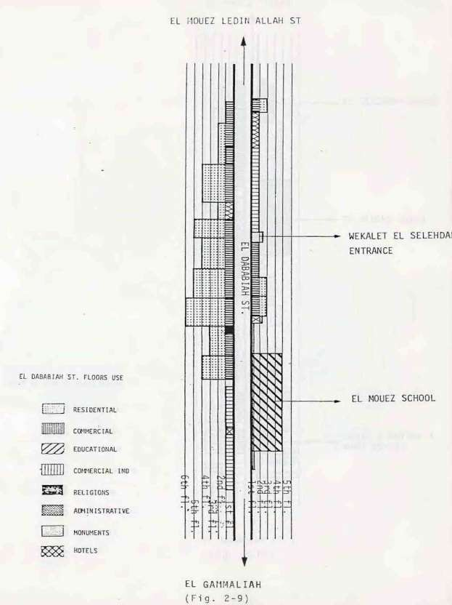

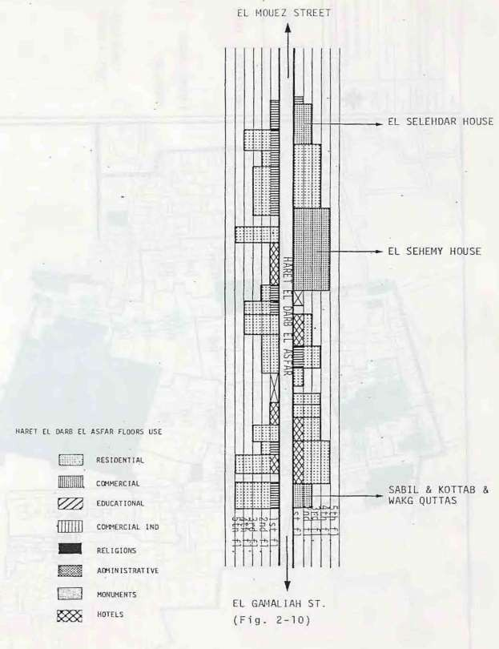

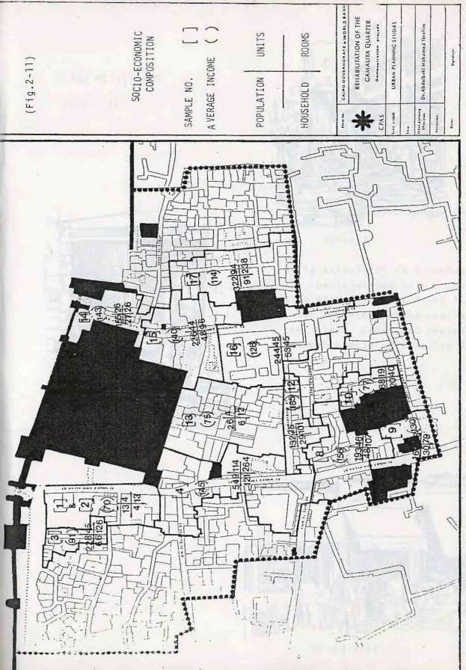

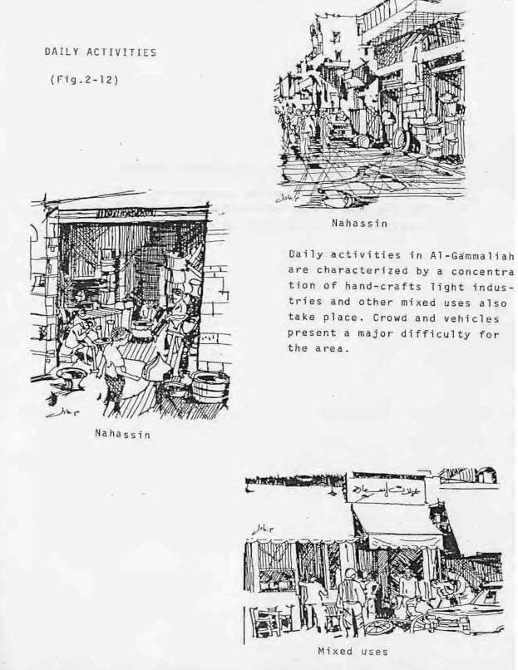

- Planning concept of Al-Gammaliah.
3-1 Introduction to the general development policy 3-2 Organization of the development process.
3-3 Planning concepts for Al-Gammaliah.

- Planning concept of Al-Gammaliah.
  - Introduction to the general development policy
The development plan of Al-Gammaliah is an integration approach for deve1oping the area in a sequence of urban communities along the main spine including the clusters of historical buildings as their centers - This requires the replacement of functions and uses according to the plan within the area. This development plan should be achieved along three levels of decisions. The first on the level of the area as a whole, the second on the level of community (harah) and the third on the level of the community cluster. The development projects will be determined on the same three levels. The action on traffic, utilities systems, community services and economic development projects could be taken on the level of the area as a whole. Upgrading and investment projects are tackled on the harah level while conservation and preservation projects are taken on the level of the cluster. The action taken at each level will be translates to programmed projects, budgets and a plan of work for the appropriate authority. (Fig. 3 – 1)

  - Organization of the development process.
To estimate the size of financial implication of the development of the area as a whole, and the role of each authority in the implementation process, it is most effective to start within the study of a demonstration area where samples of all sides of the overall development process could be represented.

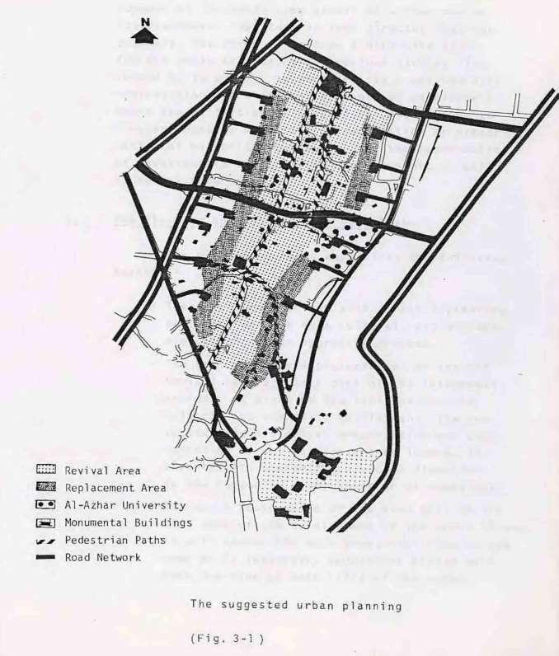

In the meantime, the outline of urban development of the whole area should be worked out as its framework. The study is then directed into two channels. The first is to draw a directive plan
For the whole area based on previous studies. The second is to examine in more details a defined area representing the different elements of development where the estimation of up-grading costs can be estimated together with cost of restoration or preservation of historical buildings, and the construction of investment projects which have economic as well as social returns

  - Planning concepts for Al-Gammaliah.
The planning concept emphasizes the following aspects:-
- The development of the area is not a planning procedure as much as a cultural, social, economic and urban upgrading process.
-The restoration and preservation of the historical heritage is a part of the integrated process. It might be the ignition for the cultural and community development. he in• vestment in historical preservation and con• servation is not for leasure or luxury, it also has its economic and social dimension in the community development of Al-Gammaliah.
-The North South spine of the area will be the back bone of the development of the urban tissue. It will absorb the main pedestrian flow in the area while subsidiary pedestrian allays will take the flow at both sides of thespine.

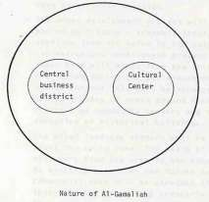

-The area will be served by a ring road and a system of loops or cu1-de-sacs serving the inner parts of the area and reaches the pedestrian spine at certain points, where traffic will be avoided unless for emergencies where pedestrian ways could be used by official vehicles.
-The urban development process will be accompanied by " Sacio- economic transaction " starting from the spine to the outside. The infrastructure development process on the other hand will start from the fringes to the inside during the socio-economic trans• action period. This will be accompanied by the up-grad ng of areas around historical _ clusters as community centers and the conservation of historical buildings.
-The mixed land-use pattern will be dominant along the spine zone. The ratio of mixture will vary from one area to the other according to existing condition and future development. Commercial uses will be starched along the spine and the subsidiary pedestrian roads.
Then come the handcraft industies within the second wave of land-use attached to the commercial uses in the same level or above. A cross-section perpendicular to the spine shows the mixture of land-uses in the different levels.
- The upgrading of built-up areas is an essential part in the development process of the area.
The upgrading operation implies technical legal and financial factors which requires a well organized management.

The upgrading operation starts from the vicinities of historical cluster to the outside of the area. The upgrading of the physical structure of the area will be a natural product of upgrading of the socio-economic structure of the community.
- The flow of sewerage water and electricity networks will eventually follow the street pattern. The existing network could be developed to absorb more capacities of sewerage and water. The capacities of net• works depend on the size of expected uses densities of expected population. Local sewerage and water networks will be part of East Cairo System.
- The shifts in touristic uses will take part along the major spine of the area. Touristic activities will not be confined to the traditional area of Khan Al-Khalili and the historical buildings. The whole area will be converted to a touristic center. The clusters of historical buildings will be developed as touristic sub- centers comprising hostels providing traditional accommodation, rest rants offering typical local specialties, show rooms selling local arts and handcrafts. Occasional celebration and processions will be given space and consideration in urban planning. The expansion in touristic activities requires special arrangements for parking areas, pedestrian malls with the special townscape of the Islamic city. The old Khans and bazars will be revived.

- The revival of the old city will not be confined to shifts in economic, commercial residential and touristic uses; the area will regain its religious and cultural functions. Old mosques will regain their comprehensive functions comprising religious, clinical and cultural activities. The revival of the functions of old mosques is another touristic asset to the area.

- Al-Gammaliah Development Policy.

  - Nature of Al-Gammaliah.
  - Decisions and planning levels.
  - Diversity of development and resources 4-4 Conflict of decisions and phasing
  - Development Agency
  - Architectural Character and the revival of the deep rooted Islamic val ues 4-7 Monumental Buildings
  - Population Densities
  - Existing building stock
  - Infrastructure and circulation network 4-11 Shift of land use

- Al-Gammaliah Development Policy.
The main policy of the up-grading development plan for the area of Gammaliah is covered in the following items:-

  - Nature of Al-Gammaliah.
  - Decisions and planning levels.
  - Diversity of development and resources 4-4 Conflict of decisions and phasing
  - Development Agency
  - Architectural Character and the revival of the deep rooted Islamic val ues 4-7 Monumental Buildings
  - Population Densities
  - Existing- building stock
  - Infrastructure and circulation network 4-11 Shift of land use

  - Nature of Al-Gammaliah.
Al-Gamrnaliah is a unique cultural and historical center and a part of the central business district at the same time. The development project must consider the equilibrium of this double nature fig. (4-1-)
    - The Cultural Center:
      - The development restoration, protection and exploitation of the monumental buildingsin the area should take place the preservation of the cultural character of the Islamic arab city.
-The social and economic historical activities of the area, should be developed protected and regenerated.
      - The disappearing activities and traditional commodities should be revived as a way of cultural development of the area.

      - The inconvenient activities, to the cultural area, like stables and polluting industries, should be removed to external locations.
    - The Central Business District:
      - The central usage of commerce3 crafts and administration mixed inside the area should be activated, especially when dealing with a change of land use.
      - The local traditional industries commerce and crafts in the area must be protected and regenerated.
      - The inconvenient activities to the central area; ie whole-sale stores and polluting industries should be removed to outside locations.
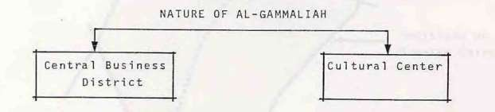
  - Decisions and planning levels.
- The planning of the area should be approached on three levels.
The level of greater Cairo region, the level of Gammaliah and the level of the action area. The interaction between the three planning levels should be considered. Decisions must be taken only on the proper planning level. (fig. 4-2).

  - Level of greater Cairo Region the decisions are related to the general policy and function of the area as a whole, major shifts of population densities and land use, main transportation arteries water and sewage main network etc.
  - Level of AT-Gammaliah: The decisions are related to the local infrastructure network, the exploitation of the local amenities, the local implementation policy and programs, the Gammaliah and vehicular road network, the local shifts of population densities and land use...etc.

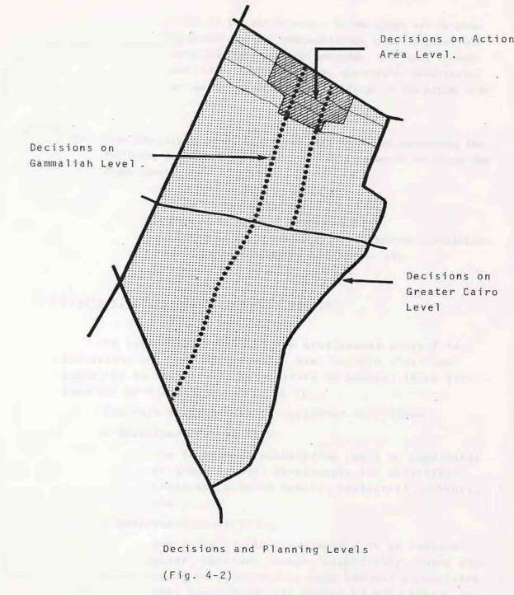

-

Level of the action area: The decisions are related to minor specific implementation issues such as the detailed implementation programs, the local streets and infrastructure network, the repair, demolishion or use change of certain buildings in the action area etc.

- From the policy above, we can see that decisions concerning the following subjects in the demonstration area would not be on the right level:
  - Major shifts of land use.
  - Changes of major utilities networks.
  - Changes at major vehicles and pedestrian circulation.
-Decrease of population densities. etc.

  - Diversity of development and resources
To assure the success of the development project in execution, the role distribution must be both clear and appealing to the various authorities to attract their attention for participation. (Fig.4-3} The role distribution is suggested as follows:
- Investment Authorities:
The investment authorities could be candidates or group capital investments for profitable projects, such as hotels, restaurants, shops, etc ....
..
- Government Authorities:
The infrastructure projects such as potable water, sanitary sewage, electricity, roads etc would be sponsored by governmental authorities. This would encourage others to participate in the development process.

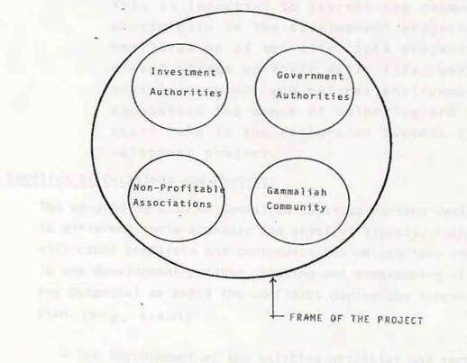

-To assure the success of the development project in execution, the role distribution must be both clear and appealing to the various authorities to attract their attention for participation. (Fig.4-3)

- Non Profitable Associations
Many non-profitable association of local and international development programs are particularly interested in cultural conservation, monument restoration, archeological researches, community up-grading and environmental development.

-Gammaliah Community
This is important to attract the community to participate in the development projects and the amelioration of the site. Such projects are of direct effect on their daily life, work, residence, social, economic and natural environment. It emphasizes the sense of belonging and assure their role in the failure or success of the development project.
  - Conflict of decisions and phasing
The up-grading plan of Gammal1ah consists various decisions related to different socio-economic and physical aspects. Such decisions will cause conflicts and contradictions unless they are all integrated in one development program. Phasing and programming of the process are essential to avoid the conflicts during the execution of the plan.(Fig. 4- 4-1)

- The improvement of the existing utilities and services in the action area might reinforce undesirable land use. It is a question of up-grading versus 1 and-use shifting, and short versus long term planning.

-The improvement of the environment and of the building conditions will increase the population density in the area. It contradicts with the developmental decisions aiming to decrease the population density. The conflict is up-grading versus population densities.

- The conservation policy might be opposed by the pressures of development and land ownership. The conflict is conservation versus public desire.

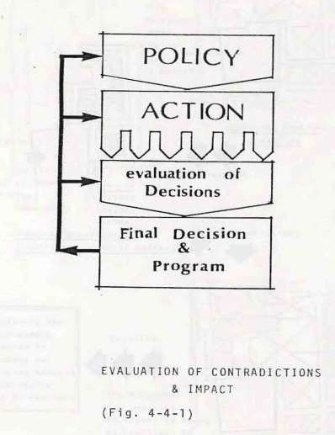

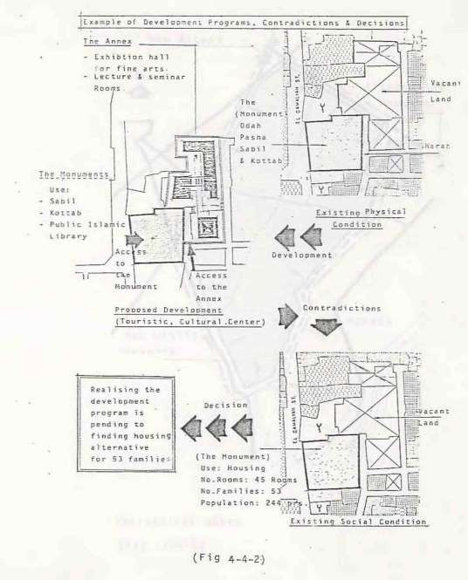

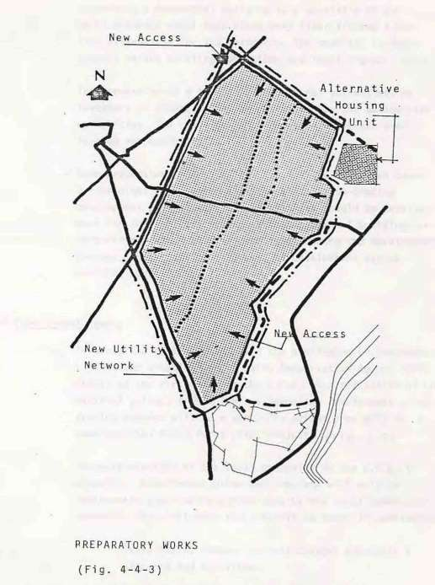
-

Converting a monumental building to a touristic or cultural activity might take place only after finding a housing alternative for its residents. The conflict is development versus existing conditions and legal rights.(4-4-2)

- The conversion to a touristic or cultural activities by investors or others, might be restricted by the antiquities authorities. The conflict is of development versus overlapping responsibilities.
-Some preparatory works, mainly outside the Gammaliah boundaries might be required as a first in the up-grading development program housing alternatives should be development for the families living in the monumental buildings or in buildings which will be demolished during the development process. This conflict is phases of development versus existing conditions. (4-4-3)

  - Development Agency
- To avoid the contradictions and the overlapping of responsibilities, the establishment & Cairo Conservation Agency (CCA) should be the first step in the C.C.A. is a reflection of the national policy, from which the Gammaliah development or upgrading program will be a part. The action area will be a demonstration field for a pi1ot project. (Fig. 4_5)
- The participation of the 1oca1 community in the C.C.A. is essential. Development plans and programs will only be implemented after being agreed upon by the local community.
Meanwhile, the following facts should be taken in consideration:
*Avoid rapid, sudden, radical changes and shift & patterns and activities.
*Avoid conflicts between the plan and land ownership and land va1ues.

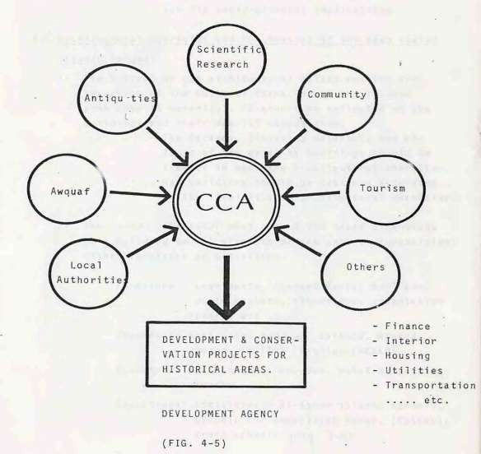
- Respecting the existing conditions social life way of life and values.
- Avoid threatening the economic activities for its socio-economia implications.

  - Architectural Character and the revival of the deep rooted Islamic values
- The Revival of the architectural values and the preservation of the cultural character of the Islamic arab city is essential. It should be reflecteden the buildings and their special composition:
  - The facades, finishing materials and colors of the existing buildings should be treated to meet the architectural character.
  - New buildings should be designed according to the local Islamic architectural character.

- The Local character must exceed the three dimensions of a building to all elements of the spatial composition; either furniture or activities.
-Furniture = Lightposts, (Street Banks) mail ffiox waste baskets, flewer box, orientation boards etc ...
-Commercial Activities =Flower essence, Mawardy, Herbs, (ATTAR) Textiles (AKKAD)
-Industrial Activities= oodden, Meta1 or textile crafts.
-Educational Activities = Al-Azhar islamic schools.
schools for memorizing Koran, (Kottab), craft schools. (Fig. 4-6)

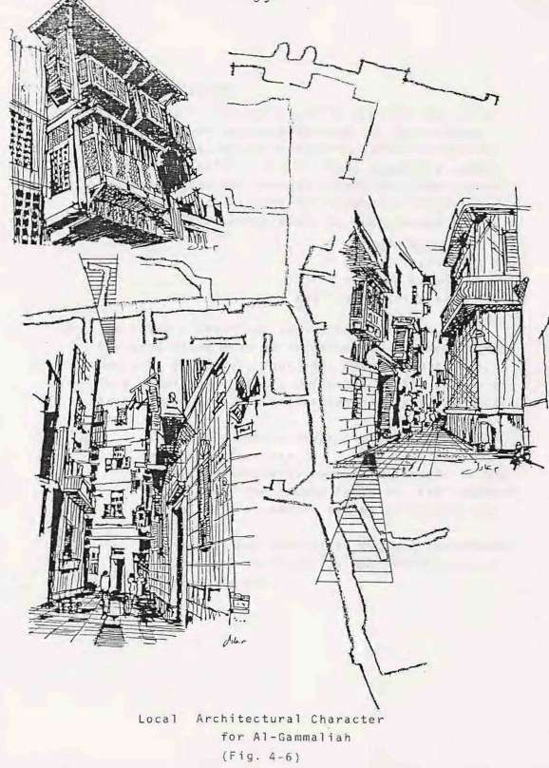

  - Monumental Buildings
- Monumental buildings should be treated else an a mere sector of services lacking for maintenance resources, to an investment sector either financtia1 or socia1 (Fig-4-7-1) They shou1d be preserved restorated and renewed. Their functions could be changed according to the suggested plan: -
  - Some monuments could be transformed to " islamic hotels " " public librairies" "islamic schools " and "art galleries "
- The islamic doctrine, the social environment and the traditions must be respected by any development project. (Cultural Touristic Economic etc ...) This should be directly reflected on the nature of development use, administration and type of recreation.
  - A mosque should never change its function to any other use.
  - Islamic monuments must be respected in the choice of the future function. For instance, a night club should not be allowed in any monument.
  - Alcohols and prohibited actions (Moharramat) should be forbidden in the restaurants of the whole area.

-

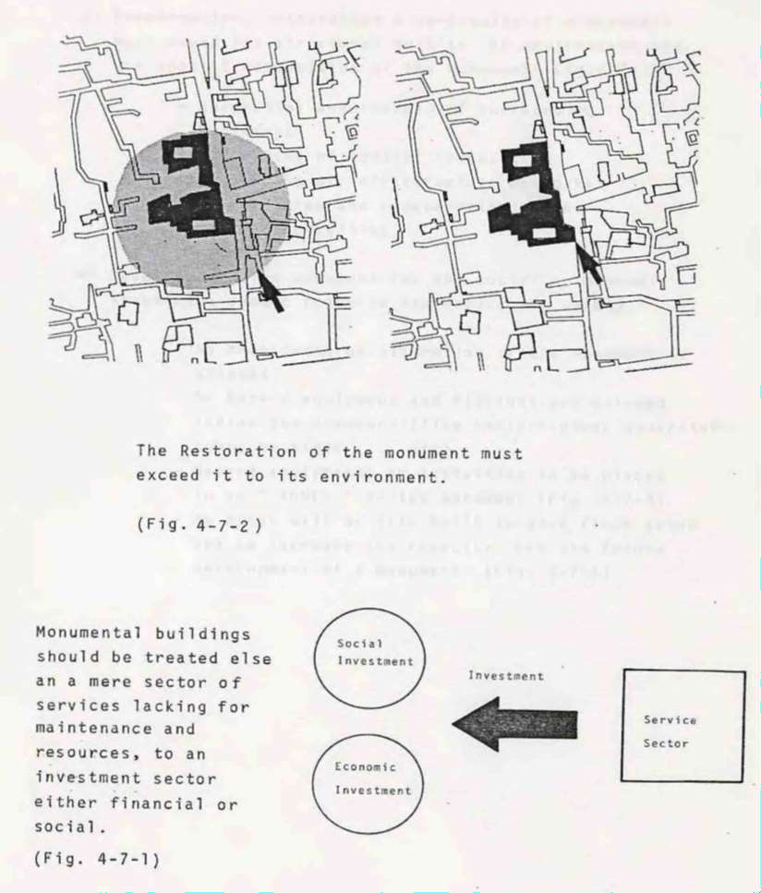

- Preservation; restoration & up-grading of a monument must exceed its structural bulk to the environment and the spatial composition of the monument (Fig.-7-2)
  - Up-grading and renewal of surrounding buildings
  - Up-grading qf spatial composition
  - Up-grading of infrastructure networks.
  - Preservation and regeneration of the related activities.
- Development of a monument for any social or economic investment should preserve and assure its safety.
  - No Architectural alteration of the monument is allowed.
-No hazard equipment and fittings are allowed inside the monument (like boilers- power generators heavy machines etc)
  - Hazard equipments or activities to be placed in an “ANNEX “to the monument (Fig. 4-7-3)
  - An Annex will be also built to give floor space and to increase the capacity. For the future development of a monument. (Fig. 4-7-4)

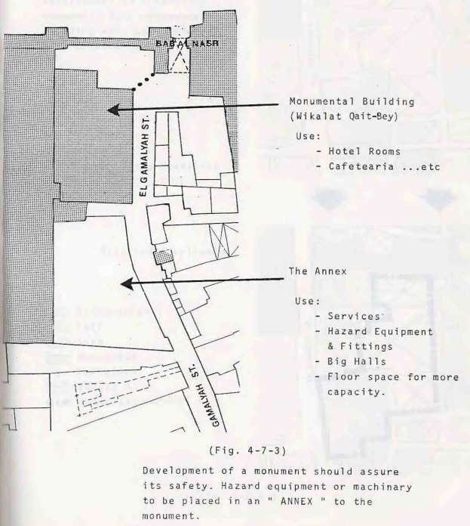

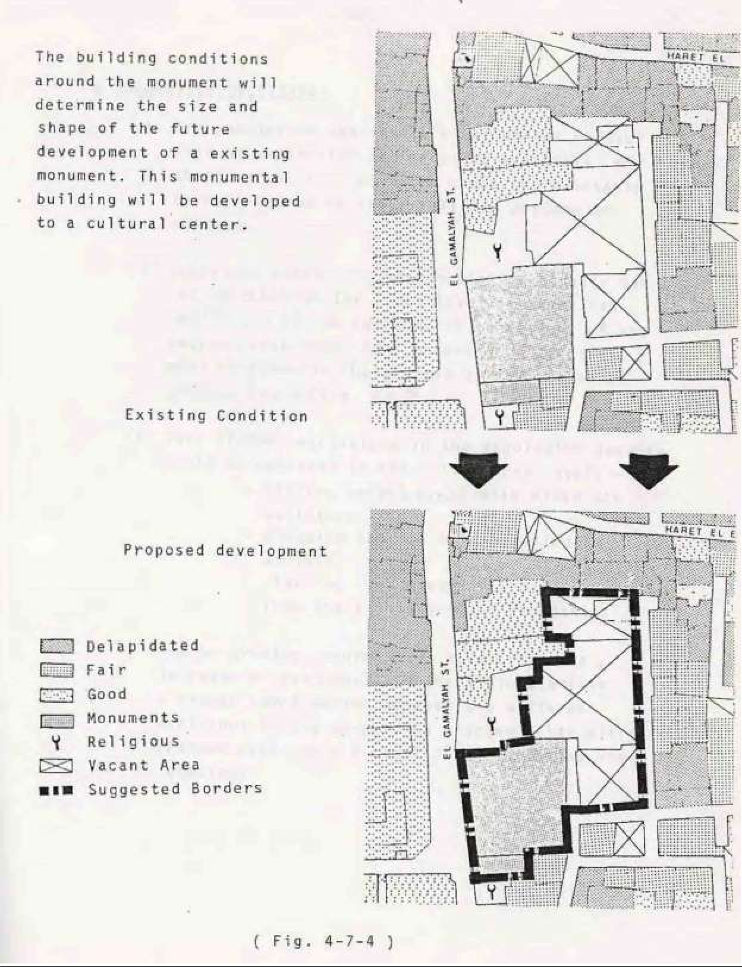

  - Population Densities
- The population density is a reflection of the size of activities and services available. Any change of activities might cause unpredictable transformation of the population pattern and density.
- Decisions concerning the population density cannot be taken on t e local level of Gammaliah regardless of the surrounding conditions of the metropolitan area. As a general policy they must be taken in the context of the region of greater Cairo. (Fig. 4- 8)
- Very limited variations in the population density could be achieved in the action area level: -
  - Filling vacant lands with mixed use buildings.
  - Changing the use of a building to another.
  - Clearing some monumental buildings from their unauthorized residents.
- The up-grading program will accelerate the increase of the population densities unless a proper coordination between the different decisions in the up-grading program takes place. (Please refer to 4.4 conflict of decisions and phasing).

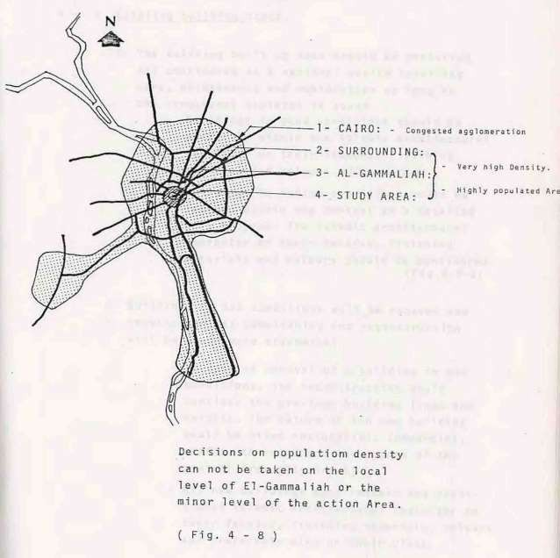

  - Existing building stock
- The existing built up mass should be preserved and considered as a national wealth requiring care, maintenance and restoration as long as the structural skeleton is sound
-Buildings in good conditions should be preserved within the Islamic architectural character on their facades, finishing material and colours.
(Fig.4-9-2)
-Buildings in medium conditions would be renewed within the context at a detailed work program. The islamic architectural character on their facades, finishing materials and colours should be considered.(Fig.4-9-2)
- Buildings of bad conditions will be renewed and required unless demolishing and reconstruction will be found more economical.
  - In case of removal of a building in bad conditions, the reconstruction would consider the previous building lines and heights. The nature of the new building would be mixed residential, commercial, crafts, to reinforce the nature of the central area.(Fig.4-9-3)
-All new buildings must respect the traditional islamic architectural character on their facades, finishing materials, colours and preferably also on their plans.

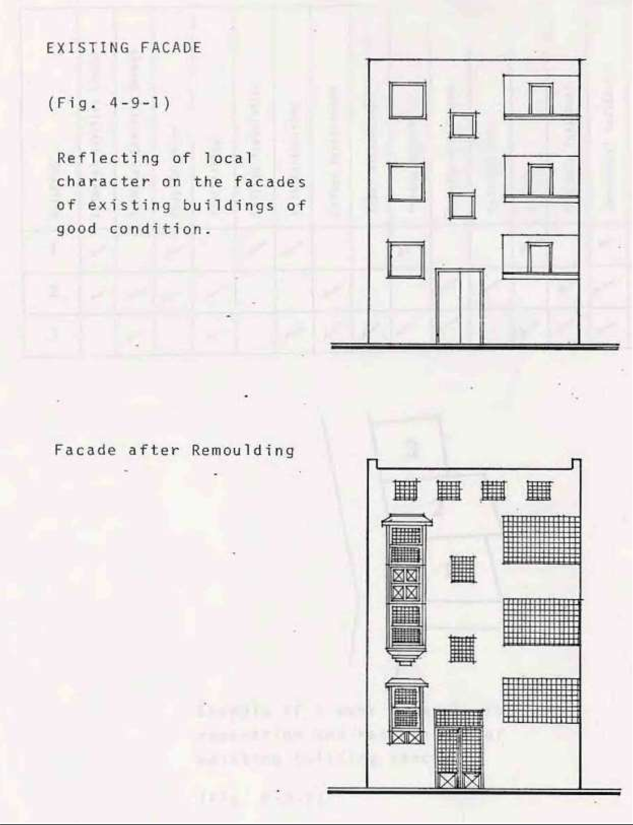

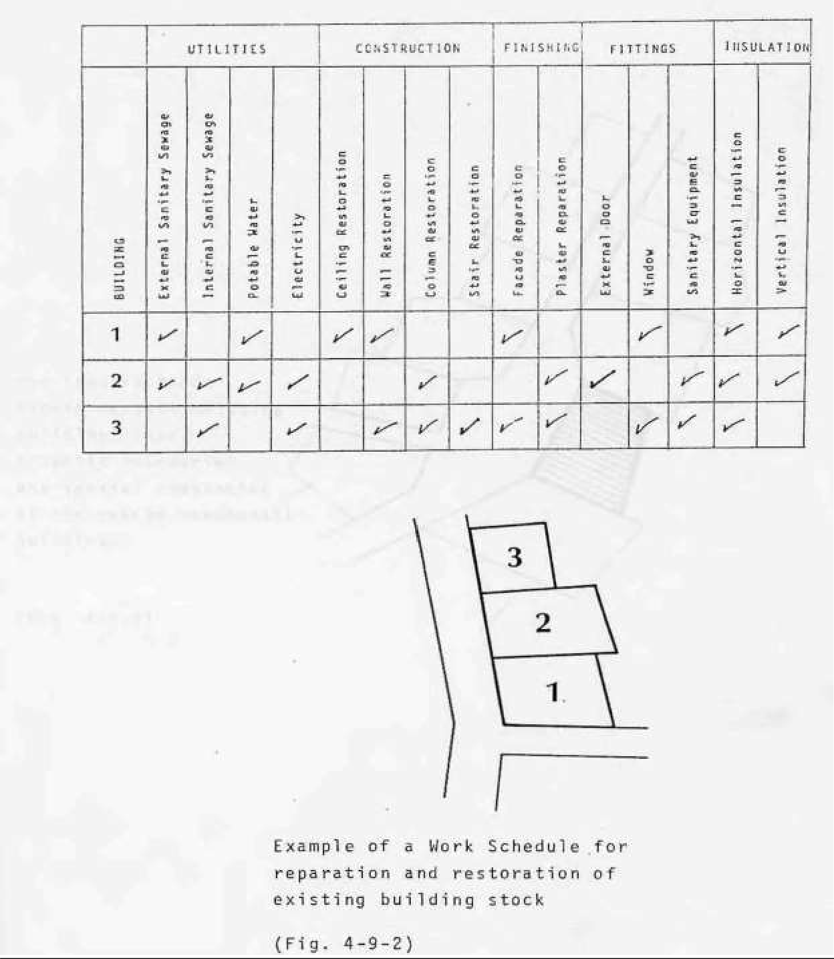

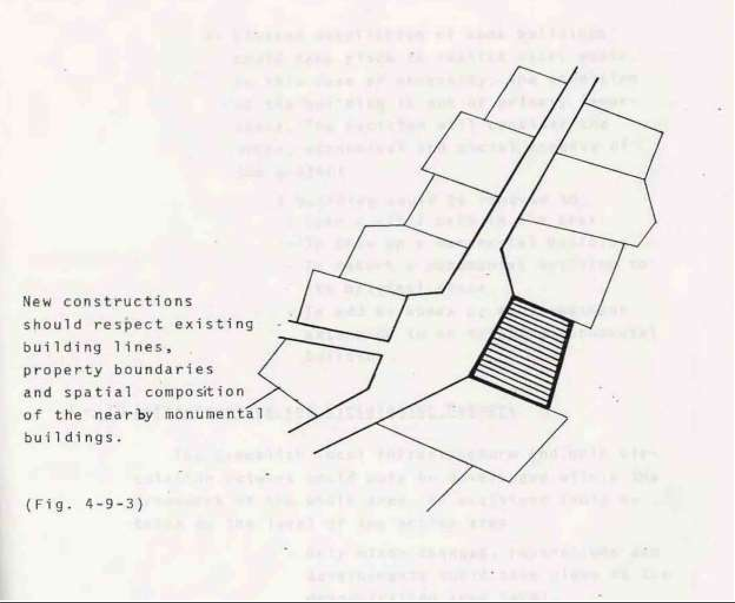

- Limited demolition of some buildings could take place to realize vital goals. In this case of necessity, the condition of the building is not of primary importance. The decision will consider the urban economical and social aspects of the project A building would be removed to:
  - Open a vital path in the area.
-To show up a monumental building.
-To return a monumental building to its original state.
-To add an annex or an investment extension to an existing monumental building.

  - Infrastructure and circulation network
The Gammaliah local infrastructure and main circulation network could only be developed within the framework of the whole area. No decisions could be taken on the level of the action area.

- Only minor changes, reparations and developments could· take place in the demonstration area level.
- The decisions to be taken on the action area level ought to be looked at within the context of the whole area of Gammaliah. They will be a subject for the implementation pro• grams and priorities (Fig.4-10) (Please refer to 3.3. Diversity of development and resources.
(Please refer to 3.4.Conflict of decisions and phasing}.

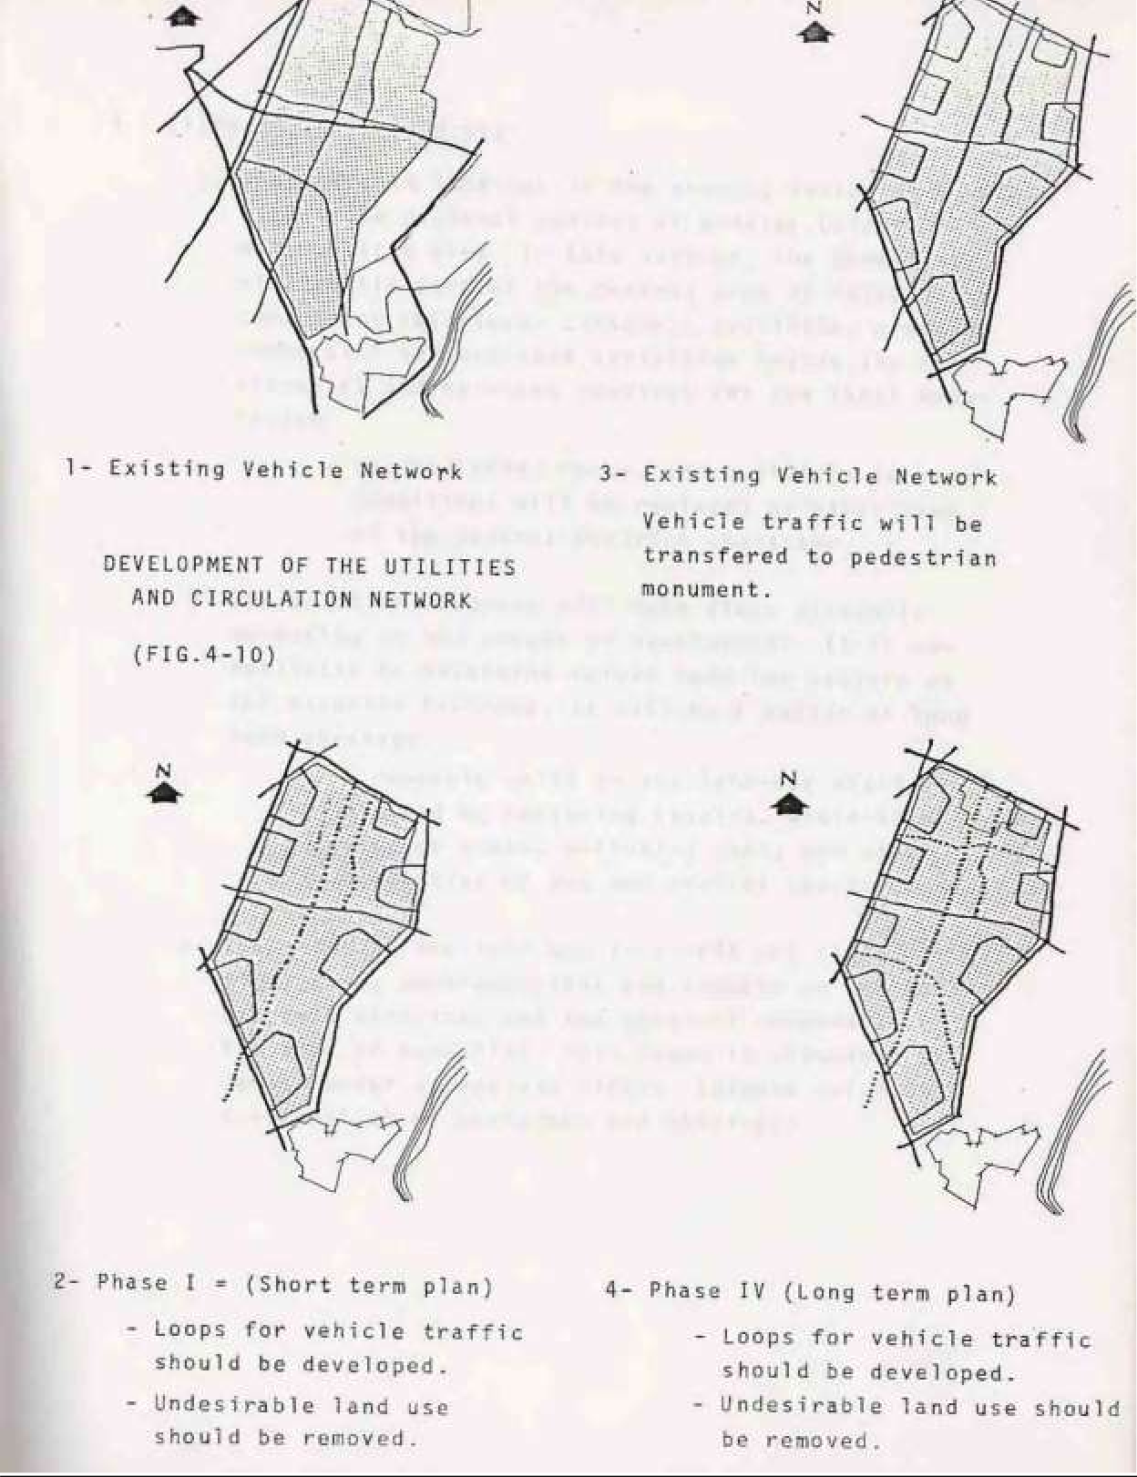

  - Shift of land use
- The shift in land-use in the area is looked at within the regional context of greater Cairo metropolitan area. In this context, the Gammaliah will remain part of the central area of Cairo comp risingre1igious cu1tura1, touristic., crafting commercial and business activit1es beside the residential and services required for the local population.
  - Vacant lands, ruins, and buildings in bad conditions will be replaced by other uses of the central district character.
- The shift in land-use will take place gradually according to the stages of development. It is un• realistic to determine beforehand the pattern of the expected land-use. It will be a matter of long term strategy.
  - A feasible shift in the land-use might be limited by replacing stables, whole- sale storage areas, polluting uses, and other activities of the non-central character.
- The shift in the 1and use is acritica1 issue. It might cause contradictions and impacts on the socio•economic structure and the physical components of the area of Gammaliah. This issue is discussed in detail under a separate tittle. (please refer to 4.4. Conflict of decisions and phasing).

5- Preliminary concept for the Urban Planning of the demonstration area. 5-1 The Main Spine.
5-2 The Northern Monumental Complex. 5-3 Wakalat Qait-Bey
5-4 Midan Al -Nasr Gate and the Cairo North - Eastern wall 5-5 The Sourthern Border of Al-Hakim Mosque
5-6 The industrial area, south to Al-Hakim Mosque 5-7 sabi1 and Kottab Auda Basha
5-8The Complex of Beit El-Seheimy and Beit Al-Selehdar. 5-9 Other monumental buildings.
5-10 Other buildings and Urban places. 5-11 Streets and Paths
5-12 Utility network

- Preliminary concept for the Urban Planning of the demonstration area.
The outline of the preliminary concept of the development of the demonstration area, within the context of the general and executive planning policy of the Gammaliah, is as follow:(Fig 5-1)
  - The Main Spine.
The area situated between El-Muez street and Al• Gammaliah street will have to be accentuated as an area of central activities, commercial and craftwork within the frame-work of the proposed land-use of the main spine of the whole quarter of Gammaliah. The central uses will decrease in the lateral direction to the exterior, where the residential use will predominate.
  - The Northern Monumental Complex.
Al-Hakim mosque, Wekalat Qait-beY,,Al-Nasr and Al• Fotouh gates and the Northern Cairo wall should be considered a focal point for the various urban development and touristic projects for the demonstration area speciallyand the wholearea of Gammaliah in general.
  - Wakalat Qait-Bey
Waka1et Qait-Bey could be restored and transformed to an islamic touristic hotel. The actual capacity of the wakalat is of 26 rooms, that could be increased to the double with the work of restoration and the annex.

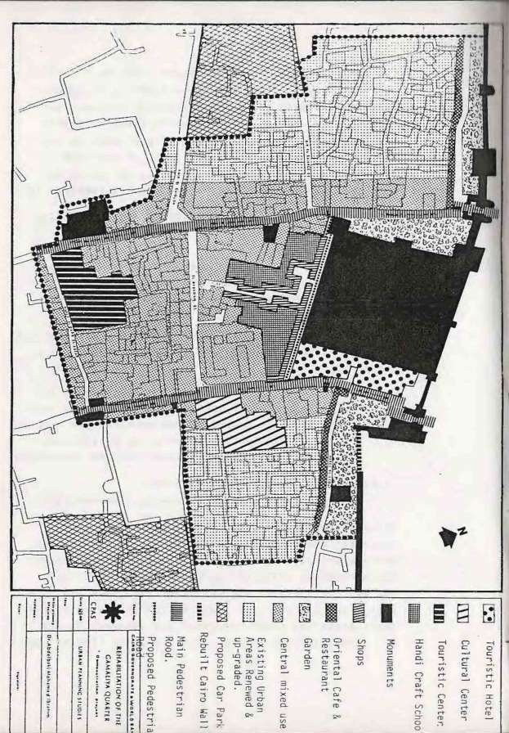

The buildings on its south should be removed. On their place, an annex including the services of the hotel; the kitchen, the laundry the emergency generator and the storage, and any other uses that can harm the monumental building, might be built. Thus, the Wakalab should be left for the residential use of the tourists, and other light usages (ex. cafeteria, restaurant etc0 that cannot affect its serenity.
The acceptance of such suggestions necessitates solutions for the following problems:
- An alternative residence must be developed for 156 persons members of 27 families actually living in the Wakalat. The alternative housing should also include the residents of the buildings to be removed for the annex of the hotel.
- The owners should be compensated for the buildings and lands that might be necessary for the annex.
- The owners must be compensated for their shops and light industries workshops, in case of any resulting harm from the development plan.
  - Midan Al -Nasr Gate and the Cairo North - Eastern wall
The integration of the whole area is crucial. In this context, the demolished part of the Northern Cairo wall, must be reconstructed. The existing spontaneous buildings in Midan Al-Nasr must be removed. Also, the buildings between harat Al O'touf and the Northern Cairo wall should be cleared. An islamic garden would take their place. The fades of the buildings facing the garden and the wall must be treated to meet the islamic architectural character.
In the ground floors, some oriental restaurants, café and hand crafts shops might take place. The acceptance of those suggestions necessitates the solutions for the following problems:
    - An alternative housing should be developed for the residents of the buildings to be removed because of the restoration work, the completion of the wall construction and the islamic garden.
    - Appropriate capitals to fund the restoration, the development plan and for the compensations.
  - The Sourthern Border of Al-Hakim Mosque
A commercial pedestrian path should be conceived along the southern wall of Al-Hakim Mosque and Bein Al-Sayareq street, thus linking El-Muez street and Al-Gammaliah street. The shops would not exceed one floor on the opposite side of the mosque.
The acceptance of those suggestions necessitates: -
    - Payment of the appropriate compensations.
    - Having the suitable capital to fund the restoration of the southern wall and the development of the commercial passage.
  - The industrial area, south to Al-Hakim Mosque
(crafts & commercial center)
Dilapidated buildings, worshops and stables have to be removed from this area. A craft center and a school could replace those activities, and in the mean time be considered as a point of attraction

for tourists. The suggested above shops along the new street to the south of Al-Hakim Mosque could serve for the marketing of the products.
The acceptance of this suggestion necessities:
-Payment of the appropriate compensations.
-Having the suitable capital to fund the craft school and center.
  - sabi1 and Kottab Auda Basha
(Cultural Center)
Sabil and Kottab of Auda Bacha m t be cleared from its residents and restorated. The Kottab (School for memorizing Koran} could be developed. An islamic library with old Islamic manuscript could be added.
The adjacent vacant land could be used to build an annex to the monument. This annex might be used as a fine art gallery and a cultural lecture room.
The acceptance of such suggestion necessitates:
- An alternative residence for 244 persons, members of 53 families actually living in the Sabil.
- The appropriate capital to fund the restoration, the furnishing of the monumental building and also for the construction of the annex.
- Appropriate compensations should be payed to the owners of the adjacent vacant land
  - The Complex of Beit El-Seheimy and Beit Al-Selehdar.
(The Touristic Center)
Beit El-Seheimy and Beit Al-Selehdar must be both restorated and renewed. The dilapidated house situated between then1 could be removed, and its area to be used to built an annex comprising a restaurant, a cafeteria and an oriental garden. Also the vacant land situated on the western side of Beit El-Seheimy could be used for an oriental garden.
The acceptance of those suggestions necessitates: -
- An alternative residence must be developed for 65 persons, members of 14 families. actually living in the monuments.
- An appropriate capital to fund the restoration of the monuments, the ownership of the vacant lands, the demolition of the dilapidated house and the various development works.

  - Other monumental buildings.
The following monuments should be restored and renewed. Dome of Al-Kased, Sabil of Al-Amir Mohammed, Khanekah of Baibers, Al-Selehdar Mosque, Zawiyat Aboul
Kheir Al-Kilani - Appropriate funds are needed. 5-10 Other buildings and Urban places.
-New buildings should meet the architectural islamic character. Their facades must be treated
to fit with the environment. Some Mashrabiahs could be added. The color or the external plaster might be changed. The use would remain unchanged.
-Buildings in good conditions must be renewed and repaired. The architectural islamic character must be respected on their facades.The remaining uses must not be disturbing for the area.
-Buildings in bad conditions either to be repaired or removed and reconstructed, respecting the previous area the building lines, the property and height.The islamic architectural character must be respected. Commercial shops might take all ground floors, administrative and residential use might follow in the upper floors to keep the central character of the area.
  - Streets and Paths
-All streets and paths must be for pedestrian only. The spatial composition should be restudied in the light of the nature of the touristic area (light posts, flooring, street banks….etc) The special sequence and the visual perception must be respected for their high aesthetic value.
-A visual and spatial contrast must exist between the main spine and the secondary paths. The feeling in El-Muez street and Al-Gammaliah street should be different from the h rahs and the other streets. For instance, Al-Dabbabiah street and harat Al-Darb Al• Aafar might be covered by light tents or wood·work.
-It must be taken in consideration that the decision of keeping the traffi c out of the spine cannot be taken on the level of the demonstration area alone, but on the level of the whole area. It mig ht be considered as a long term strategy.
  - Utility network
Actually, some local reparations must take place for the utility network. The streets should be cleaned and tiled. The overall repairs for the whole network will be on a long term strategy and through the reparation of the whole area.

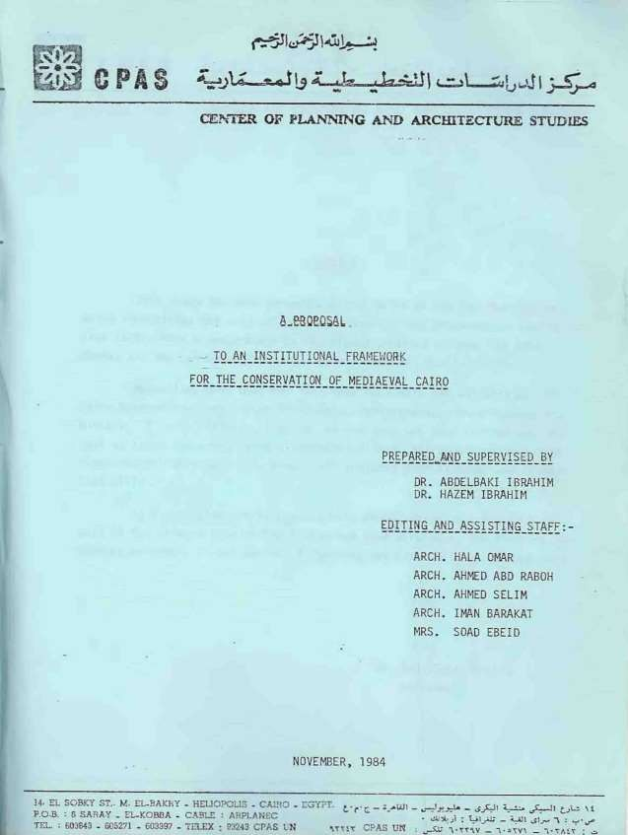

PREFACE

This study has been prepared on the basis of the job description, which identifies the duty of the administration and organization specialist (ADS). This in accordance to the signed contract between the Arab Bureau and the Center of Planning and Architectural Studies(CPAS).
Meanwhile, Cairo Governorate, many meetings have been held with the authorities Hayy Wasat A1-Kahi rah, Infrastructure directorates and Ministry of Social Affairs. A survey of the area has been carried out, as well as inquiries among social, professional and craftsmen committees and organizations working in the area, that included Darb Al-Ahmar and Gammaliah districts.
It is our pleasure to present this study, which is a fruitful result of the efforts done by the integrated team working at the Planning and Studies Sections, in the Center of Planning and Architectural Studies(CPAS).

Dr. Abdelbaki Ibrahim President

TABLE OF CONTENTS INTRODUCTION

- PROPOSAL
  - The Proposed Approach to the Institutional Structure. 1-2 Nature of Mediaeval Cairo Consertion Organization. l-3 Objectives of the Organization.
1-4 The General Organizational Structure. 1-5 The Internal Organizationa1 Structure.
l-6 A Brief Job Description of the Key Personnel. 1-7 Preliminary Steps to the Establishment.

APPENDIX I
1- THE EXISTING CONDITION IN THE STUDY AREA
l-1The Administrative Structure.
1-2 Roles and Responsibilities of Hayy Wasat Al-Kahira. 1-3 Decision Making and Project Approval.
1-4 Existing Associations in the Study Area•

LIST OF ILLUSTRATIONS

FIG.1: General Structure of Cairo Conservation Organization FIG.2: The Steering Committee of Cairo Conservation Organization
FIG.3: Internal Organizational Structure of Cairo Conservation Organization. FIG.A-1: Administrative Borders of the various districts in Hayy Wasat Al-Kahira. FIG.A-2: Administrative Borders of the Quarters Hayy.
FIG.A-3: Administrative Borders of Subsidary Districts {Shiakhas) FIG.A-4: Procedure of Decision making and approval.
FIG.A-5: Tables of Voluntary Associations in the Area.

INTRODUCTION: -

There are many organizations and authorities interested in Mediaeval Cairo. Those authorities are the General Organizati0n of Antiquities, Minis try of Waqfs, Ministry of Local Governments represented through Cairo Governorate, Ministry of Construction and Rehabilitation represented through General Organization of Physical Planning (GOPP) besides other local and governmental authorities as Ministry of Interior, Transportation Tourism and other governmental sectors as well.
In addition to these authorities, there is the society itself whose interests are declared either in publicopinion or through the council of Local Governorate and the religious and socio-economic activities in the area.
In order to assure the success of the development project in the area, all the organizations and authorities involved who have a common interest in the area must be unified in one entity such that its• efforts are coordinated and to avoid interference and conflict of roles and activities of each of these organizations and authorities.
To reach appropriate decrees for the establishment of such an administrative authority. There are many steps to be taken and a certain procedure to be followed; this may sound exaggerated and it is sometimes negligible to some sectors, yet, Midiaeval Cairo is worth of all this effort for its architectural and urban heritage, that reflects he Islamic culture along the ages in the Middle East, starting from the beginning of Islam Ummayad, Abbassoids, Tulunid, Fatimid, Aubid, Mammeluk, Othomens and Mohammed Ali’s successors and ending after the 23rd of July1952 up till now.

1-Mediaevel Cairo refers to Historic Islamic Cairothat will be considered the area worth of conservation and development. This area will include parts of Bab El-Sheria Gammaliah El-Darb El-Ahmar, Abdein districts.

This study will discuss the following items: -
l-The Proposed Approach to the institutional Structure. 2- Nature of “Cairo Conservation Organization”
- Objectives.
- The General Organizational Structure. 5- Internal Organizational Structure.
6- Brief Job Description of Key Personnel. 7- Preliminary Steps to the Establishment

The preceding proposal is based upon the studies carried out, showing the existing conditions in the area. These studies will be discussed in the appendix.

1- THE PROPOSAL
TO THE INSTITUTIONAL FRAMEWORK

  - The Proposed Approach to the institutional Structure
Mediaevel Cairo is considered a field of Common interest of several organizations, each of which has its own interests, its own view of priorities its' own faci1ities and capabi1ities that might interfere or conflict with those of another organization in the same area especially when enlargement of development projects in the area is involved. This might negatively affect the development programmes of one organization in favour to the other which will end in the failure of efforts of both.
Therefore, it is important to coordinate all these organizations in one entity, through which efforts are organized and coordinated, concepts are unified and priorities are programmed to avoid confliction and to prevent duplications in order to achieve the success of development programmes in the area.
In other wands, it is suggested to establish a “Cairo Conservation Organization" (cco) that will have its own 1ega1 status through 1egislations that accentuate its nature, aspects of its activities, organizational framework and its' resources.

  - Nature of “Cairo Conservation Organization”

This Organization attains its nature from that of the area itself and from the role required from it. Although Mediaevel Cairo is a unique area in its style and includes precious treasures, yet, it is in a very bad condition; due to the great economic importance of the area as a part of the center business district of Cairo and due to the multiplication of authorities involved in the a-rea, it is necessary to establish one big entity, capable of dealing with the various aspects of the area, making decisions and executing them freely away from governmental routine constraints.

In this context some alternatives to the proposed organization are suggested and will be discussed. First Alternative
    - Establishing an-investing company for “Cairo Conservation Organization " Such an alternative will change the activity of the authority into the commercial and economic investment field already activated in the area. Accordingly, a large sector (cultural sector) will be neglected-unless it is benefit able and directly profitable because the cultural and social development activities are not of direct interest of the Organization. Thus, this concept is not recommended.
Second Alternative
    - Establishment of an organization affiliated to one of the Governmental Cultural authorities such as Ministry of Culture or Academy of Scientific Research.
This alternative will direct the activities of the Organization into cultural and scientific activities. Accordingly, the cultural aspects only will be accentuated and emphasized, thus neglecting the

economic aspects, capital and necessities of economic development in the area. This will end by the failure in achieving the objectives of the organization.
This alternative is not recommended. Third Alternative
    - Establishment of an organization affiliated to one of the existing Ministries directly related with the area (Ministry of Construction and Rehabilitation - Ministry of Local Government MLG).
This alternative does not ensure the success of the orga•nization because the parent authority's interest will affect the main features of the activities and it might be uncap able of convincing all the authorities related to the area to form a teamwork in one entity• as a partner, to achieve the objectives of the " Cairo Conservation Organization) (CCO)
This alternative is not recommended. First Alternative
    - Establishing an-investing company for " Cairo Conservation Organization '' Such an alternative will change the activity of the authority into the commercial and economic investment field already activated in the area. Accordingly a large sector (cultural sector) will be neglected-unless it is benefit able and directly profitable because the cultural and social development activities are not of direct interest of the Organization. Thus, this concept is not recommended.
Second Alternative
-Establishment of an organization affliated to one of the Governmental Cultural authorities such as Ministry of Culture or Academy of Scientific Research.
This alternative will direct the activities of the Organization into cultural and scientific activities. Accordingly, the cultural aspects only will be accentuated and emphasised, thus neglecting the economic aspects, capital and necessities of economic development in the area. This willend by the failure in achieving the objectives of the organization.
This alternative is not recommended. Third Alternative
    - Establishment of an organization affliated to one of the existing Ministries directly related with the area (Ministry of Construction and Rehabilitation - Ministry of Local Government MLG).
This alternative does not ensure the success of the because the parent authority’s interest will affect the main features of the activities and it might be uncap able of convincing all the authorities related to the area to form a teamwork in one entity• as a partner, to achieve the objectives of the " Cairo Conservation Organization) (CCO)
This alternative is not recommended. Fourth Alternative
Establishment of an autonomous governmental organization.

Such an alternative avoids the draw-backs of the previous alternatives and establish a governmental organization involving all members related to the area. It will be under direct supervision of the Council of Minister so Thus this organization will be capable of making decisions and flexible in work and can coordinate the efforts between the different authorities.
…………..This alternative is recommended

  - Objectives of the organization
    - To lay down the general policy for development and conservation and renewing of Historical Cairo
    - Preparation of socio-economic and physical development plans or nominating those capable of this task.
    - Approval of socio economic and physical development plans in the area.
l-3-4 Supervision and follow up the implementation of socio-economic and physical development projects in the area.
1 3-5 Co-ordination between projects and the different authorities working in the area. 1-3-6 Providing adequate finance and resources required for the different projects.
1-3-7 Laying do\the execution list and suggesting the legislations that control the development plans in the area.
l-3-8 Carrying out researches related to the nature of the area and coordinating between the Scientific Research Academies and, Antiquities organizations.
    - Assigning and training of technical personnel capable of preparing and executing projects of the conservation and development programmes
    - Making scientific and technical channel programmes with international organizations interested in Conservation and development of Historical Cairo.
    - Taking part in the establishment of committees and companies directly related with the investment and development of the historical area through the formal governmental channels.
    - Proposing a system of incentives to ensure the sharing of the society in the conservation and development of the historical area.
  - The General Organizational Structure.
The proposed structure of the organization consists of a steering committee with technical consultants. The work of the general manager of the organization will be under supervision of the committee.
The organization is divided into four internal sectors: planning sector, economic and finance sector, project implementation sector and assisting technical sector, these in addition to the organization’s administration. (Fig. 1)
*Steering Committee
The Committee includes all Ministries directly related with the Area and their representatives as follows: -
- Ministry of Loca1 Governments:
Cairo Governorate – Chairman Head of Mid Cairo district's Council - member

- Ministry of Construction and Rehabilitation: -
General Organization of Physical Planning (GOPP)- Member
- Ministry of Culture:
General Organization of Antiquities (Member)
- Ministry of Tourism:
General Organization of Restraining Tourism in Cairo(Member)
- Ministry of Wakfs:- Properties directorate (Member)
-Head of Mid Cairo district public council (Member)
- Manager of “Cairo Conservation Organization " (Secretary)
The Committee might invite other members representing other governmental organizations, consultants and others either to take part in the committee's activities or to give the necessary recommendations. (Fig. 2)
  - Internal Organizational Structure.
The internal structure of the organization will be composed of the following members;- (Fig. 3) 1-5-1 The General Organization manager assisted by a technical coordinator and as administrative assistant.
1-5-2 The technical coordinator will supervise over the technical sections whi1e the administrative assistant will supervise over the administrative sections.
The technical section is composed of: -
    - Planning department which includes physical planning, infra structure, environment and housing departments within social, economic and urban aspects.
    - Economics and finance department which in turn is composed of finance, marketing and economic planning departments:
    - Project implementation department which consists of the urban section whose activities cover up all urban, infra• structure and environmental aspects and the population section whose activities deal with the socio-economic aspect of the population.
    - Supporting technical department which consists of survey, mapping, information co- ordination and supervision, advertising training and general communications departments.
1-5-5 The Genera1 administration of the organization is composed of financial, personnel sales purchase

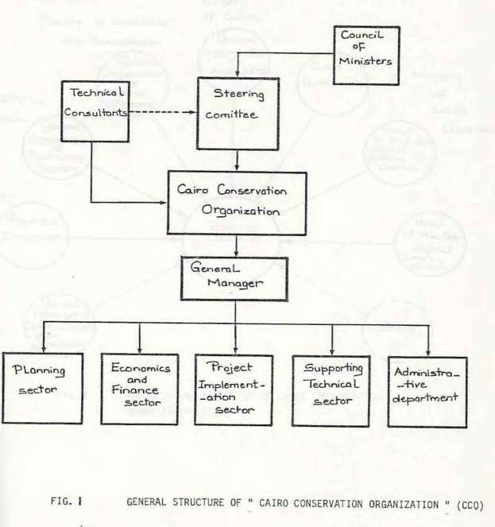

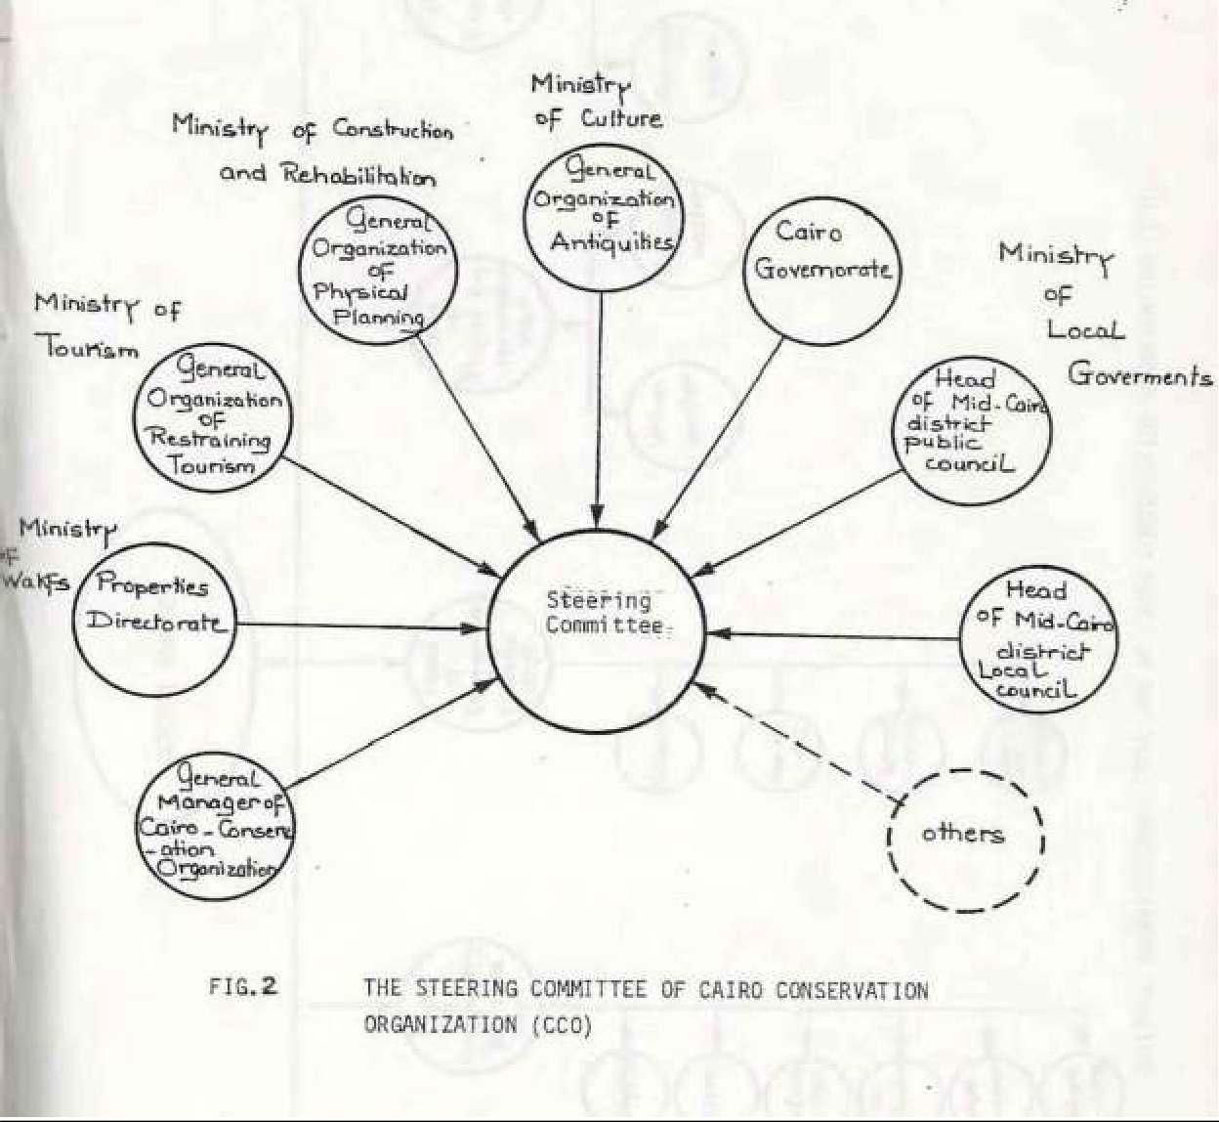

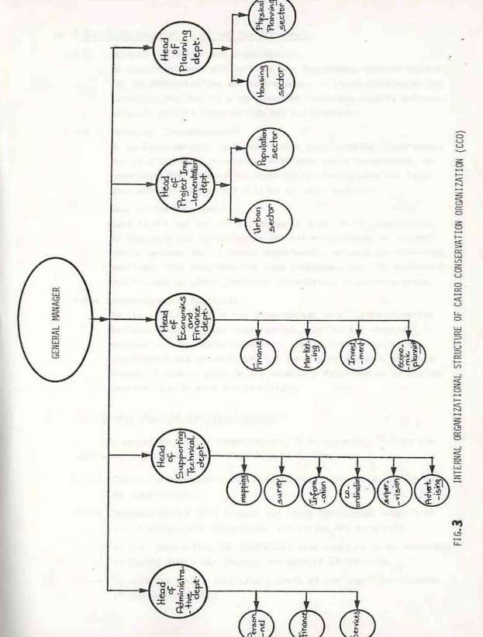

- Brief Job Description of Key Personnel.
l-6-l General Manager of the Organization: -
He supervises over all sections and departments whether technical on administrative and participates in the activities of the steering committee as a chairman and nominates experts and con• sultans for the organization and the Committee.
l-6-2 Technical Coordinator: -
He works as an assistant supervision over technical departments and as a technical coordinator between these departments. He represents the head of the organization during work and lays• down work programmers and follows up their execution.
    - Head of the Department: -
Each in his own specialization works under direct supervision of the technical coordinator and within the range of coordination between meetings lays and follows up the different departments, attends coordinating down detailed work programmers for his department their execution to achieve a high performance.
    - Administrative Assistant: -
He assists the head of the organization in all administrative matters concerning the organization, assiststhe technica1 manager is administrative matters concerning the technical departments and co-ordinates the administrative work with the technical work to provide the necessary requirements to achieve maximum flow of work and discipline.
- Preliminary Steps to the Establishment
To establish such an organization, it is suggested to take the fo11owing steps as a preliminary stage as follows: -
    - The Cairo Governorate will make an initiative to establish such an organization.
    - The Governorate will discuss and study the various aspects of the organizations' objectives, activities and structure.
    - It will then define the historical area required to be conserved by laying down a map showing the borders of the area.
    - It will lay down a preliminary draft of the legal constitution of the organization.
    - Meetings to exchange views are to be held to unify the activities with other authorities directly related with the area and may be nominated as members of the steering committee in order to reach an agreement on the principles of the administrative regulations and legal constitutions of the organization.
    - Announcing the idea of: estab1ishing the organization, its aim, ro1e and activities to the responsible authorities and institutions in order to reach a principle approval to the establishment of the organization.
    - Discussing the proposed draft of the organizational administrative list with the CAPMAS before laying down the final draft and assigning it from CAPS.
    - Discussing the draft in its final form with the responsible authorities to get the approval and assignment of establishment of the organization.

1- Appendix

- The Existing Condition
  - The Administrative Structure
  - Roles and Responsibilities of Hayy Wsat Al Kahirah 1-3 Decision Making and Project Approval
1-4 Existing Associations in the Area

l- THE EXISTING CONDITION IN THE STUDY AREA 1-1 THE ADMINSTRATIVE STRUCTURE
    - The study area is situated in Hayy Wasat Al-Kani (Middle District Quarter of Cairo) which includes the following districts (Sections) (Fig.A1) & (Fig.A2).
      - Kism Bab El-She'reyah
      - Kism A1- Mosky
      - Kism A1- Gamrnaliah
      - Kism A1- Darb Al-Ahmar
    - The study area includes parts of the Kisms of Al-Gamrnaliah A1- Darb Al-Ahmar and Bab El-She'reyah. it is divided to the fallowing Shiakhas (Subsidiary districts) (Fig.A3).
      - Bab El-She'reyah and Al-Sha'rany from Kism Bab El-She'reyah
      - Beni El-Sourein Al-Koronfish, Gawhar Al-Kaed, Al-Hamzawi, Bab El-Fotouh, Khan El- Khalily, Al-Gammaliah,Kasr E1-Shok, Al-Mash’had Al• Hoseiny, Al'Dtouf, A1- Mansoureyyah and A1-Danssah from Kism A1- Gamrnaliah. ·
      - Darb Sa'adah, Taht El-Rab',Al-Kerabeyyah Al-Ghoureyyah, Haret El-Roum, A -Dara Al- Ahmar, Al-Bateneyyah and Dab Sha'lan from Kism Al•Darb Darb Al-Ahmar.

* Hayy Wasat Al-Kahirah will be referred to later on, as Mid-Cairo district

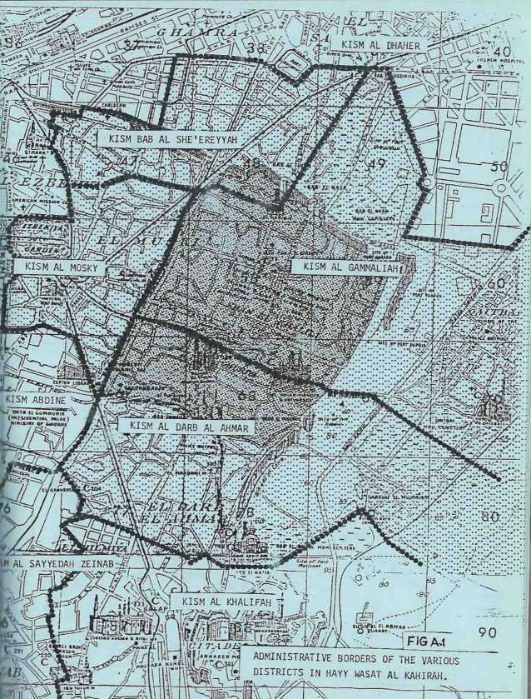

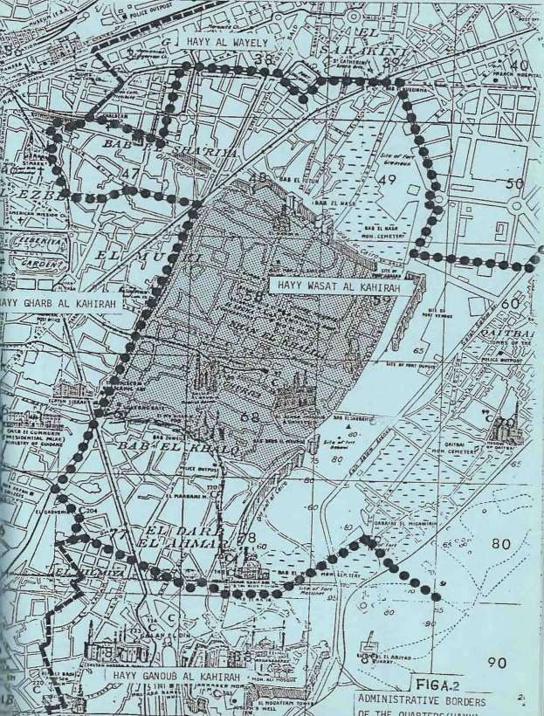

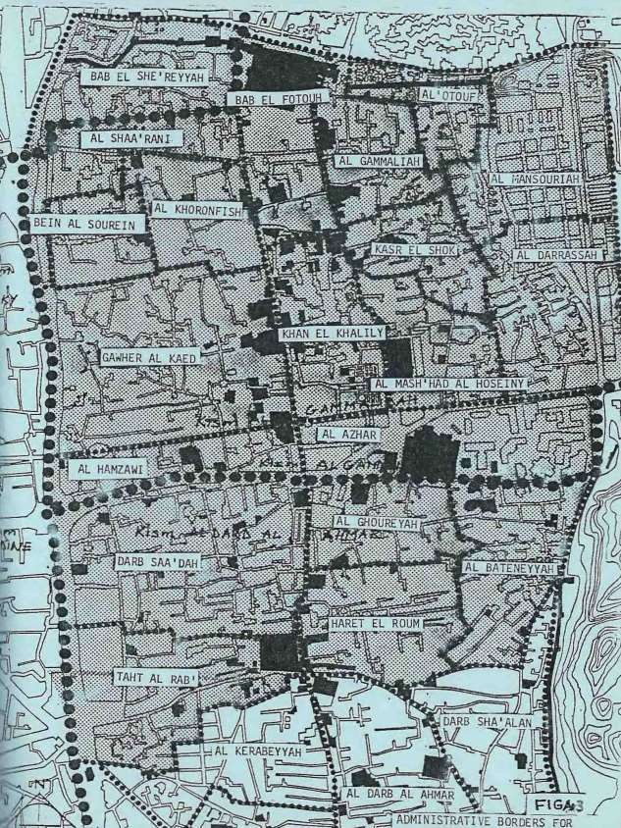

  - Roles and Responsibilities of Hayy Wsat Al Kahirah 1-2-1 PLANNING, FOLLOW-UP AND EXECUTION.
Hayy Wasat Al-Kahirah is not entitled to cover any general planning for the area. In the meantime, it takes the responsibility of the follow-up of approved planning projects from the General Organization for Physical Planning (GOPP) and from the Governorate of Cairo. The main task of Hayy Wasat Al-Kahirah consists of the super•vision of the execution of the approved planning rules and regulations in the domains of construction and street networks.
    - INFRASTRUCTURE AND SERVICES: -
The procession of the approved projects for infrastructure (Electricity, water supply and sewage, street networks etc…..) by the Governorateof Cairo or by the specialized agency of infrastructure, cannottake place without the work permission of Hayy Wasat Al-Kahirah.
The supervision of the execution of the project is not the responsibility of the Hayy. It only coordinates between the involved organizations and inspects the work according to the rules and regulations of the local planning authorities.
The technical supervision of the services of education, health, social affairs and public culture is the responsibility of the concerned ministries while the administrative dependency concerns the Hayy. There is a special directorate for each service, and an office in each Kism (District).
  - Decision Making and Project Approval
1-3-1 The projects fulfilled by Hayy Wasat Al –Kahirah are urgent projects·
taking place upon the public pressure of its inhabitants and their needs. The projects must be within the financial capability of the Hayy's budget. (does not exceed100000 LE).
The financing of the protects is usually from the budget of the Governorate of Cairo, the services in the district or from aid programs.
Property Registration, building licenses, work permission, land and property expropriation (for publicuse) are a part of the responsibility of the Hayy.
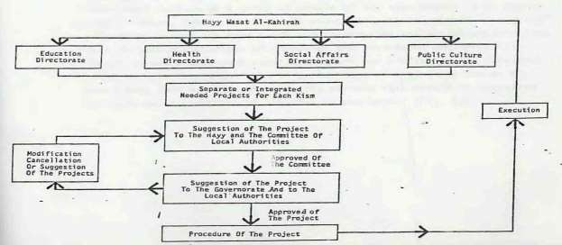
The project must proceed in the following hierarchy for its approval: -

  - Existing Associations in the Area
1-4-1 Lately, there has been a great trend to the establishment of associations whose aim is to fulfil the requirement and the needs of the inhabitants within the district. This appears clearly in the study area where as 113 associations are founded in Garronaliah and Darb Al-Ahmar and declared in the ministry of Social Affairs in order to participate their activities (role).Only12 of these associations are funded from the ministry of social affairs and ministry of culture, while the rest are supported by gifts and by their member so These associations cover up all kinds of religious, social, health and cultural services such as building mosques. city halls, a culture center, a library as well as play grounds for sports activities. These associations are classified according to their nature into voluntary associations that consist of a group of
people sharing the same craft e.g. shoemakers and varied associations that include associations of companies and government employees. It should be noted that such associations are non- profitable and from one point of view they might seem of narrow range of activities but as a whole they form one body of community service that should be organized to avoid multiplication of services in one area (Fig.5).

(VOLUNTARY ASSOCIATION IN THC STUDY AREA)
 | KISM OF Al-  Gammaliah | KISM OF DAPB AL- AHMAR | AREA
Number of Associations | 66 | 47 | 113
Table Showing the Number of Declared Associations in the History of Social Affairs for Each Kism,
 | MINISTRY OF SOCIAL AFFAIPS | Ministry OF Culture | TOTAL
Number of Associations | 10 | 2 | 12
Table Showing the Association Funded From the Ministry of Social Affairs and the Ministry of Culture for the Area
KISM | SOCIAL MD | RELIGIOUS, Cultural And SCIENTIFIC  AID | FAMILY AFFAIRS. SOCIAL DEVELOPMENT HEALTH  SERVICE | TOTAL
Al- Gammaliah  Al-Darb Al-Ahmar | 41  24 | 15  13 | 10  10 | 66  47
Total | 55 | 28 | 20 | 113
Table Showing the Activities of the Associates in Each Kísm.
 | VOLUNTARY ASSOCIATIONS | CRAFT ASSOCIATIONS | VARIED ASSOCIATIONS | TOTAL
Al- Gammaliah  Al-Darb Al-Ahrrar | 21  23 | 12  4 | 33  20 | 66  47
Total | 44 | 16 |  | 113

