**Paper’s No. BUE-FISC2010-141**

**AN INSPIRED SUSTAINABLE VISION FOR 6TH OF OCTOBER NEW CITY IN EGYPT**

**THE APPLICATION OF LAND READJUSTMENT FOR THE NEW CITY EXTENSIONS**

**E. Salma Ahmed Yousry**

ArchPlan consultancy

salmayousry@yahoo.com

**Dr. Florian** **Wiedmann**

Albert Speer & Partner GmbH

florian_wiedmann@yahoo.de

**ABSTRACT:**

*Cities, like human begins, have the common nature of continuous change. Being called growth, deviation or expansions reflects the same sense ensuring that a city is never in a stagnant state.*

*This was the main reason behind having the government of Egypt -represented in the Ministry of Housing, Utilities and Urban Development and specifically the New Urban communities Authority- prepare updated periodical strategic plans for the new Egyptian cities to feedback cities problems, potentials and constrain defining new visions and objectives within the comprehensive plan for the country.*

*When the studies for the updated strategic plan for 6th of October city started in 2007, obvious deviations of its executive plans from the original city’s goals and objectives were noticed. These unplanned extensions resulted in random urban growth and land uses changes that lead to the lack of a comprehensive city vision and the creation of an urban environment that lacks identity and cohesiveness with a poor quality of life due to the difficulty in creating a clear hierarchy of infrastructure and services and the resulting growing social segregation.*

*This study will explore the application of Land readjustment scheme to the southern extension areas of 6th of October city to help manage and face the existing challenges for the application of the proposed strategic plan targeting the year 2027 and the inspired sustainable and cohesive vision for the city that would support transferring the current market driven policy in the city to an efficient functioning one. The new proposed city center and sustainable planning districts with the integrated landscape fingers in the new extensions will be further illustrated and the concluded benefits to the city by the application will be illustrated at the end of the study.*

**Conference Topic: "Future Intermediate Sustainable Cities: A message to future generations"**

**Keywords: New Cities, Land Readjustment, Land Ownership, Urban Management, Sustainable Planning.**

# ABBREVIATIONS

|  |  |
| --- | --- |
| MHUUD | Ministry of Housing, Utilities, and Urban Development |
| GOPP | General organization for physical planning |
| NUCA | New Urban communities Authority |
| October city | 6th of October and Sheikh Zayed cities |
| LR | Land Readjustment |
| UNCHS | United Nations Centre for Human Settlements (Habitat) |
| NHP | National Housing Program |
| GCR | Greater Cairo Region |
| CBC | Central Business Campus |
| GFA | Gross Floor area |

**1. INTRODUCTION:**

**.1.1 6th Of October New City Background**

When new towns were first introduced in Egypt in the late 1970's, their aim was explicitly to attract population, create an industrial base outside the Valley, and attract public and private investments. The legislative and institutional framework for the new towns created the New Urban Communities Authority (NUCA) within the Ministry of Housing (MHUDD). When towns were to develop standard municipal local administration under the relevant governorate the Town Agency under NUCA is created (The World Bank,2008).

6th Of October was one of the four 'first generation' new towns in Egypt, located West of Cairo at a desert location about 40 km from the centre of the metropolis. October's original urban mass area was 4788 Hectares and target population 500,000. The city had an integrated master plan that included residential neighbourhoods with commercial, mixed uses spine, open spaces, an industrial zone, sports and tourism areas (Wahdan, Ahmed Abdel Mohsen,1980).

Over the years, despite its little success, October was still the most successful among the New towns. The thing that encouraged NUCA to further use its rights described in (The World Bank,2008) as rights that neither Governorates nor ministries could enjoy; to declare special development zones on State-owned desert lands, develop and sell those lands and to retain these revenues to finance further development.

Between the growing demand and the changing policies, a speculative, supply driven, wholesale land market in 6th of October was created. Without a vision, objectives or even a new city plan, thousands of new hectares of extension areas on subdivided land were released to both individuals and developers. As a result, extension areas of the city turned to patchy plot shapes that could not function efficiently and would require the government to spend multiples of what should be spent to utilise those lands. Now that the city's area is twelve times its original plan[1] and has almost achieved it original target population[2]; it became critical to pause, analyse and readjust for the future.

**1.2 The New Inspired Vision**

At the beginning of 2007, MHUDD Commissioned international management and planning consultants to prepare a strategic plan revitalizing the city. The plans aimed at setting up a clear vision and aspiration for 6th of October city, defining constrains, setting objectives and planning strategies. The outcome of the study was very promising; providing a physical and economic transformation for the city to become ' A symbol of Egyptian aspirations for a better life' creating new connections and interfaces to become a national hub and landmark, while providing all necessary functions and services to become a self sustaining city operating independently within the Greater Cairo Region. (Ashour, Mohamed Ayman,2010)

**1.3 The Challenge**

Behind this promising aspiration laid the important question; how and where can this plan be implemented?

The most common problems of resources; Land and finance were facing the project:

* Shortage in the available areas in the city urban mass (9% only left) , in addition to having the available land scattered within the patchy plot shapes which makes it very hard and expensive to integrate and use.
* The government had already invested in the infrastructure of extension areas. Allocating new budgets (even if available) to projects that opposes their previous policy would be a clear recognition of their decision mistakes.
* The government had commitments to the National Housing Project having most of the program allocated in October city.

The following figure illustrates the land availability in the city. Lighter colours are the more difficult to change as they are already used or fully services plots with infrastructure. Even if those plots still have low occupancy rates but ownership is already distributed to different tenure systems and would be very difficult to redevelop. Allocated unoccupied land to either government or private sector could be more feasible as investments are not yet large in those areas, however ownerships are complicated and most of the public lands are needed for the national housing project. Finally Non-allocated lands are the ones available to be assigned for strategic projects by the municipality, but as previously emphasised are not enough and badly located.

­­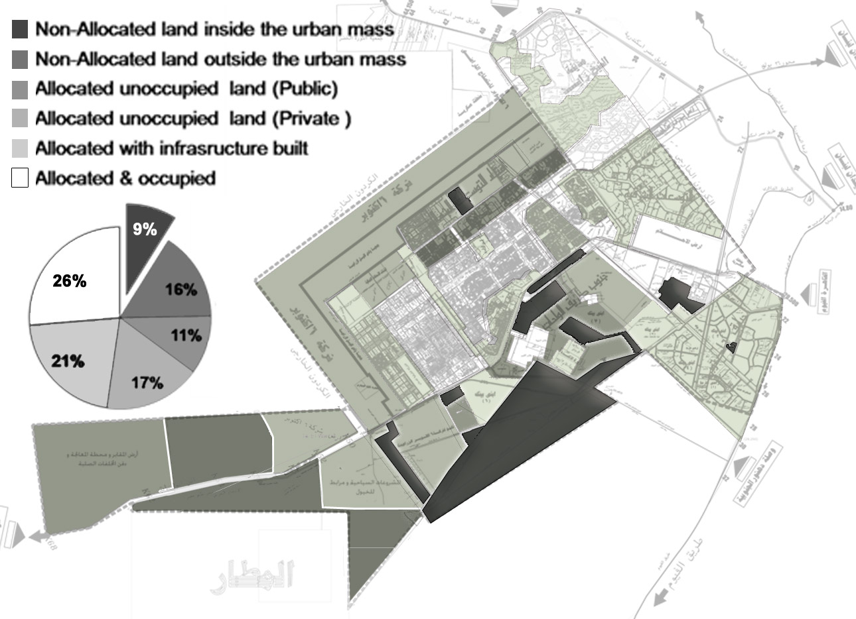

**Figure 1: Land availability in October city (2009)**

Source: (Author based on information from city authority)

**1.4 Research objectives**

As a result of the illustrated challenges facing the implementation of the prepared strategic plan, a development tool was needed to provide adequate land for the development of the strategic plan projects, integrating the government's commitments and uses as minimum external financing as possible.

Having defined the requirements for the system needed, LR is chosen as the tool to redevelop the southern extension areas of October city. The system is to be applied by government initiation in order to implement the key outcome projects of the General strategic plan for the city. The LR scheme would aim also at creating revenues to the municipality to finance other outcome projects in the city as phased in the plans inspired for the city. [3]

This paper will provide an illustrative background on Land readjustment development tool and its application on October city focusing on the sustainable approach maintained through the application. The research then concludes the benefits of applying LR to achieve the sustainable integrated vision for the city and ends with recommendations and future research needed.

**2. LAND READJUSTMENT BACKGROUND**

**.2.1 The Need for LR Technique**

LR as a concept reflected the necessity need for an alternative land development technique to deal with outdated, inefficient and patchy shaped allocated or developed land plots. With the many reasons creating these problems, governments, landowners and developers have tried different approaches to reform those areas with a main common goal of resources efficient use. With their various tools; expropriation, betterment charges, land assembly and other techniques were widely tested but often did not work either for being financially non affordable, causing social inequity or facing enforcement disability.

**.2.2 LR Definition**

One of the key elements behind the LR approach success is its flexibility as an application. Since the early twentieth century LR has been used and adapted to local situations and objectives. This is why a wide variety of definitions for LR exists according to the contexts and constrains overcome. However, some definitions focused on the main concept of the LR;

"Land Readjustment is a system which enables fragmented and irregularly shaped plots to be consolidated for the creation of service and usable parcels. Land is then redistributed to the original landowners, with public infrastructure costs borne collectively by the increase in development value, on a pro-rata basis" (Adams, David, Disberry, Alan, Hutchison, Norman and Munjoma, Thomas,2001).

"Under land readjustment programs, undeveloped areas, usually an urban fringe can be designated for improvement, including the rearrangement of plots, the grading of land, the construction of roads and the provision of infrastructure. Instead of paying a betterment levy, landholders must surrender part of their land to the local authority as payment for the improvements. The local authority can then resell this portion of land to recoup the improvement costs."(UNCHS (Habitat),1990)

**.2.3 LR Process**

Since LR is quite a changeable and adaptable system, This part of the study will focus on the elements of the process that enable LR systems to provide social and economic benefits as shown in the chart below.

At the beginning of the project, it is very important to define the institutional frame work and actors involved and the roles of public and private parties. (Larsson, Gerhard,1993) explains that once the process has started, one or more main actors must actively prosecute it and commit the resources which this requires. These main actors are generally the initiators (possibly together with additional interests), a circle of disposed co-actors, passive participants, counter-actors and Authorities are grouped according to the case.

One important factor also for a successful LR application is to maintain it as participatory and transparent as possible throughout the process and especially in the valuation and deduction stages.

4

3

6

7

8

9

2

5

1

V=

V1=X - V2=Y ….V9=Z

4

3

5

6

7

8

2

For sale

For sale

**Chart 1: LR conceptual process**

**.2.4 Benefits of a well adopted LR system**

According to (Hong, Yu-Hung and Needham, Barrie,2007),(Home, Rob,2007), (Yomralioglu, Tahsin,1993) The major benefits of LR systems for both municipalities and land owners could be summarized as follows:

**.2.4.1 Financially**

* Reinforce the self funding mandate and facilitate fully-serviced urban development without direct public funding
* Provide with revenues that could cross finance other related projects
* Minimize the transaction costs by providing an ideal governance structure in the redevelopment process and thus reducing development risk costs
* Efficiently and innovatively usage of land and creating new economic interest and combining the assembly and re-parceling of land for better planning
* After the project, land values increase very rapidly and land become more valuable for landowners and Tax revenue increases within project area.
* It distributes the financial benefits of development (also known as betterment, or the added value that can be created by planning permission) between land owners and the development agency

**.2.4.2 Socially**

* At the end of the project, basic public services are supplied to new lots, therefore the new social services are brought into to the project area
* Help minimize the political and social costs of urban renewal and disputes about land planning injustices are reduced
* Promotes participation for the overall public and private benefits
* Equitable assigning of property rights with proper registration (Land rights are transferred after the re-plotting).
* A zoning plan is realized in a short time, and urban land development projects are achieved rapidly.

**2. LR APPLICATION IN OCTOBER CITY**

This part of the study will propose LR system as a tool to rearrange the southern extension area and provide the needed land, finance for infrastructure and other strategic projects and a better function city and conclude the benefits October will gain from this LR application.

The following chart proposes the LR process to be applied in October city followed by an illustration for the elements of the main process.

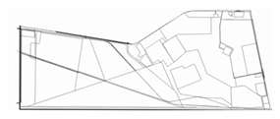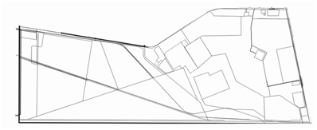

1

2

3

4

5

6

7

8

9

10

11

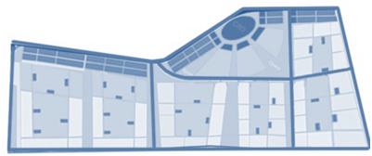

1

2

3

5

6

7

8

9

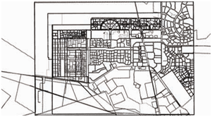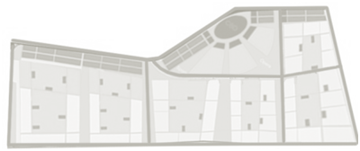

Investors

*Marketing Plan*

Detailed plan for phase one

Detailed planning for Next phase

Strategic plan Consultant

Participatory

NUCA

Admin. + Shares

City Agency

Gov NHP + Unallocated

NHP by Private

Private owners

Landowners

**Chart 2: LR application in 6th of October city**

**2.1 PROJECT INITIATION**

The project is initiated after having the prefeasibility studies that would project preliminary figures for cost, financing options in addition to defining boundaries and main activities. Before announcing the project, NUCA should identify and register the beneficiaries and the land areas required for the NHP provided by the government or through private investors in the city.

**Table 1: Actors proposed in the LR application in 6th of October city**

|  |  |
| --- | --- |
| Main Actors | * Central Government represented in NUCA as one of the main Landowners (NHP land representatives and unallocated land that belongs to NUCA) * Initiating Landowners (with maximum shares and interest) * City Agency will Manage the project and have the first right to buy shares in the project before it is announced to the public. This aims at having a stronger local power and control over future city projects. |
| Co-actors | * Other Land owners * Representatives from Governmental authorities with land in the project area or will be engaged in rehabilitation projects[4] (Ministry of Electricity, Ministry of Petroleum, Military, etc) * Strategic plan consultants (to make sure the plan reflects the strategic needs of the city and coordinate provided finance to other priority projects in the city) |

**2.2 Define Valuation Method**

When the project actors are mobilized, valuation method is then decided. A special appraisal committee will be assigned to define basic values which are then negotiated in within main actors’ board. The value of lands would be based on its legal market value[5] before the project announcement depending on the location, surrounding values, area and physical land properties.

**2.3 Project Announcement & Stock Offering**

In this stage, the project is announced and shares are offered in market; first to the City Agency, NUCA, landowners and finally to the public. The share prices and allowed percentage for various stakeholders are set in participation with main initiators (Main Actors). This is done through a market plan for the project.

**2.4 Planning and Implementing**

Since the project is of a big area and holds the main elements of achieving the inspired sustainability for the city, a flexible plan is designed in close coordination with the strategic plan for the city. The plan should be one that is easily phased and managed throughout the process. Implementation priority would be given according to preset criteria but basically to original landowners and NHP beneficiaries.

**2.4.1 The Proposed New Sustainable Plan For The Project**

As explained earlier, the new plan proposed for the area should be flexible and phase-able; therefore the proposed project includes three main elements;

* The CBC
* The residential districts
* The Green integrated landscape fingers

These three elements work together to achieve the overall sustainability concepts for the project as explained below.

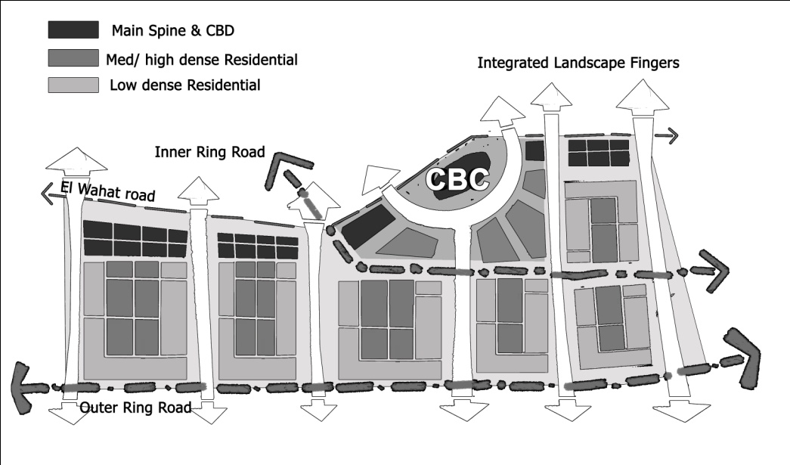

**Figure 2: project concept plan sketch**

1. **The New CBC**

The currently elaborated Master Plan includes a new regional city centre proposed as Central Business Campus (CBC), whose iconic design follows the principle of creating a green cultural forum surrounded by the main business spine. In spite its introverted structure this “pearl in a shell”-design principle recognizes the already existing and planned urban structure by integrating the proposed central green corridor leading from the Northern Spine to the southern extension areas. The green core of the CBC is described by a concentric system of boulevards, which aim to reduce traffic congestion. The concentric form of the cultural forum is in addition to the road system created by the integration of high rise developments within the middle spine. This frame of high rise developments allows various lines of sight into the forum, which even in far distance gains importance. Thus, an iconic dimension of the city centre attracts investment and subsequently leads to a quality enhancement of the built environment within 6th of October City.

The design of each individual block is mainly restricted on certain key building conditions such as land use, GFA and building height. Most of the areas are defined as mixed use areas providing the possibility to develop commercial or residential projects. The individual size of each block provides flexibility regarding investors. In addition to the location of possible high rise projects the Detailed Master Plan suggests locations for the main shopping area, entertainment centre and public administration. Furthermore, a detailed proposal has been elaborated for the inner green area and cultural forum regarding the various uses of areas and buildings. In addition, services, such as schools and mosques, are integrated within the city centre in order to guarantee walk-able distances for future inhabitants. Moreover, the mixed use developments along main roads provide sufficient areas for retail and further commercial services. Last but not least, the linear spine with mixed use and high density developments provides the possibility of integrating an efficient public transport system.

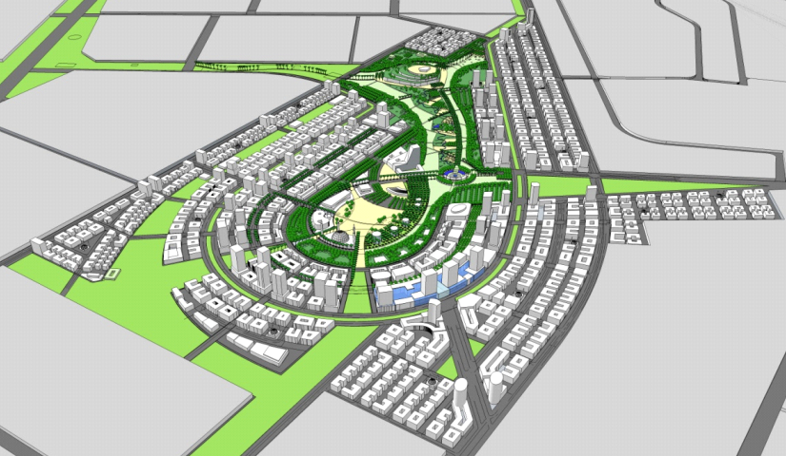

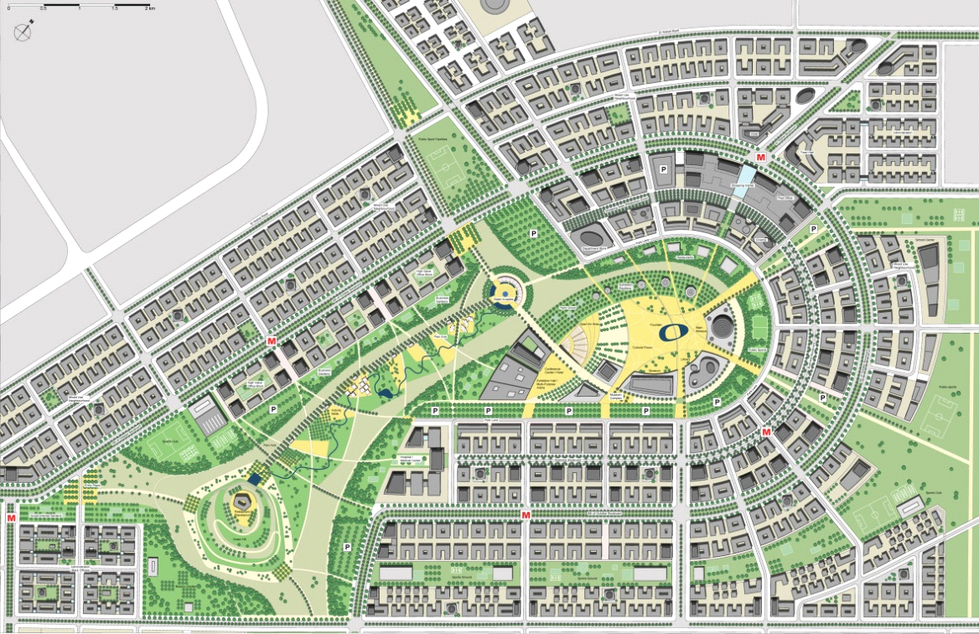

**Figure 3: CBC Detailed Master Plan** (original scale 1: 2.000)

The central open space connects the various elements of the Central Business Campus linking the centre with the surrounding urban areas by being the main core of the green corridor concept. Its particular form provides the possibility to establish an interesting and attractive visual relationship between various view points and landmark features.One of the main goals of this master plan is to establish the balance between a sophisticated open space, reasonable maintenance costs and a sustainable irrigation concept. While on the one side the ratio between areas of vegetation, hardscaped surfaces and extensive areas is kept in balance, the private sector has to participate at the maintenance costs of the future park. Thus, certain public institutions and private companies have to cooperate in public private partnerships (i.e. for example the maintenance of the tree frame or of the cultural forum. The enforcement of a public private partnership system is an important aspect of the recommended maintenance concept and it can be gradually extended. Leading local, national and international companies are expected to establish headquarters around the central park. Due to the benefit of the landmark location they can be asked to contribute in maintaining the quality of the green open space. This can be achieved in form of privately owned business gardens or the implementation of a levy system forcing the private sector to pay the maintenance of a certain amount of green area. The size will depend on the developed floor area. In the case of certain cultural or commercial elements within the park, such as the exhibition pavilions, it is recommended that the public sector or the operating company of the conference center remains in charge of the main maintenance responsibility in order sustain the balance between commercial and cultural use. Another component of raising the maintenance costs is the introduction of fees for private enterprises, which are interested to operate their businesses in the park area such as sports clubs, parking spaces or garden restaurants. Parallel to these commercially used areas the public sector should take responsibility for other parts of the open space such as the suggested botanical garden, Hospital Park or administrative gardens. Based on this definition of distinct zones and responsibilities it is possible to reduce the main central park to a controllable size (Dilger, Matthias, 2010).

In addition to the establishment of public private partnerships the maintenance costs have to be generally reduced by introducing a grey water concept regarding the irrigation of green areas and the preference of planting arid vegetation.

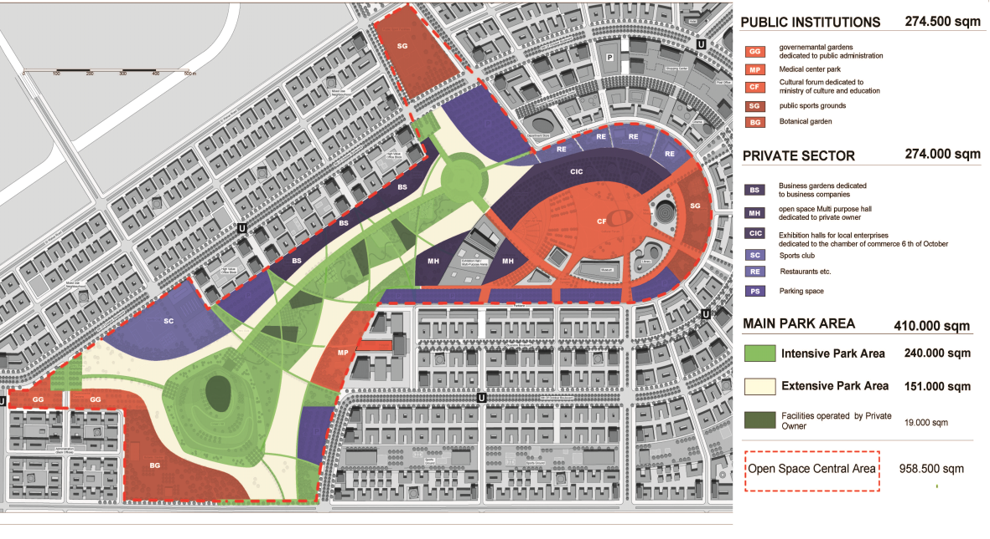

**Figure 4: Recommendations for maintenance in the CBC**

1. **The New Residential Districts**

While the Southern Spine and the CBC will be mainly occupied by commercial land uses most of the southern part of the expansion area will be developed by residential projects. In this regard the urban density is expected to decrease towards the green belt along the fringes of 6th of October City. Each residential district consists of around nine neighborhoods, which are expected to have a population between 5,000 to 10,000 inhabitants. The new residential districts are designed as self-contained cities within the city integrating all needed services. While social services, such as schools, will be integrated within residential districts, there will be the possibility to develop commercial buildings along main access roads. The main commercial centers will focus on junctions of the main roads, where it is furthermore planned to integrate leisure areas, such as pocket parks. In addition to small mosques within each neighborhood there will be the possibility to build cultural and religious institutions along main roads and at their junctions. While hospitals are located along the green corridors most other public services are proposed to be developed along main roads due to the provided accessibility. Schools are distributed in each neighborhood according to current standards of catchment areas and radii. Technical infrastructure is mainly located within the large green corridors between single residential districts.

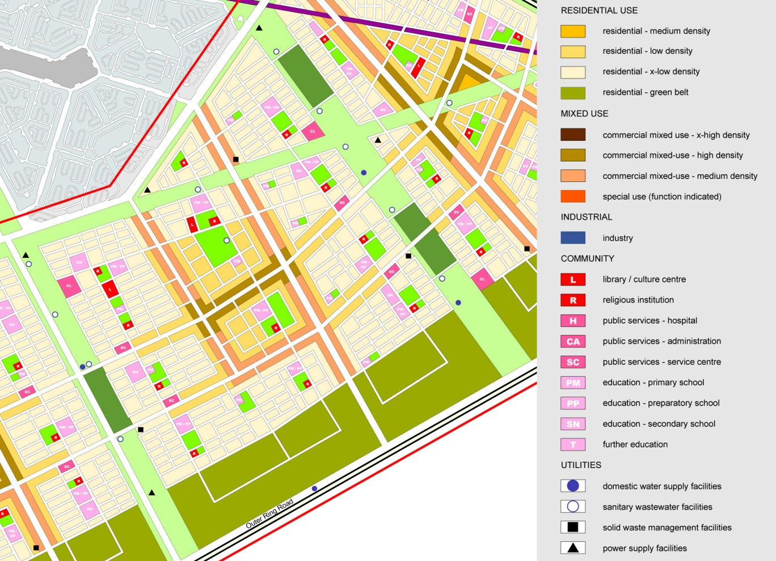

**Figure 5: Land use distribution of new residential districts**

1. **The Green Fingers (Integrated Landscape Corridors)**

Main structural element of the southern residential areas will be the system of landscape corridors and main arterial roads. One central landscape corridor will lead from the outer ring road through the residential areas towards the CBC, where it interlinks with the urban landscape corridor leading to the Northern Spine. All in all five landscape corridors define the planning area and connect the new development areas with the currently existing urban areas in the north. The central corridor will lead through the CBC, where a large park will form the new public centre of 6th of October City. While most areas of these corridors will be extensive landscape areas, which means desert-like vegetation and reduced investments into maintenance, certain areas will be developed as intensive landscape areas with continuous cultivation. These intensive landscape areas include leisure facilities, such as sports clubs, or agricultural uses. Thus, public as well as private sports clubs of larger scale are located at certain junctions of the extensive green corridors serving adjacent city districts. Continuous pedestrian friendly green boulevards along the main axes and roads complete the main open space network.

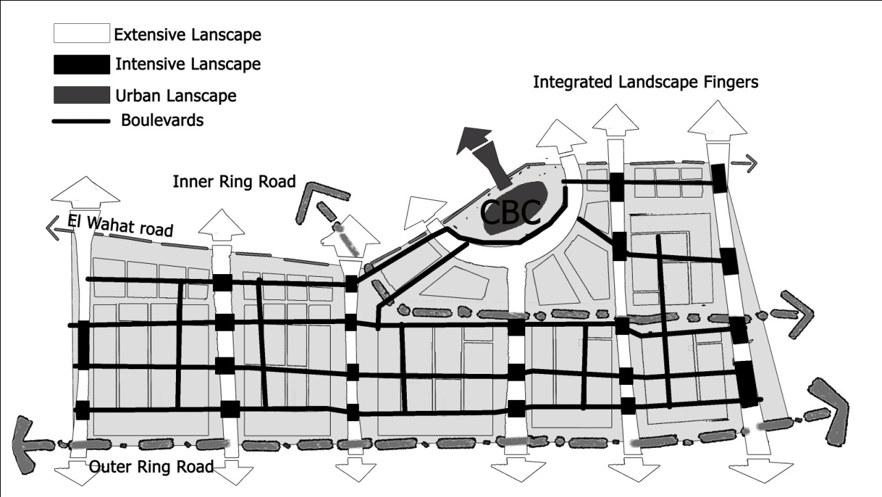

**Figure 6: concept sketch for the system of green corridors and boulevards**

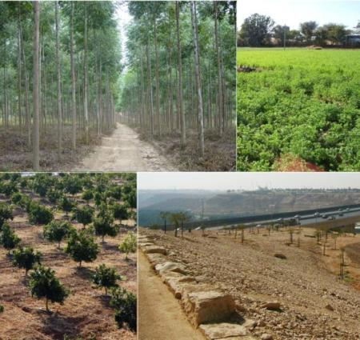 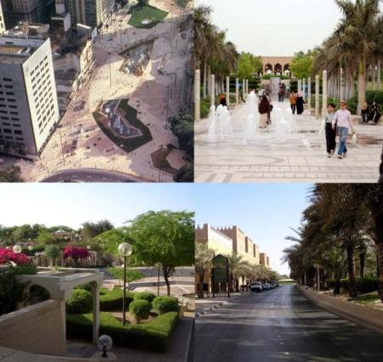 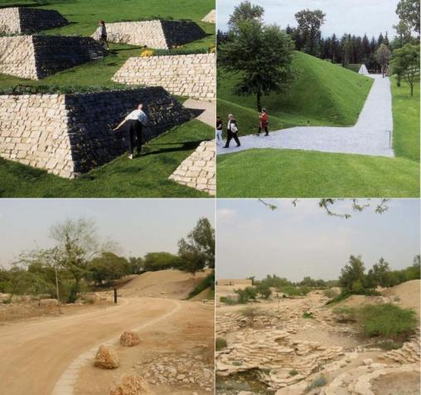

Extensive landscape Urban Landscape Intensive landscape

**Figure 7: Examples illustrating landscape categories**

**2.5 Reallocating**

Reallocation plan will be set from early stages of the project parallel to the implementation plan and according to the valuation of new areas. These plans will define when new investment lands will be available for the share holders to decide either to keep them or sell their shares. This system should be flexible so that investors and landowners would have options to invest in other parts of the city and links into other development plans and closely coordinated with the marketing plan for the project.

**3. CONCLUSION & BENEFITS GAINED FROM LR APPLICATION**

Since the main goal of the LR application in October city is to achieve the strategic plan objectives, the main benefit gained to the city is providing adequate land for the implementation of the main projects and objectives of the strategic plan in addition to increasing the value of existing land and thus providing financing opportunities for the plan and maintenance to the city.

Without the LR scheme the projects should have fit within the badly distributed available land which would have caused significant less impact and revenues to the city.

The current plan applied with LR scheme now provides a unique landmark quality and a new city image with a viable public transit system creating a new identity that could present the new quality of life in the city and maintain the envisioned sustainability concepts studied carefully while designing the main elements of the new city plan.

**4. RECOMMENDATIONS**

In order to maintain the sustainable vision illustrated for the southern extension areas for October city, it is very important to integrate this project with other strategic projects locally and regionally through phasing, prioritizing and financing. The LR scheme should be part of a bigger strategic program to support finance or manage them as a value capture tool to the city with a broader look on the strategies for GCR and Egypt as a whole. This requires coordination and strong role of the local City Agency and governance on one hand and NUCA for regional coordination on the other.

LR application in October city could act as a unique pilot project that introduces LR schemes in Egypt with an extreme case that would emphasize the significant impact of LR systems on Land and housing markets.

### FUTURE RESEARCH WORK PROPOSED

Since the main objective of this study was to verify the economic, social and physical planning advantages of the application, future studies should involve a more focused consideration to the legislative management framework and legal Egyptian laws that would support the application. Also studies should define the specific cost benefit analysis and financial cycle for the project.

**References**

1 **The World Bank** "Toward an urban sector strategy", 2008

2 **A. A. M. Wahdan** "6th of October city, General structural plan", 1980

3 **M. A. Ashour** "The strategic plan for 6th of October\Zayed city (existing situation analysis)", 2010

4 **D. Adams, A. Disberry, N. Hutchison and T. Munjoma** "Managing Urban Land: The Case for Urban Partnership Zones", Regional Studies,

5 **UNCHS (Habitat)** "Shelter for All, Global Strategy for Shelter to the Year 2000", 1990

6 **G. Larsson** "Land readjustment: A modern approach to urbanisation", Avebury, 1993

7 **Y.-H. Hong and B. Needham** "Analyzing Land Readjustment

Economic, Law and Collective action", Lincoln Institute of Land Policy, Cambridge, Massachusetts, 2007

8 **R. Home** "Land readjustment as a global land tool: focus on the Middle East", 2007

9 **T. Yomralioglu** "A Nominal Asset Value-Based Approach for Land Readjustment and Its Implementation Using Geographical Information Systems", Publisher, Place Published, 1993

10 **M. Dilger** "6th of October City - Conceptual Master Plan", 2010

11 **Salma yousry** "Urban transformations in new cities in Egypt (case study 6th of October city)”, 2010

1. Original urban mass area of 9,166 Fd and the current area is about 126,000 fd (52920 hectares)
2. According to Central organization for general Computation and statistics, the population in 2006 was 220.441 thousand. The city authority claims it is between 505-525 thousand inhabitants in 2006 and 700,000 in 2010 which is still almost the target set to the original area in 1980.
3. Different urban land reassembling tools were explored and compared in the research submitted for the masters degree by the author, and LR tool was thus chosen.

   Salma yousry, “Urban transformations in new cities in Egypt (case study 6th of October city)” Cairo, 2010.
4. Projects suggested in the strategic plan to rehabilitate the area and prepare it for investment like moving the sewage unit, cemeteries, train, gas line, high cable lines from the middle of the urban mass.
5. Some areas have high expectations for changing land use (like the agriculture company), however those areas are valued for the market value of their legal land use.